

User’s Guide

Draft Version 2.9

Revised February 2021



**Expanded   
Programme on Immunization**

This page is intentionally blank.

Table of Contents

Acknowledgements 1

Chapter 0. Preliminary Material 3

Document Revision History 3

Acronym List 4

License Agreement 5

Chapter 1. Introduction 7

Chapter 2. Overview 8

2.1 Running VCQI 8

2.2 The Indicators 8

2.3 Files that comprise VCQI 9

2.4 Files Used by VCQI 9

2.5 Files Produced by VCQI 10

2.6 Levels of Survey Strata 11

2.7 Program Progress Log 11

2.8 Structure of VCQI Control Programs 12

2.9 Specifying VCQI Input Parameters 12

Chapter 3. Analyzing Routine Immunization (RI) Surveys 14

3.1 Dataset File Names (goes in Block D) 14

3.2 Vaccination Schedule Metadata (goes in Block D) 15

3.3 Survey Metadata (goes in Block D) 17

3.4 Analysis Metadata and Options (goes in Block D) 20

Chapter 4. Analyzing Tetanus Protection at Birth (TT) Surveys 23

4.1 Dataset File Names (goes in Block D) 23

4.2 Schedule Metadata (goes in Block D) 24

4.3 Survey Metadata (goes in Block D) 24

4.4 Analysis Metadata and Options (goes in Block F) 25

Chapter 5. Analysis of Post-Campaign (SIA) Surveys 26

5.1 Dataset File Names (goes in Block D) 26

5.2 Vaccination Schedule Metadata 27

5.3 Survey Metadata 27

5.4 Analysis Metadata and Options 28

Chapter 6. Vaccination Coverage Quality Indicator Descriptions 29

6.1 Weighted and unweighted analyses 29

6.2 Analysis Counter 29

6.3 DESC: All Surveys: Describing the Survey Sample 32

6.4 RI_COVG: RI Survey – Measures Related to Coverage 45

6.5 RI_ACC: RI Survey – Measures Related to Access 55

6.6 RI_CONT: RI Survey – Measures Related to Continuity of Services 56

6.7 RI_QUAL: RI Survey – Measures Related to quality of Services 58

6.8 RI_CCC: RI Survey – Cumulative Coverage Curves (CCC) 78

6.9 RI_CIC: RI Survey – Cumulative Interval Curves (CIC) 83

6.10 RI_VCTC: RI Survey – Vaccination Coverage and Timeliness Charts (VCTC) 87

6.11 TT_COVG: Tetanus Survey – Measures Related to Coverage 105

6.12 SIA_COVG: Post-SIA Survey – Measures Related to Coverage 107

6.13 SIA_QUAL: Post-SIA Survey – Measures Related to Quality of Services 116

6.14 Hypothesis Tests for Differences in Coverage 117

Chapter 7. Examples of Control Programs 124

7.1 Block A – Start with clear memory 125

7.2 Block B – Specify input/output folders & analysis name 127

7.3 Block C – CD to output folder & open VCQI log 129

7.4 Block D – Specify dataset names & important metadata 130

7.5 Block E – Pre-process survey data 144

7.6 Block F – Calculate VCQI indicators requested by the user 148

7.7 Block G – Exit gracefully 158

7.7 Block H – Document changes to the control program template 159

Chapter 8. Troubleshooting VCQI 160

Annex A. Nested Strata in VCQI 162

Annex B. Controlling How Strata Are Listed in VCQI Output 166

B.0 Demographic stratification using the VCQI_LEVEL4_SET_VARLIST and LAYOUT 167

B.1 Sample listings of stratum name and order datasets 170

B.2 Example: Nested output for all Levels: 1, 2, and 3 with additional Level 4 stratification 172

B.3 Example: Nested output for all Levels: 1, 2, and 3 175

B.4 Example: Non-nested output for all Levels: 1, 2, and 3 178

B.5 Example: Output for Level 3 only 181

B.6 Example: Output for Level 3 with additional Level 4 stratification 184

B.7 Example: Output for Level 4 Only 187

B.8 A Large Realistic Level 4 LAYOUT Example 190

B.9 Changing Order of Strata in Inchworm and Unweighted Plots 194

B.10 Additional Options for Customizing VCQI Output 197

Annex C. Customizing VCQI Plot Output 198

C.1 Customizing Plot Colors 198

C.2 Generate Bar Charts Rather Than Inchworm Plots 202

C.3 Changing Confidence Interval Information on Inchworm Plots 204

C.4 Changing Confidence Interval Information on Double Inchworm Plots 210

C.5 To Customize VCQI Plots in Other Ways 214

Annex D. VCQI Output Databases 215

Annex E. VCQI Augmented Dataset 218

Annex F. Additional Tools for Working with VCQI Output 219

F.1 Missed Opportunities for Vaccination R-Shiny Application 219

F.2 ICCLOOP Program for Reporting Survey Planning Parameters 224

Annex G. RI Date Data Quality – Method for Detailed Assessment 226

List of Tables

Table 2-1. VCQI control programs consist of seven blocks of code 12

Table 3-1. How RI_RECORDS inputs affect outcome calculation 19

Table 3-2. How RI_RECORDS inputs affect the main valid dose outcome (RI_COVG_02) 19

Table 4-1. How TT_RECORDS inputs affect indicator calculations 25

Table 6-1. VCQI indicators that rely on others being run first 31

Table 6-2. Fields reported in DESC_01 33

Table 6-3. Denominator definitions for DESC_02 34

Table 6-4. Numerator definitions for DESC_02 34

Table 6-5. Optional inputs for DESC_02 36

Table 6-6. Interpretation of DESC_02 39

Table 6-7. Denominator definitions for DESC_03 40

Table 6-8. Numerator definitions for DESC_03 40

Table 6-9. Optional inputs for DESC_03 42

Table 6-10. Interpretations for DESC_03 44

Table 6-11. Naming convention for RI_COVG_01 databases 45

Table 6-12. Naming convention for RI_COVG_02 databases 47

Table 6-13. Naming convention for RI_QUAL_01 databases 59

Table 6-14. How RI_QUAL_07B uses RI_RECORDS inputs 68

Table 6-15. User inputs for RI_CCC_02 79

Table 6-16. User inputs for RI_CIC_02 84

Table 6-17. RI_VCTC_01 inputs that are usually set in the control program 90

Table 6-18. RI_VCTC_01 inputs that are often unchanged in globals_for_timeliness_plots.do 92

Table 6-19. RI_VCTC_01 inputs to customize timeliness categories for individual doses 98

Table 6-20. Naming convention for SIA_COVG_01 databases 107

Table 6-21. Naming convention for SIA_COVG_03 databases 111

Table 6-22. Naming convention for SIA_QUAL_01 databases 116

Table 6-23. User inputs for COVG_DIFF_01 117

Table 6-24. Weighted coverage variables that are eligible for hypothesis testing 120

Table 6-25. User inputs for COVG_DIFF_02 121

Table A-1. Overview of three nested levels of administrative hierarchy 162

Table B-1. Where to specify the names and listing order of various strata 166

Table B-2. Stratum sort order for VCQI inchworm plots 171

Table B-3. Nested output for all Levels: 1-3 with Level 4 stratification 173

Table B-4. Nested output for all Levels: 1, 2, and 3 176

Table B-5. Non-nested output for all Levels: 1-3 179

Table B-6. Output for Level 3 only 182

List of Figures

Figure 6-1. Cumulative Coverage Curves for Oral Polio Vaccine (OPV) in Harmonia 78

Figure 6-2. Cumulative Interval Curve for OPV Dose1-to-Dose2 Interval in Harmonia 83

Figure 6-3. Vaccination Coverage & Timeliness Chart (VCTC) for Harmonia using default parameters 87

Figure 6-4. VCTC for Harmonia District 03 using customized BCG and HepB timeliness parameters 97

Figure A-1. The Fictional Country of Harmonia 163

Figure A-2. Harmonia holds a Northern and Southern Province 163

Figure A-3. Each province holds five districts 164

Figure B-1. Inchworm plot showing nested output for all Levels: 1-3 with Level 4 stratification 174

Figure B-2. Inchworm plot showing nested output for all Levels: 1, 2, and 3 177

Figure B-3. Inchworm plot showing nested output for all Levels: 1, 2, and 3 180

Figure B-4. Inchworm plot showing sorted output for Level 3 only 183

Figure B-5. Inchworm plot showing sorted output for Level 3 with Level 4 stratification 186

Figure B-6. Unweighted proportion plot showing outcomes for every level of two demographic stratifiers 189

Figure B-6. Inchworm plot with strata sorted by outcomes, low-to-high, bottom-to-top 195

Figure B-7. Inchworm plot with strata sorted by outcomes, high-to-low, bottom-to-top 195

Figure B-8. Inchworm plot with strata sorted in table order 196

Figure C-1. Inchworm plots with default colors and with customized colors 201

Figure C-2. Inchworm plot and its corresponding bar chart 203

Figure C-3. Inchworm plot demonstrating VCQI_IWPLOT_CITEXT 1 205

Figure C-4. Inchworm plot demonstrating VCQI_IWPLOT_CITEXT 2 205

Figure C-5. Inchworm plot demonstrating VCQI_IWPLOT_CITEXT 3 206

Figure C-6. Inchworm plot demonstrating VCQI_IWPLOT_CITEXT 4 207

Figure C-7. Inchworm plot demonstrating VCQI_IWPLOT_CITEXT 5 208

Figure C-8. Double inchworm plot demonstrating VCQI_DOUBLE_IWPLOT_CITEXT 1 211

Figure C-9. Double inchworm plot demonstrating VCQI_DOUBLE_IWPLOT_CITEXT 2 212

Figure C-10. Double inchworm plot demonstrating VCQI_DOUBLE_IWPLOT_CITEXT 3 213

Figure F-1. Missed Opportunities R-Shiny App – Main Bar Chart 220

Figure F-2. Missed Opportunities R-Shiny App – Main Results Table 221

Figure F-3. Missed Opportunities R-Shiny App – Cumulative Time to Correction Graphs 222

Figure F-4. Missed Opportunities R-Shiny App – Time to Correction Table 223

This page is intentionally blank.

# 

# Acknowledgements

The Vaccination Coverage Quality Indicators (VCQI) software was developed in 2015 for the World Health Organization by Biostat Global Consulting.

We express our very fond gratitude for helpful ideas and feedback furnished by Tony Burton, Pierre Claquin, Felicity Cutts, Carolina Danovaro, Marta Gacic-Dobo, Martha Velandia, John Ndegwa Wagai, David Brown, Kathleen Wannemuehler, David Koffi, Mamadou Diallo, Riswana Soundardjee, Michelle Selim and the dozens of engaging survey analysts who have attended in-person VCQI training events in Europe, Asia, and Africa.

This User’s Guide was written by Dale Rhoda, Caitlin Clary, Mary Prier, and   
Mary Kay Trimner.

This page is intentionally blank.

# Chapter 0. Preliminary Material

## Document Revision History

|  |  |
| --- | --- |
| 2015-12-16 | Original draft |
| 2016-03-11 | Second draft |
| 2016-06-14 | Version 2.1 |
| 2016-10-11 | Version 2.4: New logo on cover and replaced vcqi_halt_immediately with vcqi_cleanup |
| 2017-02-15 | Version 2.5: New ability to specify 2+ demographic stratification variables   New RI data quality report  New inchworm plots with two distributions per row |
| 2017-07-24 | Version 2.6: Add EPI logo to cover |
| 2018-01-21 | Version 2.7: Revised RI_QUAL_01.  Added SIA_COVG_04 and SIA_COVG_05.  Added RI_CCC_01 and RI_CIC_01. |
| 2019-10-11 | Version 2.8: Options to specify number of decimal places and to  substitute bar graphs for inchworm plots |
| 2021-02-14 | Version 2.9: Material on new indicators RI_CCC_02, RI_CIC_02, RI_VCTC_01.   Remove details for deprecated indicators: RI_QUAL_03 & RI_QUAL_13.  Several new annexes. |

|  |
| --- |
| Acronym List |

|  |  |
| --- | --- |
| ACC | Access - indicators that measure access to vaccination services |
| CONT | Continuity - indicators that measure continuity of vaccination services |
| COVG | Coverage - indicators that estimate vaccination coverage |
| CCC | Cumulative coverage curve |
| CIC | Cumulative interval curve |
| DEFF | Design effect |
| FVL | Forms and Variable List Document (that accompanies this User’s Guide) |
| HC | Health center (might sometimes be used interchangeably with “health facility”) |
| ICC | Intracluster correlation coefficient |
| LCB | Lower one-sided confidence bound |
| MCV | Measles Containing Vaccine |
| MOV | Missed opportunity for simultaneous vaccination |
| PCCS | Post-campaign coverage survey |
| QUAL | Quality - indicators that measure quality of vaccination services |
| RI | Routine Immunization |
| SIA | Supplementary Immunization Activity (Vaccination Campaign) |
| TT | Tetanus toxoid - also used here to mean a survey that measures protection at birth from neonatal tetanus |
| CI | Two-sided Confidence Interval |
| UCB | Upper one-sided confidence bound |
| VCQI | Vaccination Coverage Quality Indicators |
| VCTC | Vaccination coverage and timeliness curve |

## License Agreement

(Pending approval by WHO)

Copyright (c) 2015-2021, World Health Organization  
All rights reserved.

Redistribution and use of the Vaccination Coverage Quality Indicators (VCQI) programs and documents, with or without modification, are permitted provided that the following conditions are met:

1. Redistributions of source code must retain the above copyright notice, this list of conditions and the following disclaimer.

2. Redistributions in binary form must reproduce the above copyright notice, this list of conditions and the following disclaimer in the documentation and/or other materials provided with the distribution.

3. Neither the name of the copyright holder nor the names of its contributors may be used to endorse or promote products derived from this software without specific prior written permission.

THIS SOFTWARE IS PROVIDED BY THE COPYRIGHT HOLDERS AND CONTRIBUTORS "AS IS" AND ANY EXPRESS OR IMPLIED WARRANTIES, INCLUDING, BUT NOT LIMITED TO, THE IMPLIED WARRANTIES OF MERCHANTABILITY AND FITNESS FOR A PARTICULAR PURPOSE ARE DISCLAIMED. IN NO EVENT SHALL THE COPYRIGHT HOLDER OR CONTRIBUTORS BE LIABLE FOR ANY DIRECT, INDIRECT, INCIDENTAL, SPECIAL, EXEMPLARY, OR CONSEQUENTIAL DAMAGES (INCLUDING, BUT NOT LIMITED TO, PROCUREMENT OF SUBSTITUTE GOODS OR SERVICES; LOSS OF USE, DATA, OR PROFITS; OR BUSINESS INTERRUPTION) HOWEVER CAUSED AND ON ANY THEORY OF LIABILITY, WHETHER IN CONTRACT, STRICT LIABILITY, OR TORT (INCLUDING NEGLIGENCE OR OTHERWISE) ARISING IN ANY WAY OUT OF THE USE OF THIS SOFTWARE, EVEN IF ADVISED OF THE POSSIBILITY OF SUCH DAMAGE.

This page is intentionally blank.

# Chapter 1. Introduction

The Vaccination Coverage Quality Indicators (VCQI[1]) software is a set of programs written in Stata to make standard output tables and figures using vaccination coverage survey datasets. The VCQI programs are freely available, courtesy of the World Health Organization. You may download VCQI and supporting manuals and materials at the VCQI Resources website[2]. You must have a licensed copy of Stata software (version 14.1 or later) to run VCQI.

This guide assumes that you have basic knowledge of how to use Stata and that you have successfully followed the instructions in the manual entitled: *Getting Started with VCQI*. The details included here will help you understand the detailed definitions and run-time options of VCQI’s indicators and understand the flexible features of the software that you may change by editing the code in Blocks B, D, and F of the control program.

There is a VCQI User’s Group hosted on the Technet-21 website[3]. If you have not done so already, join the group to receive updated announcements about VCQI training materials. You may post your questions there and help answer questions posted by other users. Be sure to post celebratory messages there when you accomplish a goal with VCQI.

# Chapter 2. Overview

This section of the document gives an overview of a) files that comprise VCQI, b) datasets and parameter files that need to be assembled in order to run VCQI, and c) the files that are produced by VCQI (VCQI outputs).

## 2.1 Running VCQI

The usual practice is to copy a VCQI control program (.do file) from the examples provided, edit the file (to provide the appropriate file locations and analysis parameters), save it and run it in Stata. Open the resulting spreadsheet and check the log sheet for errors or warnings. If VCQI ran successfully, examine the results to see if they make sense. If yes, you might copy tabulated results or automatically generated figures into a report. Save the control program and output for future reference. To run a second analysis, copy the control program to a new, empty folder; edit the new program to send its output to that new folder where the control program is saved; save the control program, and run it.

Please note that you will need to spend some time customizing the control program for each new project. You need to specify parameters to describe the vaccination schedule, the coverage survey, and the analyses you wish to run. The main purpose of this *User’s Guide* is to help you understand the rich set of parameter options available in Blocks B, D, and F of every control program. When you begin a new project the first challenge is to make your dataset compatible with VCQI. The *VCQI Forms and Variables Lists (FVL)* document will help you accomplish that. The second challenge is to edit a control program template and specify parameters that are relevant for YOUR SURVEY. The control program templates are filled with parameters to describe fictional surveys in the fictional country of Harmonia. You must replace the parameters that describe Harmonia’s vaccination schedule and survey with parameters to describe the schedule and survey in your country. The chapters that follow will show you how to do it.

VCQI performs a series of checks to be sure the user has defined the necessary inputs and that the input datasets and necessary variables are all present. When something goes wrong, it tries to provide informative error messages both to the Stata output screen and in a VCQI log file. If VCQI detects an important error, the log is copied into the output spreadsheet before the program halts. If an unanticipated error occurs, the incomplete log will be a Stata dataset saved in the VCQI output folder. If you open the spreadsheet and find only placeholder text in the Log worksheet, then close the Excel file and type the command “vcqi_cleanup” in the Stata command line. In most cases this will cause the log to be closed, processed, and copied to the output spreadsheet file. Re-open the spreadsheet and look at the log tab. Otherwise follow the instructions found in the placeholder Log tab in the spreadsheet.

If you experience problems running VCQI, contact [Dale.Rhoda@biostatglobal.com](mailto:Dale.Rhoda@biostatglobal.com).

## 2.2 The Indicators

Several types of analyses are included with VCQI; they are described in this document using short abbreviations:

* DESC: Descriptive indicators document the composition of the survey sample and summarize responses to multiple-choice questions; these indicators may be calculated for any survey.

Within each survey the indicators are organized according to vaccination program attributes that have proven useful in earlier assessments:

* COVG: Indicators related to estimated proportion served, known informally as *coverage*
* ACC: Indicators related to whether respondents have *access* to vaccination services
* CONT: Indicators related to whether respondents experience *continuity* of services
* QUAL: Indicators related to the *quality* of vaccination service
* CCC: Make *cumulative coverage curves* to summarize vaccination timeliness
* CIC: Make *cumulative interval curves* to summarize vaccination timeliness
* VCTC: Vaccination coverage and timeliness charts

Finally, there are indicators to conduct formal hypothesis tests:

* DIFF: Indicators to estimate *differences* in coverage may be calculated for many outcomes. VCQI calculates differences in coverage a) between strata, and b) between sub-groups within a single stratum.

Additional indicators are added over time.

## 2.3 Files that comprise VCQI

### Stata Programs

VCQI is a set of Stata programs that work together to analyze the survey data. No special license key is required to run the VCQI programs – if you have the VCQI programs and you have a licensed copy of Stata (version 14.1 or later), then you can run VCQI.

### Control Program

A primary purpose of this *User’s Guide* is to help you understand the VCQI control program and learn to confidently adapt it to meet your needs. A control program is a set of Stata commands save in a .do-file. In most cases a VCQI user will not need to look inside of any of the several hundred VCQI programs except the control program because the control program calls all the other programs that it needs. Every control program alternates between clearly marked blocks of code that the user *should edit* and blocks that they *should not edit*. Portions of the control program that you might edit include those that point to folders and datasets, lines that describe the vaccination schedule and survey, and those that list which indicators you want to calculate. To run VCQI, the user copies a control program and edits the appropriate sections before instructing Stata to run the program. Sample control programs are provided with VCQI and several are annotated in this *User’s Guide*. See Chapter 7 for detailed examples, but truly the entire document is meant to help you understand how to use the control program.

You will find control program templates in the folder where you downloaded VCQI. They are stored in a sub-folder named: CONTROL.

## 2.4 Files Used by VCQI

### Datasets

You need to assemble a small set of files to run VCQI – precisely which files depends on whether you are analyzing data from a routine immunization (RI) survey, a post-supplemental immunization activity (SIA) survey, or a tetanus protection at birth (TT) survey. Details appear in later sections of this document. VCQI assumes that the survey data were collected using the survey questions described in the accompanying document named *Vaccination Coverage Surveys – Forms & Variable Lists (FVL) Structured for Compatibility with VCQI* (described hereafter as ‘the FVL document’). VCQI assumes that variables are named and coded as described there. If the data were collected using other survey instruments, it will be necessary to recode the data to look as though it comes from questions in the FVL document. VCQI can also analyze immunization coverage data collected from other surveys, however, the variables must be renamed and recoded to be consistent with those described in the FVL document.

### Parameter Files

The user provides parameter files listing the names of geographic or administrative strata in the survey and the order in which they should be listed in output tables. VCQI requires that these files be in place regardless of whether you are analyzing RI, SIA or TT data. Annex A describes how VCQI structures nested geographic strata and Annex B describes how to specify names and listing orders of each stratum.

## 2.5 Files Produced by VCQI

VCQI can produce five types of files.

### Analysis Datasets

For each indicator, there is usually an intermediate analysis dataset (flat file) produced that includes only the variables required for that indicator. The analysis file usually includes elements from several input datasets (e.g., from the list of households (HH), from the list of household members (HM), from the cluster metadata (CM) and from the subject matter dataset: RI, TT, or SIA). The analysis file will also include new so-called *derived variables* that VCQI calculates from the survey data and uses to calculate the indicators.

If the user requests it, VCQI will generate a so-called *augmented dataset* where the original survey responses are merged with the derived variables and indicator outcome variables. The resulting dataset is an excellent resource for a) exporting to other statistical packages to audit VCQI results, b) conducting advanced analyses, like logistic regression to analyze socio-demographic correlates of coverage, or c) generating customized tables or figures. See Annex E for more details.

### Output Databases

Most indicators produce one or more databases documenting indicator outcomes by geographic or administrative stratum in the dataset. These databases are saved as Stata datasets and are suitable for importing by other programs. They could be used for later calculations or to tabulate or graph results in a way that is not supported by VCQI. The database files have the word *_database* in their filenames. Later sections of this document list the databases saved by each indicator. When VCQI finishes running, it aggregates most of the databases into one large dataset. See Annex D for more details.

### Tabulated Output

VCQI saves tabulated output in an Excel file, usually generating one tab or worksheet per indicator. The output is formatted and ready to be copied and pasted into project reports. The user controls which strata appear in the tables and in what order (see Annex B). Typically, a VCQI control program analyzes only one sort of survey data and produces only one Excel output file. If a survey asked questions about routine immunization, tetanus doses for pregnant women, and campaign coverage, that data would be analyzed using at least three separate control programs and the outputs for each portion of the survey would be saved in a different Excel workbook.

For RI survey analysis, there is an option to summarize the quality of the vaccination data. If the user requests this analysis, its outcomes will be put into a separate Excel spreadsheet with the words “dates_ticks” in the filename.

### Graphic Output

Many VCQI indicators generate figures. The control program includes options so the user can stipulate whether the program should make any figures at all, and if so, which types and which strata should appear in them. As a rule, the same strata that appear in the tabulated output also appear in the figures. Each figure is saved as a portable network graphics file (extension .png). The control program has an option to also save the figures in Stata’s .gph format, which makes it possible to edit the figures later using Stata’s graph editor.

At this time VCQI generates six kinds of graphical output, organ pipe plots, inchworm plots, unweighted sample proportion plots, cumulative coverage curves, cumulative interval curves and vaccination coverage and timeliness charts. Each is described in the *VCQI Results Interpretation Quick-Reference Guide.* Also, Annex B of this *User’s Guide* shows some examples of VCQI figures. There is helpful information on organ pipe plots and inchworm plots in the 2018 WHO Vaccination Coverage Cluster Survey Reference Manual[4] – specifically in Chapter 6 and Annex M. There are helpful conference presentations on organ pipe plots and inchworm plots on the Stata website[5],[6].

## 2.6 Levels of Survey Strata

VCQI is flexible and can analyze data from a single geographic region (stratum) or from several strata. If the strata comprise all the pieces of a higher level (e.g., all the provinces in a nation) then VCQI can calculate the aggregated higher-level results as well.

The examples in this user’s guide assume that your survey was conducted in strata at sub-sub-national level (e.g., a separate survey in each health district). It assumes that the districts are nested within provinces, and the survey was conducted in every district in every province in the nation. This document provides examples of estimating results at the district level, at the provincial level, and at the national level.

It is possible to do simpler or even more complex analyses, such as a single survey in a single stratum, or even four nested levels of hierarchy. The variations are described in Annex B.

## 2.7 Program Progress Log

Every VCQI session generates a log file with messages to document the user’s inputs and inform the user which programs were used, what version of those programs, and whether their progress was successful or if they issued errors or warnings. While VCQI is running, the log entries are stored in a Stata dataset. The many VCQI .ado file programs append new comments onto the dataset throughout the run. When VCQI exits, the log entries are copied into the output Excel workbook in a sheet named “Log”.

VCQI users should look at the Log tab in the spreadsheet before focusing on other output. Errors are shaded red and warnings are yellow and all errors and warnings appear at the top of the Log tab. Errors typically must be addressed and VCQI must be re-run. Warnings do not require you to re-run VCQI but they are messages important enough to be brought to your attention before you interpret the VCQI output.

As far as most VCQI users are concerned, the only portion of the log that is of interest is whether there are errors, and if so, how to correct them. The many hundreds of other lines in the log are useful to VCQI developers for debugging problems. You will not need to interpret them, but you may be asked to e-mail your log to the VCQI developers if you have difficulty with a VCQI analysis.

The error messages are meant to be worded in a clear enough manner to help you correct the problem. If the messages are not clear, please send feedback to [Dale.Rhoda@biostatglobal.com](mailto:Dale.Rhoda@biostatglobal.com).

## 2.8 Structure of VCQI Control Programs

Users should copy and edit the control programs that are provided with VCQI. It is good practice to use a different control program for each analysis and save the control program and resulting output for later reference.

Regardless of whether you are analyzing an RI, TT, or SIA survey, the typical VCQI control program consists of eight sections or blocks of code. There are five sections that the user *should not edit* and three that they *should edit*. Chapter 7 lists example control programs for each type of survey, line by line, and describes what they do.

##### Table 2-1. VCQI control programs consist of seven blocks of code

|  |  |
| --- | --- |
| Block of Stata Code | User Edits Code in this Block? |
| 1. Initialize Stata – clean out old data, programs, and macros | No |
| 1. User specifies input and output folders and a name for this analysis | Yes |
| 1. Open the log file & document which version of VCQI programs are running | No |
| 1. User specifies datasets and metadata about survey, schedule and analysis | Yes |
| 1. VCQI checks inputs; pre-processes analysis dataset | No |
| 1. User specifies which indicators to calculate, and any required inputs | Yes |
| 1. VCQI closes log, deletes temporary files, informs the user of any errors | No |
| 1. Document changes to the control program template over time | No |

## 2.9 Specifying VCQI Input Parameters

In the remainder of this guide there is a lot of specific guidance that describes VCQI input parameters that you specify in the control program. Parameters are specified in two ways, using Stata global macros and using Stata scalar variables.

The syntax to specify a global looks like this:

global PARAMETER_NAME parameter_value

or

vcqi_global PARAMETER_NAME parameter_value

Experienced Stata programmers may already be familiar with the global command to specify global macros. VCQI sometimes uses the familiar global command but it usually uses the customized command named vcqi_global which accomplishes two purposes: 1) it sets the global macro named PARAMETER_NAME to hold the value parameter value, and 2) it writes a message in the VCQI log listing the name of the global and its updated value. Please note that VCQI’s user-specified globals are always listed in upper case letters and the user may not change their names. The names are fixed and hard-coded. In most cases the allowable values are also fixed and described in this User’s Guide. If you specify a value that is not allowed, VCQI will issue a clear error message. Although it Is possible to edit code in blocks B, D, and F, the user should not edit the words vcqi_global or the PARAMETER_NAMES. They should only edit the parameter values. In many cases, to turn on a feature, the user will specify a value of one. For instance, we will see later that to tell VCQI you want VCQI to generate plots in this run, you specify:

vcqi_global MAKE_PLOTS 1

and to tell VCQI not to make plots , you specify:

vcqi_global MAKE_PLOTS 0

Only those two values are allowed for MAKE_PLOTS: 1 or 0, which correspond conceptually to YES and NO. When we say that the user may edit Block D, we mean that the user may turn various parameters on or off or select different values for some categorical parameters. But the user should not try to change the names of any VCQI global macros.

While the vast majority of VCQI parameters are specified using Stata global macros, one set of parameters is specified using Stata scalar variables. That is the routine immunization schedule. The details are listed in section 3.2. VCQI programmers may be familiar with Stata’s scalar command. In VCQI we use the customized vcqi_scalar command because it also writes the new value into the Stata log which can sometimes be useful for debugging purposes. For schedule parameters, the user has some flexibility concerning the names of doses, but the remainder of the schedule scalars are fixed. The possibilities include:

<dose>_min_age_days

<dose>_max_age_days

For 2- and 3-dose antigens it is valid to specify

<dose>2_min_interval_days

and

<dose>3_min_interval_days

See Chapters 3 & 7 for examples of how to use Stata scalars to specify the vaccination schedule.

# Chapter 3. Analyzing Routine Immunization (RI) Surveys

To analyze RI survey data, you will use a dedicated control program, copied from an example and modified to fit your survey and dataset. RI control programs differ in several ways from TT and SIA control programs, so you should start with an RI control program template that is provided with the VCQI programs. The template is saved in the folder named CONTROL. VCQI currently calculates twenty indicators from RI surveys.

1. One regarding access to vaccination (RI_ACC_01)
2. One regarding continuity of vaccination (RI_CONT_01)
3. Five regarding vaccination coverage (RI_COVG_01 thru _05)
4. Ten regarding the quality of the vaccination program   
   (RI_QUAL_01 thru _09, RI_QUAL_12[7])
5. And four that summarize vaccination timeliness using cumulative curves (RI_CCC_01 & RI_CCC_02 and RI_CIC_01 & RI_CIC_02)

## 3.1 Dataset File Names (goes in Block D)

The first lines of code in Block D tell VCQI the names of the (up to 5) survey datasets.

**********************************************************************

* Code Block: RI-D (User may change)

*---------------------------------------------------------------------

* Specify dataset names and important metadata

*---------------------------------------------------------------------

* Name of datasets that hold RI data

vcqi_global VCQI_RI_DATASET RI_Harmonia_2015

vcqi_global VCQI_RIHC_DATASET RIHC_Harmonia_2015

* Name of dataset that holds cluster metadata

vcqi_global VCQI_CM_DATASET CM_Harmonia_2015

* If you will describe the dataset using DESC_01 then you need

* to also specify the HH and HM datasets

vcqi_global VCQI_HH_DATASET HH_Harmonia_2015

vcqi_global VCQI_HM_DATASET HM_Harmonia_2015

Only the surveys that hold vaccination evidence from the household interview (VCQI_RI_DATASET) and that hold the list of cluster metadata (VCQI_CM_DATASET) are strictly required for every RI analysis. If the survey protocol included visits to health centers to collect vaccination evidence from immunization registers, then the RI health center dataset (VCQI_RIHC_DATASET) will be required, too. Both the household listing and household member listing datasets (VCQI_HH_DATASET and VCQI_HM_DATASET) are only required if you wish to run DESC_01 to summarize the sample; these are often omitted in the early stages of analysis when there is great enthusiasm to examine output from the coverage indicators.

There is no need to include the data file folder path here. All the input datasets must be present in the VCQI_DATA_FOLDER that was named in Block B. There is also no need to include the .dta file extension here because VCQI knows that all Stata datasets use that extension. Please note that dataset names are case sensitive.

To purposefully omit one of these filenames, simply delete the filename in the template, but leave the first two words of the line in place. For example, to omit the RIHC dataset, use a line like this:

vcqi_global VCQI_RIHC_DATASET

(You could also comment out the line or omit it entirely, but that might make it difficult to remember the keywords you need to type if you add an RIHC dataset to the analysis later.)

It is quite common to see code like this at the top of Block D:

**********************************************************************

* Code Block: RI-D (User may change)

*---------------------------------------------------------------------

* Specify dataset names and important metadata

*---------------------------------------------------------------------

* Name of datasets that hold RI data

vcqi_global VCQI_RI_DATASET RI_mdy_Harmonia_2015

vcqi_global VCQI_RIHC_DATASET

* Name of dataset that holds cluster metadata

vcqi_global VCQI_CM_DATASET CM_dataset_Harmonia_2015

* If you will describe the dataset using DESC_01 then you need

* to also specify the HH and HM datasets

vcqi_global VCQI_HH_DATASET

vcqi_global VCQI_HM_DATASET

## 3.2 Vaccination Schedule Metadata (goes in Block D)

The user must specify the vaccination schedule that was in place over the time being evaluated by the survey. If the target population is children 12-23 months, then the user should specify the vaccination schedule in place over the preceding 24 months. The schedule is defined using Stata scalar values, typically in Block D of the control program. The schedule ages vary from country to country.

For single-dose vaccines, specify the minimum age in days at which the dose should be given. E.g.,

vcqi_scalar[8] bcg_min_age_days = 0 // birth dose

vcqi_scalar hepb_min_age_days = 0 // birth dose

vcqi_scalar opv0_min_age_days = 0 // birth dose

vcqi_scalar ipv_min_age_days = 98 // 14 weeks

vcqi_scalar mcv1_min_age_days = 270 // 9 months

vcqi_scalar yf_min_age_days = 270 // 9 months

In most countries, most doses do not have a maximum age for valid administration, but if a dose does have a maximum age, specify it thus:

vcqi_scalar opv0_max_age_days = 14 // valid in 1st 2 wks

vcqi_scalar hepb_max_age_days = 14 // valid in 1st 2 wks

For multi-dose vaccines, specify the minimum age in days for the first dose, and the minimum age and interval (also in days) for later doses. E.g.,

vcqi_scalar penta1_min_age_days = 42 // 6 weeks

vcqi_scalar penta2_min_age_days = 70 // 10 weeks

vcqi_scalar penta2_min_interval_days = 28 // 4 weeks

vcqi_scalar penta3_min_age_days = 98 // 14 weeks

vcqi_scalar penta3_min_interval_days = 28 // 4 weeks

In many countries the scheduled interval between doses is 28 days, but other countries like to space out the vaccination visits. In the case of doses spaced farther apart, use the min_interval_days scalar to indicate the minimum interval before the next dose would be considered valid (usually 28 days) and use the min_age_days to indicate when the dose is scheduled to be given. For example, in some of the former Soviet republics, children are scheduled to receive Penta when they are 2, 4 and 6 months old. But the second dose of Penta would be considered a valid dose if at least 28 days had elapsed since a valid first dose, so the values would look like this:

vcqi_scalar penta1_min_age_days = 60 // 2 months (30.4 days/mon)

vcqi_scalar penta2_min_age_days = 121 // 4 months

vcqi_scalar penta2_min_interval_days = 28 // 4 weeks

vcqi_scalar penta3_min_age_days = 182 // 6 months

vcqi_scalar penta3_min_interval_days = 28 // 4 weeks

Every dose in the analysis must have a _min_age_days. Every second dose in 2- and 3-dose antigens must have a <dose>2_min_interval_days and every third dose in 3-dose antigens must have a <dose>3_min_interval_days.

### A Note on Dose Names

The convention in VCQI is for dose names to be expressed using lower case letters in variable names and scalar names. These are case sensitive. Before running VCQI, you will need to rename the dose-related variables from the FVL document and include the dose names in the variable names. The following lines show how the variables might be renamed for penta1. When evaluating dates, VCQI expects to find month, day, and year coded in separate variables named <dose>_date_card_m, <dose>_date_card_d, <dose>_date_card_y, and <dose>_tick_card in the RI dataset[9], and corresponding variables with the word ‘register’ substituted for ‘card’ in the RIHC dataset. The user should write a program to either rename the survey variables, or to make new variables to meet that expectation.

In the RI dataset:

rename RI39d penta1_date_card_d

rename RI39m penta1_date_card_m

rename RI39y penta1_date_card_y

rename RI40 penta1_tick_card

In the RIHC dataset:

rename RIHC29d penta1_date_register_d

rename RIHC29m penta1_date_register_m

rename RIHC29y penta1_date_register_y

rename RIHC30 penta1_tick_register

The user can name the doses anything they wish (with 6 or fewer characters in the name). For instance, it would be perfectly valid to use the name penta1, dpt1, or dtp1. The doses must be named consistently in the RI and RIHC datasets and in the scalars that define the schedule. So if the variables use penta1, then the schedule scalars should not say dpt1; they should say penta1.

The only dose name that is hard-coded into VCQI is bcg. If the survey asks interviewers to record whether they saw the BCG scar on the child, then VCQI expects to find a variable named bcg_scar_history. All other doses are free to use any alternate abbreviations.

Dose names should use abbreviations with 6 or fewer characters. If it is a multi-dose sequence, the letter portion of the abbreviation should use 5 or fewer characters. So ‘penta’ is okay and ‘pneum’ is okay, but ‘pneumo’ is too long because when the numbers 1, 2, or 3 are appended for first, second, and third doses, the abbreviation would be 7 characters – too long!

Again, the VCQI convention is for the scalars and these date and tick variables to use lower case names.

But in VCQI control programs we sometimes require a single dose name or a list of dose names as inputs and those may be specified in upper or lower case. (VCQI will convert the case to what it needs when it runs.) If you see a dose name being listed using the vcqi_global[10] command, it can be either upper or lower case.

## 3.3 Survey Metadata (goes in Block D)

There are three categories of information that VCQI requires to describe the survey:

1. What are the earliest and latest allowable dates of vaccination for respondents and doses inquired about in this survey?
2. What are the minimum and maximum age of children eligible for the survey (in days)?
3. Did the survey protocol include seeking vaccination records at health centers, and if yes, for which respondents?

These are specified in Block D of the control program.

### Earliest and Latest Allowable Vaccination Dates for this Survey

The user must specify the earliest and latest possible vaccination dates of respondents who are eligible for the RI survey. For surveys that include birth doses, the earliest date will be the same as the earliest possible birth date of survey respondents and the latest date will be the last day of the survey data collection. This information will be used to assess the data quality of dates on cards and registers. If a card or register shows a date that is earlier than the earliest allowable date or later than the latest date, then the date is assumed to contain an error, and VCQI will replace the date with a tick mark.

Specify those dates with the following global macros[11] in the control program:

vcqi_global EARLIEST_SVY_VACC_DATE_M 1

vcqi_global EARLIEST_SVY_VACC_DATE_D 1

vcqi_global EARLIEST_SVY_VACC_DATE_Y 2013

vcqi_global LATEST_SVY_VACC_DATE_M 1

vcqi_global LATEST_SVY_VACC_DATE_D 1

vcqi_global LATEST_SVY_VACC_DATE_Y 2015

These global macros are not dose-specific or child-specific – they apply to all doses and all children. In the (fictional) survey described above, all the field data collection was conducted on January 1, 2015. To be 12-23 months old on January 1, 2015, a child must have been born sometime in the calendar year 2013. The earliest date of vaccination eligibility for that cohort was January 1, 2013. And the survey can consider vaccinations that occurred anytime in the two years from January 1, 2013 through December 31, 2015. Any vaccination date that falls outside the window specified by these scalars will be considered incorrect – vaccination dates that fall outside that window will be treated as tick marks on the card and will not be included in analyses that evaluate date of vaccination.

Eligible Ages for this Survey

The user should specify the age inclusion criteria for the survey using two global macros. If omitted, VCQI assumes that children had to be between 365 and 730 days of age (maybe 731 if there was a leap year in the past two years). The minimum age of eligibility is used on a dose-by-dose basis to decide which children were age-eligible for which doses. This is particularly relevant in surveys that ask about doses administered in the second year of life.

vcqi_global VCQI_RI_MIN_AGE_OF_ELIGIBILITY 365

vcqi_global VCQI_RI_MAX_AGE_OF_ELIGIBILITY 731

### Records Sought at Health Centers

The user must specify whether vaccination records were sought at health facilities, by setting one and only one of the following global macros to 1 in the control program with code like the following:

vcqi_global RI_RECORDS_NOT_SOUGHT 1

vcqi_global RI_RECORDS_SOUGHT_FOR_ALL 0

vcqi_global RI_RECORDS_SOUGHT_IF_NO_CARD 0

This selection affects calculations for many of the outcomes. All RI indicators interpret this data the same, except for the MOV indicators (RI_QUAL_07B, RI_QUAL_08, RI_QUAL_09). The table below outlines how the data will be used.

##### Table 3-1. How RI_RECORDS inputs affect outcome calculation

|  |  |  |  |  |
| --- | --- | --- | --- | --- |
| RI_ RECORDS_ NOT_ SOUGHT | RI_ RECORDS_ SOUGHT_ FOR_ALL | RI_ RECORDS_ SOUGHT_ IF_ NO_CARD | Outcome is based on: | Notes |
| 1 | 0 | 0 | Card and History Only | Data from EPI registers is ignored, even if it is present in the RIHC dataset |
| 0 | 1 | 0 | Card or History or Register | There may be records with data from both card and register. In that case, the indicators set the final outcome to whichever record (card or register) is more favorable to the vaccination program. In other words, it gives the benefit of the doubt to the program and assumes that the source that documents a good outcome is correct. |
| 0 | 0 | 1 | Card and History if card was seen;  Register and History for those without Cards | Only looks at data for the register for respondents who did not furnish a card. If the survey team happens to collect register data for a respondent who also has card data, the register data will be ignored. |

For example, for the indicator for valid vaccination coverage (RI_COVG_02), if the card shows that the child received the dose too early to be valid, but the register date indicates that it was valid, then the outcome variables are listed below for each RI_RECORDS_SOUGHT option:

##### Table 3-2. How RI_RECORDS inputs affect the main valid dose outcome (RI_COVG_02)

|  |  |  |  |  |
| --- | --- | --- | --- | --- |
| RI RECORDS SOUGHT | Card Seen | Valid_dose_by_card | Valid_dose_by_register | Valid_dose_to_analyze  (main outcome) |
| FOR_ALL | Yes | Invalid dose | Valid dose | Valid dose (from register) |
| NOT_SOUGHT | Yes | Invalid dose | n/a | Invalid dose (from card) |
| IF_NO_CARD | No | n/a | Valid dose | Valid dose (from register) |
| IF_NO_CARD | Yes | Invalid dose | Valid dose | Invalid dose (from card) |

Changing which of these three inputs is set to 1 will affect the results of the final indicator. The final indicator is sometimes recorded with a variable that uses the suffix “to_analyze” and is often saved in a database with the abbreviation “_a_” in its filename. Chapter 6 contains detailed information about individual indicators.

## 3.4 Analysis Metadata and Options (goes in Block D)

### Lists of Doses

The user must specify the names of the doses in the coverage analysis. This is accomplished in three steps in the control program.

First, specify the names of the single dose vaccines:

vcqi_global RI_SINGLE_DOSE_LIST BCG HEPB OPV0 IPV MCV1 YF

The doses can be listed in any order and in either upper or lower case. The spelling of dose names must correspond exactly to those in the schedule scalars and the date and tick variable names in the RI and RIHC datasets.

Next, specify the name of any two-dose vaccines:

vcqi_global RI_MULTI_2_DOSE_LIST ROTA

For this global macro you should not specify numbers on the end of the dose names. Do not list ROTA1 and ROTA2; simply list ROTA and VCQI will know that there is a 1 and 2. If there are no two-dose vaccines in the schedule, leave the list blank.

Next, specify the name of any three-dose vaccines:

vcqi_global RI_MULTI_3_DOSE_LIST PENTA PCV OPV

For this global macro you should not specify numbers on the end of the dose names. Do not list PENTA1 PENTA2 PENTA3; simply list PENTA and VCQI will know that there is a 1, 2, and 3 dose.

It is recommended to list all doses here that appear in the survey questionnaire. In some cases, you might do a limited analysis of a short list of doses and you might be tempted to shorten these lists to include only the doses of interest so VCQI will run faster. But doing so may affect what you are able to calculate in that analysis. If you exclude a dose from this list, no information about its coverage will be available in any of the indicators. And it will be important, in particular, to list all doses from the survey when calculating indicators that summarize missed opportunities for simultaneous vaccination (RI_QUAL_07B, RI_QUAL_08 and RI_QUAL_09).

If the immunization schedule in your country has vaccine series with more than three doses, you will need to specify the name in the RI_MULTI_3_DOSE_LIST and then list doses 4 (and later, if applicable) in the RI_SINGLE_DOSE_LIST. When calculating whether dose 4 was valid or not, VCQI will not take into consideration whether doses 1-3 were valid, so you may want to correspond with the VCQI software developers concerning how to interpret or confirm outcomes for doses 4 and after.

### List of Stratum Levels

The user specifies which level of strata should appear in tables and plots and datasets using syntax like this in Block D:

vcqi_global SHOW_LEVEL_1_ALONE 0

vcqi_global SHOW_LEVEL_2_ALONE 0

vcqi_global SHOW_LEVEL_3_ALONE 1

vcqi_global SHOW_LEVEL_4_ALONE 0

vcqi_global SHOW_LEVELS_2_3_TOGETHER 0

vcqi_global SHOW_LEVELS_1_4_TOGETHER 0

vcqi_global SHOW_LEVELS_2_4_TOGETHER 0

vcqi_global SHOW_LEVELS_3_4_TOGETHER 0

vcqi_global SHOW_LEVELS_2_3_4_TOGETHER 0

Annex B describes several common combinations of 0’s and 1’s for these parameters and how they affect the tables and plots.

If the user asks for output only for LEVEL 1, then VCQI will only calculate outcomes for LEVEL 1. If the user asks for output for several levels, VCQI will calculate outcomes for all levels that are requested. The selection here affects not only the tables and plots, but also the databases of results.

In these globals, the word “TOGETHER” can be interpreted to mean “NESTED”. The results for the lower levels will be nested underneath results from the appropriate higher level. See Annex B.

### Options for Individual Indicators (goes in Block F)

See sections on DESC_01 in Chapter 6 for how to run the analysis that describes the RI dataset.

See sections on DESC_02 and DESC_03 in Chapter 6 for how to summarize responses to multiple-choice questions.

The user specifies a title, subtitle, and as many footnotes as they like for the Excel worksheet that holds the indicator output. These are specified using global macros in the control program. For example, the following code specifies the title and two footnotes for the RI_COVG_01 indicator. It specifies an empty subtitle. (The footnotes are long and wrap onto several lines each in this document but they are each specified on a single long line of Stata code in the sample control program that comes with VCQI.)

vcqi_global RI_COVG_01_TO_TITLE Crude Coverage

vcqi_global RI_COVG_01_TO_SUBTITLE

vcqi_global RI_COVG_01_TO_FOOTNOTE_1 Abbreviations: CI=Confidence Interval; LCB=Lower Confidence Bound; UCB=Upper Confidence Bound; DEFF=Design Effect; ICC=Intracluster Correlation Coefficient

vcqi_global RI_COVG_01_TO_FOOTNOTE_2 Note: This measure is a population estimate that incorporates survey weights. The CI, LCB and UCB are calculated with software that take the complex survey design into account.

Footnotes are numbered sequentially, and you may specify as many footnotes for a single measure as you wish. It is important not to skip any numbers. Begin with 1 and increase by 1 up to the number that you wish to list.

If you skip a number when specifying footnotes (e.g., 1, 2, 4, and 5) then VCQI will only list the footnotes from before the break (i.e., 1 and 2).

Several indicators include some automatic footnotes, based on user inputs. The logic that produces these is laid out in Chapter 7.

There are no special inputs or metadata required to calculate RI_COVG_01-02 or RI_QUAL_01-02. Use the default titles and footnotes in the example control program, or specify new ones if you wish.

The remaining indicators each require the user to specify one or more global macros to define precisely what to analyze and how. See the individual descriptions of the indicators in later sections of this document.

See sections on COVG_DIFF_01 and COVG_DIFF_02 for how to test hypotheses about whether population levels of RI coverage differ a) between strata, or b) between sub-groups within a stratum, respectively.

See Annex B for details on how to control which strata appear in the Excel output and the graphic figures.

# Chapter 4. Analyzing Tetanus Protection at Birth (TT) Surveys

Analysis of TT survey data is accomplished with a dedicated control program, copied from an example and modified to fit the user’s survey and dataset. VCQI currently calculates a single measure from tetanus surveys *TT_COVG_01: Proportion of the children born in the last 12 months protected at birth from tetanus*. VCQI assumes that the survey datasets are consistent with the FVL document, so you will need to rename and recode all applicable variables accordingly before running VCQI.

## 4.1 Dataset File Names (goes in Block D)

The first lines of code in Block D tell VCQI the names of the (up to 5) survey datasets.

**********************************************************************

* Code Block: TT-D (User may change)

*---------------------------------------------------------------------

* Specify dataset names and important metadata

*---------------------------------------------------------------------

* Names of datasets that hold TT data

vcqi_global VCQI_TT_DATASET TT_Harmonia_2015

vcqi_global VCQI_TTHC_DATASET TTHC_Harmonia_2015

* Name of dataset that holds cluster metadata

vcqi_global VCQI_CM_DATASET CM_dataset_Harmonia_2015

* If you will describe the dataset using DESC_01 then you need

* to also specify the HH and HM datasets

vcqi_global VCQI_HH_DATASET HH_dataset_Harmonia_2015

vcqi_global VCQI_HM_DATASET HM_dataset_Harmonia_2015

Only the surveys that hold vaccination evidence from the household interview (VCQI_TT_DATASET) and that hold the list of cluster metadata (VCQI_CM_DATASET) are strictly required for every TT analysis. If the survey protocol included visits to health centers to collect vaccination evidence from immunization registers, then the TT health center dataset (VCQI_TTHC_DATASET) will be required, too. Both the household listing and household member listing datasets (VCQI_HH_DATASET and VCQI_HM_DATASET) are only required if you wish to run DESC_01 to summarize the sample; these are often omitted in the early stages of analysis when there is great enthusiasm to examine output from the coverage indicators.

There is no need to include the data file folder path here. All the input datasets must be present in the VCQI_DATA_FOLDER that was named in Block B. There is also no need to include the .dta file extension here because VCQI knows that all Stata datasets use that extension. Please note that dataset names are case sensitive.

To purposefully omit one of these filenames, simply delete the filename in the template, but leave the first two words of the line in place. For example, to omit the TTHC dataset, use a line like this:

vcqi_global VCQI_TTHC_DATASET

(You could also comment out the line or omit it entirely, but that might make it difficult to remember the keywords you need to type if you add an TTHC dataset to the analysis later.)

It is quite common to see code like this at the top of Block D:

**********************************************************************

* Code Block: TT-D (User may change)

*---------------------------------------------------------------------

* Specify dataset names and important metadata

*---------------------------------------------------------------------

* Name of datasets that hold TT data

vcqi_global VCQI_TT_DATASET TT_Harmonia_2015

vcqi_global VCQI_TTHC_DATASET

* Name of dataset that holds cluster metadata

vcqi_global VCQI_CM_DATASET CM_dataset_Harmonia_2015

* If you will describe the dataset using DESC_01 then you need

* to also specify the HH and HM datasets

vcqi_global VCQI_HH_DATASET

vcqi_global VCQI_HM_DATASET

## 4.2 Schedule Metadata (goes in Block D)

This indicator does not require any vaccination schedule information.

## 4.3 Survey Metadata (goes in Block D)

### Records Sought at Health Centers

The user must specify whether vaccination records were sought at health centers, by setting one and only one of the following global macros to 1 in the control program with code like the following:

* vcqi_global TT_RECORDS_NOT_SOUGHT 1
* vcqi_global TT_RECORDS_SOUGHT_FOR_ALL 0
* vcqi_global TT_RECORDS_SOUGHT_IF_NO_CARD 0

This selection affects how the main outcome of TT_COVG_01 is calculated.

##### Table 4-1. How TT_RECORDS inputs affect indicator calculations

|  |  |  |  |  |
| --- | --- | --- | --- | --- |
| TT_ RECORDS_ NOT_ SOUGHT | TT_ RECORDS_ SOUGHT_ FOR_ALL | TT_ RECORDS_ SOUGHT_ IF_ NO_CARD | Outcome is based on… | Notes |
| 1 | 0 | 0 | Card and History Only | Data from the TTHC dataset is ignored even if the control program names a TTHC file – evidence for protection at birth comes only from the card & respondent’s recall. |
| 0 | 1 | 0 | Card or History or Register | The dataset may contain records with data from both card and register. In that case, the indicator considers evidence from respondent recall, from the vaccination card, and from the health facility register. If data from any source indicates that the child was protected at birth, then the main outcome will indicate that the child was protected at birth. |
| 0 | 0 | 1 | Card and History if card was seen;  Register and History for those without cards | Only looks at data from the health facility for respondents who did not furnish a card. If the survey team happens to have collected register data for a respondent who also has card data, the register data will be ignored. |

## 4.4 Analysis Metadata and Options (goes in Block F)

See sections on DESC_01 in Chapter 6 for how to run the analysis that describes the TT dataset.

See sections on DESC_02 and DESC_03 in Chapter 6 for how to summarize responses to multiple-choice questions.

See section on TT_COVG_01 in Chapter 6 for how to generate the protected at birth indicator.

See sections on COVG_DIFF_01 and COVG_DIFF_02 for how to test hypotheses about whether population levels of protection at birth differ a) between strata, or b) between sub-groups within a stratum, respectively.

See Annex B for details on how to control which strata appear in the Excel output and the graphic figures.

# Chapter 5. Analysis of Post-Campaign (SIA) Surveys

Analysis of SIA survey data is accomplished with a dedicated control program, copied from an example and modified to fit the user’s survey and dataset. One important limitation at this time is that VCQI assumes that the SIA consisted of a single dose. If your vaccination campaign included more than one dose, each will need to be saved in separate datasets and analyzed with separate VCQI control programs.

VCQI currently calculates six indicators for SIA surveys.

* Proportion of target population who received the campaign dose (SIA_COVG_01)
* Proportion of target population whose campaign dose was their first-ever dose (SIA_COVG_02)
* Estimated proportion of each single-year birth cohort in the target population who have had 0, 1, or 2+ lifetime doses of the SIA vaccine (SIA_COVG_03)
* Proportion of target population who received the campaign dose, stratified by the number of times they received that dose PRIOR to the campaign (SIA_COVG_04)
* List of clusters that exhibit surprisingly low campaign coverage (SIA_COVG_05)
* Proportion of vaccinated respondents who received a campaign card (SIA_QUAL_01)

VCQI assumes that the survey datasets are consistent with the FVL document, so you will need to rename and recode all applicable variables accordingly before running VCQI.

## 5.1 Dataset File Names (goes in Block D)

The first lines of code in Block D tell VCQI the names of the (up to 5) survey datasets.

**********************************************************************

* Code Block: SIA-D (User may change)

*---------------------------------------------------------------------

* Specify dataset names and important metadata

*---------------------------------------------------------------------

* Names of datasets that hold SIA data

vcqi_global VCQI_SIA_DATASET SIA_Harmonia_2015

* Name of dataset that holds cluster metadata

vcqi_global VCQI_CM_DATASET CM_dataset_Harmonia_2015

* If you will describe the dataset using DESC_01 then you need

* to also specify the HH and HM datasets

vcqi_global VCQI_HH_DATASET HH_dataset_Harmonia_2015

vcqi_global VCQI_HM_DATASET HM_dataset_Harmonia_2015

Only the surveys that hold vaccination evidence from the household interview (VCQI_SIA_DATASET) and that hold the list of cluster metadata (VCQI_CM_DATASET) are strictly required for every SIA analysis. Both the household listing and household member listing datasets (VCQI_HH_DATASET and VCQI_HM_DATASET) are only required if you wish to run DESC_01 to summarize the sample; these and are often omitted in the early stages of analysis when there is great enthusiasm to examine output from the coverage indicators.

There is no need to include the data file folder path here. All the input datasets must be present in the VCQI_DATA_FOLDER that was named in Block B. There is also no need to include the .dta file extension here because VCQI knows that all Stata datasets use that extension. Please note that dataset names are case sensitive.

To purposefully omit one of these filenames, simply delete the filename in the template, but leave the first two words of the line in place. For example, to omit the HH dataset, use a line like this:

vcqi_global VCQI_HH_DATASET

(You could also comment out the line or omit it entirely, but that might make it difficult to remember the keywords you need to type if you add an HH dataset to the analysis later.)

It is quite common to see code like this at the top of Block D:

**********************************************************************

* Code Block: SIA-D (User may change)

*---------------------------------------------------------------------

* Specify dataset names and important metadata

*---------------------------------------------------------------------

* Name of datasets that hold SIA data

vcqi_global VCQI_SIA_DATASET SIA_Harmonia_2015

* Name of dataset that holds cluster metadata

vcqi_global VCQI_CM_DATASET CM_dataset_Harmonia_2015

* If you will describe the dataset using DESC_01 then you need

* to also specify the HH and HM datasets

vcqi_global VCQI_HH_DATASET

vcqi_global VCQI_HM_DATASET

## 5.2 Vaccination Schedule Metadata

The SIA module does not use schedule metadata.

## 5.3 Survey Metadata

Block D also specifies whether the coverage survey documented coverage using fingermarks or not. If not, then the fingermark outcome is not summarized in the Excel spreadsheet. The value 1 means yes, and the value 0 means no.

vcqi_global SIA_FINGERMARKS_SOUGHT 1

VCQI currently assumes that every coverage survey checks accepts evidence from either a campaign card or caregiver’s recall. Code the variables SIA20 and SIA22 in accordance with *VCQI Forms and Variable Lists (FVL)* document. If the campaign did not use cards, then there will be some extra card-related columns in the output table that may be safely ignored or deleted.

## 5.4 Analysis Metadata and Options

See sections on DESC_01 in Chapter 6 for how to run the analysis that describes the SIA dataset. See sections on DESC_02 and DESC_03 in Chapter 6 for how to summarize responses to multiple-choice questions.

SIA_COVG_04 and _05 require user-defined inputs; see the appropriate sections of Chapter 6. The other SIA indicators do not require special metadata. You may use the titles, subtitles, footnotes and inputs from the example control program, or specify new ones in your control program.

See sections on COVG_DIFF_01 and COVG_DIFF_02 in Chapter 6 for how to test hypotheses about whether population levels of campaign coverage differ a) between strata, or b) between sub-groups within a stratum, respectively.

See Annex B for details on how to control which strata appear in the Excel output and graphic figures.

The electronic supplement to Cutts et al., 2021[12]-[13] is a helpful outline of a Post-SIA survey report.

# Chapter 6. Vaccination Coverage Quality Indicator Descriptions

The following pages list the individual indicators that are available in VCQI. Each contains an overview, a list and description of required global macro inputs (if any), and a short list of outputs that the software generates. The VCQI files that you download include examples of control programs to run each of these indicators and include examples of output from each.

## 6.1 Weighted and unweighted analyses

Many of the analyses listed here are described as “Weighted: Yes”. Those analyses are always weighted even if there are some respondents for whom we do not have sufficient data to be able to put them in the numerator. Valid coverage is a good example. If we do not have vaccination dates from the card or register then we cannot say that a respondent got a valid dose, but the convention for these indicators is to put all respondents in the denominator so the measure is interpreted as “% of the population represented by the respondents for whom we a) had data elements required and b) found evidence of valid coverage”.

Some of the analyses listed below are described as “Weighted: No”. These are usually analyses where only a subset of respondents will be in the denominator, so it could be confusing to draw conclusions about the overall population.

VCQI does not currently provide estimates of sampling error for unweighted analyses. The estimate is a description of a proportion observed in the sample and is reported without an estimate of uncertainty.

## 6.2 Analysis Counter

Block F of the control program sets a global macro named ANALYSIS_COUNTER. It is required, and usually set to 1. In most control programs it will only be set once and never changed.

In the remainder of this chapter, you will note that the analysis counter appears in the names of many VCQI output files and worksheets.

In advanced analyses, the user can conduct sensitivity analyses by running an initial analysis and then changing some of the analysis parameters, changing the analysis counter and re-running the indicator. In the first run, the output files and tabs would list the value 1 for ANALYSIS_COUNTER and in the second run they would be named with the value 2 and would therefore not overwrite the first set of output. This can be accomplished in a single control program.

For example, one could explore how valid coverage changes if we allow a four-day “grace period” whereby we count a dose as valid if the child receives it up to four days before they were scheduled to do so. This can be done with code like the following:

* Initial run uses the usual schedule established in Block D

vcqi_scalar penta1_min_age_days = 42 // 6 weeks

vcqi_scalar penta2_min_age_days = 70 // 10 weeks

vcqi_scalar penta2_min_interval_days = 28 // 4 weeks

vcqi_scalar penta3_min_age_days = 98 // 14 weeks

vcqi_scalar penta3_min_interval_days = 28 // 4 weeks

* intervening code from Block E goes here

* intervening code from Block E goes here

* intervening code from Block E goes here

* This code in block F accomplishes the original analysis

* Tabular output goes to tab named “RI_COVG_02 1”

* Databases and plots have the ANALYSIS_COUNTER value 1 in filenames

vcqi_global ANALYSIS_COUNTER 1

RI_COVG_02

* Now re-run using a schedule with a grace period

* Tabular output goes to tab named “RI_COVG_02 2”

* Databases and plots have the ANALYSIS_COUNTER value 2 in filenames

vcqi_global ANALYSIS_COUNTER 2

vcqi_scalar penta1_min_age_days = 38 // 6 weeks minus 4 days

vcqi_scalar penta2_min_age_days = 66 // 10 weeks minus 4 days

vcqi_scalar penta2_min_interval_days = 24 // 4 weeks minus 4 days

vcqi_scalar penta3_min_age_days = 94 // 14 weeks minus 4 days

vcqi_scalar penta3_min_interval_days = 24 // 4 weeks minus 4 days

RI_COVG_02

This same sensitivity analysis could be accomplished using two CONTROL programs that send output to two different Excel files altogether. In that case, there is no need to change the value of ANALYSIS_COUNTER.

Some indicators use the ANALYSIS_COUNTER to open datasets from indicators that were run earlier, so it is best to experiment carefully with changing the ANALYSIS COUNTER. Note that the indicators in Table 6-1 rely on datasets constructed earlier. The value of ANALYSIS_COUNTER must be the same when the later indicator is run that it was when the earlier indicator was run. In most cases, VCQI will copy the output from the run when ANALYSIS_COUNTER was set to 1 and will put a warning in the VCQI Log. But in some cases, to do the sensitivity analysis, it may be necessary to change ANALYSIS_COUNTER and re-run several indicators or to use a Stata command to rename copies of earlier datasets. (E.g., to do a sensitivity analysis on RI_QUAL_08 with different inputs, it will be necessary to re-run RI_COVG_02 using the new value of ANALYSIS_COUNTER as well or to copy the dataset named RI_COVG_02_1 to a new dataset named RI_COVG_02_2.)

Table 6-1 lists indicators that rely on output from other indicators.

##### Table 6-1. VCQI indicators that rely on others being run first

|  |  |  |  |
| --- | --- | --- | --- |
| Indicators that use output from RI_COVG_01  (crude coverage) | Indicators that use output from RI_COVG_02 (valid coverage) | Indicators that use output from RI_COVG_03 (fully vaccinated) | Indicators that use output from RI_QUAL_01 (card availability) |
| RI_ACC_01  RI_CONT_01  RI_COVG_02  RI_COVG_03  RI_COVG_04  RI_COVG_05  RI_VCTC_01 | RI_COVG_03  RI_COVG_04  RI_QUAL_06  RI_VCTC_01 | RI_COVG_04 | RI_VCTC_01 |
| Indicators that use output from SIA_COVG_01 (campaign coverage) |  |  |  |
| SIA_COVG_04  SIA_COVG_05 |  |  |  |

## 6.3 DESC: All Surveys: Describing the Survey Sample

### DESC_01: Expected vs. observed sample: clusters, households, & respondents

Description: This indicator generates a table that describes the expected number of clusters, households, and respondents, based on records from the survey design phase, and will document the actual numbers observed in the survey. It documents the number of households visited, the number of households where no one was home and the number of respondents who refused. It also describes the number of selected respondents (by gender) and interview disposition as well as the number of respondents for whom records were found in health facility registers.

Weighted: No

Denominator: All households selected to be visited (first portion of the table)  
 All eligible respondents (second portion of the table)

Numerator: Counts from survey design and from survey dataset

User inputs: The user must specify what sort of survey dataset is being summarized:

vcqi_global DESC_01_DATASET <*TT, RI or SIA*>

Control   
Program  
Command: DESC_01

Outputs: This indicator generates three databases that describe the households visited, the eligible respondents, and the RI dataset. They are named

DESC_01_HH_<RI, TT, or SIA>_*<analysis counter>*_database.dta

DESC_01_EL_<RI, TT, or SIA>_*<analysis counter>*_database.dta

DESC_01_RI_*<analysis counter>*_database.dta

The Excel worksheet is named DESC_01.

This indicator does not generate any plots.

In the Excel worksheet, VCQI reports the following quantities for each stratum. These items are listed in rows here, because of space consideration, but in the VCQI spreadsheet, they are columns. In the VCQI output, each row in the output table represents a different stratum.

##### Table 6-2. Fields reported in DESC_01

|  |  |  |  |  |
| --- | --- | --- | --- | --- |
| Worksheet Column | Summary of: | Category | Sub-category | What is  reported |
| B | HH Visited | Expected | Total | N |
| C | Observed | Total | N |
| D | Info From | Occupant | Total | N |
| E | % |
| F | Eligible | N |
| G | % |
| H | Neighbor | Total | N |
| I | % |
| J | Eligible | N |
| K | % |
| L | No Info | Total | N |
| M | % |
| N | Info From Occupant | Eligible | Total | N |
| O | Selected | Total | N |
| P | Completed | Total | N |
| Q | % |
| R | Male | N |
| S | % |
| T | Female | N |
| U | % |
| V | Found Register Records | N |
| W | % |
| X | Did Not Complete | Caretaker Unavailable | N |
| Y | % |
| Z | Refused | N |
| AA | % |
| AB | Other | N |
| AC | % |

Within a stratum, there are some relationships that should hold among columns:

1. D + H + L = C
2. P + X + Z + AB = O
3. R + T = P
4. E + I + M = 100%
5. Q + Y + AA + AC = 100%
6. S + U = 100%

### DESC_02: Response to multiple-choice question (e.g., education, occupation, etc.)

Description: Most surveys will include some multiple-choice questions to be summarized in the survey report. These often describe the respondents’ demographics, opinions, sources of info and reasons for not vaccinating.  
  
DESC_02 summarizes responses to questions where the respondent must select only one response, and the responses are saved in a single outcome variable., The variable is usually saved as an integer with a value label to describe the response option.

**To summarize responses to questions where the respondent can select more than one response, see DESC_03**.

Weighted: Yes or No – the user decides

Denominator: Depends on user selections:

##### Table 6-3. Denominator definitions for DESC_02

|  |  |  |
| --- | --- | --- |
| DESC_02_WEIGHTED | DESC_02_DENOMINATOR | Denominator Description |
| No | Responded | Number of respondents who answered the question |
| No | All | Number of all respondents |
| Yes | All | Sum of weights for all respondents |

Numerator: Depends on user selections:

##### Table 6-4. Numerator definitions for DESC_02

|  |  |
| --- | --- |
| DESC_02_WEIGHTED | Numerator Description |
| No | Number of respondents who selected a particular choice |
| Yes | Sum of weights for respondents who selected that choice |

User inputs: For each requested table, the user specifies

Required:

DESC_02_DATASET <RI, SIA or TT>

DESC_02_VARIABLES <name of variable(s) that holds the response[14]>

DESC_02_WEIGHTED <YES or NO>[15]

DESC_02_DENOMINATOR <ALL or RESPONDED>[16]

**f the user asks for weighted output then the denominator must be ALL. The estimated proportion for each response will be weighted and will be accompanied by a confidence interval. If the user asks for unweighted output, the user can stipulate that the denominator should be ALL respondents, or only those who RESPONDED to the question (response is not missing).**

Optional:

Several inputs are optional. If you wish to over-ride the label for one of the response options, you may do so using the “RELABEL” options. And if you want to report subtotals of response options, you may do so using the “SUBTOTAL” options. To work correctly, the items indicated in <angle brackets> in Table 6-5 should be replaced with integers.

##### Table 6-5. Optional inputs for DESC_02

| Optional Globals | Description | Values | Notes |
| --- | --- | --- | --- |
| DESC_02_TO_SUBTITLE | Table subtitle | Text |  |
| DESC_02_N_LABEL | New label for N column | Text | *Default value: N* |
| DESC_02_NTWD_LABEL | New label for Weighted N column | Text | *Default value: Weighted N* |
| DESC_02_N_RELABEL_LEVELS | Number of replacement labels | Integer |  |
| DESC_02_RELABEL_LEVEL_<1 up to the N_RELABEL_LEVELS> | Response value that new label will apply to | Integer |  |
| DESC_02_RELABEL_LABEL_<1 up to the N_RELABEL_LEVELS> | New value label | Text |  |
| DESC_02_N_SUBTOTALS | Number of response groups user would like to create for variable | Integer |  |
| DESC_02_SUBTOTAL_LEVELS_<1 up to the N_SUBTOTALS> | Response values that will be grouped together | List of Integers |  |
| DESC_02_SUBTOTAL_LABEL_<1 up to the N_SUBTOTALS> | New value label for grouped responses | Text |  |
| DESC_02_SUBTOTAL_LIST_<1 up to the N_SUBTOTALS> | Placement of DESC_02_SUBTOTAL_LABEL_<1 up to the N_SUBTOTALS> within table. | Contains the word “before” or “after” and the appropriate variable value (e.g., after 4 would put the subtotal column after the column for the value #4. | *Default value: At end of table*  *If global* DESC_02_SHOW_SUBTOTALS_ONLY is set, this global is ignored. |
| DESC_02_SHOW_SUBTOTALS_ONLY | When set to yes will only output the subtotals requested in the table. | Yes or blank | Subtotals will show in order in which they are requested. |
| DESC_02_LIST_N_BEFORE_PCT | Lists N and percent for each variable value. | Yes or blank | If not selected only percent will appear in table. |
| DESC_02_LIST_NWTD_BEFORE_PCT | Lists Weighted N and percent for each variable value. | Yes or blank | If not selected only percent will appear in table. |
| DESC_02_TO_FOOTNOTE_<4 up to the total number of desired footnotes> | Additional footnote(s) for table | Text | Start with FOOTNOTE_4 as FOOTNOTE_1 and _2 and _3 are hard coded in program. |

The RELABEL options are implemented to give the user control over table column labels. By default, VCQI uses the variable value labels as column headers. In many cases those will be appropriate. Stata does not allow missing values to be assigned value labels, so one common use for the RELABEL options is to assign text labels to the column header for missing values. In other cases the options are used to specify a label that differs from the value label. The user can replace the label for any number of levels. Levels that are not specified with RELABEL options will use the value label. If the user wishes to specify a label for a single level, set N_RELABEL_LEVELS to 1 and identify which level. A common option will be to specify the missing level denoted in Stata with a single period. (See example below.) If the user wishes to specify revised labels for other levels, then supply those as well.[17]

In the example below, the value label for the 3 has a value label that says “Other, please specify”. The user wishes to shorten this label to “3: Other”. The user also wants to label the column of missing values with the word “Missing”.

vcqi_global DESC_02_N_RELABEL_LEVELS 2

vcqi_global DESC_02_RELABEL_LEVEL_1 3

vcqi_global DESC_02_RELABEL_LABEL_1 3: Other

vcqi_global DESC_02_RELABEL_LEVEL_2 .

vcqi_global DESC_02_RELABEL_LABEL_2 Missing

When the DENOMINATOR is set to RESPONDED, VCQI will not list missing as a level in the output table – it assumes that you are not interested in tabulating missing responses. But the RELABEL options may still be used to re-label non-missing responses, like 3 in the example above.

When the DENOMINATOR is set to ALL, it will be a good idea to specify a LABEL for missing values (.). Otherwise, the output table may include a column header that says “ . (%) ”, which may confuse some readers who do not know that a dot is Stata’s way of representing a missing value.

A second goal is accomplished with optional inputs to specify subtotals. Tell Stata how many subtotals there will be, and then for each, specify the list of response categories that should be grouped together. Stipulate what label to put at the top of the column and optionally specify where the subtotal should appear from left-to-right in the table. The default is for subtotal columns to appear at the far right of the tabulated output.

vcqi_global DESC_02_N_SUBTOTALS 1

vcqi_global DESC_02_SUBTOTAL_LEVELS_1 1 2

vcqi_global DESC_02_SUBTOTAL_LABEL_1 Subtotal: 1 or 2

Sometimes the user may wish to show only subtotal columns. This is possible with the DESC_02_SHOW_SUBTOTALS_ONLY option.

Unlike nearly every other indicator, DESC_02 does not insert the user-specified TO_TITLE global in cell A1 of the Excel worksheet. Instead, it always uses the Stata label of the variable that is being summarized. The user may specify a global named DESC_02_TO_TITLE for purposes of readability in the control program, but VCQI will ignore it. If the user specifies a DESC_02_TO_SUBTITLE, VCQI will copy it into cell A2 of the output worksheet.

The default order for each output category is to list the column for PCT before the column for N (or NWTD) but the user can ask VCQI to reverse the order with options LIST_N_BEFORE_PCT and LIST_NWTD_BEFORE_PCT.

While most yes/no globals in a VCQI control program are specified using the value 1 for yes and 0 for no (e.g., the global named MAKE_PLOTS must be set to 0 or 1), DESC_02 and _03 have several options that expect to see the words “Yes” or “No” or “All”. (Any combination of letter case is fine, but the words must be exactly one of the valid options.

Control   
Program  
Command: DESC_02

Outputs: This indicator makes one database per variable summarized. The file will be named DESC_02_<*analysis counter*>_<DESC 02 counter>.dta. The DESC 02 counter starts at 1 and increases by 1 every additional time DESC_02 is called. The database lists the % for each option along with total N for every stratum at every level. If the user requests weighted results, it reports weighted N and reports a 95% CI for each response level.

This indicator makes one Excel worksheet per variable summarized. The worksheet will be named DESC_02_<*DESC_02 counter*>_<*name of variable being summarized*> <*analysis counter*>.

This indicator does not generate any plots.

This indicator generates three footnotes automatically, so user-specified footnotes should begin with DESC_02_TO_FOOTNOTE_4.

Interpretation: Depends on the user’s selections:

##### Table 6-6. Interpretation of DESC_02

|  |  |  |
| --- | --- | --- |
| DESC_02_WEIGHTED | DESC_02_DENOMINATOR | Interpretation |
| Unweighted | All | “Among the N respondents, X% selected this response option.” |
| Unweighted | Responded | “Among the N respondents who answered the question, X% selected this response option.” |
| Weighted | All | “X% of eligible respondents in the population are estimated to be in the category of person who would select this response option.” |

**More Notes:**

It is possible to summarize the responses to numerous questions. After setting the input global macros and calling DESC_02, simply change the DESC_02 global macros and call DESC_02 again. The output for each call is summarized in a new tab in the Excel worksheet. See the example control programs that you downloaded with VCQI for examples.

It is allowable to specify more than one variable for DESC_02_VARIABLES. If you specify two variables, they will each be summarized in their own worksheets. They will use the same options for the required and optional inputs. It may be rare to have two variables where you wish to use all the same options, but it is allowed.

### DESC_03: Response to multiple-choice question (e.g., education, occupation, etc.)

Description: Most surveys will include some multiple-choice questions to be summarized in the survey report. This indicator summarizes responses to questions where the respondent may select more than one response option.

**To summarize responses to questions where the respondent can select only one response, see DESC_02.**

Weighted: Yes or No – the user decides

Denominator: Depends on user selection:

##### Table 6-7. Denominator definitions for DESC_03

|  |  |  |
| --- | --- | --- |
| DESC_03_WEIGHTED | DESC_03_DENOMINATOR | Denominator Description |
| No | Responded | Number of respondents who answered the question |
| No | All | Number of all respondents |
| Yes | All | Sum of weights for all respondents |

Numerator: Depends on user selection:

##### Table 6-8. Numerator definitions for DESC_03

|  |  |
| --- | --- |
| DESC_03_WEIGHTED | Numerator Description |
| No | Number of Respondents who selected a particular choice |
| Yes | Sum of weights for respondent who selected that choice |

User inputs: For each requested table, the user specifies

Required:

DESC_03_DATASET <RI, SIA or TT>

DESC_03_SHORT_TITLE <title for worksheet tab>

DESC_03_VARIABLES <name of variables that hold responses>

DESC_03_SELECTED_VALUE <number that indicates the user   
 selected the response – often 1>

DESC_03_WEIGHTED <YES or NO>[18]

DESC_03_DENOMINATOR <ALL or RESPONDED>[19]

Example:

global DESC_03_DATASET RI

global DESC_03_SHORT_TITLE whynot

global DESC_03_VARIABLES RI89 RI90 RI91 RI92 RI93 RI94 RI95 RI96 RI97 RI98 RI99 RI100

global DESC_03_SELECTED_VALUE 1

global DESC_03_WEIGHTED NO

global DESC_03_DENOMINATOR RESPONDED

If the user asks for weighted output, then the denominator must be ALL. The estimated proportion for each response will be weighted and will be accompanied by a confidence interval. If the user asks for unweighted output, they can stipulate that the denominator should be ALL respondents, or only those who RESPONDED to the question (response is not missing).

Optional:

The user will need to complete the Global Names below with the correct integer value in place of < > text if they wish to utilize the RELABEL_LEVELS or SUBTOTAL functions.

##### Table 6-9. Optional inputs for DESC_03

| Optional Globals | Description | Values | Notes |
| --- | --- | --- | --- |
| DESC_03_TO_TITLE | Table title | Text |  |
| DESC_03_TO_SUBTITLE | Table subtitle | Text |  |
| DESC_03_N_LABEL | New label for N column at end of table. | Text | *Default value: N* |
| DESC_03_NTWD_LABEL | New label for Weighted N column at end of table. | Text | *Default value: Weighted N* |
| DESC_03_N_RELABEL_LEVELS | Number of replacement labels | Integer |  |
| DESC_03_RELABEL_LEVEL_<1 up to the N_RELABEL_LEVELS> | Variable that new label will apply to | Variable Name |  |
| DESC_03_RELABEL_LABEL_<1 up to the N_RELABEL_LEVELS> | New value label | Text |  |
| DESC_03_N_SUBTOTALS | Number of response groups user would like to create for variable | Integer |  |
| DESC_03_SUBTOTAL_LEVELS_<1 up to the N_SUBTOTALS> | Response values that will be grouped together | List of Variables |  |
| DESC_03_SUBTOTAL_LABEL_<1 up to the N_SUBTOTALS> | New value label for grouped responses | Text |  |
| DESC_03_SUBTOTAL_LIST_<1 up to the N_SUBTOTALS> | Placement of DESC_03_SUBTOTAL_LABEL_<1 up to the N_SUBTOTALS> within table. | Contain the word “before” or “after” and the appropriate variable name; so after | *Default value: At end of table*  *If global* DESC_03_SHOW_SUBTOTALS_ONLY is set, this global is ignored. |
| DESC_03_SHOW_SUBTOTALS_ONLY | When set to yes will only output the subtotals requested in the table. | Yes or blank | Subtotals will show in order in which they are requested. |
| DESC_03_LIST_N_BEFORE_PCT | Lists N and percent for each variable value. | Yes or blank | If not selected only percent will appear in table. |
| DESC_03_LIST_NWTD_BEFORE_PCT | Lists Weighted N and percent for each variable value. | Yes or blank | If not selected only percent will appear in table. |
| DESC_03_TO_FOOTNOTE_<4 up to the total number of desired footnotes> | Additional footnote(s) for table | Text | Start with FOOTNOTE_4 as FOOTNOTE_1 and _2 and _3 are hard coded in program. |

Recall that DESC_02 uses the Stata variable label to populate cell A1 of the Excel worksheet, but for DESC_03 the user is asked to specify the title for the worksheet.

global DESC_03_TO_TITLE Why is the child under vaccinated?

The “RELABEL” options accomplish the same goals described above in DESC_02: allow the user to over-ride variable labels and specify what label they would like to see in the output table. If the user wishes to specify a label for one level, set N_RELABEL_LEVELS to 1 and identify which level. A common option will be to override the label for “Other, Please specify” and make it simply “Other”. E.g.:

vcqi_global DESC_03_N_RELABEL_LEVELS 1

vcqi_global DESC_03_RELABEL_LEVEL_1 RI100

vcqi_global DESC_03_RELABEL_LABEL_1 12. Other

Another goal for optional inputs is to allow the user to identify several response options that should be aggregated into a subtotal. The resulting table will list each individual response and the subtotal. To specify a subtotal, tell Stata how many subtotals there will be, and then for each, specify the list of response categories that should be grouped together. Specify the label to put at the top of the column and where to list the subtotal column. It is also possible to list only the subtotal columns.

vcqi_global DESC_03_N_SUBTOTALS 3

vcqi_global DESC_03_SUBTOTAL_LEVELS_1 RI89 RI90 RI91 RI92 RI93 RI94 RI95

vcqi_global DESC_03_SUBTOTAL_LABEL_1 Troubles

vcqi_global DESC_03_SUBTOTAL_LEVELS_2 RI96 RI97 RI98

vcqi_global DESC_03_SUBTOTAL_LABEL_2 Beliefs

vcqi_global DESC_03_SUBTOTAL_LEVELS_3 RI99 RI100

vcqi_global DESC_03_SUBTOTAL_LABEL_3 Knowledge

The default order for each output category is to list the column for PCT before the column for N (or NWTD) but the user can ask VCQI to reverse the order with options LIST_N_BEFORE_PCT and LIST_NWTD_BEFORE_PCT.

While most yes/no globals in a VCQI control program are specified using the value 1 for yes and 0 for no (e.g., the global named MAKE_PLOTS must be set to 0 or 1), DESC_02 and _03 have several options that expect to see the words “Yes” or “No” or “All”. (Any combination of letter case is fine, but the words must be exactly one of the valid options.)

Control   
Program  
Command: DESC_03

Outputs: This indicator makes one database per variable summarized. The file will be named DESC_03_*<analysis counter>*_<*DESC 03 counter*>.dta. The DESC 03 counter starts at 1 and increases by 1 every additional time DESC_03 is called. The database lists the % for each option along with total N for every stratum at every level. It reports weighted N if the user requests weighted results and reports 95% CI for each option if the calculation is weighted.

This indicator makes one Excel worksheet per variable summarized. The worksheet will be named DESC_03_<*DESC_03 counter*>_<*DESC_03_SHORT_TITLE*> <*ANALYSIS_COUNTER*>.

This indicator does not generate any plots.

This indicator generates three footnotes automatically, so user-specified footnotes should begin with DESC_03_TO_FOOTNOTE_4.

Interpretation: Depends on the user’s selections:

##### Table 6-10. Interpretations for DESC_03

|  |  |  |
| --- | --- | --- |
| DESC_03_WEIGHTED | DESC_03_DENOMINATOR | Interpretation |
| Unweighted | All | “Among the N respondents, X% selected this response option.” |
| Unweighted | Responded | “Among the N respondents who answered the question, X% selected this response option.” |
| Weighted | All | “X% of eligible respondents in the population are estimated to be in the category of person who would select this response option.” |

**Notes:**

This indicator, unlike DESC_02, does summarize responses even if no one selected them.

It is possible to summarize the responses to numerous sets of questions. After setting the input global macros and calling DESC_03, simply change the DESC_03 global macros and call DESC_03 again. The output for each call is summarized in a new tab in the Excel worksheet.

For each response option, DESC_03 uses the variable label as the title of the column to summarize those responses. So if the variables being summarized are XY14 and its label is “Apples” and XY15 and its label is “Oranges”, then those will form the labels. The variable labels may be over-ridden by the user, using the DESC_03_RELABEL options.

## 6.4 RI_COVG: RI Survey – Measures Related to Coverage

### RI_COVG_01: Crude coverage

Weighted: Yes

Denominator: Sum of weights for all respondents

Numerator: Sum of weights for respondents who received the vaccine dose according to card, register, history

Vaccines: Calculated for each dose

Time options: By the time of survey

Variations: By card

By history

By register

By card or history (for purpose of comparison with older surveys)

By card or register (i.e., by documented source)

By card or history or register

To analyze (depends on whether RI records were sought at health facilities, and for whom; see Chapter 3.)

User inputs: The dose list (See Chapter 3).

Whether RI records were sought at health facilities. See section 3.3 for a description of the three global macros that describe what was done at health facilities.

Control   
Program  
Command: RI_COVG_01

Output: This indicator generates databases that summarize crude coverage:

##### Table 6-11. Naming convention for RI_COVG_01 databases

|  |  |
| --- | --- |
| According to evidence from… | Database Name |
| Card | RI_COVG_01_<dose>_*<analysis counter>*_c_database.dta |
| Caretaker’s Verbal History | RI_COVG_01_<dose>_*<analysis counter>*_h_database.dta |
| Card or History | RI_COVG_01_<dose>_*<analysis counter>*_ch_database.dta |
| Register | RI_COVG_01_<dose>_*<analysis counter>*_r_database.dta |
| Card or Register | RI_COVG_01_<dose>_*<analysis counter>*_cr_database.dta |
| Card or History or Register | RI_COVG_01_<dose>_*<analysis counter>*_chr_database.dta |
| Main Outcome to Analyze | RI_COVG_01_<dose>_*<analysis counter>*_a_database.dta |

How the main outcome for crude coverage is calculated for each respondent depends on whether RI records were sought at health centers, and if so, for whom. This is indicated in the control program by setting one (and only one) of the RECORDS_SOUGHT global macros to 1. See section 3.3 for details on RECORDS_SOUGHT global macros in RI Analysis.

Databases for weighted outcomes include the following output fields each outcome and stratum: estimated %, 2-sided 95% CI, 1-sided 95% lower confidence bound (LCB), 1-sided 95% upper confidence bound (UCB), Design Effect (DEFF), Intracluster correlation coefficient (ICC), N (unweighted), N (weighted), the number of clusters in the calculation, and the weighted number of persons with the outcome of interest.

The databases include detailed output fields for every dose and every outcome listed above in every stratum. See Annex D for a description of database contents.

This indicator makes two worksheets. The first is named RI_COVG_01_BRIEF <*analysis counter>.* It lists the point estimate and two-sided 95% confidence interval for crude coverage for each dose (using all sources of evidence available in the dataset).

The second worksheet is named: RI_COVG_01 <*analysis counter*>. For outcomes by card, history, and register it simply lists estimated % and the two-sided 95% CI. For the main outcome it lists estimated %, 95% CI, LCB, UCB, DEFF, ICC, N (unweighted), N (weighted). Note that VCQI always constrains the coverage calculation to use a design effect that is ≥ 1.

The plots generated by the indicator include one organ pipe plot of the main outcome per dose per stratum and one inchworm plot per dose summarizing the main crude coverage outcome.

The organ pipe plots are named   
RI_COVG_01_<*analysis counter*>_opplot_<*dose*>_ <*stratum id*>_<*stratum name*>.png

The inchworm plots are named RI_COVG_01_<analysis counter>_iwplot_<*dose*>*_<four 0/1 flags to show which levels are plotted>*.png.

In addition to .png files, the user may specify that VCQI should also save figures in Stata’s .gph file format. Files saved in that format may be edited later using Stata’s graphics editor.

Interpretation: “X% of the population who were eligible for the survey are estimated to have received <*dose*>, as documented by <*source(s)*>.”

**Notes: For BCG there is an additional outcome for coverage by scar stored in a database named RI_COVG_01_<*analysis_counter*>_BCG_s_database.dta. And for BCG, evidence from the scar is counted in the card or history outcome, the card or history or register outcome and the ‘to analyze’ outcome.  
  
If the survey did not ask for BCG evidence by scar then the RI_COVG_01 table will include scar columns that could be ignored or deleted and will include the words “or scar” in several column labels. In the future, it would be possible to add a user input to tell VCQI that the survey did not include a scar question and then the output could appear without alluding to scars. Alternatively, VCQI could check to see whether BCG scars were observed for any respondents. If not, the scar-related columns could be suppressed and the columns could be relabeled automatically.**

### RI_COVG_02: Valid coverage

Weighted: Yes

Denominator: Sum of weights for all respondents

Numerator: Sum of weights for respondents who received a valid dose according to card or register

Vaccines: Calculated for each dose

Time options: By the time of survey, or

By 12 months of age

Variations: By card

By register

By card or register

To analyze

The main motivation is to assess valid coverage when using dates from both cards and registers. One reason for reporting card and register data alone, in addition to card or register, is to show how much coverage estimates increase when the survey team goes to the effort and expense of collecting data from health centers.

User inputs: The dose list (See Chapter 3).

Whether RI records were sought at health facilities. See description above for RI_COVG_01.

The RI dose schedule (See Chapter 3).

Control   
Program  
Command: RI_COVG_02

Output: This indicator generates databases that summarize valid coverage:

##### Table 6-12. Naming convention for RI_COVG_02 databases

|  |  |
| --- | --- |
| According to evidence from… | Dataset name |
| Card | RI_COVG_02_<dose>_*<analysis counter>*_c_database.dta |
| Register | RI_COVG_02_<dose>_*<analysis counter>*_r_database.dta |
| Card or Register | RI_COVG_02_<dose>_*<analysis counter>*_cr_database.dta |
| Main Outcome to Analyze | RI_COVG_02_<dose>_*<analysis counter>*_a_database.dta |
| By age 1, according to card | RI_COVG_02_<dose>_*<analysis counter>*_ca1_database.dta |
| By age 1, according to register | RI_COVG_02_<dose>_*<analysis counter>*_ra1_database.dta |
| By age 1, according to card or register | RI_COVG_02_<dose>_*<analysis counter>*_cra1_database.dta |
| Main outcome for valid coverage by age 1 | RI_COVG_02_<dose>_*<analysis counter>*_aa1_database.dta |

How the main outcomes for valid coverage and valid coverage by age 1 are calculated for each respondent depends on whether RI records were sought at health centers, and if so, for whom. This is indicated in the control program by setting one (and only one) of the RECORDS_SOUGHT global macros to 1. See section 3.3 for details on RECORDS_SOUGHT global macros in RI Analysis.

The databases include detailed output fields for every dose and every outcome listed above in every stratum. See Annex D for a description of database contents.

This indicator makes two worksheets. The first is named RI_COVG_02_BRIEF <*analysis counter>.* It lists the point estimate and two-sided 95% confidence interval for valid coverage for each dose.

The second worksheet is named: RI_COVG_02 <*analysis counter*>. For the outcomes by card, by register, and by card or register it simply lists estimated % and 95% CI. For the main outcomes it lists estimated %, 95% CI, LCB, UCB, DEFF, ICC, N (unweighted), N (weighted).

The plots generated by the indicator include one organ pipe plot of the main outcome per dose per stratum and three inchworm plots per dose: one showing results for the main outcome for valid coverage another for the main outcome of valid coverage by age 1 and a third (so-called *double inchworm*) showing valid and crude coverage on the same figure. Valid coverage appears in color and crude coverage appears as a hollow gray outline. The indicator does not currently make organ pipe plots of any outcomes by age 1.

The organ pipe plots are named   
RI_COVG_02_<*analysis counter*>_opplot_<*dose*>_ <*stratum id*>_<*stratum name*>.png

The inchworm plots are named RI_COVG_02_<analysis counter>_iwplot_<*dose*>_<*a or age1 or a_double*>*_<four 0/1 flags to show which levels are plotted>*.png.

The inchworm plots that show both valid and crude coverage on the same plot also have the word “double” in the filenames.

Interpretation: “X% of the population who were eligible for the survey are estimated to have a documented record of vaccinations (<*source(s)*>) and to have received a valid dose of <*dose*> <by 1 year of age>.”

Notes:

The survey report should describe what is meant by a “valid dose”:

1. The child had reached the minimum age of eligibility for this dose.
2. If the schedule specifies a maximum age of eligibility, then the child was within the allowable age range when they received the dose.
3. If the dose is number 2 or 3 (or higher) in a sequence, then the minimum interval had passed since receiving the earlier dose, so the child was eligible to receive the next dose.

### RI_COVG_03: Fully vaccinated

Weighted: Yes

Denominator: Sum of weights for all respondents

Numerator: Sum of weights for respondents who received all doses in the list that makes up   
“fully vaccinated” in that country at that time

Time options: By the time of survey (crude or valid), or

By 12 months of age (valid)

Variations: By any source (crude)

By card or register (valid)

User inputs: You must provide a list of doses that define “fully vaccinated”. This is accomplished in the control program with a line like this (the text is wrapped here in the user’s guide but should appear on a single line in the VCQI control program):

vcqi_global RI_DOSES_TO_BE_FULLY_VACCINATED BCG MCV1 YF PENTA1 PENTA2 PENTA3 OPV1 OPV2 OPV3

In this global macro, the user must specify dose numbers on the multi-dose vaccines: PENTA1 PENTA2 PENTA3, etc. It does not matter what order the doses are listed in, but their names must match the dose names of the date and tick variables in the RI dataset and in the schedule scalars described in Chapter 3.

The control program must also provide the vaccination schedule described in Chapter 3 (which affects which doses were valid).

This measure calculates both crude and valid outcomes and fully vaccinated by age 1. It uses the output from RI_COVG_01 and RI_COVG_02, so those measures must be calculated before asking for this one.

Control   
Program  
Command: RI_COVG_03

Output: This indicator generates databases that summarize results in every stratum for:

* Those who received crude doses of all the vaccines in the full vaccination list.   
  This file is named RI_COVG_03_*<analysis counter>*_fvc_database.dta.
* Those who received valid doses of all those vaccines.

This file is named RI_COVG_03_*<analysis counter>*_fvv_database.dta.

* Those who received a dose by the age of one year.   
  This file is named RI_COVG_03_*<analysis counter>*_fva1_database.dta.

See Annex D for a description of database contents.

This indicator yields two worksheets. One is named RI_COVG_03_BRIEF <*analysis counter>.* It lists the three outcomes and their two-sided 95% confidence intervals. The second worksheet is named: RI_COVG_03 <*analysis counter*>. It provides additional columns of estimated parameters.

The plots generated by the indicator include three organ pipe plots per stratum and four overall inchworm plots both showing results for crude, valid, and by age 1, and one double inchworm showing both crude and valid outcomes on the same figure.

The organ pipe plots are named   
RI_COVG_03_<*analysis counter*>_opplot_<*fvc, fvv, or fva1*>_<*stratum id*>_<*stratum name*>.png

The inchworm plots are named RI_COVG_03_<analysis counter>_iwplot_<*fvc, fvv, or fva1 or fvv_double*>*_<four 0/1 flags to show which levels are plotted>.png*

Interpretation: “X% of the population who were eligible for the survey are estimated to be fully vaccinated, with <*either crude or valid doses>* having received <*list of doses to be fully vaccinated*>.”

### RI_COVG_04: Not vaccinated

Weighted: Yes

Denominator: Sum of weights for all respondents

Numerator: Sum of weights for respondents who received none of the doses in the list that makes up “vaccinated” in that country at that time

Time options: By the time of survey (crude or valid), or

By 12 months of age (valid)

Variations: By any source (crude)

By card or register (valid)

User inputs: The RI_DOSES_TO_BE_FULLY_VACCINATED list described in Chapter 3.

The vaccination schedule described in Chapter 3 (which affects which doses were valid).

This measure calculates both crude and valid outcomes and not vaccinated by age 1. It uses the output from RI_COVG_01 and RI_COVG_02 and RI_COVG_03, so those measures must be calculated before asking for this one.

Control   
Program  
Command: RI_COVG_04

Output: This indicator generates databases that summarize results for:

* Those who did not receive any crude doses of the vaccines in the full vaccination list.   
  This file is named RI_COVG_04_*<analysis counter>*_nvc_database.dta.
* Those who did not receive any valid doses of those vaccines.

This file is named RI_COVG_04_*<analysis counter>*_nvv_database.dta.

* Those who did not receive a dose by the age of one year.   
  This file is named RI_COVG_04_*<analysis counter>*_nva1_database.dta.

See Annex D for a description of database contents.

This indicator yields two worksheets. One is named RI_COVG_04_BRIEF <*analysis counter>.* It lists the three outcomes and their two-sided 95% confidence intervals. The second worksheet is named: RI_COVG_04 <*analysis counter*>. It provides additional columns of estimated parameters.

The plots generated by the indicator include three organ pipe plots per stratum and four overall inchworm plots showing results both for crude, valid, and by age 1 and one double inchworm showing crude and valid outcomes on the same figure.

The organ pipe plots are named   
RI_COVG_04_<*analysis counter*>_opplot_<*nvc, nvv, or nva1*>_<*stratum id*>_<stratum name>.png

The inchworm plots are named RI_COVG_04_<analysis counter>_iwplot_<*nvc, nvv, or nva1 or nvv_double*>*_<four 0/1 flags to show which levels are plotted>.png*

Interpretation: “X% of the population who were eligible for the survey are estimated to be un-vaccinated, having no evidence of received any <*crude or valid*> doses of <*list of doses to be fully vaccinated*> by the sources of information examined in this survey.”

### RI_COVG_05: Clusters with surprisingly low crude coverage

Weighted: User-specifies, yes or no

Denominator: Count (or sum of weights) for all respondents in the cluster

Numerator: Count (or sum of weights) for respondents who received the dose

Vaccines: Calculate for select doses

User inputs: vcqi_global RI_COVG_05_DOSE_LIST <e.g., MCV1 PENTA1>

vcqi_global RI_COVG_05_TABLES <ALL_CLUSTERS or   
 ONLY_LOW_CLUSTERS>

vcqi_global RI_COVG_05_THRESHOLD_TYPE <COUNT or PERCENT>

vcqi_global RI_COVG_05_THRESHOLD <threshold number>

You must run RI_COVG_01 before RI_COVG_05.

The user can specify a single dose or several doses to check. The output table will list the count of persons in the cluster, the count of persons vaccinated, and the percent of persons vaccinated in the cluster for each dose in the RI_COVG_05_DOSE_LIST.

If the user wants to only see the list of clusters with surprisingly low coverage, specify ONLY_LOW_CLUSTERS. If the user wishes to see the counts for all clusters in all strata and have the tables highlight those whose coverage is low, then specify ALL_CLUSTERS. (If you specify ALL_CLUSTERS then the rows that list clusters with surprisingly low coverage will be shaded.)

The THRESHOLD_TYPE dictates whether the threshold is a COUNT (i.e., any cluster with ≤ 2 children vaccinated is flagged surprisingly low) or a PERCENT (i.e., any cluster with   
≤ 10% of children vaccinated is flagged as surprisingly low).

The THRESHOLD itself is either a COUNT (0, 1, 2, etc.) or a PERCENT (0, 1, 2, … 98, 99, 100). Clusters whose coverage is less than or equal to the threshold will be flagged as having surprisingly low coverage.

Control   
Program  
Command: RI_COVG_05

Output: This indicator makes a single database named RI_COVG_05 *<analysis counter>*_database.dta. See Annex D for a description of database contents.

If making a single table that lists ONLY_LOW_CLUSTERS, then the Excel worksheet is named RI_COVG_05 <*analysis counter*>. If making tables for each stratum (ALL_CLUSTERS) then the table name (and Excel tab name) will also list the stratum ID; in either case, the database and table will list:

* Cluster ID & name,
* count of respondents in the cluster,
* count of respondents with got_crude_<dose>_to_analyze == 1,
* % covered (sum of weights for vaccinated respondents divided by sum of weights for all respondents in the cluster)

This indicator does not make any plots. It complements the organ pipe plots of RI_COVG_01.

Interpretation: “Low coverage is defined here as being a cluster where fewer than <threshold> <percent or individuals> showed evidence of vaccination. The clusters highlighted in this list show evidence of low coverage for at least one of <list of doses considered>.”

## 6.5 RI_ACC: RI Survey – Measures Related to Access

### RI_ACC_01: Crude coverage for one dose

Weighted: Yes

Denominator: Sum of weights for all respondents

Numerator: Sum of weights for all respondents who received <dose>

Vaccines: May be calculated for any dose.

User inputs vcqi_global RI_ACC_01_DOSE_NAME <often PENTA1 or DPT1>

You must run RI_COVG_01 before RI_ACC_01.

Control   
Program  
Command: RI_ACC_01

Output: This indicator produces a single database named:

RI_ACC_01_*<analysis counter>*_*<dose >*_database.dta

See Annex D for a description of database contents.

The Excel worksheet for this indicator is named: RI_ACC_01 <*analysis counter*>.

This indicator does not produce graphic figures. RI_COVG_01 produces organ pipe and inchworm plots which may be used to describe the results of this indicator.

This indicator produces exactly the same output as RI_COVG_01, but it does not list coverage by card, history, register, etc. It only lists the final coverage outcome.

Interpretation: “X% of the population who were eligible for the survey are estimated to have access to vaccination services because they show evidence of having received <DPT1 / PENTA1>, as documented by <*source(s)*>.”

## 6.6 RI_CONT: RI Survey – Measures Related to Continuity of Services

### RI_CONT_01: Dropout between two crude doses

Weighted: No

Denominator: Number of respondents who received the first dose

Numerator: Number of respondents who received the first dose and who were eligible but did not receive the second dose

Vaccines: Any pair due to be administered at different ages

Time options: By the time of the survey

User inputs: vcqi_global RI_CONT_01_DROPOUT_LIST PENTA1 PENTA3 OPV1 OPV3

This global macro can contain several pairs of doses. The indicator calculates dropout for each pair. In this case, it would calculate dropout from Penta1 to Penta3 and dropout from OPV1 to OPV3. There is no limit to the number of doses you can list, but they must be in pairs.

You must run RI_COVG_01 before RI_CONT_01.

Control   
Program  
Command: RI_CONT_01

Output This indicator produces a single database per dose pair named:

RI_CONT_01_*<analysis counter>_<dose1>_<dose2>*_database.dta

The database fields listed include sample % and N (unweighted). N is the number of respondents whose RI_COVG_01 records indicate that they received dose1. And % is the fraction who did not receive dose2. See Annex D for a description of database contents.

The output depends on whether RI records were sought at health centers, and if so, for whom. This is indicated in the control program by setting one (and only one) of the RECORDS_SOUGHT global macros to 1.

* If records were not sought (RI_RECORDS_NOT_SOUGHT is 1) then the RI_COVG_01 result is calculated from data on the card.
* If records were sought for all respondents (RI_RECORDS_SOUGHT_FOR_ALL is 1) then the respondent will be considered to have not dropped out if any source of info indicates that they received dose1 and dose2. The evidence for dose1 does not need to be the same as that for dose2. (This is consistent with the idea of documenting the best possible outcome, as described in Section 3.3.)
* If records were sought only for those who did not present a vaccination card (RI_RECORDS_SOUGHT_IF_NO_CARD is 1) then the result will be based on cards for those who show cards, and on register data for those who do not have cards, but do have register data.

The Excel worksheet for this indicator is named: RI_CONT_01 <*analysis counter*>. The fields listed include sample % and N (unweighted).

The indicator generates one plot showing the unweighted sample % from each stratum. The file is named   
RI_CONT_01_<analysis counter>_uwplot*_<dose1 >_<dose2>_<four 0/1 flags to show which levels are plotted>.png*

Interpretation: “Among the <N> children who showed evidence of having received <earlier dose>, (per card or recall <or register>), <dropout>% did not show evidence of receiving <later dose>.”

Notes: A weighted dropout figure is straightforward to calculate from the tables made by RI_COVG_01 and RI_COVG_02. But the weights may muddle the meaning of the indicator, so we show the unweighted results here.

## 6.7 RI_QUAL: RI Survey – Measures Related to quality of Services

### RI_QUAL_01: Card and register availability

Weighted: Yes

Denominator: Sum of weights for all respondents

Numerator: There are nine numerators:

1. Sum of weights for respondents whose card (home-based record) was seen
2. Sum of weights for respondents who had card with at least one date
3. Sum of weights for respondents who had card with at least one date or tick
4. Sum of weights for respondents who had card with only clean dates  
   (where *clean* means the date fell between the child’s DOB and the date of the survey (or between the earliest possible vx date and the date of the survey) and dates for dose series were in chronological order)
5. Sum of weights for respondents whose register (facility-based record) was seen
6. Sum of weights for respondents who had register with at least one date
7. Sum of weights for respondents who had register with at least one date or tick
8. Sum of weights for respondents who had register with only clean dates
9. Sum of weights for respondents whose card or register document was seen

Variations: Had card

Had card with dates

Had card with dates or ticks

Had card with flawless dates

Had register

Had register with dates

Had register with dates or ticks

Had register with flawless dates

Had card or register

User inputs: Whether RI records were sought at health facilities. See section 3.3 for a description of the three global macros that describe what was done at health facilities.

Control   
Program  
Command: RI_QUAL_01

Output: This indicator generates databases that summarize type of card availability:

##### Table 6-13. Naming convention for RI_QUAL_01 databases

| **Evidence….** | **Database Name** |
| --- | --- |
| Card Seen[20] | RI_QUAL_01_<*analysis counter>*_card_database.dta |
| Card had at least 1 Date | RI_QUAL_01_<*analysis counter>*_card_dates_database.dta |
| Card had at least 1 Date or Tick | RI_QUAL_01_<*analysis counter>*_card_dates_ticks_database.dta |
| Card had all Clean Dates[21] | RI_QUAL_01_<*analysis counter>*_card_dates_clean_database.dta |
| Register Seen20 | RI_QUAL_01_<*analysis counter>*_register_database.dta |
| Register had at least 1 Date | RI_QUAL_01_<*analysis counter>*_register_dates_database.dta |
| Register had at least 1 Date or Tick | RI_QUAL_01_<*analysis counter>*_register_dates_ticks_database.dta |
| Register had all Clean Dates21 | RI_QUAL_01_<*analysis counter>*_register_dates_clean_database.dta |
| Card or Register Document Seen | RI_QUAL_01_<*analysis counter>*_card_or_register_database.dta |

How card availability is calculated for each respondent depends on whether RI records were sought at health centers, and if so, for whom. This is indicated in the control program by setting one (and only one) of the RECORDS_SOUGHT global macros to 1. See section 3.3 for details on RECORDS_SOUGHT global macros in RI Analysis. The Register variables and databases will only be created if RI records sought. However, the overall output *card_or_register* will always be created and will mirror *card* if Health Records NOT sought.

See Annex D for a description of database contents.

The Excel worksheet for this indicator is named: RI_QUAL_01 <*analysis counter*>. For all outcomes it lists estimated %, 95% CI, LCB, UCB, DEFF, ICC, N (unweighted), N (weighted).

Plots include:

* One organ pipe plot for each stratum to summarize card availability (Card or Register Seen)
* One inchworm plot to summarize card availability (Card Seen)
* One double inchworm plot, if registers were sought, that shows the % with cards (grey inchworm shape, not filled) and the % with card or register (filled inchworm shape)

The organ pipe plots are named   
RI_QUAL_01_<analysis counter>_opplot_sawcard_<stratum id>_<stratum name>.png

The inchworm plot is named RI_QUAL_01_<analysis counter>_iwplot_<four 0/1 flags to show which levels are plotted>.png.

The double inchworm plot is named RI_QUAL_01_<analysis counter>_iwplot_double_<four 0/1 flags to show which levels are plotted>.png.

Interpretation: To interpret columns labeled “RI Card Availability”: “Card was seen in X% of all (N) respondents.”

To interpret the column labeled “RI Card with Dates”: “Card listed at least 1 date in X% of all (N) respondents.”

To interpret the column labeled “RI Card with Dates or Ticks”: “Card listed at least 1 date or tick mark in X% of all (N) respondents.”

To interpret the column labeled “RI Card with Only Clean Dates”: “Card contained all sensible dates and no tick marks in X% of all (N) respondents.”

To interpret columns labeled “RI Register Availability”: “Register was seen in X% of all (N) respondents.”

To interpret the column labeled “RI Register with Dates”: “Register listed at least 1 date in X% of all (N) respondents.”

To interpret the column labeled “RI Register with Dates or Ticks”: “Register listed at least 1 date or tick mark in X% of all (N) respondents.”

To interpret the column labeled “RI Register with Only Clean Dates”: “Register contained all sensible dates and no tick marks in X% of all (N) respondents.”

To interpret the column labeled “RI Card or Register Availability”: “Card or Register listed seen in X% of all (N) respondents.”

### RI_QUAL_02: Ever had a card

Weighted: Yes

Denominator: Sum of weights for all respondents

Numerator: Sum of weights for respondents who say that they ever received a card for the child

Control   
Program  
Command: RI_QUAL_02

Output: This indicator produces a single database named:

RI_QUAL_02_*<analysis counter>*_1_database.dta

See Annex D for a description of database contents.

The Excel worksheet for this indicator is named: RI_QUAL_02 <*analysis counter*>. It lists estimated %, 95% CI, LCB, UCB, DEFF, ICC, N (unweighted), N (weighted).

Plots include:

* One organ pipe plot for each stratum
* One inchworm plot

The organ pipe plots are named   
RI_QUAL_02_<analysis counter>_opplot_evercard_<stratum id>_<stratum name>.png

The inchworm plot is named RI_QUAL_02_<analysis counter>_iwplot_<four 0/1 flags to show which levels are plotted>.png.

Interpretation: “X% of the population who were eligible for the survey are estimated to have received at least one home-based record (vaccination card), even if they no longer have it.”

### RI_QUAL_03: Percent of doses with dates that were invalid

RI_QUAL_03 was distributed with earlier versions of VCQI but is no longer recommended or supported because its logic was simplistic. If you want to understand the proportion of respondents who had a dose too early, run RI_QUAL_04 or RI_VCTC_01. If you want to understand the proportion who had an invalid dose, examine the difference between outcomes for valid coverage (RI_COVG_02) and crude coverage (RI_COVG_01).

If you run RI_QUAL_04 for more than one dose, be sure to use different values of the parameter ANALYSIS_COUNTER. (See Section 6.2 and the example under RI_QUAL_13.)

### RI_QUAL_04: Percent of doses administered before a certain age

Weighted: No

Denominator: Number of respondents who had DOB data and <dose> with a date, by card or register

Numerator: Number of respondents whose <dose> was given before <threshold> age

Vaccines: Any dose   
(e.g., MCV1 before 39 weeks or Penta1 before 6 weeks or Penta3 before 6 months)

User inputs vcqi_global RI_QUAL_04_DOSE_NAME <often MCV1 or MEASLES>  
vcqi_global RI_QUAL_04_AGE_THRESHOLD `=39*7’

The indicator uses logic to see if vaccination happened at an age < the threshold rather than ≤ the threshold. If the interpretation is ‘before’, then the threshold can be `=39*7’; if the interpretation is ‘by the age of’ then it might be prudent to specify something like `=39*7+1’ so that vaccination on day 39*7 would count.  
  
RI_QUAL_04_AGE_THRESHOLD must be populated with the age in days.

Control   
Program  
Command: RI_QUAL_04

This indicator uses output from RI_COVG_02, so that must be calculated first.

Output: This indicator produces a single database named:

RI_QUAL_04_*<analysis counter>_<dose>_<threshold>*_database.dta

The database lists N (unweighted) of respondents whose record includes the age at which they received <dose>, and the percent of those respondents who received it before <threshold> age. See Annex D for a description of database contents.

The output depends on whether RI records were sought at health centers, and if so, for whom. This is indicated in the control program by setting one (and only one) of the RECORDS_SOUGHT global macros to 1. See section 3.3 for details about RECORDS_SOUGHT global macros in RI Analysis.

The Excel worksheet for this indicator is named: RI_QUAL_04 <*analysis counter*>. The fields listed include sample % and N (unweighted). N is the number of respondents whose records indicate their age when they received <dose>.

The indicator generates one plot named RI_QUAL_04_<analysis counter>_uwplot*_<dose >_<threshold>_<four 0/1 flags to show which levels are plotted>.png*

Interpretation: “Of N respondents in the sample for whom age-at-vaccination could be calculated for <dose>, X% received it before the age of <threshold> days.”

### RI_QUAL_05: Percent of later doses in a series administered before <threshold> days passed

Weighted: No

Denominator: Number of <dose>2 & 3 doses administered where the date was known for that dose   
and for the preceding dose

Numerator: Number of times the <dose>2 or 3 dose was administered before <threshold> days had passed from the date of the earlier dose

Vaccines: Any two- or three-dose series; often DPT.

User inputs: vcqi_global RI_QUAL_05_DOSE_NAME <Usually PENTA or DTP or DPT>

RI_QUAL_05_DOSE_NAME should only contain the dose base name and not the dose number.

vcqi_global RI_QUAL_05_INTERVAL_THRESHOLD <number…often 28>

RI_QUAL_05_INTERVAL_THRESHOLD must be populated with age in days and the calculation flags records where the interval is strictly less than (<) the user-defined threshold. So if the threshold is 28, the outcome will be 1 if the interval was 0-27 days, and it will be 0 if the interval was 28+ days.

Control   
Program  
Command: RI_QUAL_05

Output: This indicator produces a single database named:

RI_QUAL_05_*<analysis counter>_<dose>*_database.dta

The database lists N (unweighted) of intervals where respondents had documented vaccination dates for both the first and second dose, and the % of those intervals that were shorter than the interval defined in the user inputs. See Annex D for a description of database contents.

The output depends on whether RI records were sought at health centers, and if so, for whom. This is indicated in the control program by setting one (and only one) of the RECORDS_SOUGHT global macros to 1. See Section 3.3 for details on RECORDS_SOUGHT global macros in RI Analysis.

The Excel worksheet for this indicator is named: RI_QUAL_05 <*analysis counter*>. The fields listed include sample % and N (unweighted). N is the number of Dose 1 to Dose 2 intervals plus the number of Dose 2 to Dose 3 intervals for which the data include dates for both doses. Some respondents will have dates for zero intervals, some for one interval, and some for two intervals.

The indicator generates one plot showing the unweighted sample % from each stratum. The files are named   
RI_QUAL_05_<analysis counter>_uwplot*_<dose >_<four 0/1 flags to show which levels are plotted>.png*

Interpretation: “Of N intervals in the sample where the data include dates for both the earlier and later dose of <vaccine>, X% of the intervals were shorter than <threshold> days.”

Notes: This indicator can be calculated for children without a usable date of birth because it only relies on the dates that the doses were administered and does not take the child’s age into consideration.

### RI_QUAL_06: Percent of valid <dose> doses that were administered before the age of 12 months

Weighted: No

Denominator: Number of children who had valid <dose>

Numerator: Number of children whose valid <dose>was received before the age of 12 months

Vaccines: Can be any dose; often MCV1

User inputs: vcqi_global RI_QUAL_06_DOSE_NAME <dose name, often MCV1>

The threshold for RI_QUAL_06 is always age 1 year.

Control   
Program  
Command: RI_QUAL_06

This indicator uses output from RI_COVG_02, so that must be calculated first.

Output: This indicator produces a single database named:

RI_QUAL_06_*<analysis counter>_<dose>*_database.dta

The database lists N (unweighted) of respondents who had a valid dose of <*dose>* and the % of those who had that dose before age 1, for each stratum. See Annex D for a description of database contents.

The calculation is based on the results of RI_COVG_02, so that indicator must be run before this one, and the results of this indicator will be affected by RECORDS_SOUGHT global macros via that indicator. See section 3.3 for details on RECORDS_SOUGHT global macros in RI Analysis.

The Excel worksheet for this indicator is named: RI_QUAL_06 <*analysis counter*>. The fields listed include sample % and N (unweighted).

The indicator generates one plot showing the unweighted sample % from each stratum. The files are named   
RI_QUAL_06_<analysis counter>_uwplot*_<dose >_<four 0/1 flags to show which levels are plotted>.png*

Interpretation: “Of N respondents in the sample who received a valid dose of <dose>, X% were administered before the age of 1 year.”

### RI_QUAL_07B: Valid coverage if there had been no missed opportunities for simultaneous vaccination (MOV)

Weighted: Yes

Denominator: Sum of weights for all respondents

Numerator: Sum of weights for all respondents who had valid dose plus those who would have had a valid dose if they had not experienced any MOVs

Vaccines: Calculate for each vaccine and dose

Control   
Program  
Command: RI_QUAL_07B

This indicator uses output from RI_COVG_02, so that must be calculated first. It also uses output from calculate_MOV_flags, so that program must be called in the control program before running this indicator.

Output: Databases for this indicator are Stata datasets named:

RI_QUAL_07B_*<analysis counter>*_<*dose>*_database.dta

See Annex D for a description of database contents.

The Excel worksheet for this indicator is named: RI_QUAL_07B <*analysis counter*>. Coverage is estimated for each dose in RI_DOSE_LIST and for each stratum. Each dose is summarized in two columns listing: estimated % and two-sided 95% CI. The final (right-most) column in the worksheet lists N (unweighted) and N (weighted).

How the outcome is calculated for each respondent depends on whether RI records were sought at health centers, and if so, for whom. This is indicated in the control program by setting one (and only one) of the RECORDS_SOUGHT global macros to 1.

##### Table 6-14. How RI_QUAL_07B uses RI_RECORDS inputs

|  |  |  |  |  |
| --- | --- | --- | --- | --- |
| RI_RECORDS_NOT_ SOUGHT | RI_RECORDS_SOUGHT_FOR_ALL | RI_RECORDS_SOUGHT_IF_NO_CARD | Outcome is based on… | Notes |
| 1 | 0 | 0 | Card Only | Outcome is calculated using the vaccination date on the card |
| 0 | 1 | 0 | Card; if missing Card or missing Card dose date, then Register | For single-dose vaccines: Dates from register records are used to fill in missing dates on cards; if there is a date on the card, the date from the register is ignored, even if it yields a more favorable outcome than the date on the card. [This could be the topic of a future change.] |
| For multi-dose vaccines: Dates from register records are used if the card does not contain any dates, or if the register records more doses for that vaccine series than the card does. [This also could be the topic of a future change to the software.] |
| 0 | 0 | 1 | Card if card was seen  Register for those without cards | Outcome is calculated using the card for respondents who show vaccination cards, and using the register for those without cards, but whose documented vaccination records are collected from health centers |

Plots include two inchworm plots per dose. The first shows what valid coverage would have been if there had been no MOVs and the second is a double inchworm that overlays the valid coverage results from RI_COVG_02 with a gray hollow outline. The plot files are named RI_QUAL_07B*_<analysis counter>_*iwplot_*<dose or dose_double>_<four 0/1 flags to show which levels are plotted>.png.*

Interpretation: “X% of the population who were eligible for the survey would have been estimated to have a documented record of vaccinations (<*source(s)*>) and to have received a valid dose of <*dose*> if there had been no missed opportunities for simultaneous vaccination.”

**Notes:**

This indicator should be interpreted in light of the % of respondents who showed card or register. VCQI can only generate a positive outcome for this indicator if the respondent has some vaccination dates on their card or register record.

### A note regarding RI_QUAL_08 and RI_QUAL_09)

RI_QUAL_08 and _09 all summarize missed opportunities for simultaneous vaccination (MOVs) in the survey dataset.

When interpreting their output it is very important to be clear whether the analysis was done with the CRUDE option (invalid doses count) or the VALID option (early doses are ignored).

Consider a country where DPT is scheduled to be given at 6, 10 and 14 weeks. Consider a child who received DPT at 5, 9 and 13 weeks and who received measles at 9 months of age. The child did not receive 3 valid doses of DPT…only the doses at 9 weeks and 13 weeks were valid…and they were valid for DPT1 and DPT2. The dose received at 5 weeks was an invalid dose, so the child did not receive a 3rd valid dose. So if the MOV analysis does not give credit for invalid doses (specify VALID option when running VCQI) then when the child returns for the measles vaccine at age 9 months, they are considered to be eligible for a 3rd valid dose of DPT. And if they do not receive it along with measles, it is counted as a missed opportunity.

If, instead, the user gives credit for invalid doses (specifies the CRUDE option), then the child is still counted as having two valid doses of DPT, but they are not considered eligible for a 3rd dose at the measles visit, and that visit is not considered to be a missed opportunity for DPT.

Specifying the VALID option will result in higher results for the MOV indicators. If the parameter is set to VALID then the child described above would be considered to have an MOV for DPT3 when they receive measles but not DPT at 9 months. If instead, the parameter is set to CRUDE then they would not.

It is my (Dale Rhoda) understanding that at this time (February 2017) WHO does not formally advise countries to give additional doses in a series if the child has received the full target number of doses, but some were invalid. (The practice may vary from country to country and even within countries.) So to summarize performance of the vaccination program as it is administered, it is probably appropriate to use the CRUDE option in the analysis. But biologically, children who receive a full complement of valid doses are probably more likely to develop immunity than those who receive some or all invalid doses. So it may be informative to do the MOV analysis twice…once with the parameter set to CRUDE and again with the parameter set to VALID, and to compare the output.

### RI_QUAL_08: Percent of visits with missed opportunity for simultaneous vaccination

Weighted: No

Denominator: Number of vaccination dates where a respondent was eligible to receive 1+ vaccinations

Numerator: Number of vaccination dates where a respondent did not receive all vaccinations for   
which they were eligible

Vaccines: Calculate for each vaccine and dose

Calculate over all vaccines and doses   
(rate of MOV per visit, i.e., # of vaccines missed per visit)

User inputs:

vcqi_global RI_QUAL_08_VALID_OR_CRUDE <CRUDE or VALID>

See notes in the section before RI_QUAL_08 regarding CRUDE and VALID.

Control   
Program  
Command: RI_QUAL_08

Output: This indicator produces a database for each dose in the RI_DOSE_LIST. The database is named: RI_QUAL_08_*<analysis counter>_<dose>*_database.dta. It lists the number of visits where children were eligible for the dose in question, and the % of those visits where the child had a MOV for every stratum.

The indicator also produces a database that is not dose-specific, named RI_QUAL_08_*<analysis counter>_*any_database.dta. It lists the total number of visits where a child was eligible for 1+ doses and the percent of those visits where the child had 1+ MOVs.

The indicator also produces a database that is not dose-specific, named RI_QUAL_08_*<analysis counter>*_rate_database.dta. It lists the total number of visits where a child was eligible for 1+ doses and average number of MOVs per visit.

See Annex D for a description of database contents.

How the outcome is calculated for each respondent depends on whether RI records were sought at health centers, and if so, for whom. This is indicated in the control program by setting one (and only one) of the RECORDS_SOUGHT global macros to 1. See section RI_QUAL_07B for details on how the RECORDS_SOUGHT global macros differ on MOV calculations.

The Excel worksheet for this indicator is named: RI_QUAL_08 <*analysis counter*>. It holds outcomes for all doses in a single very wide table, where each dose has two columns: unweighted number of eligible visits, and % of those visits with MOV. The aggregate data over all doses show those two columns plus three additional columns which are the sum of total_movs, the sum of all eligible visits, and the rate of total_movs / total eligible visits.

The indicator generates one plot per dose showing the unweighted % of eligible visits that yielded an MOV from each stratum. The plot files are named RI_QUAL_08*_<analysis counter>*_uwplot*_<dose>_<four 0/1 flags to show which levels are plotted>.png.*

The indicator also generates an overall plot showing the % of visits that had 1+ MOVs for any dose. That plot is named RI_QUAL_08_<analysis counter>_uwplot_any*_<four 0/1 flags to show which levels are plotted>.png.*

Interpretation: To interpret columns labeled “Visits with MOV for <dose>”: “Respondents did not receive <dose> in X% of the N visits where they were eligible for it.”

To interpret the column labeled “Visits with MOV for any dose”: “Respondents did not receive all doses for which they were eligible in X% of the N visits where they were eligible for one or more doses.”

To interpret the column labeled “MOVs per Visit”: “On average, respondents were not given R doses for which they were eligible in each vaccination visit.”

If MOVs per visit is a number smaller than 1, it may be helpful to interpret thus:

“On average, there was a missed opportunity for simultaneous vaccination in one out of every 1/R visits in the survey dataset.” (i.e., If the average MOVs per visit is 0.2, we might say “On average there was a missed opportunity for simultaneous vaccination in one out of every 5 visits represented in the survey dataset.”

Notes:

To see the difference between the CRUDE and VALID analysis, simply run the indicator twice. This can be accomplished with the following syntax in the control program:

vcqi_global ANALYSIS_COUNTER 1

vcqi_global RI_QUAL_08_VALID_OR_CRUDE CRUDE

RI_QUAL_08

vcqi_global ANALYSIS_COUNTER 2

vcqi_global RI_QUAL_08_VALID_OR_CRUDE CRUDE

RI_QUAL_08

This will result in two sets of databases and figures, one with the ANALYSIS_COUNTER value of 1 in the filenames and the other with the ANALYSIS_COUNTER value of 2 in the filenames. The tabular output will be summarized in two worksheets named RI_QUAL_08 1 and RI_QUAL_08 2. The crude and valid worksheets will have different footnotes.

### RI_QUAL_09: Percent of children with missed opportunity for simultaneous vaccination

Weighted: No

Denominator: Number of children with date of birth data and date of vaccination data indicating   
that they had 1+ visits for vaccination on days when they were eligible to receive the dose in question

Numerator: Number of children who experienced 1+ missed opportunities to be vaccinated for   
the dose in question

Vaccines: Calculate for each vaccine and dose

Calculate over all vaccines and doses (# of children with 1+ MOV / # of children with 1+ eligible visit date in the dataset)

User inputs:

vcqi_global RI_QUAL_09_VALID_OR_CRUDE <CRUDE or VALID>

See notes section in the section before RI_QUAL_08 regarding CRUDE and VALID.

Control   
Program  
Command: RI_QUAL_09

Output: This indicator produces a database for each dose in the RI dose list. Each is named:

RI_QUAL_09_*<analysis counter>_<dose >*_database.dta

The database lists output for every stratum requested via the SHOW_LEVEL globals (described in section 3.4 and Annex B), documenting the number of children who had a recorded date of birth who had 1+ documented vaccinations at an age when they were eligible to receive the dose in question, the number of children who experienced 1+ missed opportunities for the dose, the number of children whose missed opportunities were corrected, and the number of children whose missed opportunity was uncorrected at the time of the survey.

It also produces a database describing the proportion of respondents who experienced 1+ MOVs for any dose. That database is named:

RI_QUAL_09_*<analysis counter>_*anydose_database.dta

See Annex D for a description of database contents.

How the outcome is calculated for each respondent depends on whether RI records were sought at health centers, and if so, for whom. This is indicated in the control program by setting one (and only one) of the RECORDS_SOUGHT global macros to 1. See section RI_QUAL_07B for details on how the RECORDS_SOUGHT global macros differ on MOV calculations.

The Excel worksheet for this indicator is named: RI_QUAL_09 <*analysis counter*>.

Reports outcomes for all doses in a single very wide table, where each dose has four columns:

1. The number of children who had at least one visit where they were eligible to receive the dose (this is the number of children for which the indicator is   
   either 0 or 1)
2. The % of those children who had 1+ MOVs for that dose (this measure)
3. The percent of children with eligible visits who had uncorrected MOVs
4. The percent of children with eligible visits who had corrected MOVs.

The latter two figures add up to the percent calculated in this measure.

The data for all doses combined consist of five columns:

1. A total number of children who had dob data and 1+ eligible visits;
2. The percent who had 1+ MOVs for 1+ doses;
3. The percent for whom all MOVs were corrected;
4. The percent for whom none of the MOVs were corrected, and
5. The percent for whom some, but not all of the MOVs were corrected.

Column 5 is equal to 2 minus 3 minus 4.

The indicator generates two plots for each dose: one that shows the unweighted proportion of respondents who had eligible visits that experienced 1+ MOVs, and another that shows the proportion of children whose MOVs were eventually corrected.

The indicator generates two additional plots: One that shows the % of respondents who were eligible for any dose, who experienced 1+ MOVs, and one that shows the % of respondents who had 1+ MOVs and later had all of their MOVs corrected.

The plot files are named RI_QUAL_09*_<analysis counter>_*uwplot*_<dose or anydose>_<four 0/1 flags to show which levels are plotted>.png and*

RI_QUAL_09*_<analysis counter>_*uwplot*_<dose or anydose>_*cor_*<four 0/1 flags to show which levels are plotted>.png*

Interpretation: To interpret columns labeled “Had MOV for <dose> %”: “Among the N children in the survey dataset who received some vaccinations on days when they were age-eligible to receive <dose>, X% of them experienced 1+ occasions where they were eligible to receive <dose> but did not receive it.”

To interpret the column labeled “MOV uncorrected for <dose> %”: “Among the N children in the survey dataset who visited vaccination services on days when they were eligible to receive <dose>, X% of them experienced uncorrected missed opportunities for vaccination with <dose>, that is, there were 1+ occasions where they were eligible to receive <dose> but did not receive it, and as of the date of the survey they still had not received it.”

To interpret the column labeled “MOV corrected for <dose> %”: “Among the N children in the survey dataset who visited vaccination services on days when they were eligible to receive <dose>, X% of them experienced corrected missed opportunities for vaccination with <dose>, that is, there were 1+ occasions where they were eligible to receive <dose> but did not receive it, but they did receive it at a later date.”

To interpret column labeled “Had MOV for any dose (%)”: “Among the N children in the survey dataset who visited vaccination services on days when they were eligible to receive any dose, X% of them experienced 1+ occasions where they did not receive all doses for which they were eligible.”

To interpret column labeld “All MOVs were uncorrected (%)”: “Among the N children in the survey dataset who experienced 1+ MOVs for any doses, X% had all of their MOVs still uncorrected at the time of the survey.”

To interpret column labeled “All MOVs were corrected (%)”: “Among the N children in the survey dataset who experienced 1+ MOVs for any doses, X% had all of their MOVs corrected by the time of the survey.”

To interpret column labeled “Some (not all) MOVs were corrected (%)”: “Among the N children in the survey dataset who experienced 1+ MOVs for any doses, X% had some but not all of their MOVs corrected by the time of the survey.”

Notes:

To see the difference between the CRUDE and VALID analysis, simply run the indicator twice. This can be accomplished with the following syntax in the control program:

vcqi_global ANALYSIS_COUNTER 1

vcqi_global RI_QUAL_09_VALID_OR_CRUDE CRUDE

RI_QUAL_09

vcqi_global ANALYSIS_COUNTER 2

vcqi_global RI_QUAL_09_VALID_OR_CRUDE CRUDE

RI_QUAL_09

This will result in two sets of databases and figures, one with the ANALYSIS_COUNTER value of 1 in the filenames and the other with value of 2 in the filenames. The tabular output will be summarized in two worksheets named RI_QUAL_09 1 and RI_QUAL_09 2. The crude and valid worksheets will have different footnotes.

### RI_QUAL_12: Percent of later doses in a sequence administered after a particular interval

Weighted: No

Denominator: Number of times the two doses were administered and there was a recorded date for each

Numerator: Number of times the later dose was administered after the interval (in days) in question

Vaccines: Calculate separately for different dose pairs

Variations: DPT1 to 2

DPT2 to 3

Others

User inputs:

vcqi_global RI_QUAL_12_DOSE_PAIR_LIST <list of dose pairs,   
 e.g.,PENTA1 PENTA2 PENTA2 PENTA3 Penta1 mcv1>

vcqi_global RI_QUAL_12_THRESHOLD_LIST <list of thresholds,  
 e.g., 56 56 100>

**RI_QUAL_12_THRESHOLD_LIST must be populated with age in days**

**The user may specify any number of dose pairs in RI_QUAL_12_DOSE_PAIR_LIST. The number of thresholds in RI_QUAL_12_THRESHOLD_LIST must correspond to the number of dose pairs.**

Control   
Program  
Command: RI_QUAL_12

Output: This indicator produces a database for each dose pair and threshold combination. The database is named:

RI_QUAL_12_*<analysis counter>_<dose1>_<dose2>_<threshold>*_database.dta

See Annex D for a description of database contents.

How the outcome is calculated for each respondent depends on whether RI records were sought at health centers, and if so, for whom. This is indicated in the control program by setting one (and only one) of the RECORDS_SOUGHT global macros to 1. See section 3.3 for details on how the RECORDS_SOUGHT global macros in RI Analysis.

The Excel worksheet for this indicator is named: RI_QUAL_12 <*analysis counter*>. The fields listed include sample % and N (unweighted). When the indicator performs calculations for more than one dose pair, the results for second and later pairs appear in columns to the right of those for the first pair.

The indicator generates one plot per dose pair and threshold showing the unweighted sample % from each stratum. The plot files are named   
RI_QUAL_12_<analysis counter>_uwplot*_<dose1 >_<dose2>_<threshold>_<four 0/1 flags to show which levels are plotted>.png*

Interpretation: “Of N intervals in the sample where the data include dates for both the earlier and later dose of <vaccine>, X% of the intervals were longer than <threshold> days.”

Notes:

The indicator uses a calculation to determine whether the vaccination interval is greater than (>) the specified interval. Not greater than or equal to (≥).

Depending on what the user specifies for a threshold, it might be good news for the interval to exceed the threshold (i.e., that might mean it's a valid interval) or it might be bad news (i.e., the interval is 365 days). In coding the variable for analysis, we assume that it is a bad thing for the interval to exceed the threshold; so if RI_RECORDS_SOUGHT_FOR_ALL is 1 then we record a 0 if either the card or register indicates that the interval was shorter than the threshold.

Hence this indicator should NOT be used to establish whether the second dose in the interval is valid; it should rather be used to estimate the proportion of times the interval is unacceptably long.

### RI_QUAL_13: Percent of children who receive <dose> by a certain age

RI_QUAL_13 was a copy of RI_QUAL_04 that was included in earlier versions of VCQI, but is no longer documented or recommended. We recommend that you run RI_QUAL_04 instead. If you want to calculate the indictor for more than one dose, call RI_QUAL_04 twice with different values of RI_QUAL_04_DOSE_NAME and RI_QUAL_04_THRESHOLD. Be sure to change the value of ANALYSIS_COUNTER before re-running RI_QUAL_04 so the new output will not over-write the earlier results. (See example below and Section 6.2.)

Example of control program code to calculate RI_QUAL_04 for two doses using two different thresholds:

* Estimate % of MCV1 doses administered before 39 weeks of age

vcqi_global ANALYSIS_COUNTER 1

vcqi_global RI_QUAL_04_DOSE_NAME MCV1

vcqi_global RI_QUAL_04_AGE_THRESHOLD `=(39*7)'

vcqi_global RI_QUAL_04_TO_TITLE `=upper("$RI_QUAL_04_DOSE_NAME")' Received Before Age $RI_QUAL_04_AGE_THRESHOLD Days

vcqi_global RI_QUAL_04_TO_SUBTITLE

vcqi_global RI_QUAL_04_TO_FOOTNOTE_1 Note: This measure is an unweighted summary of a proportion from the survey sample.

vcqi_global SORT_PLOT_LOW_TO_HIGH 0 // 1=sort proportions on plot low at bottom to high at top; 0 is the opposite

RI_QUAL_04

* Estimate % of PENTA3 doses administered before 26 weeks (6 months) of age

* Use a different value of ANALYSIS_COUNTER

vcqi_global ANALYSIS_COUNTER 2

vcqi_global RI_QUAL_04_DOSE_NAME PENTA3

vcqi_global RI_QUAL_04_AGE_THRESHOLD `=(26*7)'

vcqi_global RI_QUAL_04_TO_TITLE `=upper("$RI_QUAL_04_DOSE_NAME")' Received Before Age $RI_QUAL_04_AGE_THRESHOLD Days

vcqi_global RI_QUAL_04_TO_SUBTITLE

vcqi_global RI_QUAL_04_TO_FOOTNOTE_1 Note: This measure is an unweighted summary of a proportion from the survey sample.

vcqi_global SORT_PLOT_LOW_TO_HIGH 0 // 1=sort proportions on plot low at bottom to high at top; 0 is the opposite

RI_QUAL_04

## 6.8 RI_CCC: RI Survey – Cumulative Coverage Curves (CCC)

### RI_CCC_01: Unweighted Cumulative coverage curves

Earlier versions of VCQI featured unweighted cumulative coverage curves with an indicator named RI_CCC_01. We recommend that you produce weighted curves using RI_CCC_02 instead.

### RI_CCC_02: Weighted Cumulative coverage curves

This figure shows an example of weighted cumulative coverage curves for three doses of oral polio vaccine (OPV) in the fictional country of Harmonia. These curves are sometimes called a *reverse Kaplan-Meier curve*. Each curve shows the portion of the eligible population (children age 12-23m in this case) who showed evidence of being vaccinated before any given age. Note, for example, that 40% of children had received OPV1 (the left-most blue curve) by the age of 70 day. Just under 20% had received OPV2 by age 98 days. Approximately 20% had received OPV by the age of about 170 days.

###### Figure 6-1. Cumulative Coverage Curves for Oral Polio Vaccine (OPV) in Harmonia

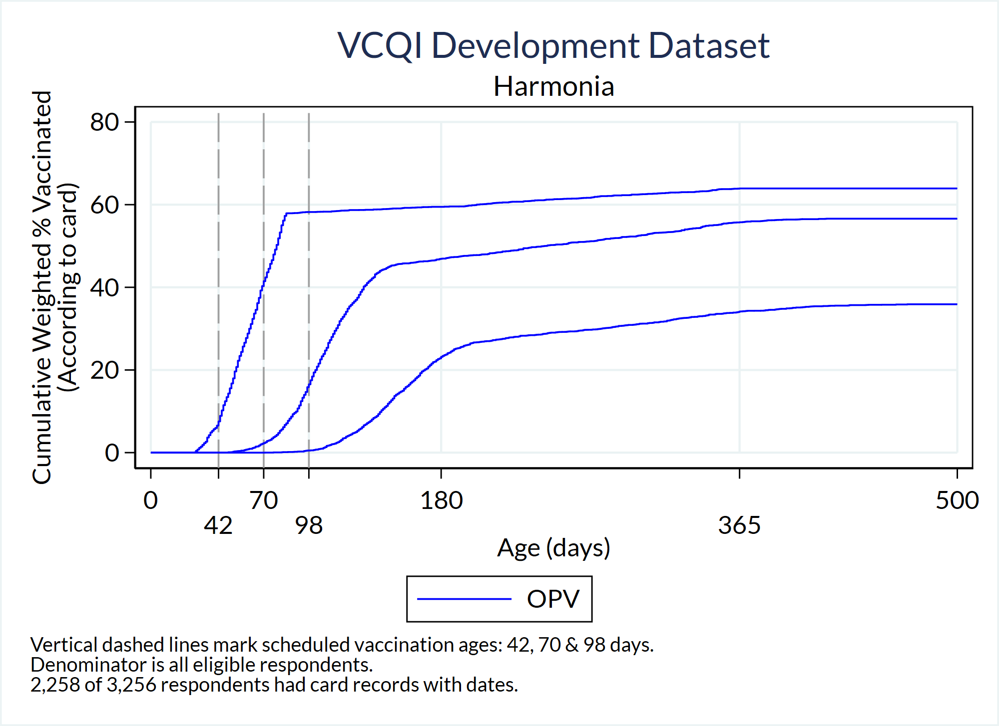

VCQI gives the user the ability to generate CCCs for all doses and all geographic strata at levels 1, 2, or 3. The figure appearance and labels are controlled by a set of input parameters specified using Stata global macros as described below.

Weighted: Yes

Denominator: Sum of weights for all survey respondents

Numerator: Sum of weights of respondents who have documented evidence of having received the given dose by age X (in days)

Vaccines: Calculate for each dose

User inputs: The following table lists the user inputs. All the inputs have defaults, so the indicator can be run without the user setting any of them, but it is highly recommended to at least set the <RI_CCC_02_PLOT_TITLE> global macro.

##### Table 6-15. User inputs for RI_CCC_02

| Global Macro | Acceptable Values | Description | Notes |
| --- | --- | --- | --- |
| RI_CCC_02_PLOT_TITLE | String | Title appearing on each CCC | Default: missing |
| RI_CCC_02_PLOT_LEVELS | 1 2 3 | The level(s), 1=Nation 2=Province and/or 3=Strata, for which CCC plots will be made | Default: 1 2 3 |
| RI_CCC_02_XMAX_INTERVAL | Number | The interval value to which the maximum age in days will be rounded up to (i.e., next multiple of 50) | Default: 50 |
| RI_CCC_02_GRAPHREGION_COLOR | Stata color name | The color of the graph region | Default: white |
| RI_CCC_02_NUM_LEGEND_ROWS | Number | The number of rows appearing in the legend | Default: 2 |
| RI_CCC_02_XLABELS | List of number(s) | If the user wishes to over-ride the automated x-labels on plot, set this global | Default: program calculates x-labels based on data and vaccination schedule |
| RI_CCC_02_XLABEL_SIZE | Stata text size style | The size of the x-labels | Default: medsmall  (Type ‘help axis_label_options’ in Stata.) |
| RI_CCC_02_XLABEL_ALTERNATE | 0 1 | Whether adjacent x-axis labels are offset as in the example above (0=No; 1=Yes) | Default: 0 |
| RI_CCC_02_COLOR | List of Stata color names | List of colors for the curves. Each antigen will be assigned one color (e.g., BCG might be blue whereas DPT1, DPT2 & DPT3 are all red)* | Default: gs3 red blue gold gs8 purple green magenta sand cyan   (Type ‘help colorstyle’ in Stata.) |
| RI_CCC_02_PATTERN | List of Stata line patterns | List of line patterns for the curves. Each antigen will be assigned one line pattern (e.g., BCG might be solid whereas DPT1, DPT2 & DPT3 are all dash)* | Default: solid dash longdash solid solid dash solid dash solid dash  (Type ‘help linepatternstyle’ in Stata.) |
| RI_CCC_02_WIDTH | List of Stata line widths | List of line widths for the curves. Each antigen will be assigned one line width (e.g., BCG might be medthin whereas DPT1, DPT2 & DPT3 are all medium)* | Default: medthin medthin medthin medthin medthin medthin medthin medthin medthin medthin  (Type ‘help linewidthstyle’ in Stata.) |
| RI_CCC_02_VLINE_COLOR | Stata color | The color of the vertical lines denoting the vaccination schedule | Default: gs10 |
| RI_CCC_02_VLINE_PATTERN | Stata line pattern | The line pattern of the vertical lines denoting the vaccination schedule | Default: longdash |
| RI_CCC_02_VLINE_WIDTH | Stata line width | The line width of the vertical lines denoting the vaccination schedule | Default: medthin |
| RI_CCC_02_CARD_REGISTER | card, register, card register, or leave blank | Data from which CCC plots will be made | Default: card and register (if register data are available) |

*The list of line colors, patterns and widths should be at least as long as the number of antigens in the schedule. (Note: user can specify more colors, patterns and widths than the number of antigens in the schedule, hence each default list consisted of 10 entries, but excess colors/patterns/widths are not used.) For example, if the schedule consists of BCG, HEPB0, OPV0, OPV1, OPV2, OPV3, DPT1, DPT2, and DPT3, then 4 colors, 4 line patterns, and 4 widths should be defined (or use the defaults): one for BCG, one for HEPB0, one for OPV, and one for DPT.

For the first time using this indicator, consider using the default line colors, patterns, and widths. If there is a line color, pattern, and/or width that needs to be changed, either (1) update the list of interest if it’s known exactly which element to change OR (2) check the VCQI log to learn which number the antigen has been assigned to and then change the element associated with it. Continuing the example above, suppose the default colors produce curves with the following colors: gs3, red, blue, and gold, and all OPV curves are gold. If the user wishes to change them to green, either (1) find gold in the list of colors and change it to green and re-run or (2) open the log file, find the log entry type “CCC” that notes what number the antigen OPV is assigned to (e.g., 4), go back to the control program and change the fourth entry in to green.

Control   
Program  
Command: RI_CCC_02

Output: This indicator produces a cumulative coverage curve plot for all doses in the RI_DOSE_LIST for the specified strataum levels (i.e., levels 1, 2 and 3). Plots are made based on dates from cards, and if register dates are available, a set of plots are made based on register dates too.

Plots are saved with the following naming convention:

RI_CCC_02_*<analysis counter>_*level*<level id>*_*<id number within the level><nation/zone/stratum name>*_alldoses_*<card or register>*.png

This indicator also produces a cumulative coverage curve plot for each antigen for the specified coverage levels (i.e., nation, zone, and/or stratum). For example, if the schedule consisted of BCG, HEPB0, OPV0, OPV1, OPV2, OPV3, DPT1, DPT2, and DPT3, then there would be one CCC plot for BCG comprised of one line, one CCC plot for HEPB0 comprised of one line, one CCC plot for OPV comprised of four lines, and one CCC plot for DPT comprised of three lines. Plots are made based on dates from cards, and if register dates are available, a set of plots are made based on register dates too.

Plots are saved with the following naming convention:

RI_CCC_02_*<analysis counter>_*level*<level id>*_*<id number within the level><nation/zone/stratum name>*_*<antigen name>*_*<card or register>*.png

The indicator produces a dataset named RI_CCC_02_*<analysis counter>*.dta. It lists the age of the child for each dose the child received based on the card (or register) date and a binary variable indicating whether or not the respondent is in the denominator.

The indicator also produces a dataset named CCC_pct.dta. For each stratum and dose, it lists the percent and number of respondents that had received the given dose based on card (or register) data for the given number of days, where days range from 0 to the maximum age a child received any dose in the dataset. Note, stratum could be from level 1 or 2 or 3. If both card and register data are available, then the statistics are calculated first based on card, and then calculated based on register.

Interpretation: A point on a given cumulative coverage curve can be interpreted as: “For this sample, Y% of respondents had evidence on their vaccination card (or register if using register data) of being vaccinated for the given dose on or before the respondent was X days old.”

In a perfect world, these curves would be a stair-step function, where 0% of respondents received the dose until the scheduled age, at which time all the respondents received the dose (vertical line straight up), then horizontal line extending to the right indicating no respondent received the dose after the minimum scheduled age.

On the plots, vertical lines mark scheduled vaccination ages, so the point at which the curve crosses its associated vertical schedule line should be at 0%. If there is white space under the curve *before* it crosses the vertical line, then that percentage of respondents received the given dose early. Similarly, white space *above* the curve after it crosses the vertical line but before the plateau represents respondents who were unprotected for that given time range.

## 6.9 RI_CIC: RI Survey – Cumulative Interval Curves (CIC)

### RI_CIC_01: Unweighted Cumulative interval curves

Earlier versions of VCQI featured unweighted cumulative interval curves with an indicator named RI_CIC_01. We recommend that you produce weighted curves using RI_CIC_02 instead.

### RI_CIC_02: Weighted Cumulative interval curves

Figure 6.2 shows an example of a curve showing the cumulative weighted distribution of intervals (in days) between when the child received OPV1 and when they received OPV2. The scheduled interval was 28 days, as indicated with the dashed vertical line and the footnote. According to the curve, a small portion (~5%) of eligible respondents received OPV2 with an interval < 28 days. It appears that about 40% received it with an interval of about 56 days. Interval timing data was available for respondents representing just over 50% of the eligible population.

###### Figure 6-2. Cumulative Interval Curve for OPV Dose1-to-Dose2 Interval in Harmonia

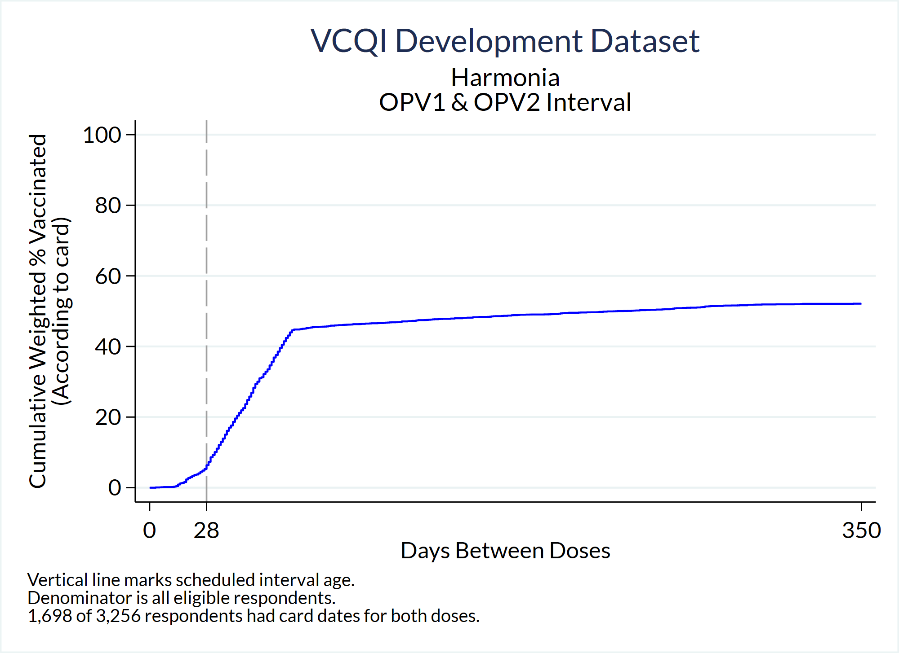

Weighted: Yes

Denominator: Sum of weights for all eligible respondents in the dataset

Numerator: Sum of weights for respondents whose interval (in days) between receiving the earlier and later dose is less than or equal to X

Vaccines: Make individual plots for every two-dose antigen (interval between doses 1 and 2) and make two plots for every three-dose antigen (intervals between 1 and 2 and between 2 and 3)

User inputs: The following table lists the user inputs. All the inputs have defaults, so the indicator can be run without the user setting any of them, but it is highly recommended to at least set the <RI_CIC_02_PLOT_TITLE> global macro.

##### Table 6-16. User inputs for RI_CIC_02

| Global Macro | Acceptable Values | Description | Notes |
| --- | --- | --- | --- |
| RI_CIC_02_PLOT_TITLE | String | Title appearing on each CIC | Default: missing |
| RI_CIC_02_PLOT_LEVELS | 1 2 3 | The level(s), 1 2 and/or 3, for which CIC plots will be made | Default: 1 2 3 |
| RI_CIC_02_XMAX_INTERVAL | Number | The interval value to which the maximum difference of age in days will be rounded up to (i.e., nearest X) | Default: 10 |
| RI_CIC_02_GRAPHREGION_COLOR | Stata color name | The color of the graph region | Default: white |
| RI_CIC_02_XLABELS | List of number(s) | If want to over-ride the automated x-labels on plot, set this global | Default: program calculates x-labels based on data and vaccination schedule |
| RI_CIC_02_XLABEL_SIZE | Stata text size style | The size of the x-labels | Default: medsmall (Type ‘help axis_label_options’ in Stata.) |
| RI_CIC_02_XLABEL_ALTERNATE | 0 1 | Whether adjacent x-axis labels are offset (0=No; 1=Yes) | Default: 0 |
| RI_CIC_02_COLOR | Stata color | Color of the curve | Default: navy (Type ‘help colorstyle’ in Stata.) |
| RI_CIC_02_PATTERN | Stata line pattern | Line pattern of the curve | Default: solid |
| RI_CIC_02_WIDTH | Stata line width | Line width of the curve | Default: medthin |
| RI_CIC_02_VLINE_COLOR | List of Stata colors | The color of the vertical line(s) denoting the difference between minimum ages of the dose pair according to the vaccination schedule* | Default: gs10 gs10 |
| RI_CIC_02_VLINE_PATTERN | List of Stata line patterns | The line pattern of the vertical line(s) denoting the difference between minimum ages of the dose pair according to the vaccination schedule* | Default: longdash solid  (Type ‘help linepatternstyle’ in Stata.) |
| RI_CIC_02_VLINE_WIDTH | List of Stata line widths | The line width of the vertical line(s) denoting the difference between minimum ages of the dose pair according to the vaccination schedule* | Default: medthin medthin  (Type ‘help linewidthstyle’ in Stata.) |
| RI_CIC_02_CARD_REGISTER | card, register, card register, or leave blank | Data from which CIC plots will be made | Default: card and register (if register data available) |

*The program uses the vaccination schedule and calculates the difference between the <dose>_min_age_days for the given dose pair and compares it with the <dose>_min_interval_days of the latter dose. If they are the same, then only one vertical line will appear on the CIC plot. If they are different, then two lines will appear. The possibility of two vertical reference lines being plotted is why the default sets two line colors, two line patterns, and two line widths. If the user only sets one color/pattern/width but two vertical lines will be plotted, then the default values will be used for the second reference line.

Control   
Program  
Command: RI_CIC_02

Output: This indicator produces a cumulative interval curve plot for each dose pair in the RI_MULTI_2_DOSE_LIST and RI_MULTI_3_DOSE_LIST, for the specified coverage levels (i.e., nation, zone, and/or stratum). Each plot consists of only one dose pair. Plots are made based on dates from cards, and if register dates are available, a set of plots are made based on register dates too.

Plots are saved with the following naming convention:

RI_CIC_02_*<analysis counter>_*level*<level id>*_*<id number within the level><nation/zone/stratum name>*_<*dose pair*>_*<card or register>*.png

The indicator produces a dataset named RI_CIC_02_*<analysis counter>*.dta. It lists the number of days between doses based on card (or register) dates.

The indicator also produces a dataset named CIC_pct.dta. For each stratum and dose pair, it lists the percent and number of respondents that had received the given dose pair based on card (or register) data for the given number of interval days, where interval days range from 0 to the maximum interval age a child received any dose pair in the dataset. Note, stratum could be the nation, a zone, or a stratum. If both card and register data are available, then the statistics are calculated first based on card, and then calculated based on register.

Interpretation: A point on a given cumulative interval curve can be interpreted as: “For this sample, Y% of respondents who had evidence of receiving both doses on their vaccination card (or register dates if using register data) had an intra-dose interval no longer than X days.”

In a perfect world, these curves would be a stair-step function, where 0% of respondents received the latter dose until the scheduled interval, at which time all the respondents received the latter dose (vertical line straight up), then a horizontal line extending to the right indicating no respondent received the latter dose after the scheduled interval.

On the plots, vertical lines mark scheduled intervals, so the point at which the curve crosses it should be at 0%. If there is white space under the curve *before* it crosses the vertical line, then that percentage of respondents had too few days between doses (i.e., received the latter dose early). Similarly, white space *above* the curve after it crosses the vertical line but before the plateau represents respondents who experienced an interval longer than the scheduled number of interval days, and possibly were unprotected for that time period.

Notes:

In some countries where disease prevalence is low, the scheduled interval is longer than what WHO considers to be the minimum interval between valid doses. For example, in much of Latin America, the scheduled interval between OPV doses or between Penta doses is two months, whereas the doses could be given with an interval as short as 28 days and still be considered valid. VCQI knows the minimum interval between valid doses because the user specifies it in Block D with the <later dose>_min_interval_days scalar. VCQI also knows the *scheduled interval* between doses because the user specifies it with the <earlier dose>_min_age_days and <later dose>_min_age_days scalars. When VCQI recognizes that the scheduled interval is longer than the minimum interval, the RI_CCC_02 indicator will put two vertical lines on the CIC plot: one to show the minimum interval and one to show the scheduled interval.

## 6.10 RI_VCTC: RI Survey – Vaccination Coverage and Timeliness Charts (VCTC)

### RI_VCTC_01: Vaccination Coverage and Timeliness Stacked Bar Charts

The figure below is an example of a stacked bar chart to summarize vaccination coverage and timeliness results from:

* RI_QUAL_01 (% of population with home-based records) and
* RI_COVG_01 (crude coverage – or % with any evidence of vaccination) using age at vaccination calculated in
* RI_COVG_02 (valid coverage) to categorize the continuous timeliness information from
* RI_CCC_02 (weighted cumulative coverage curves).

Each figure (chart) represents data for a single stratum. Each dose is represented in a single row. The coverage estimates are weighted. The length of the full bar agrees precisely with coverage estimates from RI_COVG_01, but the bar is divided into categories of timeliness. This figure shows the default categories. The VCQI user may customize the categories. Each dose is annotated with optional tabular summaries of unweighted sample size (N), effective unweighted sample size (NEFF), design effect (DEFF) and intracluster correlation coefficient (ICC).

###### Figure 6-3. Vaccination Coverage & Timeliness Chart (VCTC) for Harmonia using default parameters

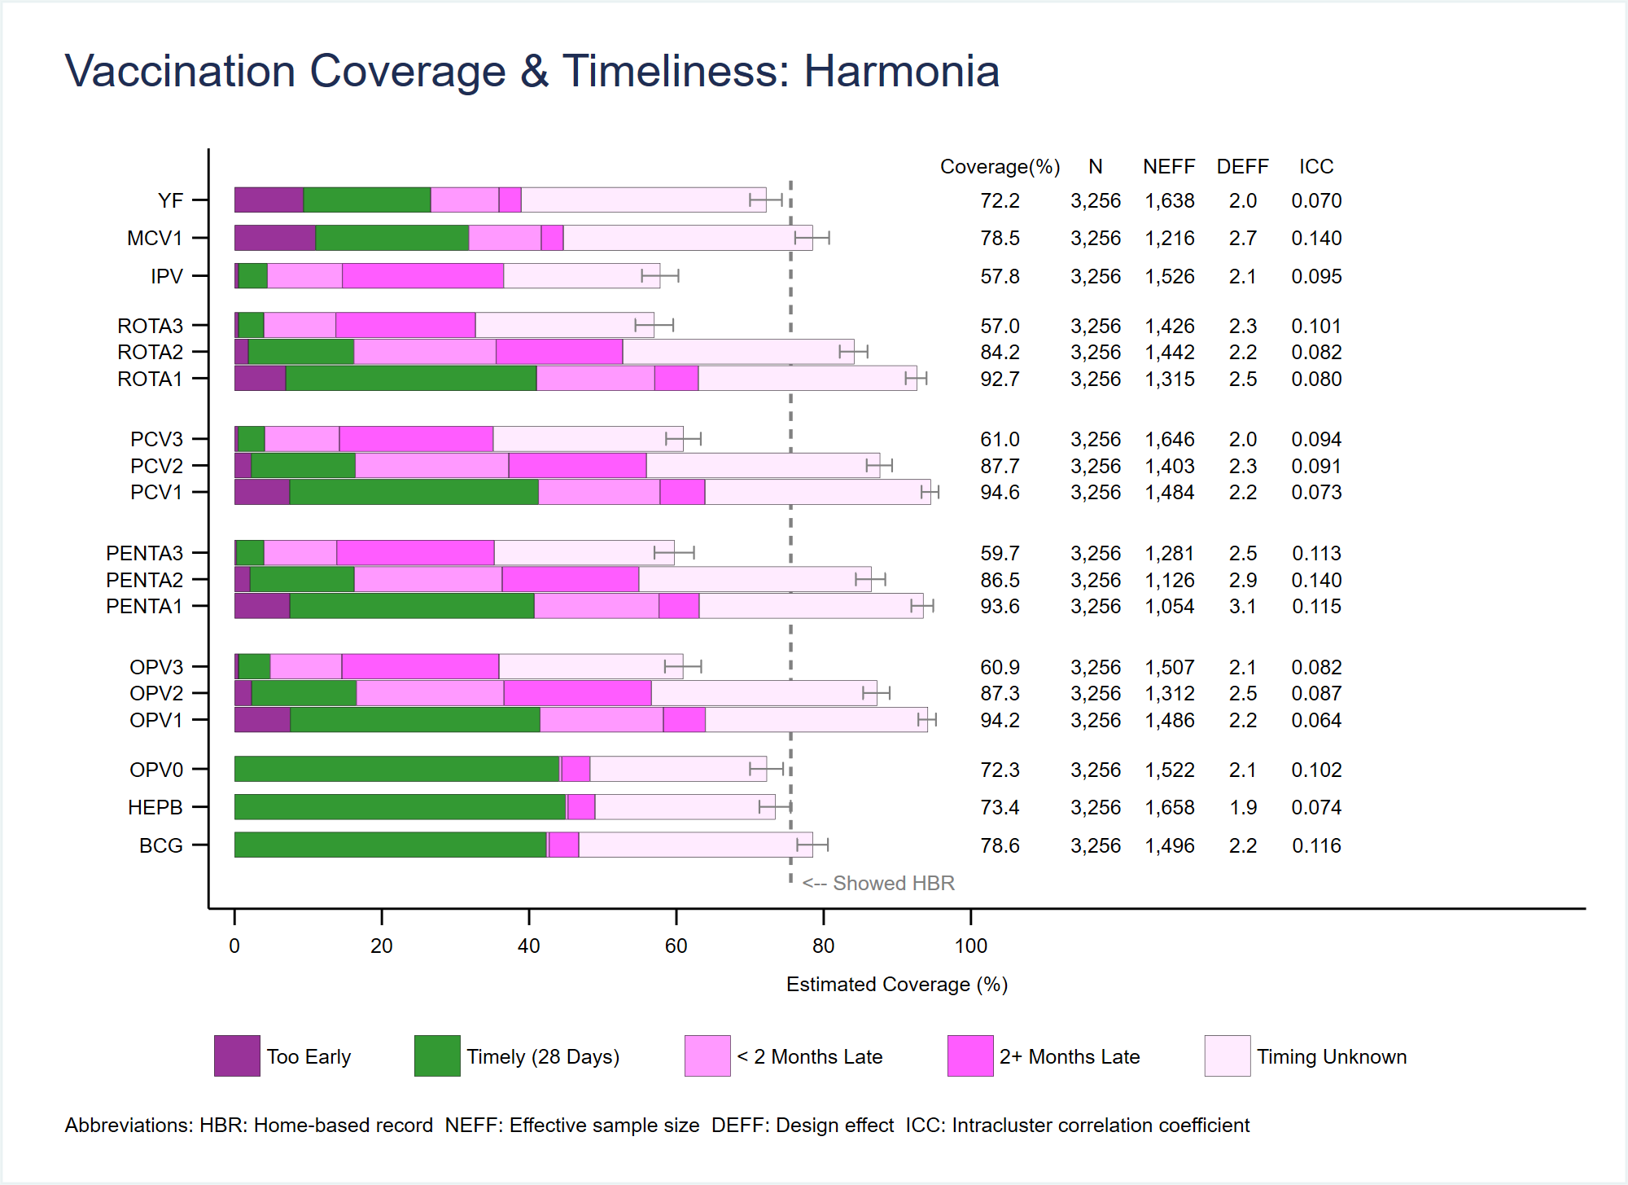

Weighted: Yes

Denominator: Sum of weights for all eligible respondents in the stratum

Numerator: Sum of weights for respondents whose vaccination evidence indicates that they received the dose in one of the timeliness categories. Timeliness is measured with respect to the minimum age for a valid dose as specified in the vaccination schedule. The software assigns each child to the appropriate category based the age at which they received the dose.

Vaccines: The user specifies the list (and order) of doses to include in the charts. In the figure above the doses are grouped by antigen. It would also be possible to order them by schedule age (put OPV1, PENTA1, PCV1, and ROTA1 beside each other, followed by dose 2 of all 4 antigens, followed by dose 3).

User inputs:

Conceptually, each dose is represented by a bar graph that stacks several tiles from left-to-right. Each tile represents a category of timeliness. In the example above, the left-most tile represents children who were vaccinated too early (if any). The second tile (in green) represents those who were vaccinated within 28 days of the age when they were scheduled to receive that dose. The third tile represents those were vaccinated between 28 and 56 days late, so < 2 months late. The fourth tile those who were vaccinated between more than 56 days late, and the fifth tile quantifies those who have some evidence of vaccination, but that evidence does not allow VCQI to calculate the child’s age. In other words, the evidence is from a tick mark, or an incomplete date or from caregiver recall.

Nearly every aspect of the figure can be modified by the user, including the timeliness categories, tile colors, dose order, labels, line widths, etc. These input parameters are described below in three tables.

These charts summarize a lot of information and VCQI provides a lot of flexibility to customize the charts, so this indicator has more input parameters than any other. If the user is happy with defaults, they do not need to specify any input parameters at all. VCQI will use default parameters to make a sensible chart.

If the user wishes to change some of the default characteristics, they may copy the parameter file that holds the settings listed in the second table below, make some changes, and save that parameter file in the VCQI_OUTPUT_FOLDER with the filename as described below.

Finally, if the user wishes to define new categories of timeliness for some or all doses, they will need to use the parameters listed in the third table below. These parameters are demonstrated in a comment block in the default parameter file that is included with the VCQI software.

Feel free to correspond with the VCQI developers with questions or with suggestions for additional features of these very informative plots.

This first table lists the input parameters that the user usually specifies explicitly, in the control program via global macros, before calling the RI_VCTC_01 program.

##### Table 6-17. RI_VCTC_01 inputs that are usually set in the control program

| Global Macro | Acceptable Values | Description | Notes |
| --- | --- | --- | --- |
| RI_VCTC_01_LEVELS | Any combination of the integers 1 or 2 or 3 | VCQI will produce a separate chart for every stratum in the levels specified. | Defaults to 3 |
| TIMELY_DOSE_ORDER | Dose names, lower-case, separated by spaces | Dose names, usually listed with lower-case letters, listed in the order you want the bars to appear from bottom-to-top in the chart | Defaults to the RI_DOSE_LIST set by VCQI, which will usually not be in a helpful order. The user may use this parameter to over-ride the default and specify a subset or a different order. |
| TIMELY_Y_COORDS | Positive numbers | Y-coordinates of the dose bars | Defaults to evenly-spaced bars at Y= 1, 2, 3, … up to the number of doses in the chart. Users sometimes specify unequally spaced values to visually *group* doses in a series together. See the example in the control program template. |
| TIMELY_YLINE_LIST | List of positive numbers separated by spaces | Y-coordinates at which to plot faint horizontal lines; used instead of (or with) Y_COORD grouping for aesthetics, to visually separate groups of doses. These coordinates should fall *between* the coordinates of the bars which are specified by TIMELY_Y_COORDS. If OPV1 OPV2 and OPV3 are plotted at Y_COORDS 20 and 30 and 40 then we might specify that we want a faint line at Y= 15 and 45 using TIMELY_YLINE_LIST | Default is empty; YLINES will not appear unless the user specifies a set of y coordinates for them. Using varied spacing in the YCOORD list produces a subtle grouping effect that some find more eye-pleasing than having the additional lines associated with the YLINE_LIST. The preference is personal. |

The next table lists the default global macro parameters that are stored with the VCQI programs in a file named named: **~/RI/globals_for_timeliness_plots - defaults.do.**

If the user wishes to change any of these parameters, before running VCQI, copy this file to the VCQI_OUTPUT_FOLDER and rename it **globals_for_timeliness_plots.do.** Make edits and save the file. The control program will run the program with the user-defined edits after setting the default values.

Alternatively, the user may over-ride any of the default parameters by re-specifying them in the VCQI control program, using lines of code that appears after this line of source:

include "$VCQI_OUTPUT_FOLDER/globals_for_timeliness_plots.do"

Note that the VCQI RI control program template over-rides two defaults by stipulating:

vcqi_global TIMELY_BARWIDTH 6.7

vcqi_global TIMELY_TEXTBAR_LABEL_Y_SPACE 9

The user may over-ride other defaults in a similar fashion.

##### Table 6-18. RI_VCTC_01 inputs that are often unchanged in globals_for_timeliness_plots.do

| Global Macro | Acceptable Values | Description | Notes |
| --- | --- | --- | --- |
| TIMELY_N_DTS | Positive integers | Number of default tiles (or timeliness categories) | Current default is 5 for these five categories: 1 – Too early  2 – Timely (28 days)  3 - < 2 months late  4 – 2+ months late  5 – Timing unknown |
| TIMELY_DT_UB_1  TIMELY_DT_UB_2  …  Up to  The number of TIMELY_N_DTS minus 1 | 0 or positive integer | DT_UB stands for “default tile upper bound” – these bounds are the upper bound of the timeliness categories specified in days relative to when the dose is scheduled. You specify this parameter for integers 1 up to TIMELY_N_DTS – 1 | The category will capture doses received before the scheduled age of vaccination plus this upper bound. So for default category 1, the value is 0 days: the category captures doses received before the dose was scheduled. The value for tile _2 is 28 so it captures doses given before 28 days had passed. For _3 it is 56 so it captures doses given before the scheduled age plus 56 days. For _4 it is 1000 days, so it captures all doses given at all ages from 12-23m.  We do not need to specify a bound for tile _5 because that final tile represents respondents whose timing is not known. |
| TIMELY_DT_COLOR_1  TIMELY_DT_COLOR_2  …  Up to TIMELY_N_DTS | Valid Stata color | Color of the default tiles |  |
| TIMELY_DT_LCOLOR_1  TIMELY_DT_LCOLOR_2  …  Up to TIMELY_N_DTS | Valid Stata color | Color of the line that forms the tile border |  |
| TIMELY_DT_LWIDTH_1  TIMELY_DT_LWIDTH_2  …  Up to TIMELY_N_DTS | Valid Stata line width | Width of the line that forms the tile border |  |
| TIMELY_DT_LABEL_1  TIMELY_DT_LABEL_2  …  Up to TIMELY_N_DTS | String | String that appears in Excel table to label the category |  |
| TIMELY_DT_LEGEND_LABEL_1  TIMELY_DT_LEGEND_LABEL_2  …  Up to TIMELY_N_DTS | String | String that appears in plot legend for this category | May differ (sometimes is more brief) than the corresponding TIMELY_DT_LABEL_*n* |
| TIMELY_DT_LEGEND_ORDER_1  TIMELY_DT_LEGEND_ORDER_2  …  Up to TIMELY_N_DTS | Positive integer | Order in which this category should appear in the plot legend | Each of the default tiles should appear in the legend, so each should have a positive integer specified for this parameter. |
| TIMELY_XLABEL_SIZE | Valid Stata text size | Size of the numbers along the x axis | 5pt is the default |
| TIMELY_XLABEL_COLOR | Valid Stata color | X label text color | Black is the default |
| TIMELY_YLABEL_SIZE | Valid Stata text size | Size of the numbers along the x axis | 5pt is the default |
| TIMELY_YLABEL_COLOR | Valid Stata color | X label text color | Black is the default |
| TIMELY_BARWIDTH | Positive number | Bar width | 0.67 is the default, so the bar will be about twice as wide as the space between bars, if the bars fall on the integer y = 1, 2, 3, etc. values. |
| TIMELY_CI_LCOLOR | Valid Stata color | Confidence interval (CI) line color | gs8 is the default |
| TIMELY_CI_LWIDTH | Valid Stata line width | CI line width | vthin is the default |
| TIMELY_CI_MSIZE | Valid Stata rcap marker size | Line cap marker size | small is the default |
| TIMELY_LEGEND_OPTIONS | Valid Stata twoway plot legend options | Misc options the user wishes to pass thru to the twoway command | row(1) symxsize(*.3) symysize(*1) size(*.5) keygap(0.5) region(lcolor(white)) span is the default |
| TIMELY_TEXTBAR_ORDER | Set of some or all of the following strings, in any order, separated by spaces: COVG N NHBR NEFF DEFF ICC | Which elements should be listed in tabular form, and in what order | Default is:  COVG N NEFF DEFF ICC |
| TIMELY_TEXTBAR_X_COVG | Positive number | X coordinate for COVG string, if it is listed in the TIMELY_TEXTBAR_ORDER | 104 is the default |
| TIMELY_TEXTBAR_X_N | Positive number | X coordinate for N string, if it is listed in the TIMELY_TEXTBAR_ORDER | 117 is the default |
| TIMELY_TEXTBAR_X_NHBR | Positive number | X coordinate for NHBR string, if it is listed in the TIMELY_TEXTBAR_ORDER | missing is the default; rather than tabulate the number of respondents with a card, the default is to show the % who showed a card |
| TIMELY_TEXTBAR_X_NEFF | Positive number | X coordinate for NEFF string, if it is listed in the TIMELY_TEXTBAR_ORDER | 127 is the default |
| TIMELY_TEXTBAR_X_DEFF | Positive number | X coordinate for DEFF string, if it is listed in the TIMELY_TEXTBAR_ORDER | 137 is the default |
| TIMELY_TEXTBAR_X_ICC | Positive number | X coordinate for ICC string, if it is listed in the TIMELY_TEXTBAR_ORDER | 147 is the default |
| TIMELY_TEXTBAR_LABEL_YSPACE | Positive number | Amount of buffer space on the y-axis between the TEXBAR labels and the first row of tabulated text | 0.67 is the default |
| TIMELY_TEXTBAR_LABEL_COVG  _N  _NHBR  _NEFF  _DEFF  _ICC | Strings | Short string to appear at the top of the tabular columns | Defaults are:  Coverage (%)  N  NHBR  NEFF  DEFF  ICC |
| TIMELY_XSCALE_MAX | Positive number | x-coordinate of the far right end of the tabular output | 155 is the default |
| TIMELY_TEXTBAR_SIZE_COVG  _N  _NHBR  _NEFF  _DEFF  _ICC | Valid Stata plot text sizes | Size of the font for tabular output | 5pt is the default |
| TIMELY_TEXTBAR_COLOR_COVG  _N  _NHBR  _NEFF  _DEFF  _ICC | Valid Stata text colors | Color of the font for tabular output | Black is the default |
| TIMELY_TEXTBAR_COVG_DEC_DIGITS | Non-negative integer, usually 1 or 0 | Number of digits to show after the decimal point for tabular coverage estimates | 1 is the default |
| TIMELY_TEXTBAR_COVG_ICC_DIGITS | Non-negative integer, usually 3 | Number of digits to show after the decimal point for tabular ICC estimates | 3 is the default |
| TIMELY_HBR_LINE_PLOT | Integer:  0 (No) or 1 (Yes) | Whether to show the line indicating the % of respondents who showed an HBR | 1 (Yes) is the default |
| TIMELY_HBR_LINE_VARIABLE | One of the following variable names (generated in RI_QUAL_01):  had_card  had_card_with_dates  had_card_with_dates_or_ticks  had_card_with_flawless_dates  had_register  had_register_with_dates  had_register_with_dates_or_ticks  had_register_with_flawless_dates  had_card_or_register | Which variable should be used to summarize the % of respondents with documented dose dates? If cards are the only source of dates, then had_card is probably the right choice. If registers are the only source: had_register. If both, had_card_or_register | had_card is the default |
| TIMELY_HBR_LINE_WIDTH | Valid Stata line width |  | Default is medium |
| TIMELY_HBR_LINE_COLOR | Valid Stata line color |  | Default is gs8 |
| TIMELY_HBR_LINE_PATTERN | Valid Stata line pattern |  | Default is shortdash |
| TIMELY_HBR_LINE_LABEL | String | This string appears slightly to the right of the HBR line, at y = 0.05 | Default is:  <-- Showed HBR |
| TIMELY_YLINE_LCOLOR | Valid Stata line color | Appears at y-coordinates specified by the user in the global TIMELY_YLINE_LIST | Default is gs14 |
| TIMELY_YLINE_LWIDTH | Valid Stata line width | Note that the user cannot currently specify the pattern. It is a faint solid line. | Default is thin |
| TIMELY_TWOWAY_OPTIONS | Valid twoway plot options | User may pass thru additional options here | Default is:  note(" Abbreviations: HBR: Home-based record NEFF: Effective sample size DEFF: Design effect ICC: Intracluster correlation coefficient", size(5pt) place(w) span) |

Figure 6.4 below shows a VCTC that specifies three new default timeliness categories: Two for the dose BCG and one for HEPB. For OPV doses, it uses the default set of categories. Note that the legend lists the new categories.

###### Figure 6-4. VCTC for Harmonia District 03 using customized BCG and HepB timeliness parameters

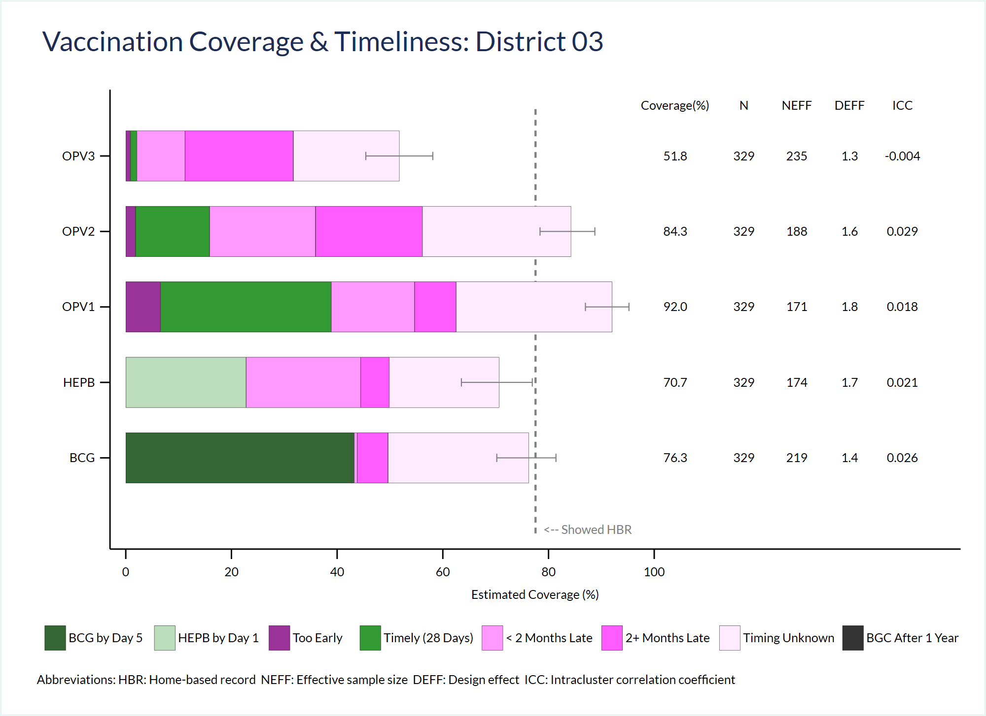

An additional set of parameters must be defined to specify customized timeliness categories and colors and legend entries and integrate them with the default categories. The parameters associated with *default tiles* had the letters _DT_ in their names. Those associated with *customized doses* have the letters _CD_ in their names. The parameter file delivered with the VCQI source code contains a set of customized dose definitions for BCG and HEPB0 in a block of code that is commented out. They are listed below the table should serve as illustrative examples.

##### Table 6-19. RI_VCTC_01 inputs to customize timeliness categories for individual doses

| Global Macro | Acceptable Values | Description | Notes |
| --- | --- | --- | --- |
| TIMELY_CD_LIST | Dose names separated by spaces | List of doses that will not use the default tile definitions |  |
| TIMELY_CD_<DOSE>_NTILES | Positive integer | Number of tiles in the stacked bar for <DOSE>  (specify for each dose in TIMELY_CD_LIST) |  |
| TIMELY_CD_<DOSE>_UB_1 | 0 or positive number | Set of upper-bound definitions to specify the timeliness categories, specified in the same manner as TIMELY_DT_UB_1, etc. | Specify values for UB_1, UB_2, etc. all the way up thru TIMELY_CD_<DOSE>_NTILES – 1.   The final (right-most) tile in every stacked bar will represent children whose timing is unknown. |
| TIMELY_CD_<DOSE>_COLOR_1 | Valid Stata color | Tile color specified in the same manner as TIMELY_DT_COLOR_1, etc. |  |
| TIMELY_CD_<DOSE>_LCOLOR_1 | Valid Stata color | Tile border line color specified in the same manner as TIMELY_DT_LCOLOR_1, etc. |  |
| TIMELY_CD_<DOSE_LWIDTH_1 | Valid Stata line width | Specified in the same manner as TIMELY_DT_LWIDTH_1, etc. |  |
| TIMELY_CD_<DOSE>_LABEL_1 | String | Specified in the same manner as TIMELY_DT_LABEL_1, etc. |  |
| TIMELY_CD_<DOSE>_LEGEND_LABEL_1 | String | Specified in the same manner as TIMELY_DT_LEGEND_LABEL_1, etc. |  |
| TIMELY_CD_<DOSE>_LEGEND_ORDER_1 | Positive integer | Specified in the same manner as TIMELY_DT_LEGEND_ORDER_1, etc. |  |

And note that if you want any of the customized dose tiles to appear in the legend then it will usually be necessary to specify updated values for   
  
TIMELY_DT_LEGEND_1, _2, _3, etc. as shown in the example below and in the comment block in the VCQI program file named **~/RI/globals_for_timeliness_plots – defaults.do**

**Examples of default tile parameters**

The default parameters make a stack of up to five *tiles* per dose, as specified by TIMELY_N_DTS below. The text below shows how they are defined and describes the logic of the parameters.

global TIMELY_N_DTS 5

global TIMELY_DT_UB_1 0

global TIMELY_DT_COLOR_1 magenta*2

global TIMELY_DT_LEGEND_ORDER_1 1

global TIMELY_DT_LEGEND_LABEL_1 Too Early

The upper bound on default tile 1 is 0 days. That means the first tile represents children who were vaccinated before the (scheduled age plus 0 days) which means they were vaccinated too early. They will appear in a tile that is colored magenta*0.2 and with a label that says “Too Early”. That label will appear first in the legend.

global TIMELY_DT_UB_2 28

global TIMELY_DT_COLOR_2 green

global TIMELY_DT_LEGEND_ORDER_2 2

global TIMELY_DT_LEGEND_LABEL_2 Timely (28 Days)

The upper bound on default tile 2 is 28 days, so the second tile represents children who were vaccinated before the (scheduled age plus 28 days). They will appear in a tile that is colored green with a label that says ‘Timely (20 Days)’. That label will appear second in the legend.

global TIMELY_DT_UB_3 56

global TIMELY_DT_COLOR_3 magenta*.5

global TIMELY_DT_LEGEND_ORDER_3 3

global TIMELY_DT_LEGEND_LABEL_3 < 2 Months Late

The upper bound on default tile 3 is 56 days, so it represents children who were vaccinated before the (scheduled age plus 56 days). They will appear in a tile that is magenta*.5 with a label that says ‘< 2 Months Late’. That label will appear third in the legend.

global TIMELY_DT_UB_4 1000

global TIMELY_DT_COLOR_4 magenta*.8

global TIMELY_DT_LEGEND_ORDER_4 4

global TIMELY_DT_LEGEND_LABEL_4 2+ Months Late

The upper bound on the fourth tile is 1000 days so it represents children who were vaccinated before the (scheduled age plus 1000 days). The oldest child in this survey is two years (~730 days) so this tile will represent all the children for whom we know the age at vaccination, who were vaccinated 56+ days after the scheduled age. They will appear in a tile that is magenta*.8 with a label that says ‘2+ Months Late’. That label will appear fourth in the legend.

global TIMELY_DT_COLOR_5 magenta*.10

global TIMELY_DT_LEGEND_ORDER_5 5

global TIMELY_DT_LEGEND_LABEL_5 Timing Unknown

Note that there is no upper bound for tile 5. Many features of these charts are customizable, but one feature is always the same. The last tile in the stack represents children whose vaccination timing is unknown. The user specifies the aesthetic properties of this tile (color, border line properties) and its label and order in the legend, but the definition of what it represents is always the difference between the next-to-last tile (all children whose vaccination age is known) and all the children with evidence of vaccination. According to the parameters listed above, this tile will appear with color magenta*.10 and a label that says ‘Timing Unknown’. The label will appear fifth in the legend.

**Examples of customized dose tile parameters**

Figure 6.4 shows customized tiles for BCG and HEPB. Those were defined using the parameters listed below.

Modifications for BCG are as follows:

* 1. There is no ‘Too Early’ tile because it is due at birth – so cannot be early.
  2. The definition of timeline is that it must be received on day 0-4 of life, so before day 5.
  3. Because this is a new category of timely, assign the tile a new shade of green.
  4. Assign a clear label and list it in position 1 in the legend. (This means the default tile legend entries will need to shift.)
  5. And for BCG we are especially interested to see if any doses are given after the age of 1 year, so assign a new tile vaccinated between the ages of 365 days and 1000 days.
  6. The tile that shows those children, if any, will be black. (There are no such children in Figure 6.4 above.)
  7. List a new label for this tile near the end of the legend, in position 8.

Modifications for HEPB include:

* 1. No early tile is needed because the dose is due at birth.
  2. The dose is timely if received within 24 hours of birth, so let’s define this as day 0 or 1 of life (i.e., before age 2 days).
  3. Assign this unique category of timely a new green color.
  4. List this category with a unique label in the legend in position #2.

Modifications for the default tiles include:

* 1. Move default tile labels from positions 1-5 to 3-7.
  2. Now we have quite a long legend, so consider adding the option row(2) to the parameter named TIMELY_LEGEND_OPTIONS; make some charts and decide which makes more sense aesthetically: a 1-row legend or a 2-row legend (In this case, 1 row just fits, so leave it alone.)

If you have difficulty specifying customized dose definitions, contact [Dale.Rhoda@biostatglobal.com](mailto:Dale.Rhoda@biostatglobal.com).

* Define customized tiles for BCG & HEPB

global TIMELY_CD_LIST bcg hepb // customized definitions for BCG & HEPB

* Note that the dose names appear in all of the customized parameters below

global TIMELY_CD_BCG_NTILES 5 // BCG still has 5 tiles

// First tile is for given < target age (0 days) plus 5 days

global TIMELY_CD_BCG_UB_1 5

// Second is for given < 2 months late

global TIMELY_CD_BCG_UB_2 56

// Third is for given 2+ months late but within a year

global TIMELY_CD_BCG_UB_3 365

// Fourth is for doses given after age 1 year

global TIMELY_CD_BCG_UB_4 1000

global TIMELY_CD_BCG_COLOR_1 green*2 //use a dark green for BCG timely

global TIMELY_CD_BCG_COLOR_2 magenta*.5 // standard color

global TIMELY_CD_BCG_COLOR_3 magenta*.8 // standard color

global TIMELY_CD_BCG_COLOR_4 black // very late BCG uses a BLACK tile

global TIMELY_CD_BCG_COLOR_5 magenta*.1 // standard color

global TIMELY_CD_BCG_LCOLOR_1 gs2

global TIMELY_CD_BCG_LCOLOR_2 gs2

global TIMELY_CD_BCG_LCOLOR_3 gs2

global TIMELY_CD_BCG_LCOLOR_4 gs2

global TIMELY_CD_BCG_LCOLOR_5 gs2

global TIMELY_CD_BCG_LWIDTH_1 *.2

global TIMELY_CD_BCG_LWIDTH_2 *.2

global TIMELY_CD_BCG_LWIDTH_3 *.2

global TIMELY_CD_BCG_LWIDTH_4 *.2

global TIMELY_CD_BCG_LWIDTH_5 *.2

global TIMELY_CD_BCG_LABEL_1 BCG by day 5

global TIMELY_CD_BCG_LABEL_2 < 2 Months Late

global TIMELY_CD_BCG_LABEL_3 2+ Months Late

global TIMELY_CD_BCG_LABEL_4 After 1 Year (BCG only)

global TIMELY_CD_BCG_LABEL_5 Timing Unknown

global TIMELY_CD_BCG_LEGEND_LABEL_1 BCG by Day 5

global TIMELY_CD_BCG_LEGEND_LABEL_2 < 2 Months Late

global TIMELY_CD_BCG_LEGEND_LABEL_3 2+ Months Late

global TIMELY_CD_BCG_LEGEND_LABEL_4 BGC After 1 Year

global TIMELY_CD_BCG_LEGEND_LABEL_5 Timing Unknown

* Only two of these are new categories...so they should go on the legend

* Because we are specifying spot 1 here, we will adjust DT_LEGEND_ORDERs

* below

global TIMELY_CD_BCG_LEGEND_ORDER_1 1 // List this first in the legend

global TIMELY_CD_BCG_LEGEND_ORDER_2

global TIMELY_CD_BCG_LEGEND_ORDER_3

global TIMELY_CD_BCG_LEGEND_ORDER_4 8 // List this next-to-last

global TIMELY_CD_BCG_LEGEND_ORDER_5

********************************************************************************

* Parameters for HEPB tiles

global TIMELY_CD_HEPB_NTILES 4 // HEPB has only 4 tiles

global TIMELY_CD_HEPB_UB_1 2 // HEPB is timely if given on day 0 or 1

global TIMELY_CD_HEPB_UB_2 56 // < 2 months late

global TIMELY_CD_HEPB_UB_3 1000 // 2+ months late

global TIMELY_CD_HEPB_COLOR_1 green*.33 // use a new green for HEPB timely

global TIMELY_CD_HEPB_COLOR_2 magenta*.5

global TIMELY_CD_HEPB_COLOR_3 magenta*.8

global TIMELY_CD_HEPB_COLOR_4 magenta*.1

global TIMELY_CD_HEPB_LCOLOR_1 gs2

global TIMELY_CD_HEPB_LCOLOR_2 gs2

global TIMELY_CD_HEPB_LCOLOR_3 gs2

global TIMELY_CD_HEPB_LCOLOR_4 gs2

global TIMELY_CD_HEPB_LWIDTH_1 *.2

global TIMELY_CD_HEPB_LWIDTH_2 *.2

global TIMELY_CD_HEPB_LWIDTH_3 *.2

global TIMELY_CD_HEPB_LWIDTH_4 *.2

global TIMELY_CD_HEPB_LABEL_1 Timely (within 1 day)

global TIMELY_CD_HEPB_LABEL_2 < 2 Months Late

global TIMELY_CD_HEPB_LABEL_3 2+ Months Late

global TIMELY_CD_HEPB_LABEL_4 Timing Unknown

global TIMELY_CD_HEPB_LEGEND_LABEL_1 HEPB by Day 1

global TIMELY_CD_HEPB_LEGEND_LABEL_2 < 2 Months Late

global TIMELY_CD_HEPB_LEGEND_LABEL_3 2+ Months Late

global TIMELY_CD_HEPB_LEGEND_LABEL_4 Timing Unknown

// Only tile 1 needs a new legend entry; put it in the 2nd position

global TIMELY_CD_HEPB_LEGEND_ORDER_1 2

global TIMELY_CD_HEPB_LEGEND_ORDER_2

global TIMELY_CD_HEPB_LEGEND_ORDER_3

global TIMELY_CD_HEPB_LEGEND_ORDER_4

********************************************************************************

* Now because we introduced new tiles in the #1 and #2 slots   
* (BCG timely and HEPB timely, respectively)

* we need to move the default tile legend entries

* from slots 1-5 to 3-7.

global TIMELY_DT_LEGEND_ORDER_1 3

global TIMELY_DT_LEGEND_ORDER_2 4

global TIMELY_DT_LEGEND_ORDER_3 5

global TIMELY_DT_LEGEND_ORDER_4 6

global TIMELY_DT_LEGEND_ORDER_5 7

********************************************************************************

Control   
Program  
Command: RI_VCTC_01

Output: This indicator produces a coverage and timeliness chart (or plot) for each stratum in RI_VCTC_01_LEVELS. It plots doses in TIMELY_DOSE_ORDER (from bottom to top).

Plots are saved in a folder named PLOTS_VCTC with the following naming convention:

VCTC_01_*<analysis counter>_*level_*<level id>*_id_*<id number within the level>_<nation/zone/stratum name>*.png

The indicator also produces a worksheet named RI_VCTC_01_<analysis_counter> that lists the quantitative aspects of each tile in the chart. In addition to some relevant labels, it lists the percent of children in the stratum represented in each tile (in columns labeled: ‘Pct width of tile for <dose>’) and what percent are represented cumulatively by that tile and all those that appear to the left of it (in columns labeled ‘Cum pct for <dose>’).

Interpretation: The overall length of each bar and its 2-sided confidence interval agree exactly with those in RI_COVG_01, so they show the estimated % of the target population with any evidence of vaccination, stratified by timeliness category. The precise percentage figures for each timeliness category is not listed on the chart, but may be read from the corresponding Excel worksheet. The relative lengths of bars for early and later doses give a sense of drop-out and the timeliness tiles give a sense of what portion received the dose at an age that was earlier than recommended (Too Early) and what percent received it more than 28 days late (< 2 Months Late) and very very late (2+ Months Late).

Notes:

The user must run RI_COVG_01, RI_COVG_02, and RI_QUAL_01 before running RI_VCTC_01.

Although RI_VCTC_01 uses some timeliness variables that are calculated by RI_COVG_02 (valid coverage), the coverage and timeliness charts do not directly summarize the % of children who received a valid dose.

The timeliness categories are defined with respect to the age at which the dose is scheduled to be given. Some children are delayed in starting their vaccination sequence and we expect those children to also be delayed in receiving later doses. If the 3-dose Penta series is scheduled to be given at ages 42, 70, and 98 days, but for some reason a child receives her first dose at age 100 days (2+ Months Late) then of course that child should not receive her second dose until age 128 days and her third dose until age 156 days. In the vaccination coverage and timeliness chart, she would appear in the darkest magenta tile (2+ Months Late) for all three doses, because she received all three doses very late with respect to the national schedule even though there is a sense in which she received doses 2 and 3 precisely when she was expected to, based on the timing of dose 1. So, bear in mind that the interpretation is of timeliness with respect to the national immunization programme schedule, and not with respect to the age at which the child received his or her early doses of vaccine.

## 6.11 TT_COVG: Tetanus Survey – Measures Related to Coverage

### TT_COVG_01: Children born protected from neonatal tetanus

Weighted: Yes

Denominator: Sum of weights for all respondents

Numerator: Sum of weights for women who are protected

Variations: By card

By history

By card or history

By register

By card or history or register

To analyze

Control   
Program  
Command: TT_COVG_01

Inputs defined

via global

macros: None for this indicator

Output: Databases for this indicator are Stata datasets named:

TT_COVG_01_*<analysis counter>*_<*abbreviation*>_database.dta

Abbreviations can include:

* by card (c)
* by history (h)
* by card or history (ch)
* by register (r) (if records were sought)
* by card, history or register (chr) (if records were sought)
* to analyze (a)

See Annex D for a description of database contents.

The output labeled “to analyze” is the main outcome and how its value is calculated for each respondent depends on whether TT records were sought at health centers, and if so, for whom. This is indicated in the control program by setting one (and only one) of the RECORDS_SOUGHT global macros to 1. See section 4.3 for details on RECORDS_SOUGHT global macros for TT analysis.

The Excel worksheet for this indicator is named: TT_COVG_01 <*analysis counter*>. Each of the databases is summarized in the worksheet.

Plots include one organ pipe plot per stratum, named TT_COVG_01_<*analysis counter*>_opplot_<*stratum id*>_<*stratum name*>.png and one inchworm plot named TT_COVG_01_<analysis counter>_iwplot_*<four 0/1 flags to show which levels are plotted>*.png.

Interpretation: “X% of babies born in the 12 months preceding the survey are estimated to have been protected at birth from neonatal tetanus, according to evidence given from [maternal vaccination card and/or maternal recall of their vaccination history and/or health center records of maternal vaccinations].”

## 6.12 SIA_COVG: Post-SIA Survey – Measures Related to Coverage

### SIA_COVG_01 Crude SIA coverage

Weighted: Yes

Denominator: Sum of weights for all respondents

Numerator: Sum of weights for respondents who received the vaccine dose according to   
[card, history, or finger mark]

Vaccines: Calculated for each dose

Time options: During the campaign

Variations: By card

By history

By finger mark

By card or history or finger mark (this is the main coverage outcome)

Control   
Program  
Command: SIA_COVG_01

Output: This indicator generates databases that summarize SIA coverage:

##### Table 6-20. Naming convention for SIA_COVG_01 databases

|  |  |
| --- | --- |
| Summarize SIA coverage according to evidence from… | Database Name |
| Campaign card | SIA_COVG_01_*<analysis counter>*_c_database.dta |
| Caretaker’s verbal history | SIA_COVG_01_*<analysis counter>*_h_database.dta |
| Fingermark | SIA_COVG_01_*<analysis counter>*_f_database.dta |
| Main outcome to analyze | SIA_COVG_01_*<analysis counter>*_a_database.dta |

See Annex D for a description of database contents.

The Excel worksheet for this indicator is named: SIA_COVG_01 <*analysis counter*>. For the outcomes by card, history, and register it simply lists estimated % and 95% CI. For the main outcome it lists estimated %, 95% CI, LCB, UCB, DEFF, ICC, N (unweighted), N (weighted).

The plots generated by the indicator include one organ pipe plot of the main outcome per stratum and one inchworm plot summarizing the main crude coverage outcome for the campaign dose.

The organ pipe plots are named   
SIA_COVG_01_<*analysis counter*>_opplot_ siadose_<*stratum id*>_<*stratum name*>.png

The inchworm plots are named SIA_COVG_01_<analysis counter>_iwplot*_<four 0/1 flags to show which levels are plotted>*.png.

Interpretation: “X% of eligible children who were living here during the campaign are estimated to have been vaccinated against [measles] during the recent campaign per information obtained [by card, by caregiver history, by finger mark].”

This indicator assumes that every respondent in the SIA dataset was in the country at the time of the campaign and meets any other inclusion criteria for the campaign. Respondents who do not meet the criteria should either be removed from the dataset in an upstream step or should have their weights set to zero.

### SIA_COVG_02: Crude SIA coverage where SIA dose was the first dose

Weighted: Yes

Denominator: Sum of weights for all respondents

Numerator: Sum of weights for respondents who received the SIA dose and had never received a dose before

Vaccines: Calculated for each dose

Time options: During the campaign

Control   
Program  
Command: SIA_COVG_02

Output: This indicator generates one database that summarizes the outcome; the file is named SIA_COVG_02_*<analysis counter>*_a_database.dta.

See Annex D for a description of database contents.

The Excel worksheet for this indicator is named: SIA_COVG_02 *<analysis counter>*. It lists estimated %, 95% CI, LCB, UCB, DEFF, ICC, N (unweighted), N (weighted).

The plots generated by the indicator include one organ pipe plot per stratum and one inchworm plot.

The organ pipe plots are named   
SIA_COVG_02_<*analysis counter*>_opplot_firstdose_ <*stratum id*>_<*stratum name*>.png

The inchworm plot is named SIA_COVG_02_<analysis counter>_iwplot*_<four 0/1 flags to show which levels are plotted>*.png.

Interpretation: “X% of eligible children who were living here during the campaign received their first-ever dose of [measles] vaccine in the recent campaign.”

This indicator assumes that every respondent in the SIA dataset was in the country at the time of the campaign and meets any other inclusion criteria for the campaign. Respondents who do not meet the criteria should either be removed from the dataset in an upstream step or should have their weights set to zero.

### SIA_COVG_03: Lifetime doses of <campaign dose>, by birth cohort

Weighted: Yes

Description: Most SIAs will be targeted at a population of children who span several years of age. Each year of age is considered to be a so-called one-year “birth cohort”. In this measure, we report how each cohort is divided across three categories: those for whom we do not find evidence (by card or history or registry) that they ever received a dose of the campaign dose (e.g., MCV) (0 doses); those for whom we find evidence of a single lifetime dose (1 dose); and those for whom we find evidence of 2+ doses (2+ doses). The three categories will sum to 100% for each cohort. (“Do not know” is not evidence and is treated as a zero.)

Denominator: Sum of weights for all respondents

Numerator: There are three numerators:

1. Sum of weights for respondents who report never having received the campaign dose
2. Sum of weights for respondents who show evidence of one lifetime dose
3. Sum of weights for respondents who show evidence of 2+ lifetime doses

User inputs: This indicator uses the SIA_MIN_AGE and SIA_MAX_AGE global macros to identify the youngest and oldest birth cohort targeted in the campaign.

vcqi_global SIA_MIN_AGE `=9*30'

vcqi_global SIA_MAX_AGE `=int(15*365.25)'

SIA_MIN_AGE and SIA_MAX_AGE must be populated with age in days

Control   
Program  
Command: SIA_COVG_03

Output: This indicator produces three databases for each year of age eligibility in the survey – one for each of the three numerators. The datasets are named SIA_COVG_03_*<analysis counter>*_<db counter>_database.dta, where the db counter is a number starting with 0 for the youngest cohort, 0 doses, then increasing by 1 with each additional database. The table below illustrates the pattern in filenames and numbers.

##### Table 6-21. Naming convention for SIA_COVG_03 databases

|  |  |
| --- | --- |
| VCQI output database filename | Outcome summarized |
| SIA_COVG_03_1_1_database.dta | 9m-12m; % with 0 lifetime doses |
| SIA_COVG_03_1_2_database.dta | 9m-12m; % with 1 lifetime doses |
| SIA_COVG_03_1_3_database.dta | 9m-12m; % with 2+ lifetime doses |
| SIA_COVG_03_1_4_database.dta | 1 year old; % with 0 lifetime doses |
| SIA_COVG_03_1_5_database.dta | 1 year old; % with 1 lifetime doses |
| SIA_COVG_03_1_6_database.dta | 1 year old; % with 2+ lifetime doses |
| SIA_COVG_03_1_7_database.dta | 2 years old; % with 0 lifetime doses |
| SIA_COVG_03_1_8_database.dta | 2 years old; % with 1 lifetime doses |
| SIA_COVG_03_1_9_database.dta | 2 years old; % with 2+ lifetime doses |
| And so on… |  |

See Annex D for a description of database contents.

The Excel worksheet for this indicator is named: SIA_COVG_03 <*analysis counter*>.

This indicator does not produce any plots.

Interpretation: “X% of children in the age cohort who had completed Y years gave verbal or documented indication of having received [0, 1, or 2+] lifetime doses of   
[the campaign vaccine].”

### SIA_COVG_04: Campaign coverage stratified by prior number of doses received

Weighted: Yes

Description: This indicator shows the campaign coverage stratified by the prior number of doses received.

Denominator: Sum of weights for all respondents

Numerator: There are up to ten numerators, each of the below for those vaccinated during campaign and not vaccinated during campaign

1. Sum of weights for all respondents who received the campaign dose and had received 0 doses prior to campaign
2. Sum of weights for all respondents who received the campaign dose and had received 1 dose prior to campaign
3. Sum of weights for all respondents who received the campaign dose and had received 2+ doses prior to campaign
4. Sum of weights for all respondents who received the campaign dose and did not know if they had received a dose prior to campaign
5. Sum of weights for all respondents who received the campaign dose and had received at least one dose prior to campaign, but not sure how many

User inputs: This indicator uses the PRIOR_SIA_DOSE_MAX global macro to identify if there was a single prior dose opportunity or multiple opportunities.

vcqi_global PRIOR_SIA_DOSE_MAX <SINGLE or PLURAL>

If not populated, the default is set to PLURAL.

If the SINGLE option is selected, output will only show respondents who received 0, 1, and unknown number of prior doses.

In order to run this Indicator, you must have already had crude coverage calculated by SIA_COVG_01.

Control   
Program  
Command: SIA_COVG_04

Output: This indicator makes a single database named   
SIA_COVG_04 *<analysis counter>*_database.dta

The database includes Estimated %, 95% CI, Weighted N who were vaccinated during the campaign, Weighted N of the denominator for the following groups if the PLURAL option is selected:

1. All respondents
2. All respondents who received 0 doses prior to campaign
3. All respondents who received 1 dose prior to campaign
4. All respondents who received 2+ doses prior to campaign
5. All respondents who did not know if they had received a dose prior to campaign
6. All respondents who received a dose prior to campaign, but not sure how many

And for the following groups if the SINGLE option is selected:

1. All respondents
2. All respondents who received 0 doses prior to campaign
3. All respondents who received 1+ doses prior to campaign
4. All respondents who did not know if they had received a dose prior to campaign

The Excel worksheet for this indicator is named: named SIA_COVG_04 *<analysis counter>*. For each level requested and each outcome listed above it simply lists estimated % , 95% CI and N (weighted).

This indicator does not currently make any plots.

Interpretation: “X% of children were vaccinated during SIA.”

“X% of children who received 0 doses prior to campaign were vaccinated during SIA.”

“X% of children who received 1 dose prior to campaign were vaccinated during SIA.”

“X% of children who received 2+ doses prior to campaign were vaccinated during SIA”

“X% of children who do not know if dose received prior to campaign were vaccinated during SIA.”

“X% of children who received a dose prior to campaign, but unsure how many were vaccinated during SIA.”

### SIA_COVG_05: Clusters with surprisingly low campaign coverage

Weighted: User-specifies, yes or no

Denominator: Count (or sum of weights) for all respondents in the cluster

Numerator: Count (or sum of weights) for respondents who received the dose

User inputs: vcqi_global SIA_COVG_05_TABLES <ALL_CLUSTERS or   
 ONLY_LOW_CLUSTERS>

vcqi_global SIA_COVG_05_THRESHOLD_TYPE <COUNT or PERCENT>

vcqi_global SIA_COVG_05_THRESHOLD <threshold number>

In order to run this Indicator, you must have already run SIA_COVG_01.

The output table will list the count of persons in the cluster, the count of persons vaccinated, and the percent of persons vaccinated in the cluster.

If the user wants to only see the list of clusters with surprisingly low coverage, specify ONLY_LOW_CLUSTERS. If the user wishes to see the counts for all clusters in all strata and have the tables highlight those whose coverage is low, then specify ALL_CLUSTERS. (If you specify ALL_CLUSTERS then the rows that list clusters with surprisingly low coverage will be shaded.)

The THRESHOLD_TYPE dictates whether the threshold is a COUNT (i.e., any cluster with ≤ 2 children vaccinated is flagged surprisingly low) or a PERCENT (i.e., any cluster with   
≤ 10% of children vaccinated is flagged as surprisingly low).

The THRESHOLD itself is either a COUNT (0, 1, 2, etc.) or a PERCENT (0, 1, 2, … 98, 99, 100). Clusters whose coverage is less than or equal to the threshold will be flagged as having surprisingly low coverage.

Control   
Program  
Command: SIA_COVG_05

Output: This indicator makes a single database named   
SIA_COVG_05 *<analysis counter>*_database.dta.

See Annex D for a description of database contents.

If making a single table that lists ONLY_LOW_CLUSTERS, then the Excel worksheet is named SIA_COVG_05 <*analysis counter*>. If making tables for each stratum (ALL_CLUSTERS) then the table name (and Excel tab name) will also list the stratum ID; in either case, the database and table will list:

* Cluster ID & name,
* count of respondents in the cluster,
* count of respondents with got_crude_<dose>_to_analyze == 1,
* % covered (sum of weights for vaccinated respondents divided by sum of weights for all respondents in the cluster)

This indicator does not make a graph at this time. It complements the organ pipe plots of SIA_COVG_01.

Interpretation: “Low coverage is defined here as being a cluster where fewer than <threshold> <percent or individuals> showed evidence of vaccination. The clusters highlighted in this list show evidence of low coverage.”

## 6.13 SIA_QUAL: Post-SIA Survey – Measures Related to Quality of Services

### SIA_QUAL_01: Received a campaign card

Weighted: No

Denominator: Number of respondents who were vaccinated in the campaign

Numerator: There are three numerators:

Number of vaccinated respondents whose card was seen by survey data collectors

Number of vaccinated respondents who reported having a card, but it was not seen

Number of vaccinated respondents who either showed a card or reported receiving one

Time options: During the campaign

Control   
Program  
Command: SIA_QUAL_01

Output: This indicator generates three databases that summarizes the outcomes – one for each numerator:

##### Table 6-22. Naming convention for SIA_QUAL_01 databases

|  |  |
| --- | --- |
| Numerator | Database Name |
| Card Seen | SIA_QUAL_01_*<analysis counter>*_s_database.dta |
| Card Unseen | SIA_QUAL_01_*<analysis counter>*_u_database. |
| Main Outcome  (Card seen or unseen) | SIA_QUAL_01_*<analysis counter>*_a_database.dta |

The databases include the number of respondents vaccinated and the unweighted % who received a card in every stratum requested via the SHOW_LEVEL globals (described in section 5.4 and Annex B). See Annex D for a description of database contents.

The Excel worksheet for this indicator is named: SIA_QUAL_01 <*analysis counter*>.

The plots generated by the indicator include one organ pipe plot of the main outcome per stratum and one inchworm plot summarizing the main outcome.

The organ pipe plots are named   
SIA_QUAL_01_<*analysis counter*>_opplot_ siacard_<*stratum id*>_<*stratum name*>.png

The inchworm plots are named SIA_QUAL_01_<analysis counter>_iwplot*_<four 0/1 flags to show which levels are plotted>*.png.

Interpretation: “Among the N children who were vaccinated in the campaign, X% demonstrated that they received a card.”

“Among the N children who were vaccinated in the campaign, X% reported having received a campaign card, but did not show it.”

“Among the N children who were vaccinated in the campaign, X% either demonstrated that they received, or reported having received a campaign card.”

## 6.14 Hypothesis Tests for Differences in Coverage

### COVG_DIFF_01: Differences between strata

Description: This indicator allows the user to test the hypothesis that coverage is the same between two strata, i.e., two provinces or two districts. The user specifies the strata of interest and the variable being tested and then runs the test. Results are written to a database and optionally to a spreadsheet.

Weighted: Yes

Null   
hypothesis: Underlying population level coverage is the same in the two strata being tested

Alternative   
hypothesis: Coverage in the first stratum is not equal to coverage in the second.

Variables: Any variable used for weighted coverage analyses. Table 6-21 at the end of this section lists the variables that are appropriate for testing.

User inputs: The inputs are a set of global macros which are defined before the first test and then re-defined for subsequent tests.

##### Table 6-23. User inputs for COVG_DIFF_01

| Global Macro | Acceptable Values | Description | Notes |
| --- | --- | --- | --- |
| COVG_DIFF_01_STRATUM_LEVEL | 2 or 3 |  |  |
| COVG_DIFF_01_ANALYSIS_COUNTER | Number | Set to whatever value was used in the analysis that generated the dataset | Usually 1 |
| COVG_DIFF_01_ID_OR_NAME | ID or NAME | Specifies whether the user will identify the two strata using their IDs or their names. | Both ID and NAME must match those in the appropriate name dataset. So if the hypothesis is between strata at level 2, then the IDs or NAMEs specified below must match the IDs and NAMEs in the LEVEL2_NAME_DATASET |
| COVG_DIFF_01_STRATUM_ID1 | ID of stratum 1 to test or BLANK |  | Can only be populated if COVG_DIFF_01_ID_OR_NAME is set to ID |
| COVG_DIFF_01_STRATUM_ID2 | ID of stratum 2 to test or BLANK |  | Can only be populated if COVG_DIFF_01_ID_OR_NAME is set to ID |
| COVG_DIFF_01_STRATUM_NAME1 | NAME of stratum 1 to test or BLANK |  | Can only be populated if COVG_DIFF_01_ID_OR_NAME is set to NAME |
| COVG_DIFF_01_STRATUM_NAME2 | NAME of stratum 2 to test or BLANK |  | Can only be populated if COVG_DIFF_01_ID_OR_NAME is set to NAME |
| COVG_DIFF_01_INDICATOR | Name of the indicator that generated the variable to test. |  | Examples: TT_COVG_01, RI_QUAL_01, or SIA_COVG_01 |
| COVG_DIFF_01_VARIABLE | Name of the coverage variable to be tested. |  | Examples: got_crude_penta3_by_card or protected_at_birth_to_analyze  Table 6-21 lists indicators and analyzes that are reasonable to include in hypothesis tests. |

Control   
Program  
Command: COVG_DIFF_01

Output: This indicator does not make a database and it does not make any plots.

The Excel worksheet is named COVG_DIFF_01 *<analysis counter>*. Each hypothesis test adds an additional row to the worksheet. It lists stratum level, stratum 1 ID & name, stratum 2 ID & name, variable tested, unweighted N and weighted N, coverage and 95% CI in stratum 1 & stratum 2, difference in coverage, degrees of freedom for the test, 95% CI for the difference, and Rao-Scott p-value for the test.

Interpretation: “The probability of observing two strata of this size with sample proportions that differ by this much or more if the underlying coverage were the same is equal to the p-value.”

Example: vcqi_global COVG_DIFF_01_STRATUM_LEVEL 2

vcqi_global COVG_DIFF_01_ANALYSIS_COUNTER 1

vcqi_global COVG_DIFF_01_ID_OR_NAME NAME

vcqi_global COVG_DIFF_01_STRATUM_NAME1 UPPER PROVINCE

vcqi_global COVG_DIFF_01_STRATUM_NAME2 LOWER PROVINCE

vcqi_global COVG_DIFF_01_INDICATOR SIA_COVG_01

vcqi_global COVG_DIFF_01_VARIABLE got_sia_dose

COVG_DIFF_01

This indicator does not generate a database or a figure. Each hypothesis test adds an additional row to the COVG_DIFF_01 worksheet.

##### Table 6-24. Weighted coverage variables that are eligible for hypothesis testing

|  |  |
| --- | --- |
| Indicator | Coverage Variable |
| TT_COVG_01 | protected_at_birth_by_card |
| protected_at_birth_by_history |
| protected_at_birth_c_or_h |
| protected_at_birth_by_register |
| protected_at_birth_c_or_h_or_r |
| protected_at_birth_to_analyze |
| SIA_COVG_01 | got_sia_dose_by_card |
| got_sia_dose_by_history |
| got_sia_dose |
| got_sia_dose_by_fingermark |
| SIA_COVG_02 | sia_is_first_measles_dose |
| SIA_QUAL_01 | campaign_card_seen |
| campaign_card_unseen |
| got_campaign_card |
| RI_ACC_01 | got_crude_<*dose*>_to_analyze |
| RI_COVG_01 | got_crude_<*dose*>_by_card |
| got_crude_<*dose*>_by_history |
| got_crude_<*dose*>_by_register |
| got_crude_<*dose*>_c_or_h  got_crude_<dose>_c_or_r |
| got_crude_<*dose*>_c_or_h_or_r |
| got_crude_<*dose*>_to_analyze |
| RI_COVG_02 | got_valid_<*dose*>_by_card |
| got_valid_<*dose*>_by_register |
| got_valid_<*dose*>_c_or_r |
| got_valid_<*dose*>_to_analyze |
| RI_COVG_03 | fully_vaccinated_ |
| fully_vaccinated_by_age1 |
| RI_COVG_04 | not_vaccinated_crude |
| not_vacinated_valid |
| not_vaccinated_by_age1 |
| RI_QUAL_01 | showed_card_with_dates |
| RI_QUAL_02 | ever_had_an_ri_card |
| RI_QUAL_07B | valid_<*dose*>_if_no_movs |
| Note: The string <dose> is a placeholder for a real dose name like bcg, penta1, mcv1, etc. The dose names in these variables use lower-case letters and should be the same names used in the RI dose list and scalars. | |

### COVG_DIFF_02: Differences between subpopulations within a stratum

Description: This indicator allows the user to test the hypothesis that coverage is the same between two subpopulations, i.e., urban vs. rural, male vs. female, literate caregiver vs. illiterate, received ante-natal care vs. did not. The user specifies the stratum of interest and the two subpopulations and the variable being tested and then runs the test. Results are written to a database and optionally to a spreadsheet.

Weighted: Yes

Null   
hypothesis: Underlying population coverage is the same in the two subpopulations being tested

Alternative   
hypothesis: Coverage in the first subpopulation is not equal to coverage in the second.

Variables: Any variable used for weighted coverage analyses. Table 6-21 at the end of the previous section lists the variables that are appropriate for this sort of testing.

Inputs: The inputs are a set of global macros which are defined before the first test and then re-defined for subsequent tests.

##### Table 6-25. User inputs for COVG_DIFF_02

| Global Macro | Acceptable Values | Description | Notes |
| --- | --- | --- | --- |
| COVG_DIFF_02_STRATUM_LEVEL | 1 or 2 or 3 |  |  |
| COVG_DIFF_02_ANALYSIS_COUNTER | Number | Set to whatever value was used in the analysis that generated the dataset | Usually 1 |
| COVG_DIFF_02_ID_OR_NAME | ID or NAME | Specifies whether the user will identify the two strata using their IDs or their names. | Both ID and NAME must match those in the appropriate name dataset. So if the hypothesis is between strata at level 2, then the IDs or the NAMEs specified below must match the IDs and NAMES in the LEVEL2_NAME_DATASET |
| COVG_DIFF_02_STRATUM_ID | ID of stratum 2 to test or BLANK |  | Can only be populated if COVG_DIFF_02_ID_OR_NAME is set to ID |
| COVG_DIFF_02_STRATUM_NAME | NAME of stratum 2 to test or BLANK |  | Can only be populated if COVG_DIFF_02_ID_OR_NAME is set to NAME |
| COVG_DIFF_02_INDICATOR | Name of the indicator that generated the variable to test |  | Examples: RI_COVG_01 or TT_COVG_01 |
| COVG_DIFF_02_SUBPOP_VARIABLE | Variable that holds the levels of the subpopulation |  | Examples: urban_cluster, sex, caregiver_literate, etc. |
| COVG_DIFF_02_SUBPOP_ID1 | Level of first population |  | Must be an integer |
| COVG_DIFF_02_SUBPOP_ID1 | Level of second population |  | Must be an integer |
| COVG_DIFF_02_VARIABLE | Name of the coverage variable to be tested. |  | Examples: got_crude_penta3_by_card or protected_at_birth_to_analyze  Table 6-21 lists indicators and analyzes that are reasonable to include in hypothesis tests. |

Control   
Program  
Command: COVG_DIFF_02

Table Output: This indicator does not make a database and it does not make any plots.

The Excel worksheet is named COVG_DIFF_02 *<analysis counter>*. Each hypothesis test adds an additional row to the worksheet. It lists stratum level, stratum ID & name, subpopulation variable, subpopulation id & name for subpopulations 1 & 2; unweighted and weighted N, variable tested, coverage and 95% CI in stratum 1 & stratum 2, difference in coverage, degrees of freedom for the test, 95% CI for the difference, and Rao-Scott p-value for the test.

Interpretation: “The probability of observing two subpopulations this size with sample proportions that differ by this much or more if the underlying coverage were the same is equal to the p-value.”

Example:

* Got campaign card coverage is equal between urban

* and rural sub-groups within Province 1

vcqi_global COVG_DIFF_02_ID_OR_NAME ID

vcqi_global COVG_DIFF_02_STRATUM_LEVEL 2

vcqi_global COVG_DIFF_02_STRATUM_ID 1

vcqi_global COVG_DIFF_02_INDICATOR SIA_QUAL_01

vcqi_global COVG_DIFF_02_ANALYSIS_COUNTER 1

vcqi_global COVG_DIFF_02_VARIABLE got_campaign_card

vcqi_global COVG_DIFF_02_SUBPOP_VARIABLE urban_cluster

vcqi_global COVG_DIFF_02_SUBPOP_LEVEL1 0

vcqi_global COVG_DIFF_02_SUBPOP_LEVEL2 1

COVG_DIFF_02

Each hypothesis test adds an additional row to the COVG_DIFF_02 worksheet.

# Chapter 7. Examples of Control Programs

As described at the end of Chapter 2, VCQI control programs usually consist of seven blocks of code. Three blocks are edited and customized by the user and four blocks are usually not edited but are necessary for the program to run correctly.

This chapter shows examples of each of the seven blocks for an RI control program, a TT control program, and an SIA control program.

## 7.1 Block A – Start with clear memory

The first block of a VCQI control program is the same, whether TT, RI, or SIA. Three lines of code clear out old data, programs, and macros and ensure that the output that goes to the screen will not pause during the run. The code below shows the top of a TT program. RI and SIA programs would look the same, with the acronyms RI or SIA being substituted for TT.

*! - Users Guide RI Control Program version 1.05 - Biostat Global Consulting - 2021-01-05

********************************************************************************

* Vaccination Coverage Quality Indicators (VCQI) control program to analyze

* data from a routine immunization survey

*

* This program is configured to analyze the VCQI demonstration datasets

* from a fictional coverage survey in the

* fictional country of Harmonia. It serves as a template that users

* may copy to use with new datasets from real surveys.

*

* After copying the program, make a set of edits in Blocks RI-B and RI-D and

* RI-F below in accordance with guidance in the VCQI User's Guide.

*

* This program example is described in detail in Chapter 7 of the

* VCQI User's Guide.

*

* You will find the latest versions of VCQI documentation and programs at the

* VCQI Resources Website: http://www.biostatglobal.com/VCQI_RESOURCES.html

*

* Written by Biostat Global Consulting

*

* See comments at the bottom of program for log of program updates.

*

* IMPORTANT: The user may customize this program by changing items below in

* code blocks marked RI-B, RI-D, and RI-F below. Those blocks are marked

* "(User may change)".

*

********************************************************************************

* Code Block: RI-A (Do not change)

*-------------------------------------------------------------------------------

* Start with clear memory

*-------------------------------------------------------------------------------

set more off

clear all

macro drop _all

## 7.2 Block B – Specify input/output folders & analysis name

Block B is the first of three sections that the user edits. It consists of three lines of code, two name folders where VCQI will find the survey datasets, where she will put the output files, and the third line gives a name to the analysis. The analysis name will appear in the name of the output spreadsheet. This page shows Block B from a TT control program and it looks exactly like one from an RI or SIA program.

********************************************************************************

* Code Block: RI-B (User may change)

*-------------------------------------------------------------------------------

* Specify input/output folders & analysis name

*-------------------------------------------------------------------------------

* Where have you saved the VCQI Stata source code?

* global S_VCQI_SOURCE_CODE_FOLDER C:/Users/Dale/Dropbox (Biostat Global)/DAR GitHub Repos/vcqi-stata-bgc

* We recommend that VCQI Users establish the global S_VCQI_SOURCE_CODE_FOLDER

* in the profile.do program that lives in your Stata personal folder.

* (Type the command 'personal' to learn the location of what Stata calls

* your personal folder.)

*

* Alternatively, you may uncomment the line of code above and set the

* global here. Make its value the path to the folder that holds your

* current VCQI source folders.

* Note that the S_VCQI_SOURCE_CODE_FOLDER global is used in the six

* lines of code below

As the comments indicate, we recommend that you set up a profile.do program in the folder that Stata considers your personal folder. One line of code in that .do file should say:

global S_VCQI_SOURCE_CODE_FOLDER <followed by the full path to your VCQI Stata source code>

If you establish the profile.do then you do not need to specify the path again here. If you have NOT set up the global in profile.do than you will need to uncomment this line, (remove the asterisk at its start) and list the path to your VCQI source code here)

adopath + "${S_VCQI_SOURCE_CODE_FOLDER}/DESC"

adopath + "${S_VCQI_SOURCE_CODE_FOLDER}/DIFF"

adopath + "${S_VCQI_SOURCE_CODE_FOLDER}/LIBRARY"

adopath + "${S_VCQI_SOURCE_CODE_FOLDER}/PLOT"

adopath + "${S_VCQI_SOURCE_CODE_FOLDER}/RI"

adopath + "${S_VCQI_SOURCE_CODE_FOLDER}/SIA"

adopath + "${S_VCQI_SOURCE_CODE_FOLDER}/TT"

vcqi_adopath_check

* Where should the programs look for datasets?

global VCQI_DATA_FOLDER Q:/- Folders shared outside BGC/BGC Team - WHO Software/Test datasets/2020-10-16

Enter the full paths to the VCQI_DATA_FOLDER and VCQI_OUTPUT_FOLDER here

* Where should the programs put output?

global VCQI_OUTPUT_FOLDER ///

Q:/- Folders shared outside BGC/BGC Team - WHO Software/Working folder - Dale/VCQI test output/RI test

* Establish analysis name (used in log file name and Excel file name)

global VCQI_ANALYSIS_NAME RI_Test

List a short text string here for the VCQI_ANALYSIS_NAME. Your tabulated output will be stored in the VCQI_OUTPUT_FOLDER in a file named <VCQI_ANALYSIS_NAME>_TO.xlsx

* Set this global to 1 to test all metadata and code that makes

* datasets and calculates derived variables...without running the

* indicators or generating output

global VCQI_CHECK_INSTEAD_OF_RUN 0

Important note!! Every time you do a new VCQI analysis:

1. Make an empty new folder.
2. Copy your project-specific control program there.
3. Edit the program and point the VCQI_OUTPUT_FOLDER to the new output folder.
4. Make other changes in Blocks B or D or F.
5. Save the program and run VCQI.

Set this parameter to 1 and run the control program to run a quick set of consistency checks and error checks on the parameters you have specified. Address any errors and then set it back to 0 to tell VCQI that you wish to RUN VCQI rather than CHECK it.

## 7.3 Block C – CD to output folder & open VCQI log

Block C has Stata change the working directory to be the output folder specified in Block B. Then it deletes any old copies of the Excel output file so this new run will be putting output into a new file. Next it opens the VCQI log, putting some initial messages in there to document the user-inputs that have been specified up to this point. Lastly it runs a program that puts more than 200 lines of output in the log file, documenting precisely which versions of the VCQI Stata programs will be used in this analysis. The log file lists the version number and date that each program was last changed in a substantial way. This may be helpful for troubleshooting problems later.

********************************************************************************

* Code Block: RI-C (Do not change)

*-------------------------------------------------------------------------------

* Put VCQI in the Stata Path and

* CD to output folder & open VCQI log

*-------------------------------------------------------------------------------

* CD to the output folder and start the log

The global macro VCP stands for VCQI Current Program; it holds the name of the program that is currently running. When a message is posted to the log file, the message lists the name of the program that made the message. This is accomplished by passing $VCP to the program that writes the log.

cd "${VCQI_OUTPUT_FOLDER}"

* Start with a clean, empty Excel file for tabulated output (TO)

capture erase "${VCQI_OUTPUT_FOLDER}/${VCQI_ANALYSIS_NAME}_TO.xlsx"

* Give the current program a name, for logging purposes

global VCP RI_Control_Program

* Open the VCQI log and put a comment in it

vcqi_log_comment $VCP 3 Comment "Run begins...log opened..."

* Document the global macros that were defined before the log opened

vcqi_log_global VCQI_DATA_FOLDER

vcqi_log_global VCQI_OUTPUT_FOLDER

vcqi_log_global VCQI_ANALYSIS_NAME

* Write an entry in the log file for each program, noting its version number

The program vcqi_log_global writes a message into the log, documenting the value of a global macro.

vcqi_log_all_program_versions

## 7.4 Block D – Specify dataset names & important metadata

Block D holds the second set of lines that a user typically edits. The user specifies the names of the Stata datasets that hold the coverage survey data. Variable names and coding conventions for those datasets are in VCQI’s Forms and Variable List (FVL) document. The user also specifies some parameters or metadata to describe the vaccination schedule, the coverage survey, and some parameters to control what VCQI generates and how it looks. Many of the lines in Block D are common across TT, RI, and SIA surveys. After the common code, three sections follow listing lines of code that are specific to TT, RI and SIA control programs.

### Block D – Code common to RI, TT, and SIA analyses

********************************************************************************

* Code Block: TT-D (User may change)

*-------------------------------------------------------------------------------

* Specify dataset names and parameters/metadata

*-------------------------------------------------------------------------------

vcqi_global VCQI_CM_DATASET CM_faux_dataset

* If you will describe the dataset using DESC_01 then you need to also specify

* the HH and HM datasets

vcqi_global VCQI_HH_DATASET HH_faux_dataset

vcqi_global VCQI_HM_DATASET HM_faux_dataset

* --------------------------------------------------------------------------

* Parameters to describe the analysis being requested

* --------------------------------------------------------------------------

* Name the datasets that give geographic names of the various strata

* and list the order in which strata should appear in tabular output.

* See Annex B of the VCQI User's Guide

vcqi_global LEVEL2_ORDER_DATASET ${VCQI_DATA_FOLDER}/level2order

See Annex B for a description and of the _ORDER_ and _NAME_ datasets.

vcqi_global LEVEL3_ORDER_DATASET ${VCQI_DATA_FOLDER}/level3order

vcqi_global LEVEL1_NAME_DATASET ${VCQI_DATA_FOLDER}/level1name

vcqi_global LEVEL2_NAME_DATASET ${VCQI_DATA_FOLDER}/level2names

vcqi_global LEVEL3_NAME_DATASET ${VCQI_DATA_FOLDER}/level3names

* The LEVEL4 parameters allow the VCQI user to ask for results to be broken out

* by levels of:

* a) a single demographic stratifier (like urban/rural), or

* b) a set of several stratifiers (like urban/rural and sex and household wealth)

*

* If the user requests a single stratifier then the stratifier will appear in

* inchworm and unweighted proportion plots as well as VCQI tables.

* If the user requests two or more stratifiers, they will appear in inchworm and

* unweighted vaccination plots as long as the user *also* specifies that

* VCQI should plot strata in the same order they appear in tables.

* (i.e., set PLOT_OUTCOMES_IN_TABLE_ORDER to 1). If the user requests two or

* more stratifiers and wants strata plotted in order of outcome level, then

* VCQI writes a warning message to the log and simply does not make inchworm

* or unweighted proportion plots.

* List of demographic variables for stratified tables (can be left blank)

vcqi_global VCQI_LEVEL4_SET_VARLIST

* Name of dataset that documents the user's preferred order and

* row labels for LEVEL4 strata(can be left blank)

* (VCQI will generate a layout file if one is not specified; you may

* copy VCQI's file, edit it, move it to the input dataset folder and

* then point to it here during later VCQI runs.)

By leaving the SET_VARLIST and SET_LAYOUT blank, the user is saying that they do not wish to show outcomes for demographic strata – only for geographic strata. See Annex B for examples where the user requested output for demographic strata, too.

vcqi_global VCQI_LEVEL4_SET_LAYOUT

* These globals control how the output looks in the tabulated dataset

* from the 05TO programs; see Annex B in the VCQI User's Guide.

vcqi_global SHOW_LEVEL_1_ALONE 1

This combination of inputs asks to see national outcomes at the top of each table, and then district outcomes (Level 3) nested within provincial outcomes (Level 2). The word TOGETHER implies the concept of nested strata. See Annex A and B for an overview of nested strata and several useful combinations of the SHOW_LEVEL* parameters.

vcqi_global SHOW_LEVEL_2_ALONE 0

vcqi_global SHOW_LEVEL_3_ALONE 0

vcqi_global SHOW_LEVEL_4_ALONE 0

vcqi_global SHOW_LEVELS_2_3_TOGETHER 1

vcqi_global SHOW_LEVELS_1_4_TOGETHER 0

vcqi_global SHOW_LEVELS_2_4_TOGETHER 0

vcqi_global SHOW_LEVELS_3_4_TOGETHER 0

vcqi_global SHOW_LEVELS_2_3_4_TOGETHER 1

vcqi_global SHOW_BLANKS_BETWEEN_LEVELS 1

* User specifies the method for calculating confidence intervals

* Valid choices are LOGIT, WILSON, JEFFREYS or CLOPPER; our default

* recommendation is WILSON.

vcqi_global VCQI_CI_METHOD WILSON

Set this parameter to 1 to generate tabular output in an Excel file. Set it to 0 if you only wish to make figures or database output.

* Specify whether the code should export to excel, or not (usually 1)

vcqi_global EXPORT_TO_EXCEL 1

* Specify if you would like the excel columns to be narrow in tabulated output

* Set to 1 for yes

Set this parameter to 1 to format the columns in an eye-pleasing narrow format after VCQI is finished with calculations.

vcqi_global MAKE_EXCEL_COLUMNS_NARROW 1

* User specifies the number of digits after the decimal place in coverage

* outcome tables and plots

vcqi_global VCQI_NUM_DECIMAL_DIGITS 1

VCQI usually provides one digit after the decimal point in tabular and graphic output, but sometimes we like to change this to zero (0) to produce compact tables.

* Specify whether the code should make plots, or not (usually 1)

* MAKE_PLOTS must be 1 for any plots to be made

If this is set to 0, VCQI will not make any plots or figures or charts.

vcqi_global MAKE_PLOTS 1

* Set PLOT_OUTCOMES_IN_TABLE_ORDER to 1 if you want inchworm and

* unweighted plots to list strata in the same order as the tables;

* otherwise the strata will be sorted by the outcome and shown in

If this parameter is 0, strata will be sorted in figures in order of their outcomes (those with best outcomes at the top and worst at the bottom). If it is set to 1, they will be sorted in the same order in plots and tables. See Annex C.

* bottom-to-top order of increasing indicator performance

vcqi_global PLOT_OUTCOMES_IN_TABLE_ORDER 1

The next two pages show options for controlling inchworm plots, bar charts, unweighted proportion plots, and organ pipe plots.

You may suppress individual types of plots.   
Turn on or off:   
- inchworm plots (VCQI_MAKE_IW_PLOTS)  
- unweighted proportion plots   
 (VCQI_MAKE_UW_PLOTS)  
- organ pipe plots (VCQI_MAKE_OP_PLOTS)

* Make inchworm plots? Set to 1 for yes.

If the survey has many Level 3 strata nested within Level 2 strata so it makes very tall inchworm and unweighted proportion plots then set VCQI_MAKE_LEVEL2_IWPLOTS   
to 1 and VCQI will also make one plot per level 2 stratum showing all its nested Level 3 strata. Sometimes those are more eye-pleasing than the very tall plots and more relevant for disseminating results in each province.

vcqi_global VCQI_MAKE_IW_PLOTS 1

vcqi_global VCQI_MAKE_LEVEL2_IWPLOTS 0

* Text at right side of inchworm plots

* 1 1-sided 95% LCB | Point Estimate | 1-sided 95% UCB

* 2 Point Estimate (2-sided 95% Confidence Interval) [THIS IS THE DEFAULT]

* 3 Point Estimate (2-sided 95% Confidence Interval) (0, 1-sided 95% UCB]

* 4 Point Estimate (2-sided 95% Confidence Interval) [1-sided 95% UCB, 100)

* 5 Point Estimate (2-sided 95% CI) (0, 1-sided 95% UCB] [1-sided 95% LCB, 100)

vcqi_global VCQI_IWPLOT_CITEXT 2

* Text at right side of double inchworm plots

* 1 (default) means show both point estimates

* 2 means show both point estimates and both 2-sided 95% CIs

* 3 means do not show any text

vcqi_global VCQI_DOUBLE_IWPLOT_CITEXT 1

Control what text is listed at the far right of each inchworm and each double-inchworm.

* IWPLOT_SHOWBARS = 0 means show inchworm distributions

* IWPLOT_SHOWBARS = 1 means show horizontal bars instead of inchworms

vcqi_global IWPLOT_SHOWBARS 0

If you prefer bar charts to inchworm plots, set this option to 1.

Again, if your survey has many Level 3 strata nested within Level 2 strata, you may wish to turn on   
VCQI_MAKE_LEVEL2_UWPLOTS  
by setting this parameter to 1.

Unweighted proportion plots only have two input parameters:

* Make unweighted sample proportion plots? Set to 1 for yes.

vcqi_global VCQI_MAKE_UW_PLOTS 1

vcqi_global VCQI_MAKE_LEVEL2_UWPLOTS 0

* Make organ pipe plots? Set to 1 for yes.

vcqi_global VCQI_MAKE_OP_PLOTS 1

* Save the data underlying each organ pipe plot? Set to 1 for yes.

*

* Recall that organ pipe plots do not include many quantitative details

* and do not list the cluster id for any of the bars.

*

* If this option is turned on, (set to 1) then the organ pipe plot program

* will save a dataset in the Plots_OP folder for each plot. The dataset will

* list the cluster id for each bar in the plot along with its height and width.

* This makes it possible to identify which cluster id goes with which bar in

* the plot and to understand the quantitative details of each bar.

This option tells VCQI to save an individual dataset holding detailed data for each organ pipe plot.

vcqi_global VCQI_SAVE_OP_PLOT_DATA 1

This final graph-related option is relevant for all VCQI graphs: Do you want VCQI to save the graph in Stata’s native graphic format (.gph) in addition to exporting a .png file? If you do save the .gph file, you will be able to modify it later using Stata’s Graph Editor. See Annex C for an example of how to use the Graph Editor to restore text that is inadvertently *clipped* at the right side of an inchworm plot. In the Graph Editor you may also edit plot titles, colors, and footnotes. If you wish to customize the VCQI figures before pasting them in your report, you might wish to save them as .gph files. Otherwise it is safe to turn this option off, by changing the parameter to 0.

* Specify whether the code should save Stata .gph files when making plots.

* Usually 0. These files are only made if MAKE_PLOTS is 1.

* Set to 1 if you want to be able to edit plots in the Stata Graph Editor

* or re-export them in a different size or graphic file format.

vcqi_global SAVE_VCQI_GPH_FILES 1

This option tells VCQI whether to save a .gph version of each figure.

* Specify whether the code should save VCQI output databases

*

VCQI generates datasets (flat files) of analysis results that it calls *databases*. See Annex D for details. When this parameter is set to 1, VCQI deletes them because we assume that most users want to look at tabular output in Excel rather than unformatted flat files. If you wish to keep the database files, set this parameter to 0.

* WARNING!! If this macro is set to 1, VCQI will delete ALL files that

* end in _database.dta in the VCQI_OUTPUT_FOLDER at the end of the run

* If you want to save the databases, change the value to 0.

* (Usually 1)

vcqi_global DELETE_VCQI_DATABASES_AT_END 1

* Specify whether the code should delete intermediate datasets

* at the end of the analysis (Usually 1)

* If you wish to keep them for additional analysis or debugging,

* set the option to 0.

This parameter is usually set to 1 so VCQI will delete its temporary datasets when it is finished running. A user might set it to 0 to keep those datasets for the purpose of debugging a program or following along to understand some of VCQI’s intermediate work products.

vcqi_global DELETE_TEMP_VCQI_DATASETS 1

* Set this parameter to 1 if you would like to create an augmented dataset

* that merges the survey dataset with derived variables calculated by VCQI.

* Default value is 1 (Yes)

vcqi_global VCQI_MAKE_AUGMENTED_DATASET 1

Set this to 1 if you want to generate an augmented dataset. See Annex E for details.

### Block D – Code specific to TT analyses

The person who makes the VCQI-compatible datasets will decide what to name these datasets. They may have any name that is valid for a Stata dataset file. Note that there is no need to include the .dta extension when you list the filename(s) here.

* Names of datasets that hold TT data

vcqi_global VCQI_TT_DATASET TT_faux_dataset

vcqi_global VCQI_TTHC_DATASET TTHC_faux_dataset

* --------------------------------------------------------------------------

* Parameters to describe the TT survey

* --------------------------------------------------------------------------

* These following parameters help describe the survey protocol

* with regard to whether they:

* a) skipped going to health centers to find TT records

* (TT_RECORDS_NOT_SOUGHT 1)

* b) looked for records for all respondents

* (TT_RECORDS_SOUGHT_FOR_ALL 1)

* c) looked for records for women who didn't present vaccination cards

* during the household interview

* (TT_RECORDS_SOUGHT_IF_NO_CARD 1)

*

* These are mutually exclusive, so only one of them should be set to 1.

* (the code checks that condition later)

vcqi_global TT_RECORDS_NOT_SOUGHT 0

vcqi_global TT_RECORDS_SOUGHT_FOR_ALL 0

vcqi_global TT_RECORDS_SOUGHT_IF_NO_CARD 1

### Block D for an RI survey analysis

The person who makes the VCQI-compatible datasets will decide what to name these datasets. They may have any name that is valid for a Stata dataset file. Note that there is no need to include the .dta extension when you list the filename(s) here.

* Name of datasets that hold RI data

vcqi_global VCQI_RI_DATASET RI_mdy

vcqi_global VCQI_RIHC_DATASET RIHC_mdy

* --------------------------------------------------------------------------

* Parameters to describe RI schedule

* --------------------------------------------------------------------------

* These parameters may change from survey to survey

* See:

* http://www.who.int/immunization/policy/Immunization_routine_table2.pdf?ua=1

* http://apps.who.int/immunization_monitoring/globalsummary/schedules

* Single-dose antigens will use a parameter named <dose>_min_age_days (required)

* Single-dose antigens may use a parameter named <dose>_max_age_days (optional)

* Note: If a dose is not considered valid *AFTER* a certain age, then specify

* that maximum valid age using the _max_age_days parameter.

* If the dose is considered late, but still valid, then do not specify

* a maximum age.

scalar bcg_min_age_days = 0 // birth dose

scalar hepb_min_age_days = 0 // birth dose

scalar opv0_min_age_days = 0 // birth dose

* Note: In this country, opv0 and hepb0 are only considered valid

* if given in the first two weeks of life

scalar opv0_max_age_days = 14 // birth dose

scalar hepb_max_age_days = 14 // birth dose

See Chapter 3 for more detail on how to parameterize the routine immunization schedule.

scalar penta1_min_age_days = 42 // 6 weeks

scalar pcv1_min_age_days = 42 // 6 weeks

scalar opv1_min_age_days = 42 // 6 weeks

scalar rota1_min_age_days = 42 // 6 weeks

scalar penta2_min_age_days = 70 // 10 weeks

scalar penta2_min_interval_days = 28 // 4 weeks

scalar pcv2_min_age_days = 70 // 10 weeks

scalar pcv2_min_interval_days = 28 // 4 weeks

scalar opv2_min_age_days = 70 // 10 weeks

scalar opv2_min_interval_days = 28 // 4 weeks

scalar rota2_min_age_days = 70 // 10 weeks

scalar rota2_min_interval_days = 28 // 4 weeks

scalar penta3_min_age_days = 98 // 14 weeks

scalar penta3_min_interval_days = 28 // 4 weeks

scalar pcv3_min_age_days = 98 // 14 weeks

scalar pcv3_min_interval_days = 28 // 4 weeks

scalar opv3_min_age_days = 98 // 14 weeks

scalar opv3_min_interval_days = 28 // 4 weeks

scalar rota3_min_age_days = 98 // 14 weeks

scalar rota3_min_interval_days = 28 // 4 weeks

scalar ipv_min_age_days = 98 // 14 weeks; may be co-administered w/ OPV

scalar mcv1_min_age_days = 270 // 9 months

scalar yf_min_age_days = 270 // 9 months

* --------------------------------------------------------------------------

* Parameters to describe survey

* --------------------------------------------------------------------------

* Specify the earliest and latest possible vaccination date for this survey.

*

* (The software assumes this survey includes birth doses, so the earliest date

* is the first possible birthdate for RI survey respondents and the latest

* date is the last possible vaccination date for this dataset - the latest

* date might be the date of the final survey interview.

vcqi_global EARLIEST_SVY_VACC_DATE_M 1

vcqi_global EARLIEST_SVY_VACC_DATE_D 1

vcqi_global EARLIEST_SVY_VACC_DATE_Y 2013

vcqi_global LATEST_SVY_VACC_DATE_M 1

vcqi_global LATEST_SVY_VACC_DATE_D 1

vcqi_global LATEST_SVY_VACC_DATE_Y 2015

* These parameters indicate the eligible age range for survey respondents

* (age expressed in days)

These are the VCQI default values: children are eligible for the survey if they are at least 12 months old and not yet 24 months old.

vcqi_global VCQI_RI_MIN_AGE_OF_ELIGIBILITY 365

vcqi_global VCQI_RI_MAX_AGE_OF_ELIGIBILITY 729

* These following parameters help describe the survey protocol

* with regard to whether they:

* a) skipped going to health centers to find RI records (RI_RECORDS_NOT_SOUGHT 1)

* b) looked for records for all respondents (RI_RECORDS_SOUGHT_FOR_ALL 1)

* c) looked for records for women who didn't present vaccination cards

* during the household interview (RI_RECORDS_SOUGHT_IF_NO_CARD 1)

*

* These are mutually exclusive, so only one of them should be set to 1.

*

vcqi_global RI_RECORDS_NOT_SOUGHT 0

vcqi_global RI_RECORDS_SOUGHT_FOR_ALL 0

vcqi_global RI_RECORDS_SOUGHT_IF_NO_CARD 1

* --------------------------------------------------------------------------

* Which doses should be included in the analysis

* --------------------------------------------------------------------------

* Note that these abbreviations must correspond to those used in the

* names of the dose date and dose tick variables. The variables are

* named using lower-case acronyms. The globals here may be upper or

* mixed case...they will be converted to lower case in the software.

*

vcqi_global RI_SINGLE_DOSE_LIST BCG HEPB OPV0 IPV MCV1 YF

vcqi_global RI_MULTI_2_DOSE_LIST

vcqi_global RI_MULTI_3_DOSE_LIST PENTA PCV OPV ROTA

Populate the dose shifting parameters to indicate whether you would like to shift evidence from later doses *down* to fill holes in evidence for earlier doses. For example, if a child has evidence of penta1 and penta3, but not of penta2, shifting the evidence will move the dose 3 evidence into the variables for dose 2. In some countries there are booster doses. To move evidence from variables for boosters, down into the variables that hold evidence of the primary dose series, populate the parameters described here. The SHIFTTO parameter holds the names of the primary dose series and the SHIFTFROM parameter holds the names of the booster doses.

* --------------------------------------------------------------------------

* Do you want to shift doses?

* --------------------------------------------------------------------------

* This can be done with multi-dose vaccines and/or boosters.

vcqi_global NUM_DOSE_SHIFTS 0 // Number of dose series you would like to shift.

// Wipe out or set to 0 if you do not wish to complete any shifts

vcqi_global SHIFTTO_1 penta1 penta2 penta3 // List of doses where evidence will be shifted *to*

vcqi_global SHIFTFROM_1 penta4 penta5 // List of doses where evidence will be shifted *from*

vcqi_global SHIFTTO_2 polio1 polio2 polio3 // List of doses where evidence will be shifted *to*

vcqi_global SHIFTFROM_2 polio4 polio5 // List of doses where evidence will be shifted *from*

Because NUM_DOSE_SHIFTS is 0 here, no shifting will occur, but we show possible values for the SHIFTTO and SHIFTFROM parameters to aid in future use. If NUM_DOSE_SHIFTS were changed from 0 to 2, then shifting would occur for both the penta and polio dose series. For penta, first evidence would be shifted within doses 1-3, and then if there were empty slots, evidence would be shifted down from the variables that hold doses 4 and 5 to fill holes in doses 1-3. A child who originally had evidence of doses 1, 3, and 5, but not 2 or 4, would finish with evidence of doses 1 and 2 and 3. Next the process would be repeated for the polio dose series.

* For RI analysis, there is an optional report on data quality

* Set this global to 1 to generate that report

* It appears in its own separate Excel file.

vcqi_global VCQI_REPORT_DATA_QUALITY 0

If you ask for a report on data quality, VCQI will generate a separate spreadsheet to describe how many dates are provided by card and by register and how many dates of birth are provided by history.

It summarizes how many of the dates have obvious problems and it summarizes whether the evidence of vaccination across sources is concordant or discordant.

The report only needs to be generated once; after the initial run, this option can be set to 0 to skip this step.

See the *VCQI Interpretation Quick Reference Guide* for assistance interpreting data quality results.

### Block D for an SIA survey analysis

The person who makes the VCQI-compatible datasets will decide what to name these datasets. They may have any name that is valid for a Stata dataset file. Note that there is no need to include the .dta extension when you list the filename(s) here.

* Names of datasets that hold SIA data

vcqi_global VCQI_SIA_DATASET SIA_faux_dataset

* ---------------------------------------------------

* Parameters to describe SIA schedule

* Minimum and maximum age to participate

* in the SIA - expressed in days (9m to 15 years)

vcqi_global SIA_MIN_AGE `=9*30'

vcqi_global SIA_MAX_AGE `=int(15*365.25)'

* ---------------------------------------------------

* Parameters to describe survey

* This survey coded a variable for whether the fingermark was

* seen and so we can report results by fingermark as well as

Set this to 0 if the survey did not record whether children had fingermarks. (Most SIA surveys do occur soon enough after the campaign to see fingermarks.)

* card and history

vcqi_global SIA_FINGERMARKS_SOUGHT 1

* Set this parameter to 1 if you would like to create an augmented dataset

* that merges the survey dataset with derived variables calculated by VCQI.

* Default value is 1 (Yes)

vcqi_global VCQI_MAKE_AUGMENTED_DATASET 1

Set this to 1 if you want to generate an augmented dataset for additional analysis or to make customized tables and figures.

## 7.5 Block E – Pre-process survey data

Block E should not be changed by the user. The code varies across RI, TT and SIA surveys. We have pasted Block E from   
each kind of survey here.

*-------------------------------------------------------------------------------

* Code Block: TT-E (Do not change)

*-------------------------------------------------------------------------------

* Pre-process survey data

*-------------------------------------------------------------------------------

check_TT_schedule_metadata

check_TT_survey_metadata

check_TT_analysis_metadata

establish_unique_TT_ids

if "$VCQI_CHECK_INSTEAD_OF_RUN" == "1" {

vcqi_log_comment $VCP 3 Comment "The user has requested a check instead of a run."

vcqi_global VCQI_PREPROCESS_DATA 0

vcqi_global VCQI_GENERATE_DVS 0

vcqi_global VCQI_GENERATE_DATABASES 0

vcqi_global EXPORT_TO_EXCEL 0

vcqi_global MAKE_PLOTS 0

}

********************************************************************************

* Code Block: SIA-E (Do not change)

*-------------------------------------------------------------------------------

* Pre-process survey data

*-------------------------------------------------------------------------------

* Prepare to do SIA analysis

check_SIA_schedule_metadata

check_SIA_survey_metadata

check_SIA_analysis_metadata

establish_unique_SIA_ids

if "$VCQI_CHECK_INSTEAD_OF_RUN" == "1" {

vcqi_log_comment $VCP 3 Comment "The user has requested a check instead of a run."

vcqi_global VCQI_PREPROCESS_DATA 0

vcqi_global VCQI_GENERATE_DVS 0

vcqi_global VCQI_GENERATE_DATABASES 0

vcqi_global EXPORT_TO_EXCEL 0

vcqi_global MAKE_PLOTS 0

}

********************************************************************************

* Code Block: RI-E (Do not change)

*-------------------------------------------------------------------------------

* Format the VCQI dose list and pre-process survey data

*-------------------------------------------------------------------------------

* Construct the global RI_DOSE_LIST from what the user specified above

* VCQI currently handles single-dose, two-dose, & three-dose vaccines.

* First, list single dose vaccines

global RI_DOSE_LIST `=lower("$RI_SINGLE_DOSE_LIST")'

* Then list each dose for two-dose vaccines

foreach i in $RI_MULTI_2_DOSE_LIST {

global RI_DOSE_LIST "$RI_DOSE_LIST `=lower("`i'")'1 `=lower("`i'")'2"

}

* Finally, list each dose for three-dose vaccines

foreach i in $RI_MULTI_3_DOSE_LIST {

global RI_DOSE_LIST "$RI_DOSE_LIST `=lower("`i'")'1 `=lower("`i'")'2 `=lower("`i'")'3"

}

This global macro named RI_DOSE_LIST holds a (lower-case) list of all the doses in the analysis. The order that doses will appear in tabulated output is determined by the order they appear in the list. By default, single-doses are listed before 2-dose series which are followed by 3-dose series.

If the user prefers a different order…perhaps they should appear in tables in the order that they are scheduled: (birth doses followed by 6-week doses, then 10-week, then 14-week, then 9-month doses, then later boosters).

If the user wishes to set a preferred left-to-right dose order for tabular output, they should put a line of code in the top of Block F to fix (over-ride) RI_DOSE_ORDER. See the example below in the section on Block F for RI control programs.

* Put a copy of the dose list in the log

vcqi_log_global RI_DOSE_LIST

* --------------------------------------------------------------------------

* Check the user's metadata for completeness and correctness

* --------------------------------------------------------------------------

check_RI_schedule_metadata

check_RI_survey_metadata

check_RI_analysis_metadata

* Run the program to look at date of birth (from history, card, and register)

* and look at dates of vaccination from cards and register. This program

* evaluates each date and checks to see that it occurred in the period

* allowed for respondents eligible for this survey. It also checks to see

* that doses in a sequence were given in order. If any vaccination date

* seems to be outside the right range or recorded out of sequence, the date

* is stripped off and replaced with a simple yes/no tick mark. This step

* means less date-checking is necessary in subsequent programs.

cleanup_RI_dates_and_ticks

* The name of the datasets coming out of these cleanup steps are:

* "${VCQI_OUTPUT_FOLDER}/${VCQI_DATASET}_clean" &

* "${VCQI_OUTPUT_FOLDER}/${VCQI_RIHC_DATASET}_clean"

* --------------------------------------------------------------------------

* Establish unique IDs

* --------------------------------------------------------------------------

* The name of the dataset coming out of the ID step is RI_with_ids

establish_unique_RI_ids

* If the user requests a check instead of a run, then turn off

* flags that result in databases, excel output, and plots

if "$VCQI_CHECK_INSTEAD_OF_RUN" == "1" {

vcqi_log_comment $VCP 3 Comment "The user has requested a check instead of a run."

vcqi_global VCQI_PREPROCESS_DATA 0

vcqi_global VCQI_GENERATE_DVS 0

vcqi_global VCQI_GENERATE_DATABASES 0

vcqi_global EXPORT_TO_EXCEL 0

vcqi_global MAKE_PLOTS 0

}

## 7.6 Block F – Calculate VCQI indicators requested by the user

Block F is the third and final section that the user edits.

It is common to run the DESC indicators first to describe the dataset, and then run the specific RI, TT or SIA indicators of interest. Finally run the COVG_DIFF indicators if you need formal hypothesis tests to decide whether coverage is likely to differ by an amount that is statistically significant. VCQI can test for differences

1. between strata themselves, or
2. between sub-groups within a stratum (e.g., males vs. females, urban vs. rural, education of caretaker, etc.)

Broadly speaking, there are four steps to run an indicator:

1. Specify required (and optional) inputs via vcqi_global statements.
2. Specify the title, subtitle, and footnotes for the Excel worksheet that will hold tabular results.
3. Call the program that calculates the indicator and generates output.
4. If you will calculate this indicator again later in the same control program, clear out the input global macros so old values are not mistakenly used again.

These steps are quite similar across indicators, but the details of the code in Block F differs substantially across TT, RI and SIA surveys. We have pasted some example code here. See the control programs that accompany this guide for full examples of how to run the VCQI indicators.

* Over-ride the default RI_DOSE_LIST so we can be in charge of the left-to-right order

* in which dose results will appear in tabulated output.

* (Remember that RI_DOSE_LIST must be lower case.)

* This new order starts with birth doses, proceeds to dose series, and ends with IPV, MCV1, and YF

vcqi_global RI_DOSE_LIST bcg hepb opv0 opv1 opv2 opv3 penta1 penta2 penta3 ///

pcv1 pcv2 pcv3 rota1 rota2 rota3 ipv mcv1 yf

* Alternatively, some users might prefer to have the doses listed strictly in order of the age

* at which they are due. If you prefer that, then this code might be appropriate:

vcqi_global RI_DOSE_LIST bcg hepb opv0 opv1 penta1 pcv1 rota1 opv2 penta2 pcv2 rota2 ///

opv3 penta3 pcv3 rota3 ipv mcv1 yf

* Describe the RI survey dataset

vcqi_global DESC_01_DATASET RI

vcqi_global DESC_01_TO_TITLE RI Survey Sample Summary

vcqi_global DESC_01_TO_FOOTNOTE_1 Abbreviations: HH = Households

DESC_01

* --------------------------------------------------------------------------

* Summarize responses to some multiple-choice questions using DESC_02

* --------------------------------------------------------------------------

* Is the card an original or replacement? (simple unweighted sample proportion)

vcqi_global DESC_02_DATASET RI

vcqi_global DESC_02_VARIABLES RI30

vcqi_global DESC_02_WEIGHTED NO

vcqi_global DESC_02_DENOMINATOR RESPONDED

vcqi_global DESC_02_TO_TITLE Is the card an original or replacement?

* No subtitle.

vcqi_global DESC_02_TO_SUBTITLE

* Remember that DESC_02 automatically assigns three footnotes, so if you

* want to include another, start with the number 4.

* We are not using it here, but clear it out in case it was used earlier.

vcqi_global DESC_02_TO_FOOTNOTE_4

DESC_02, cleanup

* Did you have to pay for replacement?

vcqi_global DESC_02_DATASET RI

vcqi_global DESC_02_VARIABLES RI31

vcqi_global DESC_02_WEIGHTED NO

vcqi_global DESC_02_DENOMINATOR RESPONDED

vcqi_global DESC_02_TO_TITLE Did you have to pay for replacement?

* No subtitle or additional footnotes

vcqi_global DESC_02_TO_SUBTITLE

vcqi_global DESC_02_TO_FOOTNOTE_4

DESC_02, cleanup

* --------------------------------------------------------------------------

* Now demonstrate using DESC_03 on a multiple-choice question

* where the respondent can select all answers that apply

* --------------------------------------------------------------------------

vcqi_global DESC_03_DATASET RI

vcqi_global DESC_03_SHORT_TITLE Vx_Msgs

vcqi_global DESC_03_VARIABLES RI127 RI128 RI129 RI130 RI131 RI132 RI133

vcqi_global DESC_03_WEIGHTED YES

vcqi_global DESC_03_DENOMINATOR ALL

vcqi_global DESC_03_SELECTED_VALUE 1

* The label on RI133 is "Other, please specify"; use the so-called

* MISSING options to re-label it simply "Other"

vcqi_global DESC_03_TO_TITLE What messages have you heard about vaccination?

vcqi_global DESC_03_TO_SUBTITLE

vcqi_global DESC_03_N_RELABEL_LEVELS 1

vcqi_global DESC_03_RELABEL_LEVEL_1 RI133

vcqi_global DESC_03_RELABEL_LABEL_1 7. Other

DESC_03, cleanup

Note: Shaded lines below are wrapped onto multiple lines in this document but appear on a single line of code (each) in Stata.

* Estimate crude dose coverage for all the doses in the RI_DOSE_LIST

vcqi_global RI_COVG_01_TO_TITLE Crude Coverage

vcqi_global RI_COVG_01_TO_FOOTNOTE_1 Abbreviations: CI=Confidence Interval; LCB=Lower Confidence Bound; UCB=Upper Confidence Bound; DEFF=Design Effect; ICC=Intracluster Correlation Coefficient

vcqi_global RI_COVG_01_TO_FOOTNOTE_2 Note: This measure is a population estimate that incorporates survey weights. The CI, LCB and UCB are calculated with software that take the complex survey design into account.

vcqi_global SORT_PLOT_LOW_TO_HIGH 1 // 1 means show strata w/ low outcomes @ bottom and high @ top

// 0 is the opposite

RI_COVG_01

This page shows an example of an indicator that uses several user-specified inputs.

* --------------------------------------------------------------------------

* Identify clusters with surprisingly low coverage of BCG MCV1 OPV1 or PENTA1

vcqi_global RI_COVG_05_DOSE_LIST BCG MCV1 OPV1 PENTA1

* Specify whether to make one table listing only the clusters with low

* coverage (ONLY_LOW_CLUSTERS)

* or to make one table per stratum, listing all clusters and highlighting

* those with low coverage (ALL_CLUSTERS)

vcqi_global RI_COVG_05_TABLES ONLY_LOW_CLUSTERS

* Specify whether surprisingly low coverage is defined by an absolute

* number of respondents vaccinated (COUNT) or by percent of respondents

* in the cluster (PERCENT)

vcqi_global RI_COVG_05_THRESHOLD_TYPE COUNT

* Specify the threshold that defines surprisingly low

* A count, like 0, 1, 2 if the THRESHOLD_TYPE is COUNT

* A percent 0 up to 100 if the THRESHOLD_TYPE is PERCENT

* Clusters whose coverage is <= the threshold will be flagged

* as having surprisingly low coverage.

vcqi_global RI_COVG_05_THRESHOLD 2

* Note that the worksheet title is built by the indicator and not specified by the user.

* Note also the indicator builds footnotes 1 and 2, so the first

* user-specified footnote would be #3.

vcqi_global RI_COVG_05_TO_FOOTNOTE_3

RI_COVG_05

Note: Shaded lines below are wrapped onto multiple line in this document but appear on a single line of code (each) in Stata. Note also that Block F uses some logic to change the wording of FOOTNOTE_7 depending on whether the users asks for a CRUDE or VALID analysis.

* Estimate the proportion of children who experienced 1+ MOVs

vcqi_global RI_QUAL_09_VALID_OR_CRUDE CRUDE

vcqi_global RI_QUAL_09_TO_TITLE Percent of Respondents with MOVs

vcqi_global RI_QUAL_09_TO_FOOTNOTE_1 Percent of respondents who had date of birth and visit date data who failed to receive a vaccination for which they were eligible on an occasion when they received another vaccination.

vcqi_global RI_QUAL_09_TO_FOOTNOTE_2 An uncorrected MOV means that the respondent had still not received a valid dose at the time of the survey.

vcqi_global RI_QUAL_09_TO_FOOTNOTE_3 A corrected MOV means that the respondent had received a valid dose by the time of the survey.

vcqi_global RI_QUAL_09_TO_FOOTNOTE_4 The denominator for Had MOV (%) is the number of respondents who had visits eligible.

vcqi_global RI_QUAL_09_TO_FOOTNOTE_5 The denominator for MOV uncorrected and corrected (%) is the number of MOVs.

vcqi_global RI_QUAL_09_TO_FOOTNOTE_6 Note that for individual doses, the % MOV uncorrected + % MOV corrected adds up to 100%.

if "`=upper("$RI_QUAL_09_VALID_OR_CRUDE")" == "VALID" vcqi_global RI_QUAL_09_TO_FOOTNOTE_7 Note: Early doses are ignored in this analysis; the respondent is considered to have not received them.

if "`=upper("$RI_QUAL_09_VALID_OR_CRUDE")" == "CRUDE" vcqi_global RI_QUAL_09_TO_FOOTNOTE_7 Note: Early doses are accepted in this analysis; all doses are considered valid doses.

RI_QUAL_09

* Estimate the proportion of intervals that are longer

For RI_QUAL_12, you may specify more than one dose pair and interval at a time. In this case we are asking for three analyses. The dose pairs are all listed on the DOSE_PAIR line and the thresholds on the THRESHOLD_LIST line.

Be sure to put the RI_QUAL_12_THRESHOLD_LIST in the same order as the corresponding dose pair in RI_QUAL_12_DOSE_PAIR_LIST.

* than the specified thresholds

* 1. Penta1 to Penta2 longer than 56 days

* 2. Penta2 to Penta3 longer than 56 days

* 3. BCG to MCV1 longer than 273 days

vcqi_global RI_QUAL_12_DOSE_PAIR_LIST PENTA1 PENTA2 PENTA2 PENTA3 BCG MCV1

vcqi_global RI_QUAL_12_THRESHOLD_LIST 56 56 273

vcqi_global RI_QUAL_12_TO_TITLE Dose Intervals Exceed Thresholds

vcqi_global RI_QUAL_12_TO_SUBTITLE

vcqi_global RI_QUAL_12_TO_FOOTNOTE_1 Note: This measure is an unweighted summary of a proportion from the survey sample.

RI_QUAL_12

*-------------------------------------------------------------------------

* Does crude (RI_COVG_01) penta3 by card differ between

* the Northern vs Southern province?

vcqi_global COVG_DIFF_01_STRATUM_LEVEL 2

vcqi_global COVG_DIFF_01_ANALYSIS_COUNTER 1

vcqi_global COVG_DIFF_01_ID_OR_NAME NAME

vcqi_global COVG_DIFF_01_STRATUM_NAME1 NORTHERN PROVINCE

vcqi_global COVG_DIFF_01_STRATUM_NAME2 SOUTHERN PROVINCE

vcqi_global COVG_DIFF_01_INDICATOR RI_COVG_01

vcqi_global COVG_DIFF_01_VARIABLE got_crude_penta3_by_card

vcqi_global COVG_DIFF_01_TO_FOOTNOTE_1 Abbreviations: CI = Confidence Interval

COVG_DIFF_01

* --------------------------------------------------------------------------

* Does crude Penta 1, 2, and 3 differ between urban and rural clusters

* in province 1?

vcqi_global COVG_DIFF_02_INDICATOR RI_COVG_01

vcqi_global COVG_DIFF_02_ANALYSIS_COUNTER 1

vcqi_global COVG_DIFF_02_SUBPOP_VARIABLE urban_cluster

vcqi_global COVG_DIFF_02_SUBPOP_LEVEL1 0

vcqi_global COVG_DIFF_02_SUBPOP_LEVEL2 1

vcqi_global COVG_DIFF_02_ID_OR_NAME ID

Establish all the global macros needed to run the test, and run it once.

vcqi_global COVG_DIFF_02_STRATUM_LEVEL 2

vcqi_global COVG_DIFF_02_STRATUM_ID 1

vcqi_global COVG_DIFF_02_VARIABLE got_crude_penta1_by_card

vcqi_global COVG_DIFF_02_TO_FOOTNOTE_1 Abbreviations:   
CI = Confidence Interval

COVG_DIFF_02

vcqi_global COVG_DIFF_02_VARIABLE got_crude_penta2_by_card

Then change the variable, and re-run the test; the 2nd and 3rd calls to COVG_DIFF_02 here use all the same global options as the first call. The only difference is the variable being tested.

COVG_DIFF_02

vcqi_global COVG_DIFF_02_VARIABLE got_crude_penta3_by_card

COVG_DIFF_02

## 7.7 Block G – Exit gracefully

Block G is the same across all three kinds of control programs. It makes the augmented dataset, if the user asked for one, Then it calls a program that cleans up after VCQI, moving the log file into Excel and, if the user wishes, deleting temporary files. The VCQI log is moved into a worksheet of the Excel output file; errors are shaded red and warnings are shaded yellow; the log is sorted so errors and warnings appear at the top of the log worksheet.

********************************************************************************

* Code Block: RI-G (Do not change)

*-------------------------------------------------------------------------------

* Exit gracefully

*-------------------------------------------------------------------------------

* Make augmented dataset for additional analysis purposes if user requests it.

if "$VCQI_MAKE_AUGMENTED_DATASET"=="1" & "$VCQI_CHECK_INSTEAD_OF_RUN" != "1" make_RI_augmented_dataset, noidenticaldupes

*

* Close the datasets that hold the results of

* hypothesis tests, and put them into the output spreadsheet

*

* Close the log file and put it into the output spreadsheet

*

* Clean up extra files

*

* Send a message to the screen if there are warnings or errors in the log

vcqi_cleanup

********************************************************************************

$VCQI____END_OF_PROGRAM

* Output to the log window is suppressed by the command $VCQI____END_OF_PROGRAM

* (which is an alias for "set output error")

* So this change log in block H will not appear when the user runs VCQI

## 7.7 Block H – Document changes to the control program template

Block H holds a set of comments to document ways in which the control program template is updated over time. It is not copied to the screen while VCQI is running but is intended to be an internal record of improvements and changes over time. The details vary sometimes across the RI, TT, and SIA control program templates. We illustrate the idea with the SIA template Block H here.

********************************************************************************

* Code Block: SIA-H (Do not change)

*-------------------------------------------------------------------------------

* Change log

Updated

version

* Date number Name What Changed

*-------------------------------------------------------------------------------

* 2020-01-16 1.00 Dale Rhoda Version as of 2020-01-16

* 2020-04-09 1.01 Dale Rhoda Add VCQI____END_OF_PROGRAM to

* suppress showing this change log

* in the VCQI log window after showing

* the VCQI ASCCI art.

* 2020-12-09 1.02 Dale Rhoda Allow the user to plot strata in table order

* 2020-12-12 1.03 Dale Rhoda Allow user to SHOW_LEVEL_4_ONLY

* and update test dataset to 2020-10-16

* which is Harmonia instead of

* Sassafrippi

* 2021-02-14 1.04 Dale Rhoda Tidy up and document in the updated

* VCQI User's Guide v2.9

********************************************************************************

* turn on normal output to the log window again

set output proc

# Chapter 8. Troubleshooting VCQI

As mentioned in section 2.1, VCQI trap obvious errors and omissions concerning input parameter values and files and tries to provide helpful error messages. If you see red error messages in the Stata results window, followed by the VCQI billboard like this:

====================================================================

VACCINATION COVERAGE QUALITY INDICATORS

====================================================================

__/\\\________/\\\________/\\\\\\\\\________/\\\________/\\\\\\\\\\\_

_\/\\\_______\/\\\_____/\\\////////______/\\\\/\\\\____\/////\\\///__

_\//\\\______/\\\____/\\\/_____________/\\\//\////\\\______\/\\\_____

__\//\\\____/\\\____/\\\______________/\\\______\//\\\_____\/\\\_____

___\//\\\__/\\\____\/\\\_____________\//\\\______/\\\______\/\\\_____

____\//\\\/\\\_____\//\\\_____________\///\\\\/\\\\/_______\/\\\_____

_____\//\\\\\_______\///\\\_____________\////\\\//_________\/\\\_____

______\//\\\__________\////\\\\\\\\\_______\///\\\\\\___/\\\\\\\\\\\_

_______\///______________\/////////__________\//////___\///////////__

=====================================================================

(C) WORLD HEALTH ORGANIZATION

=====================================================================

then either scroll back through the results window to read the error messages, or open VCQI’s tabulated output spreadsheet (Named <VCQI_ANALYSIS_NAME>_TO.xlsx) and read the error messages and warnings in the worksheet named “Log”. If the messages are confusing, provide some feedback or ask for assistance from the VCQI software developers or other members of the Technet-21 VCQI User’s Group. (See Annex A of *Getting Started with VCQI* for details on how to join the User’s Group.)

If Stata encounters a hard error and halts without showing the VCQI billboard, you will need to type the command “vcqi_cleanup” at the Stata command prompt to cue VCQI to put the log and its informative messages into the output spreadsheet file. Try to follow the instructions in those error messages, if any. If you are puzzled, send a note to the User’s Group or to [Dale.Rhoda@biostatglobal.com](mailto:Dale.Rhoda@biostatglobal.com).

The remainder of this chapter describes several challenges that can occur with VCQI and recommends steps to address them.

1. VCQI ran successfully, but you see an error when you try to look at the Excel output:

**“Microsoft Excel: We found a problem with some content in <your filename>.xlsx. Do you want us to try to recover as much as we can? If you trust the source of this workbook, click Yes.”**This can happen when you analyze a survey with many strata and you run many indicators. You may safely click ‘Yes’ and allow Excel to recover your output. All the VCQI output will be in the spreadsheet, but the cells will not be formatted as beautifully as you might have hoped. (Number of decimal digits may be wrong, column widths will be wrong, and cells will not be shaded or bordered as usual.) This is due to a problem with the library that Stata 14 uses to apply formatting to Excel table cells. When that software library is called too many times for one spreadsheet, it discards all the formatting. If you see this error when you try to open VCQI tabulated output, there are two things you can try:

1. Break the job into several VCQI runs. Copy your control program and try running fewer indicators per job. Dedicate one control program to simply calculate crude coverage. Then dedicate a second control program (with a different VCQI_ANALYSIS_NAME) to calculate valid coverage. Then dedicate a third control program (with yet another VCQI_ANALYSIS_NAME) to calculate all the other RI indicators. In our experience, this always fixes the problem. In the end, you will have three worksheet files with tabulated output, and all three will be formatted correctly. You may combine all the tabs into a single file after running VCQI and the cells will retain their formats.
2. Reduce the number of strata in the tables. This may be less satisfying than the first option because you stipulated the strata that you wanted to see. You might not wish to see results for fewer strata, but if you have that option, it may also solve this problem.
3. A second common problem occurs when VCQI runs successfully but some of the inchworm plots are missing the colored inchworms. You may see axes and row labels tick marks for 1-sided LCBs and UCBs, but no colored distribution of confidence in the figure, or they may appear as thin lines instead of eye-pleasing distributions.

This occurs when the estimated outcome for one or more strata is very near 0% or 100%. In those situations, it may be more satisfying to have VCQI create bar charts instead of inchworm plots. Edit the control program to include:

vcqi_global IWPLOT_SHOWBARS 1

in Block D and re-run VCQI. You will find bar charts in the folder named PLOTS_IW_UW and they should be clearer than the first batch of inchworm plots.

1. Stata halts with an error message like: file <file path and file name> cannot be modified or erased; likely cause is read-only directory or file

This problem is usually caused by a momentary conflict between Stata and your cloud-based syncing or backup service, like Dropbox. Here at Biostat Global Consulting, when we run VCQI, we usually pause Dropbox syncing first, which prevents this error. When VCQI is finished we resume Dropbox syncing.

This list of possible problems may grow over time, so check this chapter in future versions of the *User’s Guide,* too. If you encounter challenges, send a message to the VCQI User’s Group or to the VCQI software developers.

# Annex A. Nested Strata in VCQI

Table A-1 lists the vocabulary associated with the three nested levels of strata in our example. VCQI always requires the Level1, Level2 and Level3 datasets. Level4 datasets only need to be provided when the user specifies in the Control Program that they wish to stratify outcomes within strata.

##### Table A-1. Overview of three nested levels of administrative hierarchy

|  |  |  |  |
| --- | --- | --- | --- |
| Name | Description | Note 1 | Note 2 |
| Level 1 | Entire country | There is only one level 1 stratum per VCQI analysis | Calculating results for level 1 makes sense if the level 2 strata are exhaustive (comprise the entire country). |
| Level 2 | Sub-national strata (e.g., provinces) | All level 2 strata are contained within level 1; level 2 strata are mutually exclusive, (meaning that each level 3 stratum is part of only one level 2 stratum) but level 2 strata do not have to be exhaustive (you do not have to do the survey in every province in the nation). | Calculating results for level 2 makes sense if the level 3 strata are exhaustive (comprise the entire level 2 stratum). If you do a survey only of high-risk districts at level 3, then it may not make sense to calculate results at levels 2 or 1. |
| Level 3 | Sub-sub-national (i.e., health districts nested within provinces) | Each level 3 stratum is contained within a level 2 stratum; level 3 strata are mutually exclusive, (each cluster appears in only one level 3 stratum) but they do not have to be exhaustive (you do not need to do a survey in every district in the province). | Level 3 is typically the lowest administrative level at which the survey was conducted. Level 2 is constructed by aggregating data from a set of level 3 strata, and level 1 is constructed, if appropriate, by aggregating all the data from all level 2 strata. |
| Level 4 | Demographic variable that defines sub-groups within Levels 1-3 | The user specifies one or more categorical variables to define Level 4 strata. This variable might code the sex of the respondent, or whether they live in an urban or rural cluster | The Level 4 stratification variables are optional; users may decide not to define Level 4 strata by clearing out the global macro VCQI_LEVEL4_SET_VARLIST |

###### Figure A-1. The Fictional Country of Harmonia

Harmonia

###### Figure A-2. Harmonia holds a Northern and Southern Province

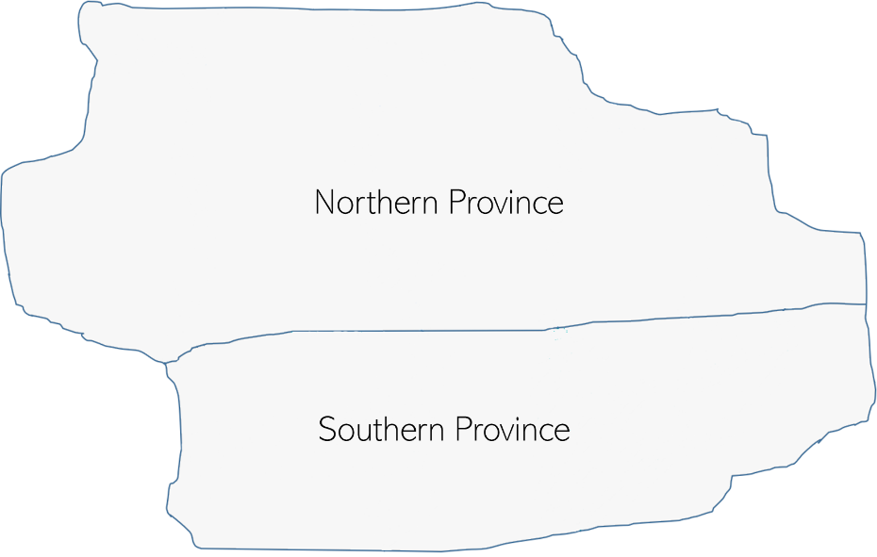

###### Figure A-3. Each province holds five districts

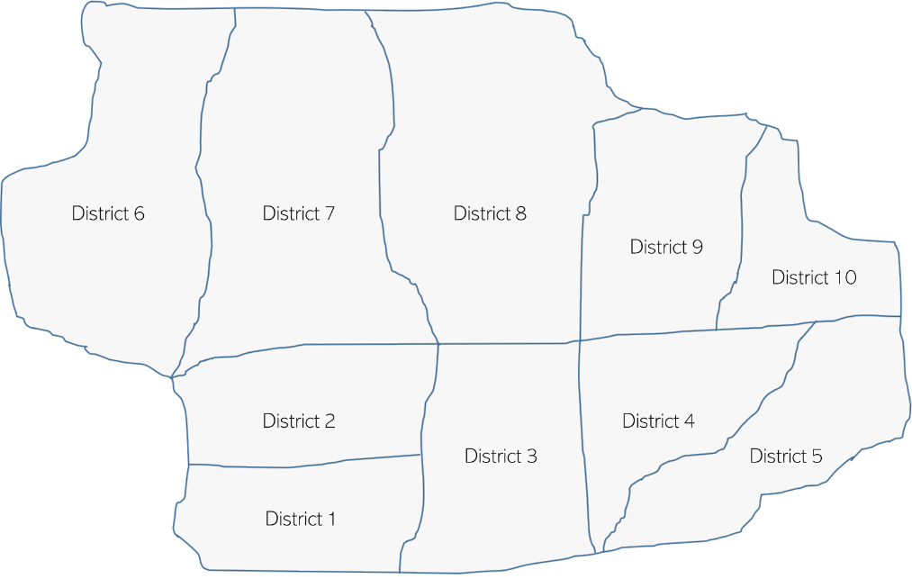

VCQI is designed to be able to analyze vaccination coverage surveys conducted at any of these three levels of administrative hierarchy. The terminology can be a little confusing because the terms Level 1, Level 2, and Level 3 can refer to different things depending on how the survey was done. Table A-1 indicates what level of hierarchy the three terms would refer to under several common survey scenarios.

Important Note!

Level 3 always refers to the lowest level of administrative hierarchy where survey reports will be reported in separate strata. So if the survey is designed to yield district-level results, then Level 3 is the district level. If it is designed to yield provincial results (but not district level) then Level 3 is the provincial level. If it is only a national survey with no sub-national strata, then Level 3 is the national level.

If the Level 3 strata are nested within a higher level, and if the survey is conducted in every Level 3 stratum, then it may make sense to report aggregated results at Level 2 and possibly at Level 1.

Table A-2. Levels 1-3 vary depending on where the survey was conducted

|  |  |  |  |
| --- | --- | --- | --- |
| Survey conducted in : | Level 1 | Level 2 | Level 3 |
| Each health district in each province in the nation | Nation | Province | District |
| Each province in the nation (alternative #1) |  | Nation | Province |
| Each province in the nation (alternative #2) | Nation |  | Province |
| A subset of health districts (not all in any province) |  |  | District |
| All health districts in one province |  | Province | District |
| National survey only (no sub-national strata) |  |  | Nation |
| Single district survey |  |  | District |

VCQI also alludes to something called Level 4, which gives users the flexibility to stratify results by demographic sub-groups within each administrative stratum. Common demographic sub-groups might include urban/rural, boy/girl, literate caregiver/illiterate caregiver, wealthy household/poorer household, etc. To calculate results using a demographic stratification variable, first be sure to establish a variable that codes the demographic sub-groups. This can be accomplished with an integer variable that has a value label, or using a string variable. Once the stratification variable is defined for every respondent, then tell VCQI to use it by including the following line in the control program:

vcqi_global VCQI_LEVEL4_SET_VARLIST *stratification_variable_name*

e.g.,

vcqi_global VCQI_LEVEL4_SET_VARLIST urban_cluster

or

vcqi_global VCQI_LEVEL4_SET_VARLIST gender

or

vcqi_global VCQI_LEVEL4_SET_VARLIST literacy_status

If the user specifies a single stratifier then it will appear in VCQI tables and figures. If the user specified more than one stratifier, it will appear in tables, but not in plots. In fact, VCQI does not make inchworm plots or unweighted proportion plots when the user specifies 2+ LEVEL4 stratification variables.

For example, when it is meaningful to have results at national, provincial, and district level, and the user requests sub-group estimates for urban and rural, then VCQI will summarize the following in tables and plots:

1. National results
   1. All respondents combined
   2. Urban respondents only
   3. Rural respondents only
2. Provincial results for each province
   1. All respondents combined
   2. Urban respondents only
   3. Rural respondents only
3. District level results for each district
   1. All respondents combined
   2. Urban respondents only
   3. Rural respondents only

See Annex B for examples of tabulated output calculated at Levels 1-3 plus urban/rural sub-groups.

# Annex B. Controlling How Strata Are Listed in VCQI Output

The user has control over the names of strata at all levels. The user has control over which strata will be listed, and in what order, in Excel tables. In inchworm plots and unweighted proportion plots, the default setting is for strata to be sorted by estimated coverage with the lowest levels at the bottom of the figure and higher levels near the top. The user can reverse that sort order or opt to plot strata in the same order as Excel tables; see Section B.9 for more details.

Table B-1 lists how stratum names and their order for tabulated output are defined:

##### Table B-1. Where to specify the names and listing order of various strata

|  |  |  |  |
| --- | --- | --- | --- |
| Level | Names | Order | Notes |
| 1 | Dataset: level1name | Not applicable | There is NO ‘s’ on the end of the dataset name as there can only be one Level 1 stratum. |
| 2 | Dataset: level2names | Dataset: level2order | There is an ‘s’ on the end of the dataset name. |
| 3 | Dataset: level3names | Dataset: level3order | VCQI obtains stratum names from variables like RI02, TT02, or SIA02, which hold the survey stratum name |
| 4 | If the user does not specify the name of a VCQI_LEVEL4_SET_LAYOUT dataset then VCQI obtains the LEVEL4 names from value label of the variable that defines the sub-groups or if the variable is a string variable, then the names are the strings themselves.  If the user names a VCQI_LEVEL4_SET_LAYOUT dataset, then VCQI takes the LEVEL4 names from that file. | If the user does not specify the name of a VCQI_LEVEL4_SET_LAYOUT dataset then VCQI obtains the LEVEL4 order from the order in which stratifiers are listed in the VCQI_LEVEL4_SET_VARLIST and the order of values of those variables.  If the user names a VCQI_LEVEL4_SET_LAYOUT dataset, then VCQI takes the LEVEL4 order from that file. | Examples:  urban_cluster, gender  If the string variable *gender* took on string values of *Male* and *Female* then the Level 4 names would be *Male* and *Female.*  If the variable gender was an integer with a value label where 1 is labeled *Boys* and 2 is labeled Girls then once again, the Level 4 names would be Boys and Girls. |

## B.0 Demographic stratification using the VCQI_LEVEL4_SET_VARLIST and LAYOUT

There are two global macros that control demographic stratifiers. The first is VCQI_LEVEL4_SET_VARLIST. This macro must be populated with one or more variable names for VCQI to use demographic stratifiers.

If the user lists a single variable in that macro, then VCQI will include the stratifier in both tables and plots, per the levels that the user request using the SHOW_LEVELS_* macros. This annex shows several examples of how the output varies with different combinations of SHOW_LEVELS_* macros.

If the user lists two or more variables in VCQI_LEVEL4_SET_VARLIST then the demographic stratifiers will be used to make tables. In this situation, demographic stratifiers will be used to make plots only if the user has also specified

vcqi_global PLOT_OUTCOMES_IN_TABLE_ORDER 1

This is important and bears repeating: If the user specifies more than one stratification variable in VCQI_LEVEL4_SET_VARLIST then VCQI does not make inchworm or unweighted proportion plots where the strata are sorted by outcome – the plots would be too confusing. But if the user specifies that VCQI should list strata in table order then VCQI will happily make those plots.

If the demographic stratifier variables have clear and succinct variable labels and value labels then it may not be necessary to also define a VCQI_LEVEL4_SET_LAYOUT dataset. When the user does not define such a dataset, VCQI builds one and saves it in the $VCQI_OUTPUT_FOLDER. The file will be named VCQI_LEVEL4_LAYOUT_automatic.dta. This dataset controls the layout of demographic strata in the tables. If the user wants to modify how the strata are listed, they may edit this dataset and rename it and then tell VCQI to use their modified layout dataset.

### Structure of a LEVEL4 LAYOUT dataset

The LAYOUT dataset holds four variables.

1. order is a numeric variable that takes integer values starting with 1 and increasing by 1. It indicates the order in which the rows should appear in VCQI tables.
2. label is a string variable that holds the label, if any, that should appear in this row in the table
3. rowtype is a string variable that takes three possible values:
   1. LABEL_ONLY means the row contains a label (i.e., Sex)
   2. DATA_ROW means the row contains a condition (i.e., sex == 1)
   3. BLANK_ROW means the user wants tables to include an extra blank row
4. condition is a string variable that holds Stata syntax to identify the demographic sub-group. For urban respondents, the condition might read “urban_cluster == 1” and for rural respondents it might read “urban_cluster == 0”.

So a simple LAYOUT dataset might look like this:

|  |  |  |  |
| --- | --- | --- | --- |
| order | label | condition | rowtype |
| 1 | Is the cluster urban? |  | LABEL_ONLY |
| 2 | 0: Rural | urban_cluster == 0 | DATA_ROW |
| 3 | 1: Urban | urban_cluster == 1 | DATA_ROW |

And if the user did not want the initial label to appear, s/he could edit the dataset to look like this:

|  |  |  |  |
| --- | --- | --- | --- |
| order | label | condition | rowtype |
| 1 | 0: Rural | urban_cluster == 0 | DATA_ROW |
| 2 | 1: Urban | urban_cluster == 1 | DATA_ROW |

And if the user wanted the urban row to appear first and the rural row to appear second, the dataset might look like this:

|  |  |  |  |
| --- | --- | --- | --- |
| order | label | condition | rowtype |
| 1 | 1: Urban | urban_cluster == 1 | DATA_ROW |
| 2 | 0: Rural | urban_cluster == 0 | DATA_ROW |

If the user specified three demographic stratifiers, like this:

vcqi_global VCQI_LEVEL4_SET_VARLIST urban_cluster RI20 RI136

vcqi_global VCQI_LEVEL4_SET_LAYOUT

Then VCQI would write a file named VCQI_LEVEL4_LAYOUT_automatic.dta that looks like this:

|  |  |  |  |
| --- | --- | --- | --- |
| order | label | condition | rowtype |
| 1 | Is the cluster urban? |  | LABEL_ONLY |
| 2 | 0: Rural | urban_cluster == 0 | DATA_ROW |
| 3 | 1: Urban | urban_cluster == 1 | DATA_ROW |
| 4 | Sex |  | LABEL_ONLY |
| 5 | 1: Male | RI20 == 1 | DATA_ROW |
| 6 | 2: Female | RI20 == 2 | DATA_ROW |
| 7 | Did anyone from this household travel for 1+ months of the last 12 months? |  | LABEL_ONLY |
| 8 | 1: Yes | RI136 == 1 | DATA_ROW |
| 9 | 2: No | RI136 == 2 | DATA_ROW |

The user might edit the dataset to remove two unnecessary labels and shorten the third label, like this:

|  |  |  |  |
| --- | --- | --- | --- |
| order | label | condition | rowtype |
| 1 | 0: Rural | urban_cluster == 0 | DATA_ROW |
| 2 | 1: Urban | urban_cluster == 1 | DATA_ROW |
| 3 |  |  | BLANK_ROW |
| 4 | 1: Male | RI20 == 1 | DATA_ROW |
| 5 | 2: Female | RI20 == 2 | DATA_ROW |
| 6 | Anyone travel for 1+ months? |  | LABEL_ONLY |
| 7 | 1: Yes | RI136 == 1 | DATA_ROW |
| 8 | 2: No | RI136 == 2 | DATA_ROW |

The user could rename the dataset “layout_edited.dta” and re-run VCQI, specifying:

vcqi_global VCQI_LEVEL4_SET_VARLIST urban_cluster RI20 RI136

vcqi_global VCQI_LEVEL4_SET_LAYOUT ${VCQI_OUTPUT_FOLDER}/layout_edited

and

vcqi_global SHOW_LEVELS_1_4_TOGETHER 1

And the resulting Excel table would look like this:

|  |  |  |
| --- | --- | --- |
| **BCG Received Before Age 7 Days** |  |  |
|  |  |  |
|  | Received BCG Before Age 7 Days (%) | N |
| **Harmonia** | **90.1** | **2,153** |
| *0: Rural* | 90.2 | 813 |
| *1: Urban* | 90.1 | 1,340 |
|  |  |  |
| *1: Male* | 90.7 | 1,071 |
| *2: Female* | 89.6 | 1,082 |
| *Anyone travel for 1+ months?* |  |  |
| *1: Yes* | 87.4 | 199 |
| *2: No* | 90.4 | 1,954 |

The ability to edit the layout file gives the user substantial flexibility in specifying which stratifiers will appear in the tables and in what order. The conditions in the example above are simple, but the user could specify more complex strata, like this:

|  |  |  |  |
| --- | --- | --- | --- |
| order | label | condition | rowtype |
| 1 | Rural Males (Families who Travel) | urban_cluster == 0 & RI20 == 1 & RI136 == 1 | DATA_ROW |
| 2 | Rural Females (Families who Travel) | urban_cluster == 0 & RI20 == 2 & RI136 == 1 | DATA_ROW |

Which results in a table like this:

|  |  |  |
| --- | --- | --- |
| **BCG Received Before Age 7 Days** |  |  |
|  |  |  |
|  | Received BCG Before Age 7 Days (%) | N |
| **Harmonia** | **90.1** | **2,153** |
| *Rural Males (Families who Travel)* | 83.9 | 31 |
| *Rural Females (Families who Travel)* | 87.2 | 39 |

## B.1 Sample listings of stratum name and order datasets

The following section shows the datasets listed above for the sample dataset analyzed in this user’s guide.

Dataset: level1name

|  |  |
| --- | --- |
| level1id | level1name |
| 1 | Harmonia |

Dataset: level2names

Note that it is not possible to examine these datasets to learn which Level 3 strata are nested inside which Level 2 strata. That nesting information is defined by the relationship between variables HH01 and province_id in the Cluster Metadata (CM) dataset. See the *VCQI Forms and Variable Lists (FVL)* document for CM details.

The purposes of the datasets described here are to a) specify how the stratum names should appear in VCQI output, and b) specify the relative order in which the strata should appear in tabulated output.

In this simple example, the level2order is the same as level2id, but that is not required. If the user wanted tables to show outcomes from the Northern Province first, s/he could reverse the order of level2order in the level2order dataset.

|  |  |
| --- | --- |
| level2id | level2name |
| 1 | Southern Province |
| 2 | Northern Province |

Dataset: level2order

|  |  |
| --- | --- |
| level2id | level2order |
| 1 | 1 |
| 2 | 2 |

Values of TT01 and TT02

|  |  |
| --- | --- |
| TT01  (also level3id) | TT02  (also level3name) |
| 1 | District 1 |
| 2 | District 2 |
| 3 | District 3 |
| 4 | District 4 |
| 5 | District 5 |
| 6 | District 6 |
| 7 | District 7 |
| 8 | District 8 |
| 9 | District 9 |
| 10 | District 10 |

Dataset: level3order

Similarly, level3order is not required to fall in the same sort order as level3id. The user may re-arrange level3order in any manner they wish, as long as every stratum in the survey is represented in this dataset and each row has a unique value of level3order.

|  |  |
| --- | --- |
| level3id | level3order |
| 1 | 1 |
| 2 | 2 |
| 3 | 3 |
| 4 | 4 |
| 5 | 5 |
| 6 | 6 |
| 7 | 7 |
| 8 | 8 |
| 9 | 9 |
| 10 | 10 |

Dataset: level4_layout_rural_urban

|  |  |  |  |
| --- | --- | --- | --- |
| order | label | condition | rowtype |
| 2 | 0: Rural | urban_cluster == 0 | DATA_ROW |
| 1 | 1: Urban | urban_cluster == 1 | DATA_ROW |

Note: When the user asks to see Level 4 stratified output, either under the national, provincial, or district level results, it will appear with urban first and rural second.

Table B-2 lists the order in which strata appear in inchworm plots.

##### Table B-2. Stratum sort order for VCQI inchworm plots

|  |  |
| --- | --- |
| Levels included | How Sorted |
| Only Level 1 | Only one row so sorting is not applicable |
| Only Level 2 or Level 3 | Sorted by estimated coverage |
| Level 2 & 4 or 3 & 4 | Sorted by the Level 2 or 3 coverage and then by Level 4 coverage |
| Levels 1 & 2 | Sorted by estimated coverage |
| Levels 1 & 2 & 3 | Sorted by Level 2 coverage and then by Level 3 within Level 2 |

## B.2 Example: Nested output for all Levels: 1, 2, and 3 with additional Level 4 stratification

This common combination of inputs will show output for every level, 1-3, and for each of the Level 4 sub-groups in each. In this example, the Level 4 stratifier is the variable that codes whether the cluster is urban or rural. The following pages show national, provincial, and district level results, each broken out by urban and rural sub-groups.[22]

vcqi_global VCQI_LEVEL4_SET_VARLIST urban_cluster

vcqi_global VCQI_LEVEL4_SET_LAYOUT ///

${VCQI_INPUT_FOLDER}/level4_layout_rural_urban

vcqi_global SHOW_LEVEL_1_ALONE 0

vcqi_global SHOW_LEVEL_2_ALONE 0

vcqi_global SHOW_LEVEL_3_ALONE 0

vcqi_global SHOW_LEVEL_4_ALONE 0

vcqi_global SHOW_LEVELS_2_3_TOGETHER 0

vcqi_global SHOW_LEVELS_1_4_TOGETHER 1

vcqi_global SHOW_LEVELS_2_4_TOGETHER 0

vcqi_global SHOW_LEVELS_3_4_TOGETHER 0

vcqi_global SHOW_LEVELS_2_3_4_TOGETHER 1

vcqi_global SHOW_BLANKS_BETWEEN_LEVELS 1

Figure B-1 shows coverage estimates sorted from bottom to top, by level 2 coverage (Northern Province has the lowest estimated coverage) and within each province the districts are sorted by district level coverage, so all the districts for the Northern Province appear at the bottom of the page, and then national coverage in the center, and then all the districts for the Southern Province appear above. Within each district, or province, or national level, the urban and rural sub-groups are sorted by estimated coverage.

In District 05, the urban coverage is higher than rural, so it appears at the top. In District 08, rural coverage is higher, so it appears above urban.

##### Table B-3. Nested output for all Levels: 1-3 with Level 4 stratification

|  |  |  |  |  |  |  |  |  |  |  |  |  |  |  |  |
| --- | --- | --- | --- | --- | --- | --- | --- | --- | --- | --- | --- | --- | --- | --- | --- |
| **Protected at Birth from Neonatal Tetanus** | | | |  | |  | |  | |  | |  | |  | |
|  |  |  |  | |  | |  | |  | |  | |  | |
|  | Protected at birth (%) | 95% CI (%) | 95% LCB (%) | | 95% UCB (%) | | DEFF | | ICC | | N | | Weighted N | |
| **Harmonia** | **81.5** | **(79.9, 83.0)** | **80.1** | | **82.8** | | **1.3** | | **0.0054** | | **3,064** | | **6,417,278** | |
| *1: Urban* | 82.2 | (80.2, 84.0) | 80.5 | | 83.7 | | 1.2 | | -0.0133 | | 1,909 | | 3,891,568 | |
| *0: Rural* | 80.5 | (77.6, 83.0) | 78.1 | | 82.7 | | 1.4 | | 0.0334 | | 1,155 | | 2,525,710 | |
|  |  |  |  | |  | |  | |  | |  | |  | |
| Southern Province | 81.8 | (79.6, 83.8) | 80.0 | | 83.5 | | 1.1 | | 0.0135 | | 1,493 | | 3,044,108 | |
| *1: Urban* | 82.8 | (80.3, 85.0) | 80.8 | | 84.6 | | 0.9 | | -0.0226 | | 897 | | 1,798,728 | |
| *0: Rural* | 80.5 | (76.4, 83.9) | 77.1 | | 83.4 | | 1.4 | | 0.0626 | | 596 | | 1,245,380 | |
|  |  |  |  | |  | |  | |  | |  | |  | |
| District 01 | 82.1 | (77.8, 85.7) | 78.6 | | 85.1 | | 0.8 | | -0.0262 | | 308 | | 1,028,427 | |
| *1: Urban* | 80.4 | (74.9, 84.9) | 75.9 | | 84.2 | | 0.7 | | -0.030 | | 185 | | 622,187 | |
| *0: Rural* | 84.7 | (77.8, 89.7) | 79.1 | | 89.0 | | 0.8 | | -0.0184 | | 123 | | 406,240 | |
|  |  |  |  | |  | |  | |  | |  | |  | |
| District 02 | 82.2 | (75.9, 87.1) | 77.1 | | 86.4 | | 1.6 | | 0.0729 | | 310 | | 284,985 | |
| *1: Urban* | 80.1 | (73.6, 85.3) | 74.8 | | 84.6 | | 1.1 | | 0.0014 | | 213 | | 194,745 | |
| *0: Rural* | 86.7 | (70.8, 94.6) | 74.0 | | 93.7 | | 2.8 | | 0.2921 | | 97 | | 90,240 | |
|  |  |  |  | |  | |  | |  | |  | |  | |
| District 03 | 81.6 | (74.4, 87.1) | 75.7 | | 86.3 | | 1.8 | | 0.0762 | | 285 | | 611,843 | |
| *1: Urban* | 88.1 | (83.0, 91.8) | 83.9 | | 91.2 | | 0.6 | | -0.0317 | | 132 | | 283,421 | |
| *0: Rural* | 75.9 | (64.9, 84.3) | 66.9 | | 83.1 | | 1.9 | | 0.1052 | | 153 | | 328,422 | |
|  |  |  |  | |  | |  | |  | |  | |  | |
| District 04 | 81.1 | (76.8, 84.7) | 77.5 | | 84.2 | | 0.7 | | -0.0278 | | 269 | | 530,378 | |
| *1: Urban* | 81.8 | (78.0, 85.1) | 78.7 | | 84.6 | | 0.3 | | -0.0784 | | 153 | | 304,827 | |
| *0: Rural* | 80.1 | (70.9, 86.9) | 72.6 | | 85.9 | | 1.1 | | 0.0414 | | 116 | | 225,551 | |
|  |  |  |  | |  | |  | |  | |  | |  | |
| District 05 | 82.2 | (77.8, 85.9) | 78.6 | | 85.3 | | 0.9 | | -0.0147 | | 321 | | 588,474 | |
| *1: Urban* | 84.9 | (79.5, 89.1) | 80.5 | | 88.4 | | 0.9 | | -0.0047 | | 214 | | 393,548 | |
| *0: Rural* | 76.8 | (71.4, 81.5) | 72.4 | | 80.8 | | 0.4 | | -0.0520 | | 107 | | 194,926 | |
|  |  |  |  | |  | |  | |  | |  | |  | |
| Northern Province | 81.2 | (78.7, 83.4) | 79.2 | | 83.1 | | 1.4 | | -0.0022 | | 1,571 | | 3,373,170 | |
| *1: Urban* | 81.6 | (78.5, 84.3) | 79.0 | | 83.9 | | 1.5 | | -0.0042 | | 1,012 | | 2,092,840 | |
| *0: Rural* | 80.5 | (76.2, 84.1) | 77.0 | | 83.6 | | 1.4 | | 0.0021 | | 559 | | 1,280,330 | |
|  |  |  |  | |  | |  | |  | |  | |  | |
| District 06 | 83.7 | (78.3, 88.0) | 79.3 | | 87.3 | | 1.2 | | 0.0110 | | 301 | | 223,164 | |
| *1: Urban* | 83.9 | (75.9, 89.6) | 77.4 | | 88.8 | | 1.4 | | 0.0352 | | 163 | | 122,839 | |
| *0: Rural* | 83.5 | (75.9, 89.1) | 77.3 | | 88.3 | | 1.0 | | -0.0078 | | 138 | | 100,325 | |
|  |  |  |  | |  | |  | |  | |  | |  | |
| District 07 | 84.0 | (80.5, 86.9) | 81.1 | | 86.5 | | 0.5 | | -0.0604 | | 292 | | 870,605 | |
| *1: Urban* | 83.8 | (79.2, 87.6) | 80.0 | | 87.0 | | 0.6 | | -0.0556 | | 197 | | 592,716 | |
| *0: Rural* | 84.4 | (79.2, 88.4) | 80.1 | | 87.8 | | 0.4 | | -0.0664 | | 95 | | 277,889 | |
|  |  |  |  | |  | |  | |  | |  | |  | |
| District 08 | 77.5 | (72.0, 82.1) | 73.0 | | 81.4 | | 1.1 | | 0.0063 | | 305 | | 1,330,046 | |
| *1: Urban* | 76.4 | (68.6, 82.7) | 70.0 | | 81.7 | | 1.1 | | 0.0063 | | 162 | | 700,511 | |
| *0: Rural* | 78.7 | (70.7, 85.0) | 72.2 | | 84.1 | | 1.1 | | 0.0138 | | 143 | | 629,534 | |
|  |  |  |  | |  | |  | |  | |  | |  | |
| District 09 | 81.9 | (76.9, 85.9) | 77.8 | | 85.3 | | 1.1 | | 0.0283 | | 336 | | 622,294 | |
| *1: Urban* | 85.0 | (80.1, 88.9) | 81.0 | | 88.3 | | 0.8 | | 0.0238 | | 232 | | 426,845 | |
| *0: Rural* | 74.9 | (65.8, 82.3) | 67.4 | | 81.2 | | 0.9 | | 0.0063 | | 104 | | 195,448 | |
|  |  |  |  | |  | |  | |  | |  | |  | |
| District 10 | 85.8 | (82.2, 88.8) | 82.8 | | 88.3 | | 0.7 | | -0.0272 | | 337 | | 327,062 | |
| *1: Urban* | 84.1 | (80.1, 87.4) | 80.8 | | 86.9 | | 0.6 | | -0.0304 | | 258 | | 249,928 | |
| *0: Rural* | 91.2 | (84.7, 95.1) | 86.0 | | 94.6 | | 0.6 | | -0.0413 | | 79 | | 77,134 | |
|  |  |  |  | |  | |  | |  | |  | |  | |
| Abbreviations: CI=Confidence Interval; LCB=Lower Confidence Bound; UCB=Upper Confidence Bound; DEFF=Design Effect; ICC=Intracluster Correlation Coefficient | | | | | | | | | | | | | | | |
| Note: This measure is a population estimate that incorporates survey weights. The CI, LCB and UCB are calculated with software that take the complex survey design into account. | | | | | | | | | | | | | | | |

###### Figure B-1. Inchworm plot showing nested output for all Levels: 1-3 with Level 4 stratification

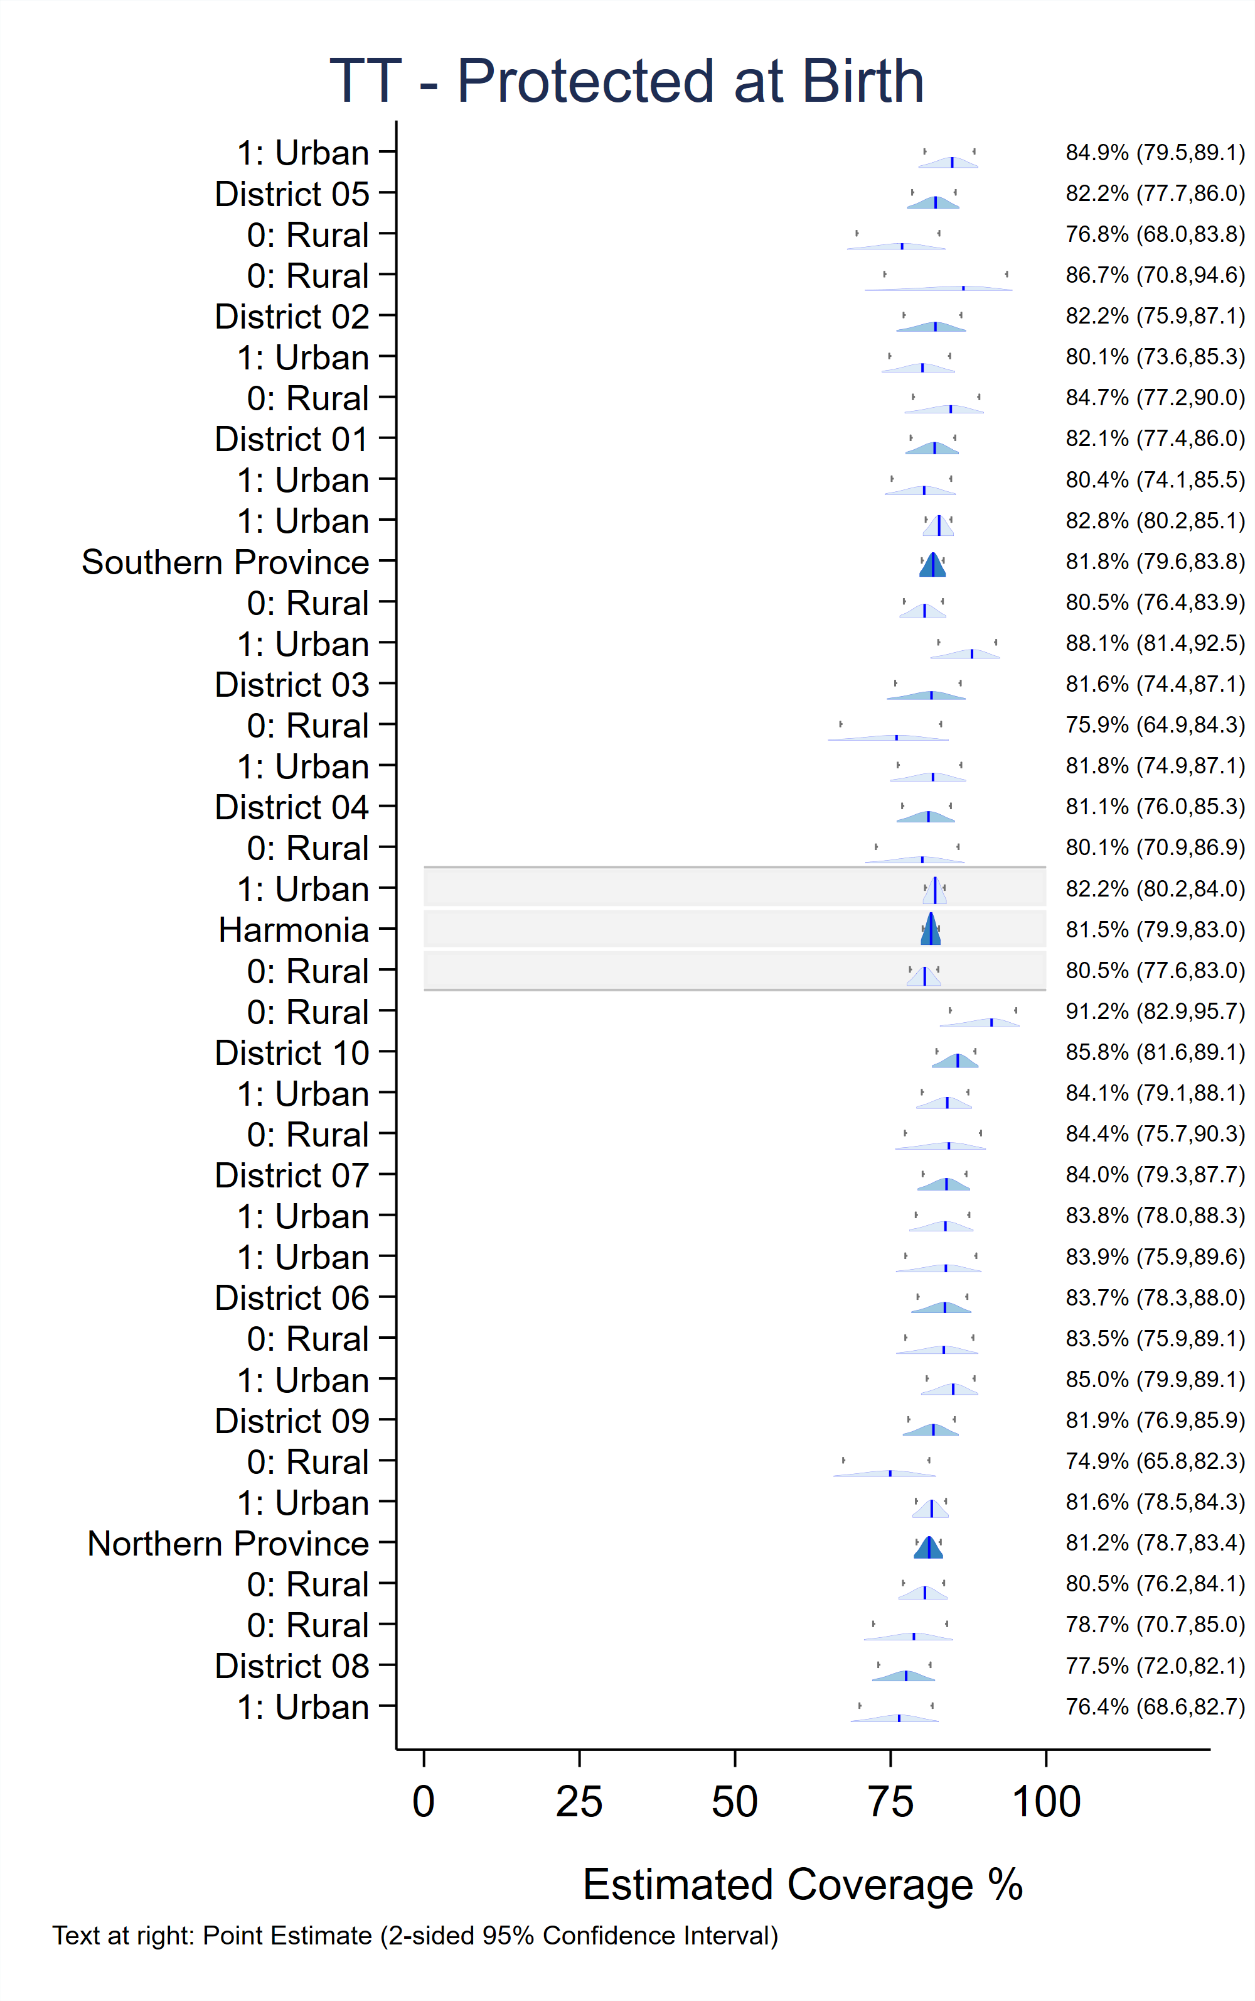

## B.3 Example: Nested output for all Levels: 1, 2, and 3

This combination of inputs will show output for every level, 1-3, with level 3 output nested under level 2, but no additional stratification by sub-group. The following page shows national, provincial, and district level results.[23]

vcqi_global VCQI_LEVEL4_SET_VARLIST

vcqi_global SHOW_LEVEL_1_ALONE 1

vcqi_global SHOW_LEVEL_2_ALONE 0

vcqi_global SHOW_LEVEL_3_ALONE 0

vcqi_global SHOW_LEVEL_4_ALONE 0

vcqi_global SHOW_LEVELS_2_3_TOGETHER 1

vcqi_global SHOW_LEVELS_1_4_TOGETHER 0

vcqi_global SHOW_LEVELS_2_4_TOGETHER 0

vcqi_global SHOW_LEVELS_3_4_TOGETHER 0

vcqi_global SHOW_LEVELS_2_3_4_TOGETHER 0

vcqi_global SHOW_BLANKS_BETWEEN_LEVELS 1

Figure B-2 shows coverage estimates sorted from bottom to top, by Level 2 coverage (Northern Province has the lowest estimated coverage) and within each province, the districts are sorted from bottom-to-top by district level coverage, so all the districts for the Northern Province appear at the bottom of the page, and then national coverage in the center, and then all the districts for the Southern Province appear above.

##### Table B-4. Nested output for all Levels: 1, 2, and 3

|  |  |  |  |  |  |  |  |  |
| --- | --- | --- | --- | --- | --- | --- | --- | --- |
| **Protected at Birth from Neonatal Tetanus** | |  |  |  |  |  |  |  |
|  |  |  |  |  |  |  |  |  |
|  | Protected at birth (%) | 95% CI (%) | 95% LCB (%) | 95% UCB (%) | DEFF | ICC | N | Weighted N |
| **Harmonia** | **81.5** | **(79.9, 83.0)** | **80.1** | **82.8** | **1.3** | **0.0054** | **3,064** | **6,417,278** |
|  |  |  |  |  |  |  |  |  |
| Southern Province | 81.8 | (79.6, 83.8) | 80.0 | 83.5 | 1.1 | 0.0135 | 1,493 | 3,044,108 |
| District 01 | 82.1 | (77.8, 85.7) | 78.6 | 85.1 | 0.8 | -0.0262 | 308 | 1,028,427 |
| District 02 | 82.2 | (75.9, 87.1) | 77.1 | 86.4 | 1.6 | 0.0729 | 310 | 284,985 |
| District 03 | 81.6 | (74.4, 87.1) | 75.7 | 86.3 | 1.8 | 0.0762 | 285 | 611,843 |
| District 04 | 81.1 | (76.8, 84.7) | 77.5 | 84.2 | 0.7 | -0.0278 | 269 | 530,378 |
| District 05 | 82.2 | (77.8, 85.9) | 78.6 | 85.3 | 0.9 | -0.0147 | 321 | 588,474 |
|  |  |  |  |  |  |  |  |  |
| Northern Province | 81.2 | (78.7, 83.4) | 79.2 | 83.1 | 1.4 | -0.0022 | 1,571 | 3,373,170 |
| District 06 | 83.7 | (78.3, 88.0) | 79.3 | 87.3 | 1.2 | 0.0110 | 301 | 223,164 |
| District 07 | 84.0 | (80.5, 86.9) | 81.1 | 86.5 | 0.5 | -0.0604 | 292 | 870,605 |
| District 08 | 77.5 | (72.0, 82.1) | 73.0 | 81.4 | 1.1 | 0.0063 | 305 | 1,330,046 |
| District 09 | 81.9 | (76.9, 85.9) | 77.8 | 85.3 | 1.1 | 0.0283 | 336 | 622,294 |
| District 10 | 85.8 | (82.2, 88.8) | 82.8 | 88.3 | 0.7 | -0.0272 | 337 | 327,062 |
|  |  |  |  |  |  |  |  |  |
|  |  |  |  |  |  |  |  |  |
| Abbreviations: CI=Confidence Interval; LCB=Lower Confidence Bound; UCB=Upper Confidence Bound; DEFF=Design Effect; ICC=Intracluster Correlation Coefficient | | | | | | | | |
| Note: This measure is a population estimate that incorporates survey weights. The CI, LCB and UCB are calculated with software that take the complex survey design into account. | | | | | | | | |

###### Figure B-2. Inchworm plot showing nested output for all Levels: 1, 2, and 3

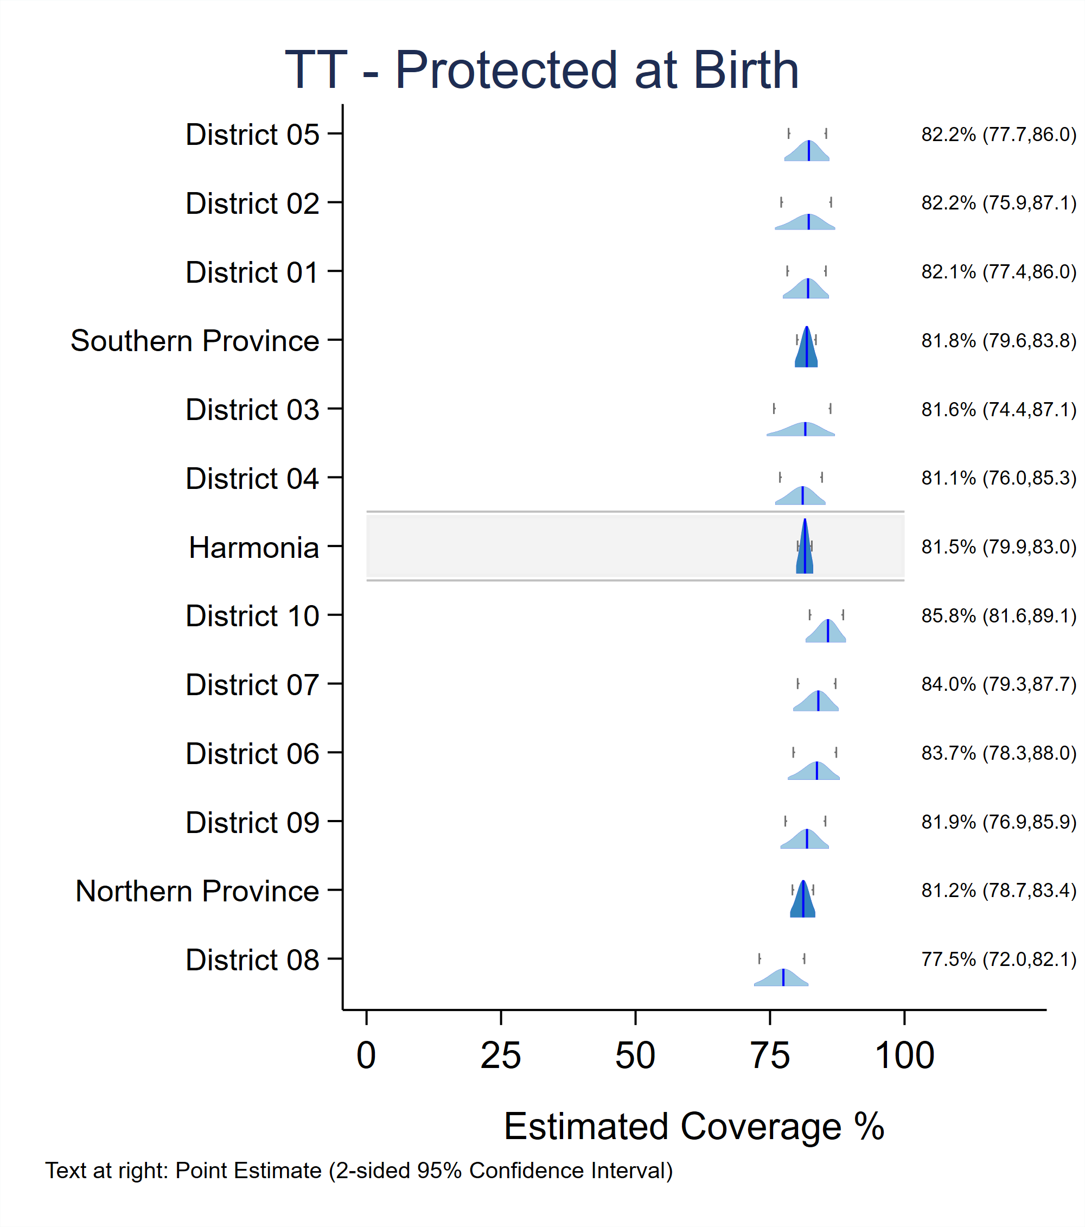

## B.4 Example: Non-nested output for all Levels: 1, 2, and 3

This combination of inputs will show output for every level, 1-3, with level 3 output listed underneath level 2, but not nested, and without stratification by sub-group. The following page shows national, provincial, and district level results.[24] The order in which results are listed is controlled by input datasets named level2order, level3order, and level4order.

vcqi_global VCQI_LEVEL4_SET_VARLIST

vcqi_global SHOW_LEVEL_1_ALONE 1

vcqi_global SHOW_LEVEL_2_ALONE 1

vcqi_global SHOW_LEVEL_3_ALONE 1

vcqi_global SHOW_LEVEL_4_ALONE 0

vcqi_global SHOW_LEVELS_2_3_TOGETHER 0

vcqi_global SHOW_LEVELS_1_4_TOGETHER 0

vcqi_global SHOW_LEVELS_2_4_TOGETHER 0

vcqi_global SHOW_LEVELS_3_4_TOGETHER 0

vcqi_global SHOW_LEVELS_2_3_4_TOGETHER 0

vcqi_global SHOW_BLANKS_BETWEEN_LEVELS 1

##### Table B-5. Non-nested output for all Levels: 1-3

|  |  |  |  |  |  |  |  |  |
| --- | --- | --- | --- | --- | --- | --- | --- | --- |
| **Protected at Birth from Neonatal Tetanus** | | |  |  |  |  |  |  |
|  |  |  |  |  |  |  |  |  |
|  | Protected at birth (%) | 95% CI (%) | 95% LCB (%) | 95% UCB (%) | DEFF | ICC | N | Weighted N |
| **Harmonia** | **81.5** | **(79.9, 83.0)** | **80.1** | **82.8** | **1.3** | **0.0054** | **3,064** | **6,417,278** |
|  |  |  |  |  |  |  |  |  |
| Southern Province | 81.8 | (79.6, 83.8) | 80.0 | 83.5 | 1.1 | 0.0135 | 1,493 | 3,044,108 |
| Northern Province | 81.2 | (78.7, 83.4) | 79.2 | 83.1 | 1.4 | -0.0022 | 1,571 | 3,373,170 |
|  |  |  |  |  |  |  |  |  |
| District 01 | 82.1 | (77.8, 85.7) | 78.6 | 85.1 | 0.8 | -0.0262 | 308 | 1,028,427 |
| District 02 | 82.2 | (75.9, 87.1) | 77.1 | 86.4 | 1.6 | 0.0729 | 310 | 284,985 |
| District 03 | 81.6 | (74.4, 87.1) | 75.7 | 86.3 | 1.8 | 0.0762 | 285 | 611,843 |
| District 04 | 81.1 | (76.8, 84.7) | 77.5 | 84.2 | 0.7 | -0.0278 | 269 | 530,378 |
| District 05 | 82.2 | (77.8, 85.9) | 78.6 | 85.3 | 0.9 | -0.0147 | 321 | 588,474 |
| District 06 | 83.7 | (78.3, 88.0) | 79.3 | 87.3 | 1.2 | 0.0110 | 301 | 223,164 |
| District 07 | 84.0 | (80.5, 86.9) | 81.1 | 86.5 | 0.5 | -0.0604 | 292 | 870,605 |
| District 08 | 77.5 | (72.0, 82.1) | 73.0 | 81.4 | 1.1 | 0.0063 | 305 | 1,330,046 |
| District 09 | 81.9 | (76.9, 85.9) | 77.8 | 85.3 | 1.1 | 0.0283 | 336 | 622,294 |
| District 10 | 85.8 | (82.2, 88.8) | 82.8 | 88.3 | 0.7 | -0.0272 | 337 | 327,062 |
|  |  |  |  |  |  |  |  |  |
|  |  |  |  |  |  |  |  |  |
| Abbreviations: CI=Confidence Interval; LCB=Lower Confidence Bound; UCB=Upper Confidence Bound; DEFF=Design Effect; ICC=Intracluster Correlation Coefficient | | | | | | | | |
| Note: This measure is a population estimate that incorporates survey weights. The CI, LCB and UCB are calculated with software that take the complex survey design into account. | | | | | | | | |

Figure B-3 is the same as Figure B-2. If the Block D parameter PLOT_OUTCOMES_IN_TABLE_ORDER is set to 0 then inchworm plots show Level 3 districts nested within Level 2, even if the Excel table does not. If the parameter is set to 1, then inchworm plots will list strata in the same order as tables. See section B.8 for an example.

###### Figure B-3. Inchworm plot showing nested output for all Levels: 1, 2, and 3



## B.5 Example: Output for Level 3 only

This combination of inputs will show output only for level 3. This might be appropriate if the survey were conducted only in high risk districts, but not in every district. The following page shows district level results.[25]

vcqi_global VCQI_LEVEL4_SET_VARLIST

vcqi_global SHOW_LEVEL_1_ALONE 0

vcqi_global SHOW_LEVEL_2_ALONE 0

vcqi_global SHOW_LEVEL_3_ALONE 1

vcqi_global SHOW_LEVEL_4_ALONE 0

vcqi_global SHOW_LEVELS_2_3_TOGETHER 0

vcqi_global SHOW_LEVELS_1_4_TOGETHER 0

vcqi_global SHOW_LEVELS_2_4_TOGETHER 0

vcqi_global SHOW_LEVELS_3_4_TOGETHER 0

vcqi_global SHOW_LEVELS_2_3_4_TOGETHER 0

vcqi_global SHOW_BLANKS_BETWEEN_LEVELS 1

##### Table B-6. Output for Level 3 only

|  |  |  |  |  |  |  |  |  |
| --- | --- | --- | --- | --- | --- | --- | --- | --- |
| **Protected at Birth from Neonatal Tetanus** | | |  |  |  |  |  |  |
|  |  |  |  |  |  |  |  |  |
|  | Protected at birth (%) | 95% CI (%) | 95% LCB (%) | 95% UCB (%) | DEFF | ICC | N | Weighted N |
| District 01 | 82.1 | (77.8, 85.7) | 78.6 | 85.1 | 0.8 | -0.0262 | 308 | 1,028,427 |
| District 02 | 82.2 | (75.9, 87.1) | 77.1 | 86.4 | 1.6 | 0.0729 | 310 | 284,985 |
| District 03 | 81.6 | (74.4, 87.1) | 75.7 | 86.3 | 1.8 | 0.0762 | 285 | 611,843 |
| District 04 | 81.1 | (76.8, 84.7) | 77.5 | 84.2 | 0.7 | -0.0278 | 269 | 530,378 |
| District 05 | 82.2 | (77.8, 85.9) | 78.6 | 85.3 | 0.9 | -0.0147 | 321 | 588,474 |
| District 06 | 83.7 | (78.3, 88.0) | 79.3 | 87.3 | 1.2 | 0.0110 | 301 | 223,164 |
| District 07 | 84.0 | (80.5, 86.9) | 81.1 | 86.5 | 0.5 | -0.0604 | 292 | 870,605 |
| District 08 | 77.5 | (72.0, 82.1) | 73.0 | 81.4 | 1.1 | 0.0063 | 305 | 1,330,046 |
| District 09 | 81.9 | (76.9, 85.9) | 77.8 | 85.3 | 1.1 | 0.0283 | 336 | 622,294 |
| District 10 | 85.8 | (82.2, 88.8) | 82.8 | 88.3 | 0.7 | -0.0272 | 337 | 327,062 |
|  |  |  |  |  |  |  |  |  |
|  |  |  |  |  |  |  |  |  |
| Abbreviations: CI=Confidence Interval; LCB=Lower Confidence Bound; UCB=Upper Confidence Bound; DEFF=Design Effect; ICC=Intracluster Correlation Coefficient | | | | | | | | |
| Note: This measure is a population estimate that incorporates survey weights. The CI, LCB and UCB are calculated with software that take the complex survey design into account. | | | | | | | | |

Figure B-4 page shows Level 3 strata sorted in order of estimated coverage. Neither the table above nor Figure B-4 make any reference whatsoever to Level 2 strata.

###### Figure B-4. Inchworm plot showing sorted output for Level 3 only

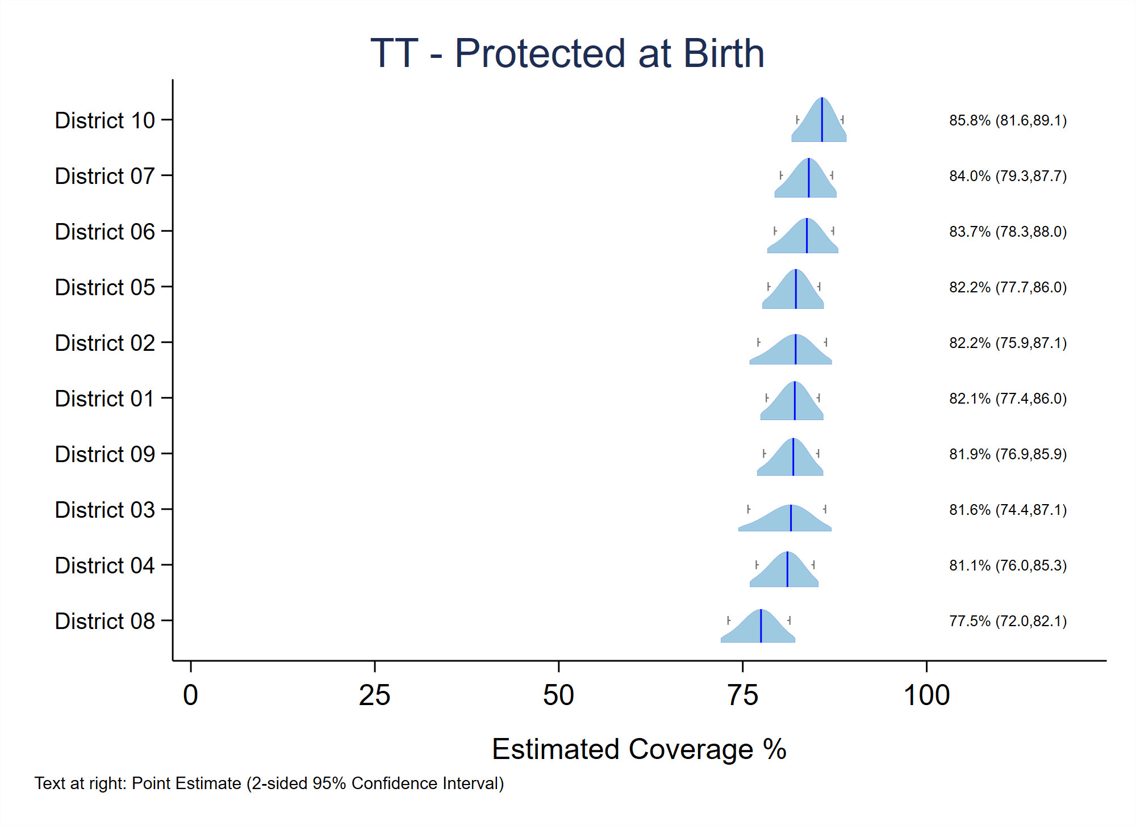

## B.6 Example: Output for Level 3 with additional Level 4 stratification

This combination of inputs will show output for level 3 and for the urban and rural sub-groups in each district. Again, omitting Levels 2 and 1 might be appropriate if the survey were conducted only in high risk districts, but not in every district. The following page shows district level results.[26]

vcqi_global VCQI_LEVEL4_SET_VARLIST urban_cluster

vcqi_global VCQI_LEVEL4_SET_LAYOUT ///

${VCQI_INPUT_FOLDER}/level4_layout_rural_urban

vcqi_global SHOW_LEVEL_1_ALONE 0

vcqi_global SHOW_LEVEL_2_ALONE 0

vcqi_global SHOW_LEVEL_3_ALONE 0

vcqi_global SHOW_LEVEL_4_ALONE 0

vcqi_global SHOW_LEVELS_2_3_TOGETHER 0

vcqi_global SHOW_LEVELS_1_4_TOGETHER 0

vcqi_global SHOW_LEVELS_2_4_TOGETHER 0

vcqi_global SHOW_LEVELS_3_4_TOGETHER 1

vcqi_global SHOW_LEVELS_2_3_4_TOGETHER 0

vcqi_global SHOW_BLANKS_BETWEEN_LEVELS 1

Figure B-5 shows Level 3 strata sorted in order of estimated coverage. Within each Level 3 stratum, the Level 4 urban and rural sub-groups are sorted by estimated coverage. Neither the table above nor Figure B-5 make any reference to Level 2 strata.

### Table B-7. Output for Level 3 with Level 4 stratification

|  |  |  |  |  |  |  |  |  |
| --- | --- | --- | --- | --- | --- | --- | --- | --- |
| **Protected at Birth from Neonatal Tetanus** | | |  |  |  |  |  |  |
|  |  |  |  |  |  |  |  |  |
|  | Protected at birth (%) | 95% CI (%) | 95% LCB (%) | 95% UCB (%) | DEFF | ICC | N | Weighted N |
| District 01 | 82.1 | (77.8, 85.7) | 78.6 | 85.1 | 0.8 | -0.0262 | 308 | 1,028,427 |
| *1: Urban* | 80.4 | (74.9, 84.9) | 75.9 | 84.2 | 0.7 | -0.030 | 185 | 622,187 |
| *0: Rural* | 84.7 | (77.8, 89.7) | 79.1 | 89.0 | 0.8 | -0.0184 | 123 | 406,240 |
|  |  |  |  |  |  |  |  |  |
| District 02 | 82.2 | (75.9, 87.1) | 77.1 | 86.4 | 1.6 | 0.0729 | 310 | 284,985 |
| *1: Urban* | 80.1 | (73.6, 85.3) | 74.8 | 84.6 | 1.1 | 0.0014 | 213 | 194,745 |
| *0: Rural* | 86.7 | (70.8, 94.6) | 74.0 | 93.7 | 2.8 | 0.2921 | 97 | 90,240 |
|  |  |  |  |  |  |  |  |  |
| District 03 | 81.6 | (74.4, 87.1) | 75.7 | 86.3 | 1.8 | 0.0762 | 285 | 611,843 |
| *1: Urban* | 88.1 | (83.0, 91.8) | 83.9 | 91.2 | 0.6 | -0.0317 | 132 | 283,421 |
| *0: Rural* | 75.9 | (64.9, 84.3) | 66.9 | 83.1 | 1.9 | 0.1052 | 153 | 328,422 |
|  |  |  |  |  |  |  |  |  |
| District 04 | 81.1 | (76.8, 84.7) | 77.5 | 84.2 | 0.7 | -0.0278 | 269 | 530,378 |
| *1: Urban* | 81.8 | (78.0, 85.1) | 78.7 | 84.6 | 0.3 | -0.0784 | 153 | 304,827 |
| *0: Rural* | 80.1 | (70.9, 86.9) | 72.6 | 85.9 | 1.1 | 0.0414 | 116 | 225,551 |
|  |  |  |  |  |  |  |  |  |
| District 05 | 82.2 | (77.8, 85.9) | 78.6 | 85.3 | 0.9 | -0.0147 | 321 | 588,474 |
| *1: Urban* | 84.9 | (79.5, 89.1) | 80.5 | 88.4 | 0.9 | -0.0047 | 214 | 393,548 |
| *0: Rural* | 76.8 | (71.4, 81.5) | 72.4 | 80.8 | 0.4 | -0.0520 | 107 | 194,926 |
|  |  |  |  |  |  |  |  |  |
| District 06 | 83.7 | (78.3, 88.0) | 79.3 | 87.3 | 1.2 | 0.0110 | 301 | 223,164 |
| *1: Urban* | 83.9 | (75.9, 89.6) | 77.4 | 88.8 | 1.4 | 0.0352 | 163 | 122,839 |
| *0: Rural* | 83.5 | (75.9, 89.1) | 77.3 | 88.3 | 1.0 | -0.0078 | 138 | 100,325 |
|  |  |  |  |  |  |  |  |  |
| District 07 | 84.0 | (80.5, 86.9) | 81.1 | 86.5 | 0.5 | -0.0604 | 292 | 870,605 |
| *1: Urban* | 83.8 | (79.2, 87.6) | 80.0 | 87.0 | 0.6 | -0.0556 | 197 | 592,716 |
| *0: Rural* | 84.4 | (79.2, 88.4) | 80.1 | 87.8 | 0.4 | -0.0664 | 95 | 277,889 |
|  |  |  |  |  |  |  |  |  |
| District 08 | 77.5 | (72.0, 82.1) | 73.0 | 81.4 | 1.1 | 0.0063 | 305 | 1,330,046 |
| *1: Urban* | 76.4 | (68.6, 82.7) | 70.0 | 81.7 | 1.1 | 0.0063 | 162 | 700,511 |
| *0: Rural* | 78.7 | (70.7, 85.0) | 72.2 | 84.1 | 1.1 | 0.0138 | 143 | 629,534 |
|  |  |  |  |  |  |  |  |  |
| District 09 | 81.9 | (76.9, 85.9) | 77.8 | 85.3 | 1.1 | 0.0283 | 336 | 622,294 |
| *1: Urban* | 85.0 | (80.1, 88.9) | 81.0 | 88.3 | 0.8 | 0.0238 | 232 | 426,845 |
| *0: Rural* | 74.9 | (65.8, 82.3) | 67.4 | 81.2 | 0.9 | 0.0063 | 104 | 195,448 |
|  |  |  |  |  |  |  |  |  |
| District 10 | 85.8 | (82.2, 88.8) | 82.8 | 88.3 | 0.7 | -0.0272 | 337 | 327,062 |
| *1: Urban* | 84.1 | (80.1, 87.4) | 80.8 | 86.9 | 0.6 | -0.0304 | 258 | 249,928 |
| *0: Rural* | 91.2 | (84.7, 95.1) | 86.0 | 94.6 | 0.6 | -0.0413 | 79 | 77,134 |
|  |  |  |  |  |  |  |  |  |
|  |  |  |  |  |  |  |  |  |
| Abbreviations: CI=Confidence Interval; LCB=Lower Confidence Bound; UCB=Upper Confidence Bound; DEFF=Design Effect; ICC=Intracluster Correlation Coefficient | | | | | | | | |
| Note: This measure is a population estimate that incorporates survey weights. The CI, LCB and UCB are calculated with software that take the complex survey design into account. | | | | | | | | |

###### Figure B-5. Inchworm plot showing sorted output for Level 3 with Level 4 stratification

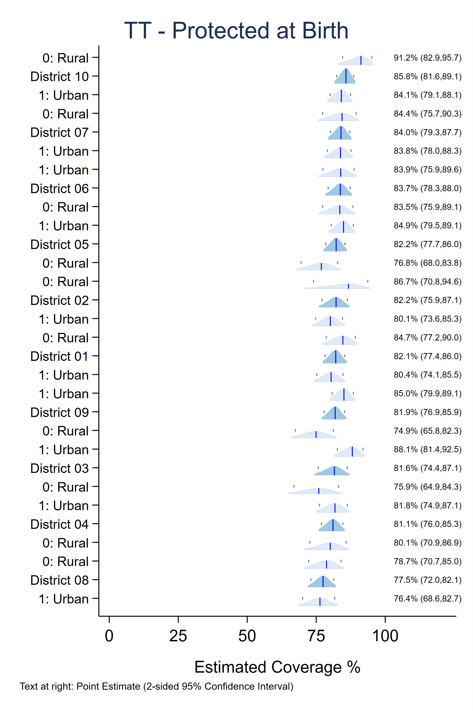

## B.7 Example: Output for Level 4 Only

Levels 1 through 3 are commonly included in coverage survey reports and this Annex demonstrates various combinations that may prove useful, but the ultimate flexibility in specifying the order of table rows is possible with the option of viewing output for Level 4 only. The user may customize a LAYOUT file as described in section B.0 above and stipulate that VCQI should

vcqi_global SHOW_LEVEL_4_ALONE 1

This combination of inputs will show output for level 4 only.

vcqi_global VCQI_LEVEL4_SET_VARLIST RI20 urban_cluster

vcqi_global VCQI_LEVEL4_SET_LAYOUT ///

${VCQI_OUTPUT_FOLDER}/VCQI_LEVEL4_SET_LAYOUT_lvl1_at_bottom

vcqi_global SHOW_LEVEL_1_ALONE 0

vcqi_global SHOW_LEVEL_2_ALONE 0

vcqi_global SHOW_LEVEL_3_ALONE 0

vcqi_global SHOW_LEVEL_4_ALONE 1

vcqi_global SHOW_LEVELS_2_3_TOGETHER 0

vcqi_global SHOW_LEVELS_1_4_TOGETHER 0

vcqi_global SHOW_LEVELS_2_4_TOGETHER 0

vcqi_global SHOW_LEVELS_3_4_TOGETHER 0

vcqi_global SHOW_LEVELS_2_3_4_TOGETHER 0

vcqi_global SHOW_BLANKS_BETWEEN_LEVELS 1

if VCQI_LEVEL4_SET_LAYOUT_lvl1_at_bottom.dta looks like this:

|  |  |  |  |
| --- | --- | --- | --- |
| order | label | condition | rowtype |
| 1 | Sex |  | LABEL_ONLY |
| 2 | 1: Male | RI20 == 1 | DATA_ROW |
| 3 | 2: Female | RI20 == 2 | DATA_ROW |
| 4 | Is the cluster urban? |  | LABEL_ONLY |
| 5 | 0: Rural | urban_cluster == 0 | DATA_ROW |
| 6 | 1: Urban | urban_cluster == 1 | DATA_ROW |
| 7 |  |  | BLANK_ROW |
| 8 | All respondents | level1id == 1 | DATA_ROW |

Will produce output like Table B-8.

### Table B-8. Output for Level 4 alone

|  |  |  |
| --- | --- | --- |
| **Dropout** |  |  |
|  |  |  |
|  | PENTA1-PENTA3 Dropout (%) | N |
| *Sex* |  |  |
| *1: Male* | 37.2 | 1,509 |
| *2: Female* | 36.3 | 1,561 |
| *Is the cluster urban?* |  |  |
| *0: Rural* | 36.9 | 1,149 |
| *1: Urban* | 36.7 | 1,921 |
|  |  |  |
| *All respondents* | 36.8 | 3,070 |
|  |  |  |
| Note: This measure is an unweighted summary of a proportion from the survey sample. | | |

If the user specifies

vcqi_global PLOT_OUTCOMES_IN_TABLE_ORDER 0

as described in Section B.9 then VCQI will not attempt to make inchworm or unweighted plots because the user specified more than one level 4 stratifier. But if the user specifies:

vcqi_global PLOT_OUTCOMES_IN_TABLE_ORDER 1

then VCQI will make those plots. The RI_CONT_01 plot for dropout from Penta1 to Penta3 is Figure B-6. Note that the strata are listed in the same order as in Table B-8.

###### Figure B-6. Unweighted proportion plot showing outcomes for every level of two demographic stratifiers

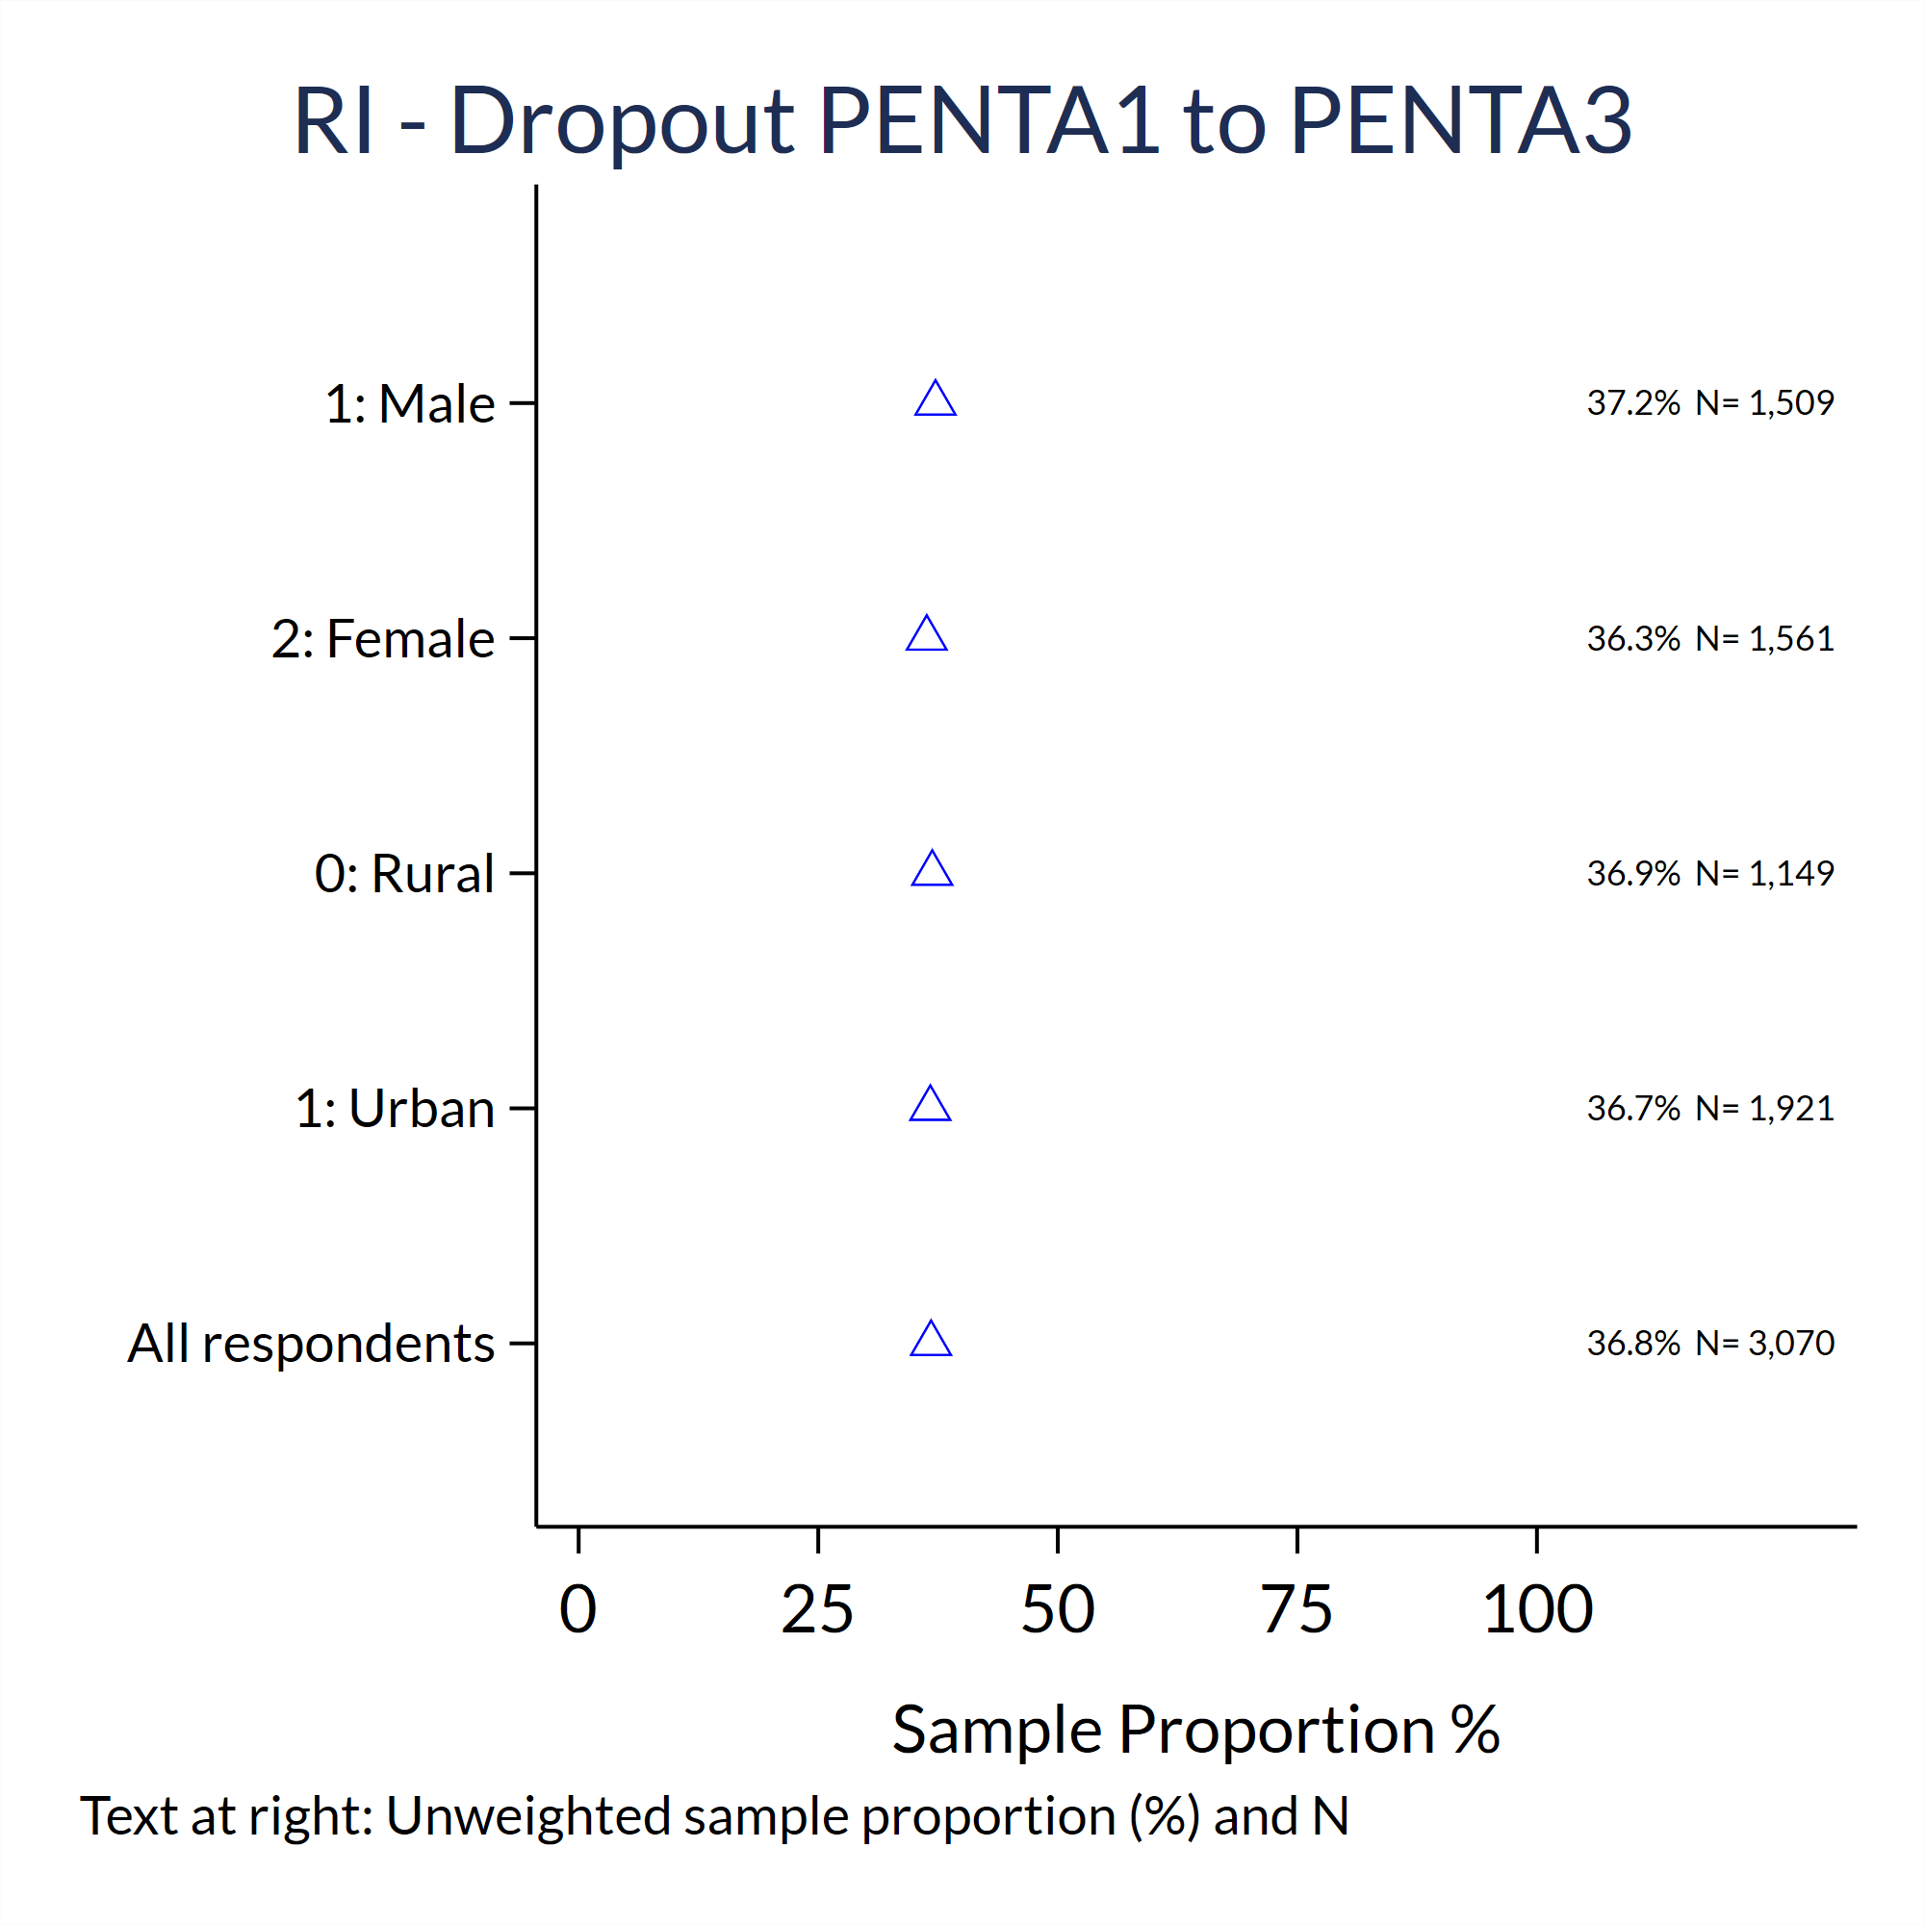

## B.8 A Large Realistic Level 4 LAYOUT Example

The LAYOUT dataset examples in this *User’s Guide* are mostly brief because of space considerations, but the full power of the Level 4 LAYOUT dataset is best demonstrated with a large realistic example from Nigeria. In the 2016-17 Multi-Indicator Cluster Survey / National Immunization Coverage Survey (MICS/NICS)[27], the table shells followed a common UNICEF MICS layout with tables split across two pages for each outcome. The first table listed seven stratifiers: sex, geopolitical zone, urban/rural, caretaker’s education, caretaker’s age, household wealth and ethnicity. The second page showed outcomes for the entire country and for each of Nigeria’s 36 states plus the federal capital territory, arranged by geopolitical zone. The following pages specify the table layout using customized VCQI Level 4 LAYOUT files. You might follow these examples in your own work.

This Level 4 LAYOUT dataset describes the table row order for seven stratification variables in Nigeria’s 2016-17 MICS/NICS Survey

vcqi_global VCQI_LEVEL4_SET_VARLIST MICS_5_hl4 MICS_5_zone ///

urban_cluster caretaker_education ///

caretaker_age_category MICS_5_windex ///

MICS_5_ethnicity

| order | label | condition | rowtype |
| --- | --- | --- | --- |
| 1 | Sex |  | LABEL_ONLY |
| 2 | Male | MICS_5_hl4 == 1 | DATA_ROW |
| 3 | Female | MICS_5_hl4 == 2 | DATA_ROW |
| 4 | Geopolitical Zone |  | LABEL_ONLY |
| 5 | North Central | MICS_5_zone == 1 | DATA_ROW |
| 6 | North East | MICS_5_zone == 2 | DATA_ROW |
| 7 | North West | MICS_5_zone == 3 | DATA_ROW |
| 8 | South East | MICS_5_zone == 4 | DATA_ROW |
| 9 | South South | MICS_5_zone == 5 | DATA_ROW |
| 10 | South West | MICS_5_zone == 6 | DATA_ROW |
| 11 | Area |  | LABEL_ONLY |
| 12 | Urban | urban_cluster == 1 | DATA_ROW |
| 13 | Rural | urban_cluster == 2 | DATA_ROW |
| 14 | Caretaker's Education |  | LABEL_ONLY |
| 15 | Primary | caretaker_education == 1 | DATA_ROW |
| 16 | Secondary/technical | caretaker_education == 2 | DATA_ROW |
| 17 | Higher | caretaker_education == 3 | DATA_ROW |
| 18 | Non-formal | caretaker_education == 4 | DATA_ROW |
| 19 | Missing | caretaker_education == 9 | DATA_ROW |
| 20 | Caretaker's Age |  | LABEL_ONLY |
| 21 | 15-19 | caretaker_age_category == 1 | DATA_ROW |
| 22 | 20-29 | caretaker_age_category == 2 | DATA_ROW |
| 23 | 30-39 | caretaker_age_category == 3 | DATA_ROW |
| 24 | 40-49 | caretaker_age_category == 4 | DATA_ROW |
| 25 | 50+ | caretaker_age_category == 5 | DATA_ROW |
| 26 | DNK | caretaker_age_category == 6 | DATA_ROW |
| 27 | Wealth index quintile |  | LABEL_ONLY |
| 28 | Poorest | MICS_5_windex5 == 1 | DATA_ROW |
| 29 | Second | MICS_5_windex5 == 2 | DATA_ROW |
| 30 | Middle | MICS_5_windex5 == 3 | DATA_ROW |
| 31 | Fourth | MICS_5_windex5 == 4 | DATA_ROW |
| 32 | Richest | MICS_5_windex5 == 5 | DATA_ROW |
| 33 | Ethnicity |  | LABEL_ONLY |
| 34 | Hausa | MICS_5_ethnicity == 1 | DATA_ROW |
| 35 | Igbo | MICS_5_ethnicity == 2 | DATA_ROW |
| 36 | Yoruba | MICS_5_ethnicity == 3 | DATA_ROW |
| 37 | Other | !inlist(MICS_5_ethnicity,1,2,3) | DATA_ROW |

This Level 4 LAYOUT dataset describes the table row order national results followed by 37 states sorted alphabetically within six geopolitical zones for Nigeria’s 2016-17 MICS/NICS Survey

vcqi_global VCQI_LEVEL4_SET_VARLIST MICS_5_hh7

|  |  |  |  |
| --- | --- | --- | --- |
| order | label | condition | rowtype |
| 1 | Nigeria | inrange(MICS_5_hh7,1,37) | DATA_ROW |
| 2 | State |  | LABEL_ONLY |
| 3 | North Central |  | LABEL_ONLY |
| 4 | FCT-Abuja | MICS_5_hh7 == 37 | DATA_ROW |
| 5 | Benue | MICS_5_hh7 == 7 | DATA_ROW |
| 6 | Kogi | MICS_5_hh7 == 22 | DATA_ROW |
| 7 | Kwara | MICS_5_hh7 == 23 | DATA_ROW |
| 8 | Nasarawa | MICS_5_hh7 == 25 | DATA_ROW |
| 9 | Niger | MICS_5_hh7 == 26 | DATA_ROW |
| 10 | Plateau | MICS_5_hh7 == 31 | DATA_ROW |
| 11 | North East |  | LABEL_ONLY |
| 12 | Adamawa | MICS_5_hh7 == 2 | DATA_ROW |
| 13 | Bauchi | MICS_5_hh7 == 5 | DATA_ROW |
| 14 | Borno | MICS_5_hh7 == 8 | DATA_ROW |
| 15 | Gombe | MICS_5_hh7 == 15 | DATA_ROW |
| 16 | Taraba | MICS_5_hh7 == 34 | DATA_ROW |
| 17 | Yobe | MICS_5_hh7 == 35 | DATA_ROW |
| 18 | North West |  | LABEL_ONLY |
| 19 | Jigawa | MICS_5_hh7 == 17 | DATA_ROW |
| 20 | Kaduna | MICS_5_hh7 == 18 | DATA_ROW |
| 21 | Kano | MICS_5_hh7 == 19 | DATA_ROW |
| 22 | Katsina | MICS_5_hh7 == 20 | DATA_ROW |
| 23 | Kebbi | MICS_5_hh7 == 21 | DATA_ROW |
| 24 | Sokoto | MICS_5_hh7 == 33 | DATA_ROW |
| 25 | Zamfara | MICS_5_hh7 == 36 | DATA_ROW |
| 26 | South East |  | LABEL_ONLY |
| 27 | Abia | MICS_5_hh7 == 1 | DATA_ROW |
| 28 | Anambra | MICS_5_hh7 == 4 | DATA_ROW |
| 29 | Ebonyi | MICS_5_hh7 == 11 | DATA_ROW |
| 30 | Enugu | MICS_5_hh7 == 14 | DATA_ROW |
| 31 | Imo | MICS_5_hh7 == 16 | DATA_ROW |
| 32 | South South |  | LABEL_ONLY |
| 33 | Akwa Ibom | MICS_5_hh7 == 3 | DATA_ROW |
| 34 | Bayelsa | MICS_5_hh7 == 6 | DATA_ROW |
| 35 | Cross River | MICS_5_hh7 == 9 | DATA_ROW |
| 36 | Delta | MICS_5_hh7 == 10 | DATA_ROW |
| 37 | Edo | MICS_5_hh7 == 12 | DATA_ROW |
| 38 | Rivers | MICS_5_hh7 == 32 | DATA_ROW |
| 39 | South West |  | LABEL_ONLY |
| 40 | Ekiti | MICS_5_hh7 == 13 | DATA_ROW |
| 41 | Lagos | MICS_5_hh7 == 24 | DATA_ROW |
| 42 | Ogun | MICS_5_hh7 == 27 | DATA_ROW |
| 43 | Ondo | MICS_5_hh7 == 28 | DATA_ROW |
| 44 | Osun | MICS_5_hh7 == 29 | DATA_ROW |
| 45 | Oyo | MICS_5_hh7 == 30 | DATA_ROW |

The flexibility afforded by Level 4 LAYOUT should enable you to construct tables with whatever table rows are suitable for your survey report. If one of the Level 1-4 combinations defined above in sections B.2 through B.6 is what you need, specify the input combinations you see there. But if you wish to customize the structure of table rows, specify the list of stratification variables in the VCQI_LEVEL4_SET_VARLIST and then customize the default LAYOUT dataset that VCQI produces in your first run.

Workflow to create the default LAYOUT and then customize it:

1. Specify a list of stratification variables in the VCQI_LEVEL4_SET_VARLIST and leave the VCQI_LEVEL4_SET_LAYOUT blank.
2. Tell VCQI to generate Level 4 output by specifying:   
   vcqi_global SHOW_LEVEL_4_ALONE 1
3. Run VCQI. It will generate a default LAYOUT dataset in your VCQI_OUTPUT_FOLDER named VCQI_LEVEL4_LAYOUT_automatic.dta.
4. Copy that dataset; name the copy something like VCQI_LEVEL4_LAYOUT_customized.dta. Use the Stata Data Editor to modify the layout and labels to suit you using options described in section B.0 and what you see in the Nigeria example above. Save the edited dataset in your VCQI_OUTPUT_FOLDER.
5. Edit the control program and update the LAYOUT line to point to your customized dataset:

vcqi_global VCQI_LEVEL4_SET_LAYOUT ///  
 $VCQI_OUTPUT_FOLDER/VCQI_LEVEL4_LAYOUT_customized

1. Re-run VCQI. The output table will appear as defined by the customized LAYOUT dataset.

## B.9 Changing Order of Strata in Inchworm and Unweighted Plots

By default, strata in inchworm, double inchworm, and unweighted plots are sorted by the estimated outcome with the poorest performing strata at the bottom of the figure and highest performers near the top. Users can change this behavior in two ways: by using the SORT_PLOT_LOW_TO_HIGH global to reverse the default plot order, or by using the PLOT_OUTCOMES_IN_TABLE_ORDER global to plot strata in the same order they appear in tabular output.

Note that when PLOT_OUTCOMES_IN_TABLE_ORDER is set to 1, then strata will be plotted in table order regardless of the value of the SORT_PLOT_LOW_TO_HIGH global.

In VCQI’s template control programs, the global SORT_PLOT_LOW_TO_HIGH is reset for each outcome in Block F to 1 or 0 depending on what the outcome represents. For indicators that summarize a desirable outcome, like vaccination coverage, the value is 1, meaning that strata with lower outcomes are plotted at the bottom of the figure. But for outcomes that represent an undesirable outcome, like drop-out, low values represent the desired condition, so the global is set to 0 so strata with high outcomes (i.e., poor performance) are plotted at the bottom of the figure and those with low outcomes (which is what we hope to see) are plotted at the top.

Two RI_COVG_01 plots below illustrate the SORT_PLOT_LOW_TO_HIGH options. (In both cases, the global PLOT_OUTCOMES_IN_TABLE_ORDER is set to 0.)

###### Figure B-6. Inchworm plot with strata sorted by outcomes, low-to-high, bottom-to-top

vcqi_global SORT_PLOT_LOW_TO_HIGH 1

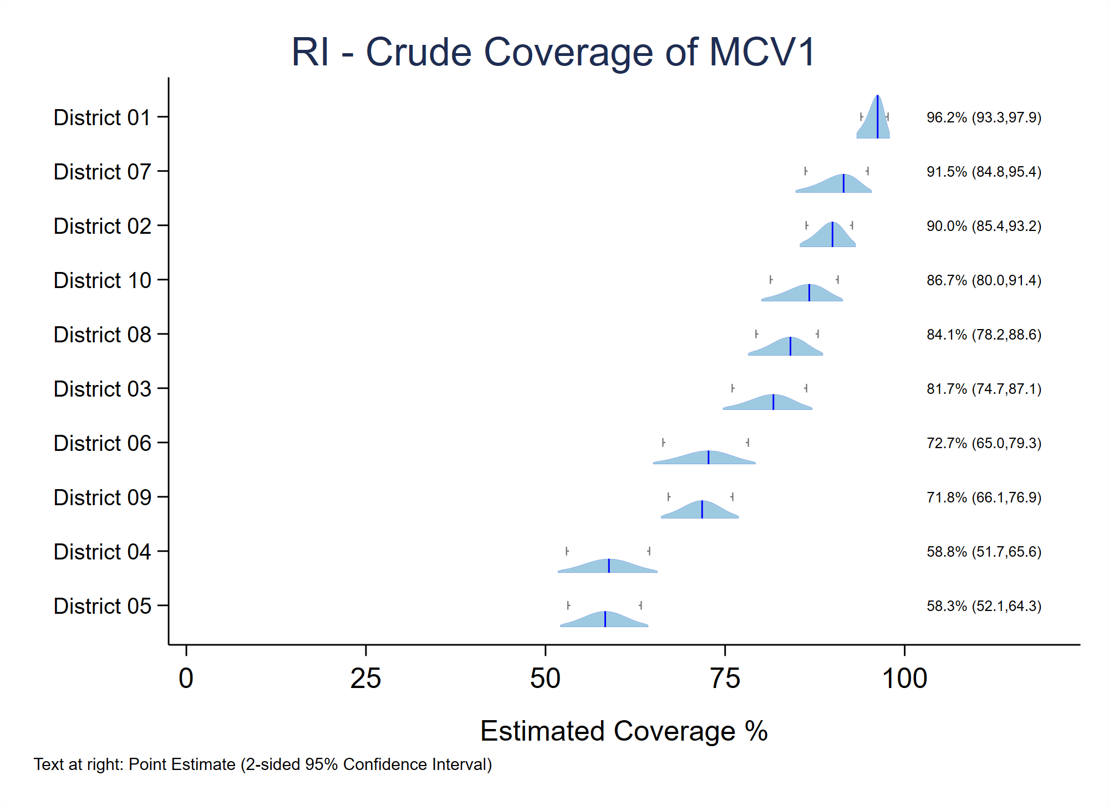

###### Figure B-7. Inchworm plot with strata sorted by outcomes, high-to-low, bottom-to-top

vcqi_global SORT_PLOT_LOW_TO_HIGH 0

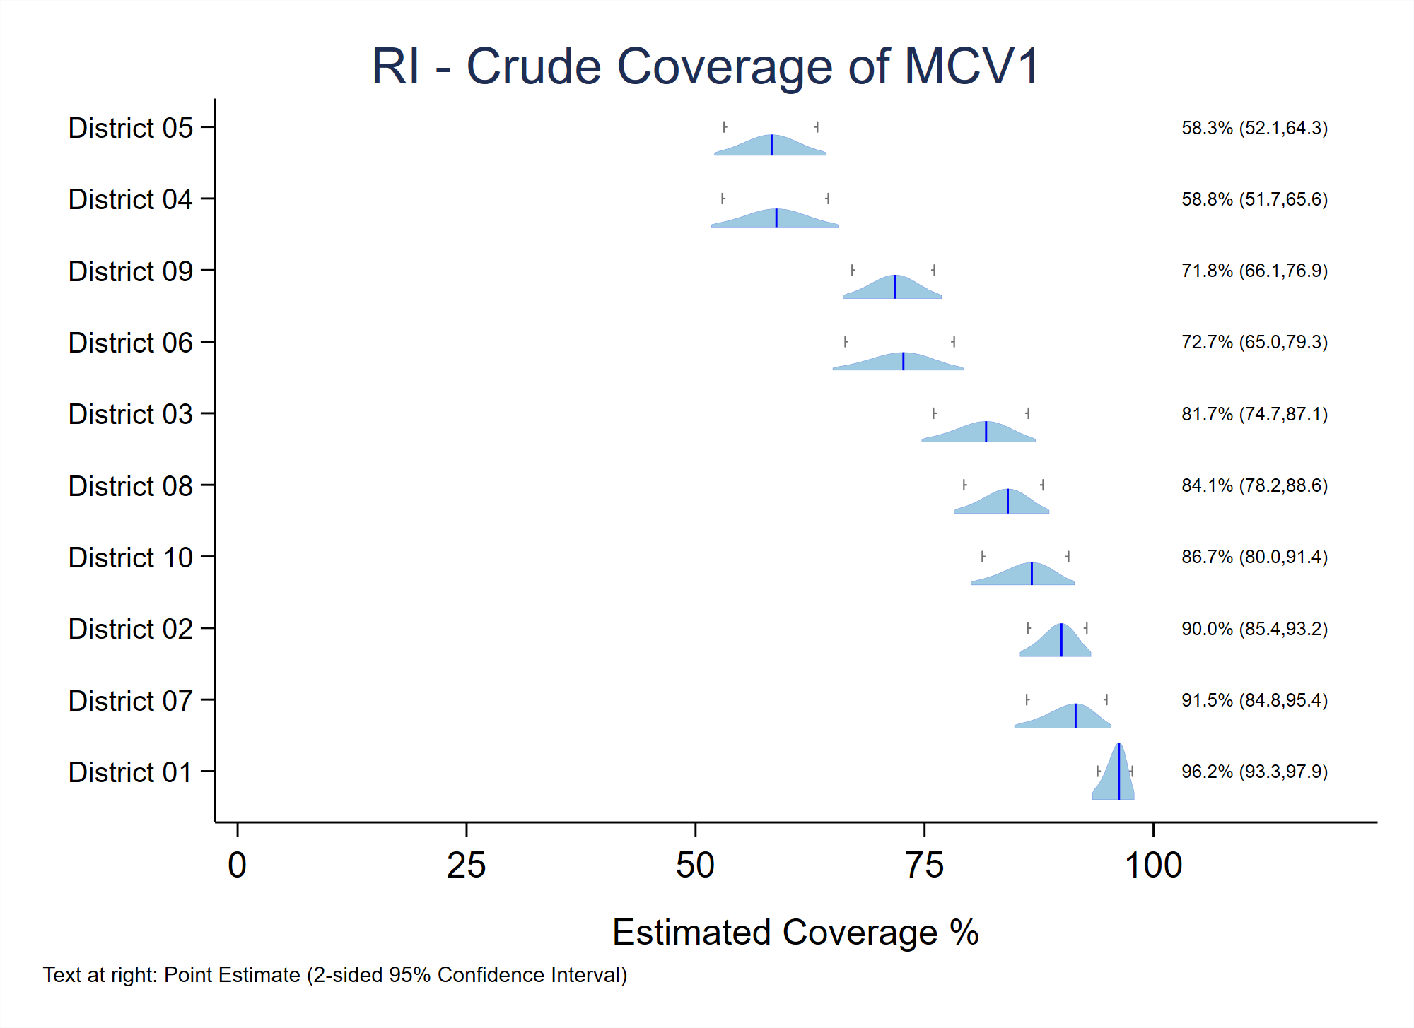

Sorting strata from worst-to-best performance yields visually pleasing figures, it means that the position of each stratum varies from figure to figure. For example, the district listed at the top of the MCV1 crude coverage inchworm plot, because it had the highest coverage of measles vaccine might appear second or third or fourth in the figure showing OPV1 crude coverage. Indeed, that district might appear at the very bottom of the figure for some other outcome if its performance is worse than all the other districts. Some viewers find it confusing to have to search for their favorite stratum – to have to scan up and down the list of district names at the left side of the figure – time and time again rather than have each fall in the same predictable location on each figure.

If the user wishes to plot strata in a predictable order, then set PLOT_OUTCOMES_IN_TABLE_ORDER to 1 and the order of strata in every inchworm plot, double-inchworm plot, and unweighted proportion plot will be precisely the same order that the strata appear in VCQI’s Excel format tabulated outcome tables.

This figure demonstrates the result, listing the districts in order 1 thru 10.

###### Figure B-8. Inchworm plot with strata sorted in table order

vcqi_global PLOT_OUTCOMES_IN_TABLE_ORDER 1

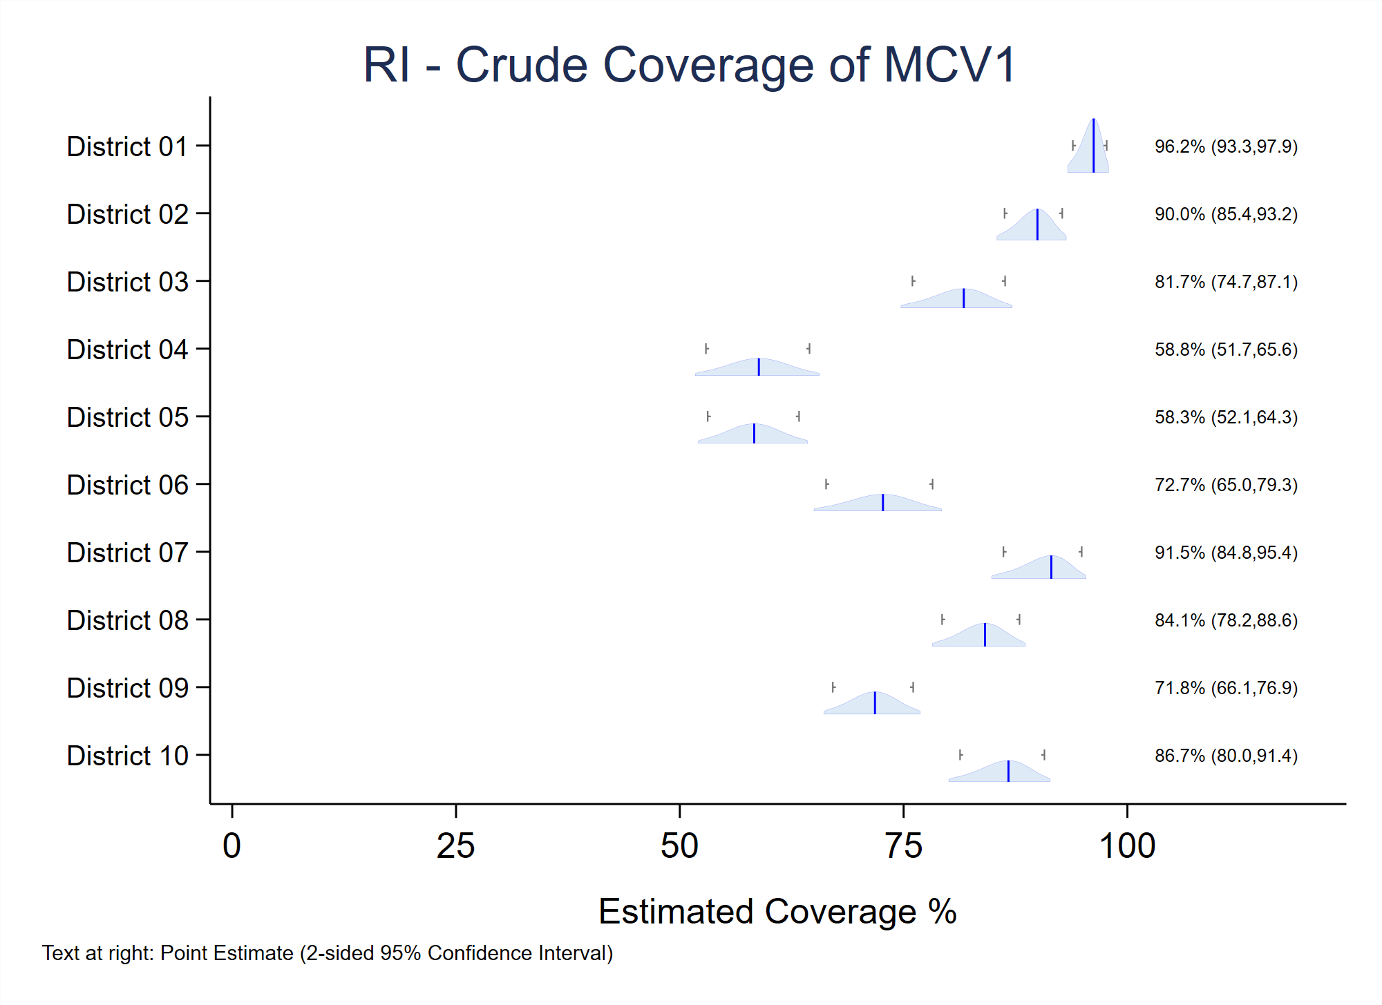

(Again, as a reminder, if the user sets PLOT_OUTCOMES_IN_TABLE_ORDER to 1 then VCQI will ignore the value of SORT_PLOT_LOW_TO_HIGH.)

## B.10 Additional Options for Customizing VCQI Output

If you have questions about how to order results, try changing the different SHOW_LEVEL settings. If the options are not to your liking, then you have the option of writing a program to access the results in the database files and construct customized tables of your own.

Similarly, you may wish to construct inchworm plots that use a different order or different set of colors than the VCQI default. In that case you might wish to copy and modify the programs vcqi_to_iwplot.ado, vcqi_to_uwplot.ado, or vcqi_to_double_iwplot.ado (located in VCQI’s folder of PLOT programs) and make some changes there.

VCQI outcome databases may be imported into Excel or R or Tableau or any visualization and table-making software that the user has mastered in order to customize every aspect of how results are presented to vaccination stakeholders. Do not hesitate to contact the VCQI developers if you have questions or suggestions about how to summarize and visualize survey results.

# Annex C. Customizing VCQI Plot Output

## C.1 Customizing Plot Colors

VCQI’s default plot colors are shades of blue defined in five files in the VCQI Stata source sub-folder named PLOT[28]. The names of those color style files and their default contents are listed below.

**color-vcqi_level1.style**

label resource "VCQI Blue 1 (dark)"

set rgb "49 130 189"

**color-vcqi_level2.style**

label resource "VCQI Blue 1 (dark)"

set rgb "49 130 189"

**color-vcqi_level3.style**

label resource "VCQI Blue 2 (mid)"

set rgb "158 202 225"

**color-vcqi_level4.style**

label resource "VCQI Blue 3 (light)"

set rgb "222 235 247"

**color-vcqi_outline.style**

label resource "VCQI outline color"

set rgb "0 0 255"

In VCQI’s default color style files, the level1 and level2 colors are the same. In inchworm and bar plots, level 1 results are visually distinguished by a light grey background stripe.

To change any of the default colors, open the .style file in your text editor of choice and change the RGB values in the set rgb "__ __ __" line to represent the color you wish to use. After making changes, save the file and run VCQI as normal.

You may edit the label resource "__" line in a style file to provide a name for the color in that file. These names are not used by VCQI but will appear in Stata dialog box lists of available colors.

Table C-1 indicates how color style files affect the components of plots.

##### Table C-1. VCQI color style files and the plot components they affect

|  |  |  |  |  |  |
| --- | --- | --- | --- | --- | --- |
|  | **Organ Pipe Plots** | **Inchworm Plots** | **Bar Chart Plots** | **Double Inchworm Plots\*** | **Double Bar Chart Plots\*** |
| **color-vcqi_level1** |  | Level 1 inchworm fill color | Level 1 bar fill color | Level 1 colored inchworm fill color | Level 1 colored bar fill color |
| **color-vcqi_level2** |  | Level 2 inchworm fill color | Level 2 bar fill color | Level 2 colored inchworm fill color | Level 2 colored bar fill color |
| **color-vcqi_level3** | Pipe fill color | Level 3 inchworm fill color | Level 3 bar fill color | Level 3 colored inchworm fill color | Level 3 colored bar fill color |
| **color-vcqi_level4** |  | Level 4 inchworm fill color | Level 4 bar fill color | Level 4 colored inchworm fill color | Level 4 colored bar fill color |
| **color-vcqi_outline** |  | Shape outlines and line indicating point estimate | Bar outline | Colored shape outlines and line indicating point estimate |  |

* Double inchworm plots and double bar chart plots have colored and hollow shapes. The colored inchworms have colors the user can change, but the hollow inchworms do not have color parameters the user can alter – the hollow inchworms are always plotted with a grey outline and no fill color.

The examples below demonstrate changing the color style files to use a palette of blues and greens. Two inchworm plots below show the plot’s appearance with the VCQI default colors and with the altered palette.

**color-vcqi_level1.style**

label resource "VCQI Blue-Green 1 (mid blue)"

set rgb "43 140 190"

**color-vcqi_level2.style**

label resource "VCQI Blue-Green 2 (light blue)"

set rgb "78 179 211"

**color-vcqi_level3.style**

label resource "VCQI Blue-Green 3 (mid teal)"

set rgb "123 204 196"

**color-vcqi_level4.style**

label resource "VCQI Blue-Green 4 (light green)"

set rgb "204 235 197"

**color-vcqi_outline.style**

label resource "VCQI outline color"

set rgb "8 104 172"

###### Figure C-1. Inchworm plots with default colors and with customized colors

With default VCQI plot colors:

With customized VCQI plot colors:

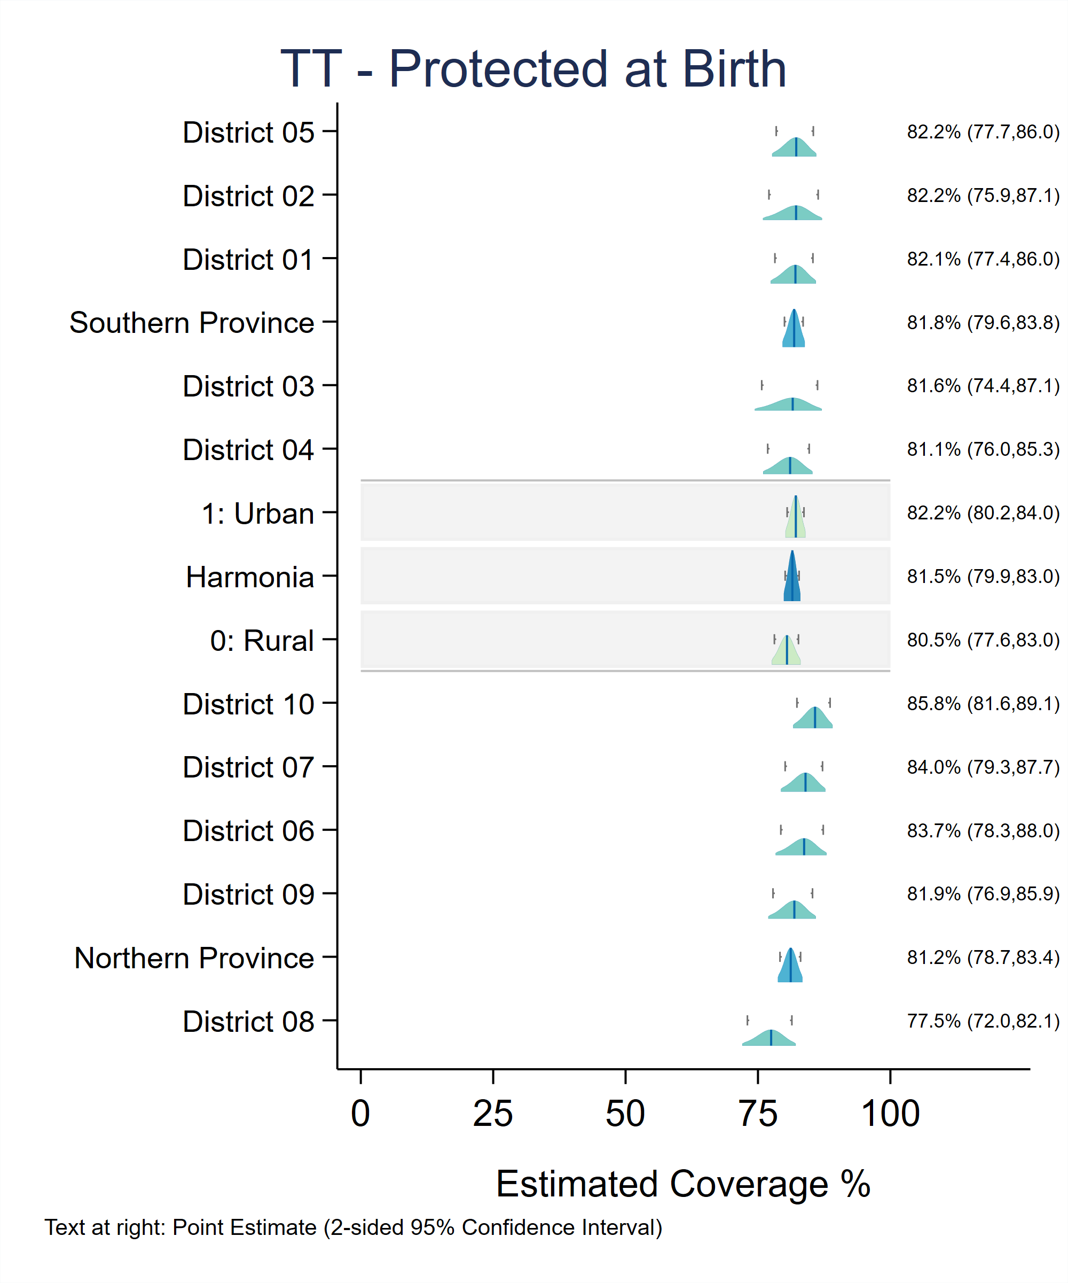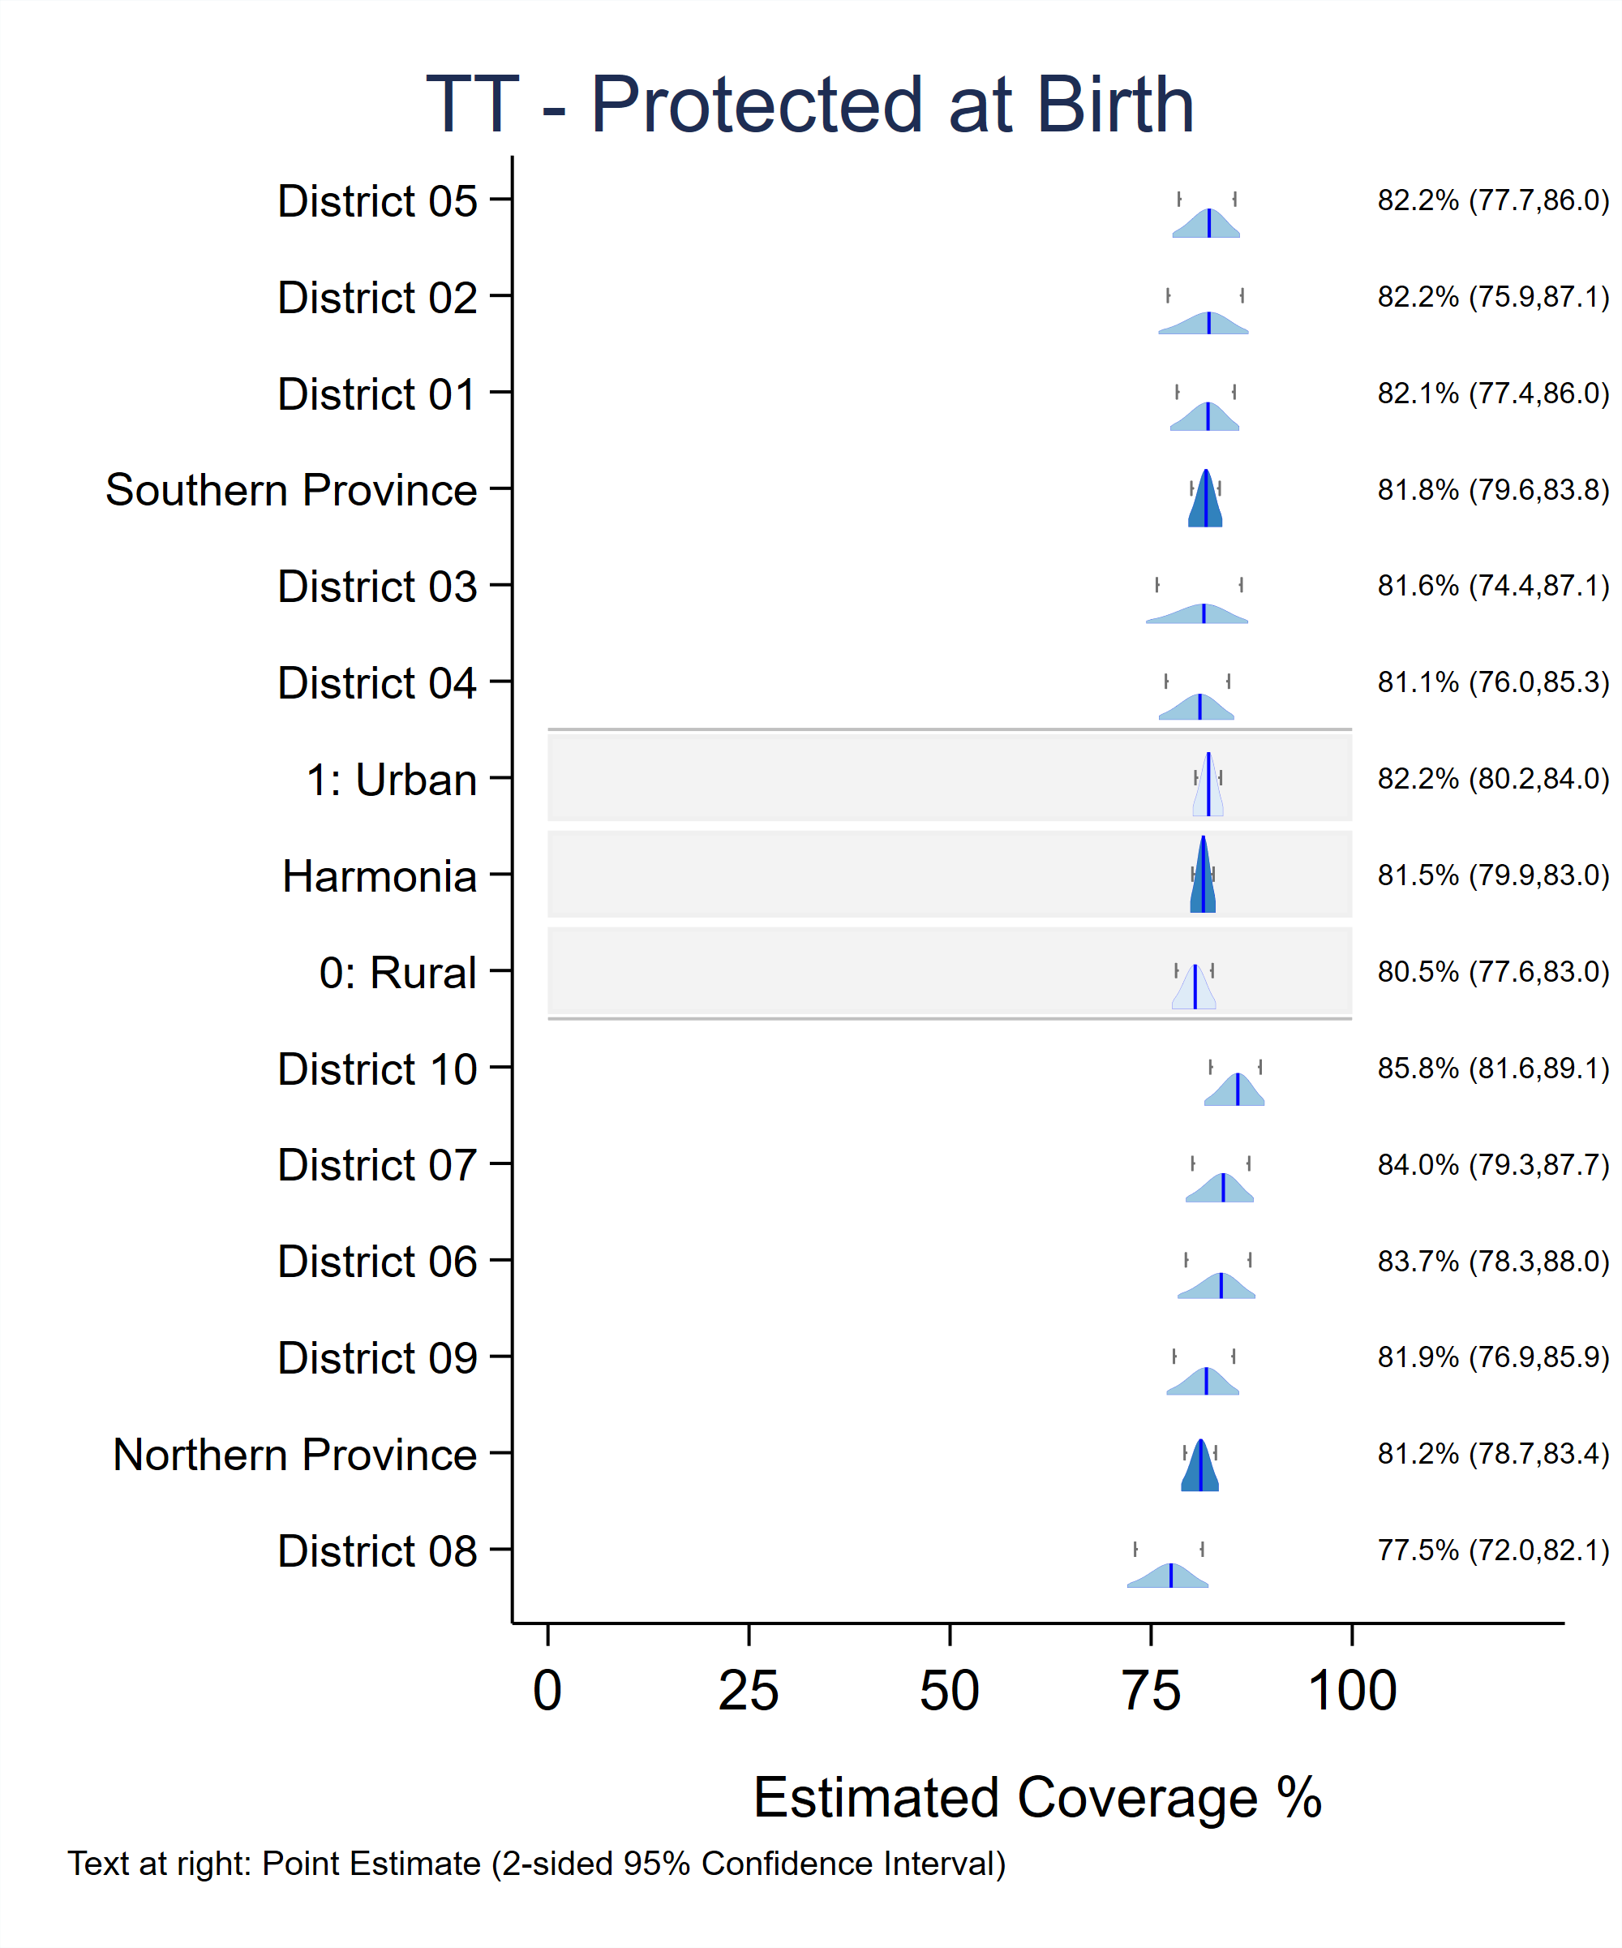

## C.2 Generate Bar Charts Rather Than Inchworm Plots

For VCQI indicators that produce inchworm plots to show estimated proportions, the user can decide to export horizontal bar charts instead of inchworm plots by setting the global IWPLOT_SHOWBARS to 1.

* IWPLOT_SHOWBARS = 0 means show inchworm distributions

* IWPLOT_SHOWBARS = 1 means show horizontal bars instead of inchworms

vcqi_global IWPLOT_SHOWBARS

VCQI does not currently have a barplot equivalent of double inchworm plots. For VCQI indicators that produce double inchworm plots to compare an outcome of interest to a related outcome (RI_COVG_02, RI_COVG_03, RI_COVG_04, RI_QUAL_01, and RI_QUAL_07B), if the IWPLOT_SHOWBARS global is set to 1, then single inchworm plots will be rendered as bar charts but double inchworm plots will be created as normal.

Examples of these plots follow:

###### Figure C-2. Inchworm plot and its corresponding bar chart

TT_COVG_01 bar chart

IWPLOT_SHOWBARS 1

TT_COVG_01 inchworm plot

IWPLOT_SHOWBARS 0

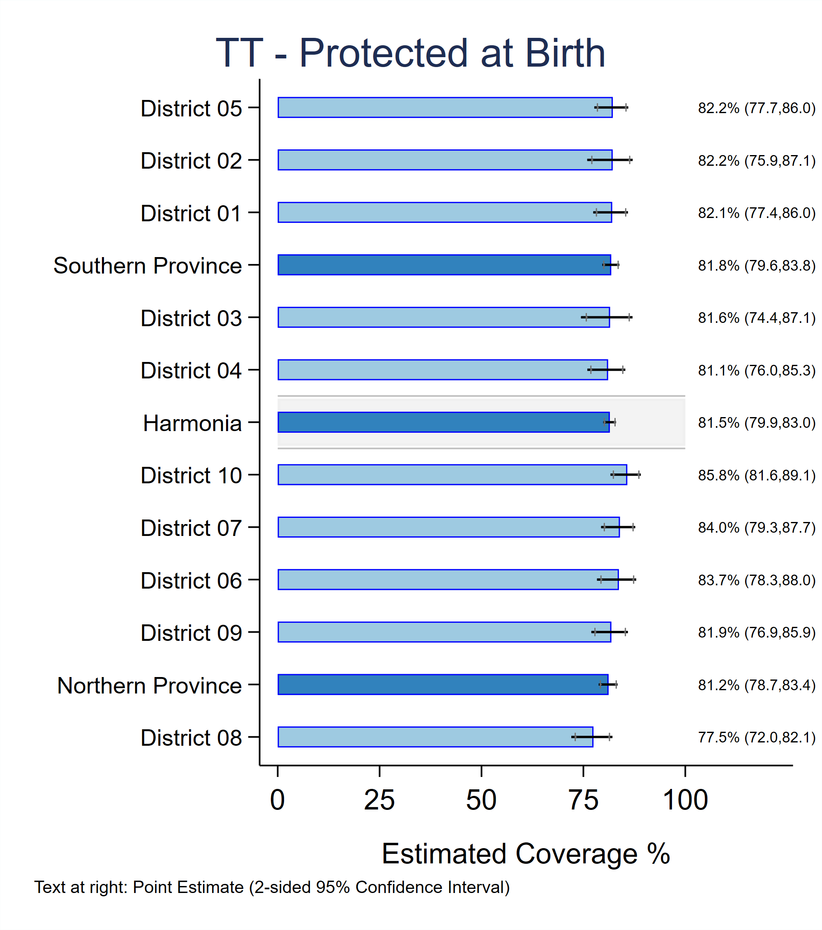

## C.3 Changing Confidence Interval Information on Inchworm Plots

The VCQI_IWPLOT_CITEXT global allows users to customize the confidence interval information included on single inchworm plots. This global can take the integer values 1, 2, 3, 4, or 5, which produce the following results:

1. 1-sided 95% LCB | Point Estimate | 1-sided 95% UCB

Example: 74.5 | 75.9% | 77.3

1. Point Estimate (2-sided 95% Confidence Interval)

Example: 75.9% (74.2, 77.6)

*Option 2 is the VCQI default.*

1. Point Estimate (2-sided 95% Confidence Interval) (0, 1-sided 95% UCB]

Example: 75.9% (74.2, 77.6) (0, 77.3]

1. Point Estimate (2-sided 95% Confidence Interval) [1-sided 95% UCB, 100)

Example: 75.9% (74.2, 77.6) [74,5, 100)

1. Point Estimate (2-sided 95% CI) (0, 1-sided 95% UCB] [1-sided 95% LCB, 100)

Example: 75.9% (74.2, 77.6) (0, 77.3] [74.5, 100)

Illustrations of each of these options follow.

###### Figure C-3. Inchworm plot demonstrating VCQI_IWPLOT_CITEXT 1

###### Figure C-4. Inchworm plot demonstrating VCQI_IWPLOT_CITEXT 2

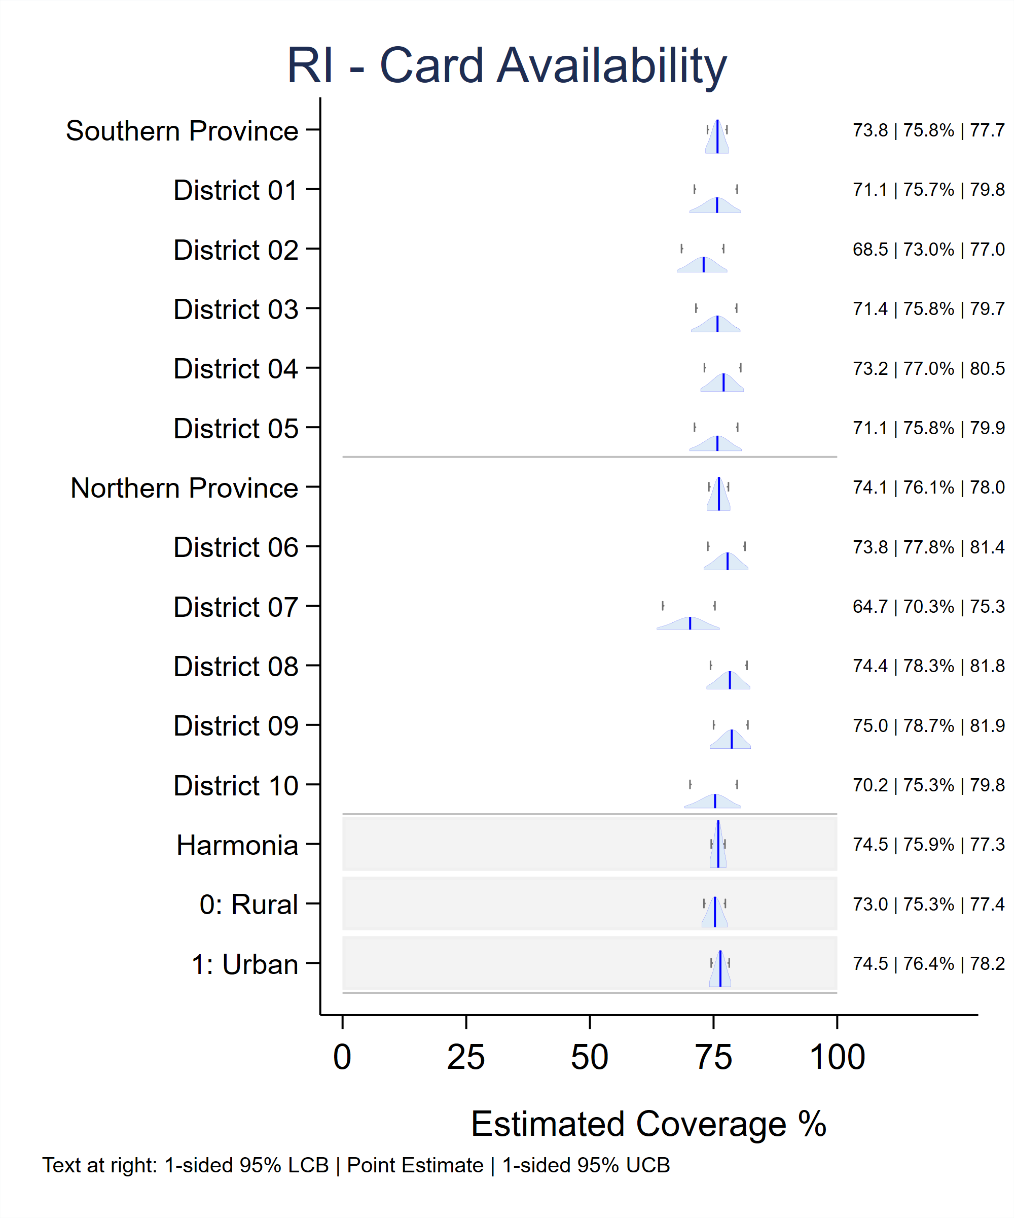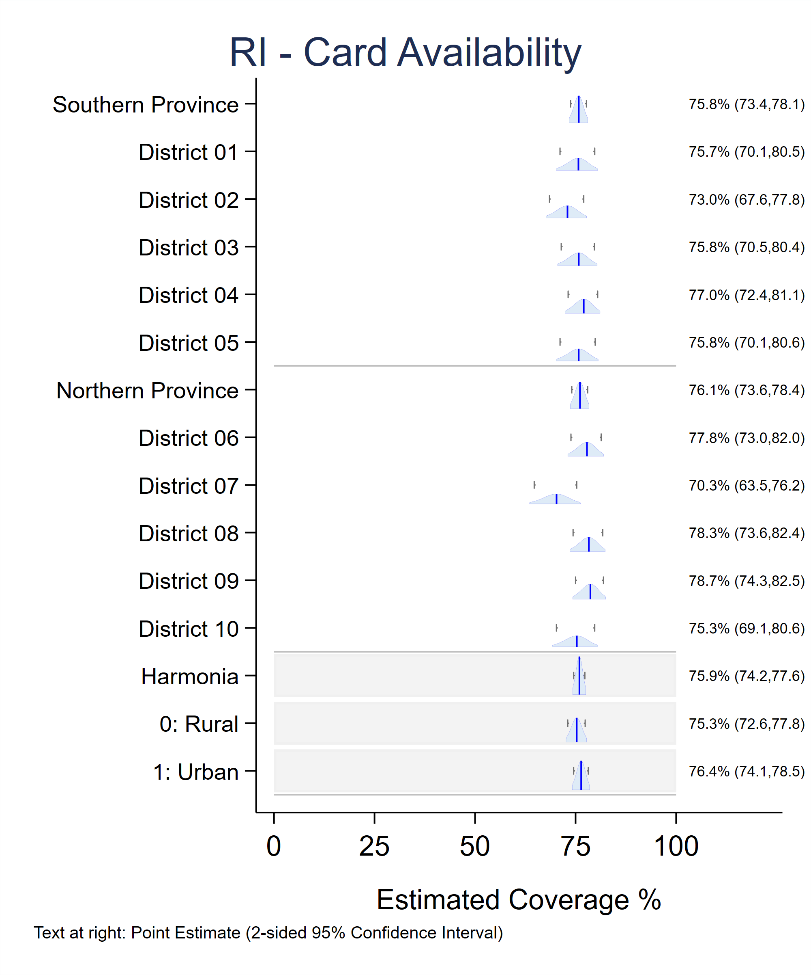VCQI_IWPLOT_CITEXT 1 VCQI_IWPLOT_CITEXT 2

###### Figure C-5. Inchworm plot demonstrating VCQI_IWPLOT_CITEXT 3

VCQI_IWPLOT_CITEXT 3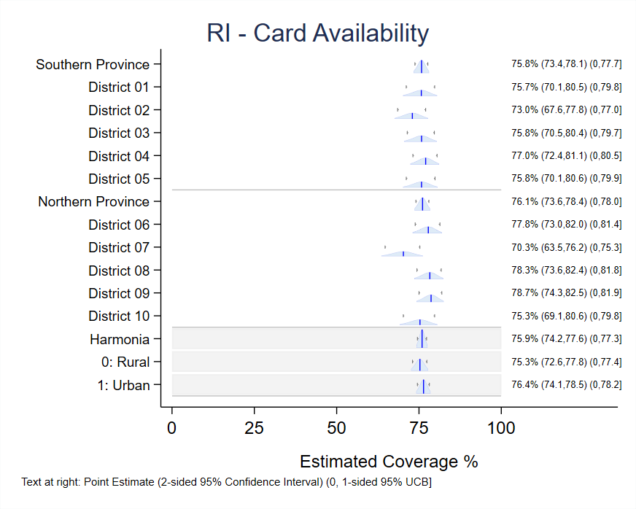

###### Figure C-6. Inchworm plot demonstrating VCQI_IWPLOT_CITEXT 4

VCQI_IWPLOT_CITEXT 4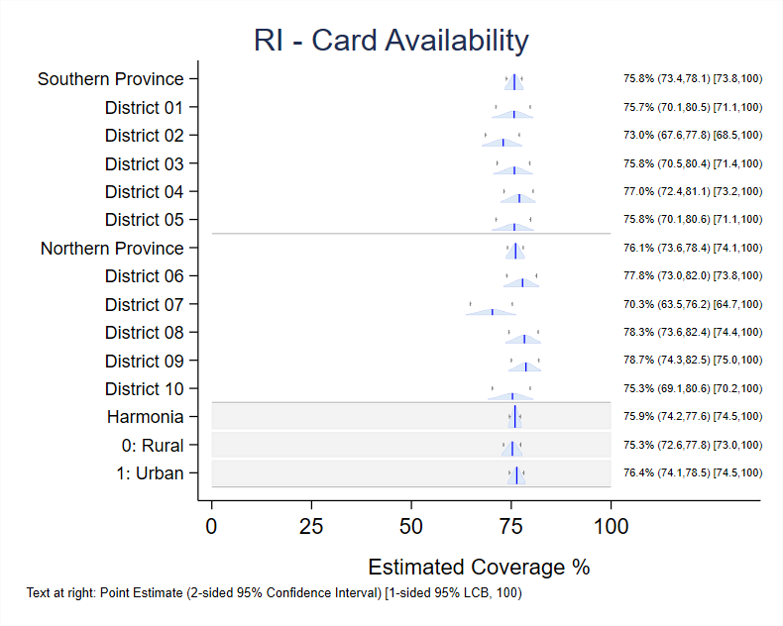

###### Figure C-7. Inchworm plot demonstrating VCQI_IWPLOT_CITEXT 5

VCQI_IWPLOT_CITEXT 5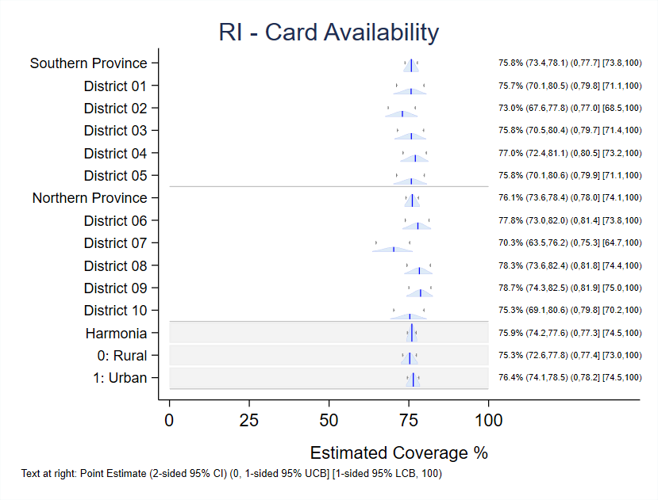

**To recover text clipped at the right side of a figure:**

Note that in some cases, the longer annotations used in options 3, 4, and 5 are clipped in the .png output when the plot is saved. It is possible to correct this problem by saving the plots in Stata’s .gph format and doing some simple post-processing of those figures that appear to be clipped.

Users can set the global SAVE_VCQI_GPH_FILES to 1 in the control program to save .gph files. The plot dimensions of these .gph files can be modified using Stata’s graph editor so that the full confidence interval text is visible. (Note in the examples above that the figures for VCQI_IWPLOT_CITEXT 1 and 2 have a tall aspect ratio whereas those for values 3, 4, and 5 have a wider-than-tall appearance.) These instructions may be helpful:

Load the .gph file into Stata, redisplay the graph using a new combination of xsize and ysize; resave the .gph file when you are happy with the appearance and reexport the .png file. This series of commands at the Stata prompt will do this.

*************************************************

graph use plot_with_clipped_text.gph

graph display, xsize(20) ysize(16)

// You will need to experiment with the values of xsize and ysize

// to find the right combination.

// (type *help region_options* in Stata for more info on those options)

graph save plot_with_recovered_text.gph, replace

graph export plot_with_recovered_text.png, width(2000) replace

*************************************************

Note that the value of ysize divided by xsize defines the so-called *aspect ratio* of the plot. So setting ysize to 16 and xsize to 20 yields a 4:5 or 4/5 or 0.8 aspect ratio. The height of the figure is 80% of its width. When the confidence interval text is clipped at the right side of the plot, you need to decrease the aspect ratio, or make the ysize relatively smaller and the xsize relatively larger. It may be easiest to fix the xsize value at 20 and then keep trying the graph display command with different values of ysize until you find the ratio that is pleasing to your eye.

It is also sometimes fruitful to use the scale() option instead of xsize() and ysize() to achieve a pleasing result. Try typing the command:

graph display, scale(0.95) // or maybe try 0.90

Stata documentation says that the scale option “makes all the text, markers, and line widths on a graph larger or smaller.” The default value for scale is 1.0, so using a value like 0.95 sometimes shrinks those elements enough to retrieve text that was formerly clipped at the right side of the figure.

## C.4 Changing Confidence Interval Information on Double Inchworm Plots

The VCQI_DOUBLE_IWPLOT_CITEXT global allows users to customize the confidence interval information printed at the right side of double inchworm plots. This global can take the integer values 1, 2, or 3 which produce the following results:

1. Point Estimate for shaded distribution | Point estimate for unshaded hollow distribution

Example: 75.9% | 77.3%

*Option 1 is the VCQI default.*

1. Shaded distribution Point Estimate & (2-sided 95% Confidence Interval) and |

Unshaded hollow distribution Point Estimate & (2-sided 95% Confidence Interval)

Example: 75.9% (74.2, 77.6) | 88.2% (86.1, 89.9)

1. No text at the right side of the plot.

Illustrations of each of these options follow.

###### Figure C-8. Double inchworm plot demonstrating VCQI_DOUBLE_IWPLOT_CITEXT 1

VCQI_DOUBLE_IWPLOT_CITEXT 1

###### Figure C-9. Double inchworm plot demonstrating VCQI_DOUBLE_IWPLOT_CITEXT 2

VCQI_DOUBLE_IWPLOT_CITEXT 2

If the right side text is clipped in the .png files, follow the instructions in section C.3 above (**To recover text clipped at the right side of a figure)** to resize those figures using post-processing syntax on the affected .gph files. (Note that the VCQI_DOUBLE_IWPLOT_CITEXT 2 example above is wider-than-tall whereas the VCQI_DOUBLE_IWPLOT_CITEXT 1 example is taller-than-wide. We used the syntax described in Section C.3 to resize the CITEXT 2 image and reveal the full CI text.)

###### Figure C-10. Double inchworm plot demonstrating VCQI_DOUBLE_IWPLOT_CITEXT 3

VCQI_DOUBLE_IWPLOT_CITEXT 3

## C.5 To Customize VCQI Plots in Other Ways

You may wish to make other changes to VCQI figures, modifying text in titles or labels or visual attributes of the plots. To do so, set the global SAVE_VCQI_GPH_FILES to 1 in the control program and then load the saved .gph file into Stata; modify it with the graph editor (Type help graph_editor at the Stata prompt or search online for tutorials). When you identify a set of edits that you wish to apply over-and-over to a series of figures, you can save a graph editor recording and replay those edits in a batch fashion using Stata syntax. (Type help graph editor##recorder.)

The Stata Forum website is a good place to find examples and ask questions ([www.statalist.org](http://www.statalist.org)). Several articles there show examples of how to incorporate syntax saved in graph editor recordings into your own .do-files.

<https://www.statalist.org/forums/forum/general-stata-discussion/general/1451572-post-editing-of-graphs-by-code>

<https://www.statalist.org/forums/forum/general-stata-discussion/general/1446634-the-graph-command-corresponds-to-graph-editor>

<https://www.statalist.org/forums/forum/general-stata-discussion/general/1393817-connect-each-bar-in-histogram-graph-to-become-line-graph>

<https://www.statalist.org/forums/search?q=gr_edit&searchJSON=%7B%22keywords%22%3A%22gr_edit%22%7D>

You may also contact the VCQI developers for assistance.

# Annex D. VCQI Output Databases

In addition to standardized tables and plots, most VCQI indicators produce one or more datasets to store indicator outcomes for each stratum. VCQI’s term for these outcome datasets is *database* but they are simply Stata datasets with one row per stratum per outcome. Broadly speaking, nearly all of the numbers that appear in VCQI tables and plots are also stored in a database. Users may import these results into whatever software they like to use to make customized tables and figures. Note that each indicator section in chapter 6 of this document lists the names of the database files produced by that indicator.

In a VCQI control program, the DELETE_VCQI_DATABASES_AT_END parameter in Block D controls whether these database files are deleted, or whether they are consolidated and saved. If DELETE_VCQI_DATABASES_AT_END is set to 1, then the databases are discarded at the end of the VCQI run. If DELETE_VCQI_DATABASES_AT_END is set to 0, then VCQI combines and saves most of the database files in a single Stata dataset named VCQI_aggregated_databases_all.dta.

The variable named db_name in VCQI_aggregated_databases_all.dta lists the original database name. Users can use this variable to extract individual databases from the aggregated databases file. For instance, to extract the database that lists crude coverage for dose PCV2, type:

use "C:\VCQI Test Output\VCQI_aggregated_databases_all.dta"

keep if db_name == "RI_COVG_01_1_pcv2_a_database"

The Block D SHOW_LEVEL* macros (described in Chapter 7 and Annex B) determine which strata are represented in the databases. For example, with the settings below, each individual database that VCQI makes will hold indicator outcomes for level 1 only. If the user asked to *show* results from other levels, then those stratum level outcomes would be stored in the databases, too.

vcqi_global SHOW_LEVEL_1_ALONE 1

vcqi_global SHOW_LEVEL_2_ALONE 0

vcqi_global SHOW_LEVEL_3_ALONE 0

vcqi_global SHOW_LEVEL_4_ALONE 0

vcqi_global SHOW_LEVELS_2_3_TOGETHER 0

vcqi_global SHOW_LEVELS_1_4_TOGETHER 0

vcqi_global SHOW_LEVELS_2_4_TOGETHER 0

vcqi_global SHOW_LEVELS_3_4_TOGETHER 0

vcqi_global SHOW_LEVELS_2_3_4_TOGETHER 0

Database contents differ for weighted and unweighted indicators: VCQI currently provides estimates of uncertainty for weighted indicators, but not for unweighted indicators. The table below summarizes which indicators produce weighted, unweighted, or custom databases.

|  |  |  |
| --- | --- | --- |
| **Indicator\*** | **Weighted or Unweighted** | **Database Type** |
| DESC_01 | Unweighted | Custom |
| DESC_02 | User decides | Custom |
| DESC_03 | User decides | Custom |
| RI_COVG_01 | Weighted | Weighted |
| RI_COVG_02 | Weighted | Weighted |
| RI_COVG_03 | Weighted | Weighted |
| RI_COVG_04 | Weighted | Weighted |
| RI_COVG_05 | User decides | Custom |
| RI_ACC_01 | Weighted | Weighted |
| RI_CONT_01 | Unweighted | Unweighted |
| RI_QUAL_01 | Weighted | Weighted |
| RI_QUAL_02 | Weighted | Weighted |
| RI_QUAL_03 | Unweighted | Unweighted |
| RI_QUAL_04 | Unweighted | Unweighted |
| RI_QUAL_05 | Unweighted | Unweighted |
| RI_QUAL_06 | Unweighted | Unweighted |
| RI_QUAL_07BS | Weighted | Weighted |
| RI_QUAL_08 | Unweighted | Unweighted** |
| RI_QUAL_09 | Unweighted | Custom |
| RI_QUAL_12 | Unweighted | Unweighted |
| RI_QUAL_13 | Unweighted | Unweighted |
| TT_COVG_01 | Weighted | Weighted |
| SIA_COVG_01 | Weighted | Weighted |
| SIA_COVG_02 | Weighted | Weighted |
| SIA_COVG_03 | Weighted | Weighted |
| SIA_COVG_04 | Weighted | Weighted |
| SIA_COVG_05 | User decides | Custom |
| SIA_QUAL_01 | Unweighted | Unweighted |

VCQI’s Weighted, Unweighted, and Custom Databases

* Not listed in this table are indicators RI_CCC_01, RI_CCC_02, RI_CIC_01, RI_CIC_02, and RI_VCTC_01 which do not produce databases.

** The estimate in the RI_QUAL_08 database is an unweighted *count*, rather than a proportion

The standard weighted and unweighted databases that VCQI produces have the following variables:

|  |  |  |  |
| --- | --- | --- | --- |
| **Variable Name** | **Variable Label** | **In Unweighted**  **Database** | **In Weighted**  **Database** |
| level | Stratum geographic label | ✓ | ✓ |
| name | Survey name for table output | ✓ | ✓ |
| level1id | Level 1 ID | ✓ | ✓ |
| level1name | Level 1 name | ✓ | ✓ |
| level2id | Level 2 ID | ✓ | ✓ |
| level2name | Level 2 stratum name | ✓ | ✓ |
| level3id | Level 3 ID | ✓ | ✓ |
| level3name | Level 3 stratum name | ✓ | ✓ |
| level4id | Sub-stratum ID | ✓ | ✓ |
| level4name | Sub-stratum name | ✓ | ✓ |
| id | Stratum ID (at its level) | ✓ | ✓ |
| outcome | Outcome variable name | ✓ | ✓ |
| estimate | Estimated proportion | ✓ | ✓ |
| stderr | Standard error |  | ✓ |
| cilevel | Confidence level |  | ✓ |
| cill | 2-sided CI lower bound |  | ✓ |
| ciul | 2-sided CI upper bound |  | ✓ |
| lcb | 1-sided lower confidence bound |  | ✓ |
| ucb | 1-sided upper confidence bound |  | ✓ |
| deff | Design effect |  | ✓ |
| icc | Intracluster correlation coefficient |  | ✓ |
| n | Sample size (unweighted) | ✓ | ✓ |
| nwtd | Sample size (weighted) |  | ✓ |
| nclusters | Number of clusters |  | ✓ |
| nwtd_est | Persons with outcome (weighted) |  | ✓ |

Most but not all VCQI databases are appended together into the aggregated database file. Exceptions include the custom-format databases produced by the DESC_* indicators, the COVG_DIFF_* indicators, RI_COVG_05, and SIA_COVG_05. Those are saved as separate individual files.

At the time of this writing (February 2021) few users outside of Biostat Global Consulting have used VCQI databases to make customized tables or figures. We would be happy to collaborate with you on ideas and tips for how to use them.

# Annex E. VCQI Augmented Dataset

If desired, VCQI can merge the input survey dataset with derived variables calculated by various VCQI indicators to create an *augmented dataset*. This dataset can be used to make custom figures and tables and for follow-up analyses. When the user calls for an augmented dataset to be made, then after all indicators have been run, VCQI will collect and merge the indicator datasets with the analysis dataset(s). Only indicators that produce output at the respondent level will be included. In particular, this means that DESC and COVG_DIFF indicators will not be merged into the augmented dataset, and neither will indicators that produce cluster-level results, such as RI_COVG_05 or SIA_COVG_05.

To generate the augmented dataset, set the global VCQI_MAKE_AUGMENTED_DATASET to 1 in Block D of the control program.

For most purposes, the names of derived variables are unique for each VCQI indicator, but if a VCQI dataset produced by one indicator does include variables with the same name but *different* values as those produced by another indicator, then both copies of the variable are kept in the augmented dataset. One variable or the other will be renamed, with a name starting with ADS_DUPVAR (which stands for augmented dataset duplicate variable) and ending with a unique suffix that lists which indicator produced it. The suffix and detailed information on the original variable name and source are stored in the Stata variable characteristics. To view the characteristics of variables in the dataset, run char list in Stata. To learn more about characteristics type help char at the Stata prompt.

With the appropriate Stata syntax, it should be possible for an analyst to load the augmented dataset and re-produce any of the analysis output numbers that appear in VCQI tables or figures. When a survey steering committee produces table shells for a report that follow a different layout or format than VCQI’s default tables, the staff at Biostat Global Consulting often start by producing VCQI tables and a VCQI augmented dataset, and then write a custom program to populate the customized table shells. It is possible to cross-check the customized tables with VCQI’s standardized tables to confirm that the outcomes are the same. In many cases it would also be populate customized table shells using a program that manipulates VCQI’s aggregated databases, which are described in Annex D.

Furthermore, augmented datasets can serve as the starting point for logistic regression analyses or time-to-event analyses to explore factors associated with whether a child received a particular dose (or combination of doses) or associated with the timeliness of vaccination.

# Annex F. Additional Tools for Working with VCQI Output

## F.1 Missed Opportunities for Vaccination R-Shiny Application

The RI_QUAL_09 indicator summarizes missed opportunities for simultaneous vaccination (MOVs) for every child in the survey dataset whose vaccination evidence includes vaccination dates from a card or register. For each dose in the dose list[29], VCQI calculates whether the child had a missed opportunity to be vaccinated with that dose, and if so, whether the MOV was corrected or uncorrected by the time of the survey. For children who experienced a corrected MOV, VCQI also calculates the time to correction: the number of days between the initial MOV and when the child eventually received the dose.

It can be useful to compare the prevalence of MOVs across different doses and different strata. There is an interactive R Shiny tool for exploring output from RI_QUAL_09 to enable those comparisons; the application is available online at <https://biostat-global-consulting.shinyapps.io/MOV_Tool_Public/>.

A series of short YouTube videos provides information on this tool, demonstrating the features of the MOV and Time to Correction tabs, and introducing the detailed data requirements for the application:

* Introduction: <https://youtu.be/GQ7Hcmh2czs>
* Exploring MOVs: <https://youtu.be/oyyBJ-NzNug>
* Time to Correction: <https://youtu.be/TS0ePSsbZRk>
* Data Requirements: <https://youtu.be/gppzvsmKoVU>

To produce a dataset compatible with the MOV application, users can do a VCQI run including RI_QUAL_09[30] and either:

1. Set the DELETE_TEMP_VCQI_DATASETS global to 0 so that the RI_QUAL_09 dataset is saved, or
2. Set the VCQI_MAKE_AUGMENTED_DATASET global to 1 to save a dataset that includes the RI_QUAL_09 variables

Use the interface on the application’s *Getting Started* tab to upload either your output dataset named RI_QUAL_09.dta or the one named RI_augmented_dataset.dta. The *MOV Occurrence* tab summarizes MOVs by stratum and by dose, and the *Time to Correction* tab visualizes the time it takes for MOVs to be corrected.

*MOV Occurrence Tab*

The centerpiece of this tab is a figure showing, for each stratum and dose combination, the proportions of children who were vaccinated at the first eligible opportunity (blue), who had a corrected MOV (yellow), and who had an uncorrected MOV (red). The stratum summary table to the right of the figure considers all doses and shows the percentage of respondents who had no MOV for any dose (NM), who had MOVs that were all corrected (AC), who had some MOVs corrected and some uncorrected (SC), and who had none of their MOVs corrected (NC).

By default, level 3 strata are displayed in the figure. The *Grouping Level* input allows users to view results for the level 1 stratum or for level 2 strata instead. Users can also view only the level 3 strata within a particular level 2 stratum by using the *Filter by Level 2* input.

###### Figure F-1. Missed Opportunities R-Shiny App – Main Bar Chart

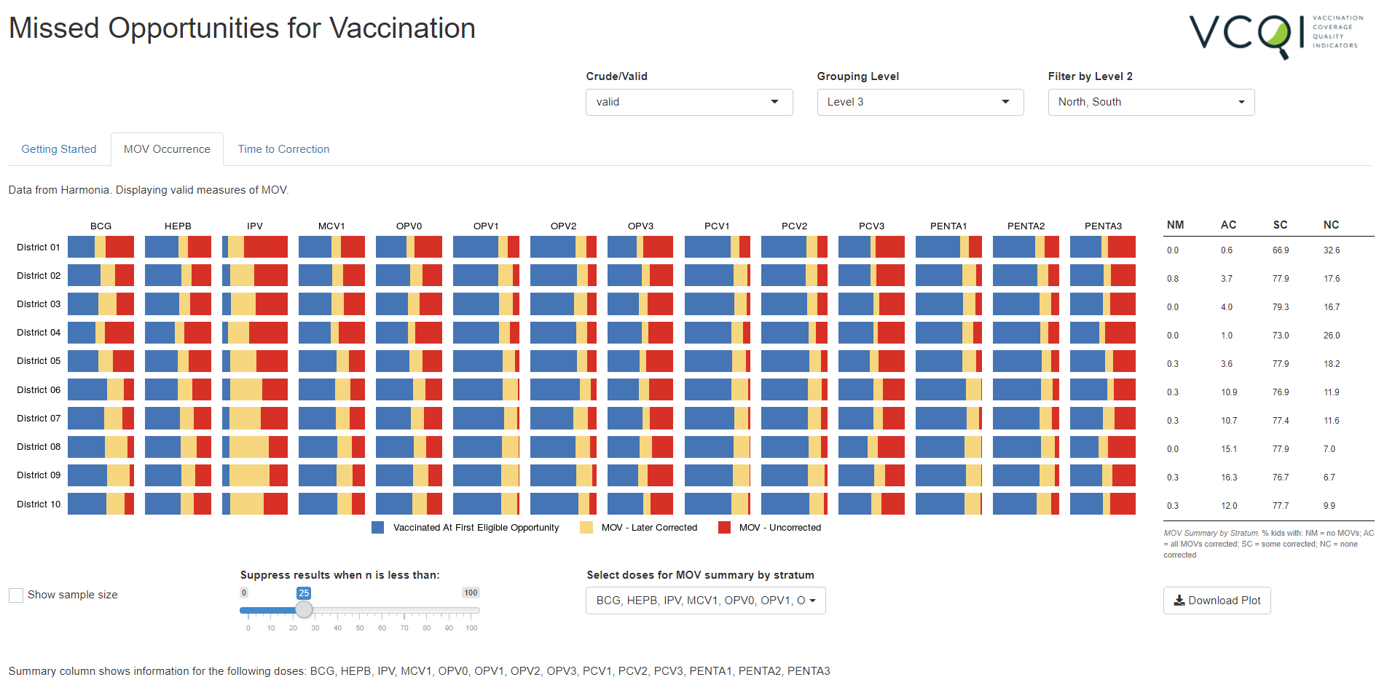

Using the controls underneath the figure, users may:

1. display sample sizes for each panel in the figure,
2. suppress results in panels with a sample size smaller than a user-specified threshold, and
3. select which doses to include in the calculations for the stratum summary table on the right

Tabular counts and percentages appear below the figure. Radio buttons under the table allow users to toggle whether the table shows counts or percentages.

###### Figure F-2. Missed Opportunities R-Shiny App – Main Results Table

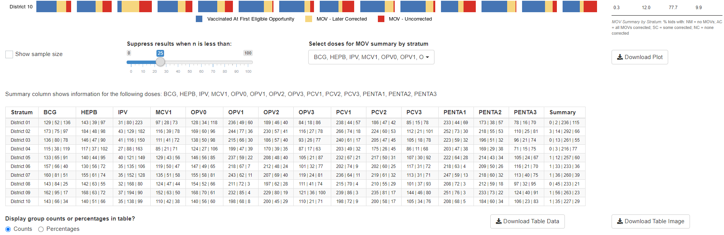

The user may download the figure and the table.

*Time to Correction Tab*

For MOVs which were corrected by the time of the survey, VCQI calculates the time elapsed between the initial MOV and the correction. The figure in the Time to Correction tab shows the cumulative percentage of children whose MOVs were corrected over time.

Users have the option to show the sample size in each panel (the total number of corrected MOVs for that stratum and dose combination), and to suppress outcomes in panels whose sample size falls below a user-specified threshold. Users may also change the limits of the X axis to view different parts of the cumulative coverage curves more clearly. Lines showing the 25th, 50th, 75th, or 90th percentile for days until correction may be overlaid on the data, allowing, for example, a comparison of the median time to correction across strata and doses.

###### Figure F-3. Missed Opportunities R-Shiny App – Cumulative Time to Correction Graphs

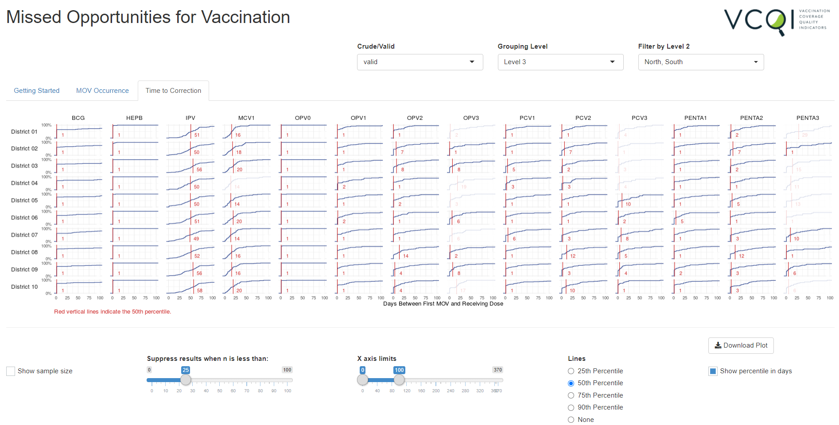

Underneath the figure, a table shows the 25th, 50th, 75th, and 90th percentiles for days to correction for each stratum and dose.

The user may download the figure and table from this tab, too.

###### Figure F-4. Missed Opportunities R-Shiny App – Time to Correction Table

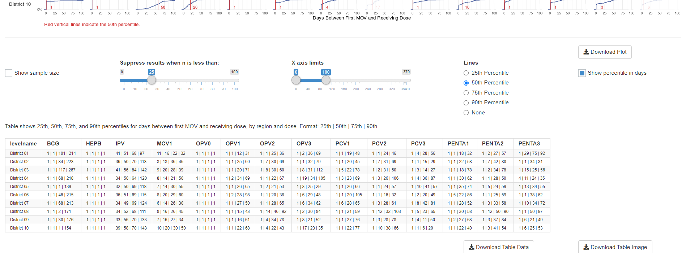

See the peer-reviewed manuscript[31] for examples of output from this R Shiny MOV application.

## F.2 ICCLOOP Program for Reporting Survey Planning Parameters

When planning a cluster survey, several parameters must be assembled to calculate an appropriate sample size. Annex B1 of the 2018 WHO Vaccination Coverage Cluster Survey Reference Manual[32] provides guidance on estimating those parameters, which include:

* The intracluster correlation coefficient (ICC), a measure of spatial heterogeneity of the outcome
* The coefficient of variation of weights (CVw), a measure of the variability of survey weights
* The design effect (DEFF), which quantifies how much larger a complex survey sample must be compared to a simple random sample to achieve a desired level of precision

After conducting the survey, it may be useful to calculate and report the observedvalues of these planning parameters, both to check the accuracy of the planning process and, perhaps more importantly, to furnish helpful inputs for the team who will plan the next coverage survey. VCQI provides estimates of ICC and DEFF in databases generated by weighted indicators like RI_COVG_01, so it is possible to use VCQI output to construct a table of those values for the survey report. At this time, VCQI does not summarize CVw in its output.

In other work with the World Health Organization, Biostat Global Consulting has written a program named **iccloop** to summarize these helpful parameters from a vaccination coverage survey dataset. The input dataset does not have to come from VCQI, but VCQI output datasets are compatible with iccloop.

As you design your survey report, consider including an annex that lists CVw, and the average number of respondents per cluster, the ICC, and DEFF for the main outcomes.

Datasets that are compatible with iccloop have one row per respondent, and include variables capturing the following concepts:

* Unique ID for each survey sampling stratum (level 3 strata, in VCQI terminology)
* Unique ID for each cluster within each stratum
* Binary outcome variable(s) of interest, coded as
  + 1 if the respondent is in the eligible group and experienced the outcome of interest,
  + 0 if the respondent is in the eligible group and did not experience the outcome, and
  + Missing (.) if the respondent is not in the eligible group
* Survey weight variable indicating the relative number of respondents in the population represented by each respondent (if the survey was self-weighted or unweighted, this variable does not need to be present)

It may also be useful for the input dataset to have other stratification variables of interest, e.g. a level 2 variable or a level 4 stratifier such as a variable indicating whether a cluster is urban or rural.

The ICCLOOP program loops through each level of a specified stratification variable and each outcome variable that the user specifies and calculates survey parameters. ICCLOOP’s output dataset contains one row for each combination of stratum and outcome:

* For a single stratum with one outcome, the program makes one row of output
* For a single stratum survey with five outcomes, the program makes five rows of output
* For a survey with five strata and five outcomes, the program makes 25 rows of output

In addition to the output dataset, ICCLOOP produces organ pipe plots for each outcome and stratum.

The dataset produced by iccloop contains:

* Identifying information for each row of output (which stratum level, which outcome variable, the file path to the dataset that was analyzed, and so on)
* Stratum-specific information: number of clusters, number of respondents, respondents per cluster (mean, minimum, maximum, standard deviation), how many clusters in the stratum had 0% coverage and how many had 100% coverage
* Coverage calculations for each stratum level: point estimate, standard deviation, and confidence interval bounds (each of the following confidence intervals is calculated: Wilson, Logit, Agresti-Coull, Clopper-Pearson, Fleiss-Cuzick, Jeffreys, and Wald)
* Design effect, effective sample size, coefficient of variation on weights, ICC, ICC confidence interval bounds, and ICC CI method
* ANOVA mean square between and mean square within
* Indicator of homogenous coverage across clusters

You may download the iccloop source code and description with supporting materials in Stata and R from the Biostat Global Consulting Github site[33].

# Annex G. RI Date Data Quality – Method for Detailed Assessment

Chapter 7 indicates that the user can request a date data quality report by including the following code in Block D of the control program:

vcqi_global VCQI_REPORT_DATA_QUALITY 1

The VCQI Results Quick Interpretation Guide has instructions for reviewing that report for evidence of incomplete or faulty or discordant dates of birth or vaccination. If the date data quality report indicates that there are a notable number of dates with problems, the user may produce yet another report that lists line-by-line details of the questionable data values and provides an Excel-based opportunity to make corrections to the dates. This more detailed report is not routinely run by VCQI, but is possible using a companion program that is distributed with VCQI. The program is named: vcqi_ri_dose_assertlist.ado and it is stored in the RI folder with the VCQI source code.

To run the program the user will need to download an additional package for Stata named **assertlist**. Assertlist includes several programs written at Biostat Global Consulting for generalized data checking and it is not distributed with VCQI. You may download the assertlist programs by typing ‘findit assertlist’ at the Stata prompt and following the instructions, or by visiting the Biostat Global Consulting Github website[34]. You will need to save the assertlist files in a folder that Stata can find. One good option is to type the command “personal” at the Stata prompt and save the assertlist programs in the folder that Stata lists as your so-called *personal ado-directory*.

Purpose: Since many VCQI indicators are contingent on the quality of the date of birth (dob) and interview and dose dates, vcqi_ri_dose_assertlist gives the user an opportunity to see details of values that are identified as problematic. In cases where vaccination evidence has been photographed as part of the household interview, users may also use the output from vcqi_ri_dose_assertlist to review and correct data quality problems prior to running VCQI.

To run the program, save a renamed copy your RI control program in a new VCQI output folder and replace all of Block F with the following single line of code: vcqi_ri_dose_assertlist

It is important to define the appropriate values of the following VCQI inputs before running vcqi_ri_dose_assertlist:

Block B:

VCQI_OUTPUT_FOLDER

VCQI_DATA_FOLDER

Block D:

VCQI_RI_DATASET

VCQI_RIHC_DATASET (If Health Records were sought at health centers)

EARLIEST_SVY_VACC_DATE_M

EARLIEST_SVY_VACC_DATE_D

EARLIEST_SVY_VACC_DATE_Y

LATEST_SVY_VACC_DATE_M

LATEST_SVY_VACC_DATE_D

LATEST_SVY_VACC_DATE_Y

RI_RECORDS_SOUGHT_FOR_ALL

RI_RECORDS_SOUGHT_IF_NO_CARD

RI_SINGLE_DOSE_LIST

RI_MULTI_2_DOSE_LIST

RI_MULTI_3_DOSE_LIST

The program saves an Excel spreadsheet named *vcqi_ri_dose_date_assertions.xlsx* in the VCQI OUTPUT FOLDER. To learn to interpret output from assertlist, type “help assertlist” at the Stata prompt.

The program completes several checks and makes a list of data elements that fail any of those checks. The checks examine two types of issue: nonsensical dates and unexpected date relationships. Each problem that is identified is listed using the values of RI01, RI03, RI11 and RI12 to uniquely identify the respondent. The assertlist output also shows the values of all variables used in the assertion.

**Note1: Register DOB and dose dates are only needed if Health Records were sought at health centers.**

**Note2: Variables RI01, RI03, RI11 and RI12 are required for all checks.**

| **Check** | **Globals Used** | **Variables Used** | **Results Found on Issue Type Tab** |
| --- | --- | --- | --- |
| DOB is sensible if populated |  | dob_date_card_m  dob_date_card_d  dob_date_card_y  dob_date_history_m  dob_date_history_d  dob_date_history_y  ***dob_date_register_m***  ***dob_date_register_d***  ***dob_date_register_y*** | nonsensical dates |
| Interview date is sensible if populated |  | RI09_m  RI09_d  RI09_y | nonsensical dates |
| DOB is before interview date if populated |  | RI09_m  RI09_d  RI09_y  dob_date_card_m  dob_date_card_d  dob_date_card_y  dob_date_history_m  dob_date_history_d  dob_date_history_y  ***dob_date_register_m***  ***dob_date_register_d***  ***dob_date_register_y*** | date relationships |
| DOB is after the earliest possible vaccination date if populated  (Child isn’t too old for survey) | EARLIEST_SVY_VACC_DATE_M  EARLIEST_SVY_VACC_DATE_D  EARLIEST_SVY_VACC_DATE_Y | dob_date_card_m  dob_date_card_d  dob_date_card_y  dob_date_history_m  dob_date_history_d  dob_date_history_y  ***dob_date_register_m***  ***dob_date_register_d***  ***dob_date_register_y*** | date relationships |
| Dose date is equal to or after DOB date if populated | ***\*Completed for all Doses provided in Globals:***  RI_SINGLE_DOSE_LIST  RI_MULTI_2_DOSE_LIST  RI_MULTI_3_DOSE_LIST | dob_date_card_m  dob_date_card_d  dob_date_card_y  dob_date_history_m  dob_date_history_d  dob_date_history_y  <dose>_date_card_m  <dose>_date_card_d  <dose>_date_card_y  ***dob_date_register_m***  ***dob_date_register_d***  ***dob_date_register_y***  **<dose>_date_register_m**  **<dose>_date_register_d**  **<dose>_date_register_y** | date relationships |
| Dose date is before or equal to interview date if populated | ***\*Completed for all Doses provided in Globals:***  RI_SINGLE_DOSE_LIST  RI_MULTI_2_DOSE_LIST  RI_MULTI_3_DOSE_LIST | RI09_m  RI09_d  RI09_y  <dose>_date_card_m  <dose>_date_card_d  <dose>_date_card_y  **<dose>_date_register_m**  **<dose>_date_register_d**  **<dose>_date_register_y** | date relationships |
| Dose date is after or equal to the earliest possible vaccination date if populated | EARLIEST_SVY_VACC_DATE_M  EARLIEST_SVY_VACC_DATE_D  EARLIEST_SVY_VACC_DATE_Y  ***\*Completed for all Doses provided in Globals:***  RI_SINGLE_DOSE_LIST  RI_MULTI_2_DOSE_LIST  RI_MULTI_3_DOSE_LIST | <dose>_date_card_m  <dose>_date_card_d  <dose>_date_card_y  **<dose>_date_register_m**  **<dose>_date_register_d**  **<dose>_date_register_y** | date relationships |
| Dose date is before or equal to latest possible vaccination date if populated | LATEST_SVY_VACC_DATE_M LATEST_SVY_VACC_DATE_D LATEST_SVY_VACC_DATE_Y  ***\*Completed for all Doses provided in Globals:***  RI_SINGLE_DOSE_LIST  RI_MULTI_2_DOSE_LIST  RI_MULTI_3_DOSE_LIST | <dose>_date_card_m  <dose>_date_card_d  <dose>_date_card_y  **<dose>_date_register_m**  **<dose>_date_register_d**  **<dose>_date_register_y** | date relationships |
| Dose date is sensible if populated | ***\*Completed for all Doses provided in Globals:***  RI_SINGLE_DOSE_LIST  RI_MULTI_2_DOSE_LIST  RI_MULTI_3_DOSE_LIST | <dose>_date_card_m  <dose>_date_card_d  <dose>_date_card_y  **<dose>_date_register_m**  **<dose>_date_register_d**  **<dose>_date_register_y** | nonsensical dates |
| Doses in a 2 dose series do not use the same date and are in correct chronological order | ***\*Completed for all Doses provided in Globals:***  RI_MULTI_2_DOSE_LIST | <dose>1_date_card_m  <dose>1_date_card_d  <dose>1_date_card_y  <dose>2_date_card_m  <dose>2_date_card_d  <dose>2_date_card_y  **<dose>1_date_register_m**  **<dose>1_date_ register _d**  **<dose>1_date_ register _y**  **<dose>2_date_ register _m**  **<dose>2_date_ register _d**  **<dose>2_date_ register _y** | date relationships |
| Doses in a 3 dose series do not use the same date and are in correct chronological order | ***\*Completed for all Doses provided in Globals:***  RI_MULTI_3_DOSE_LIST | <dose>1_date_card_m  <dose>1_date_card_d  <dose>1_date_card_y  <dose>2_date_card_m  <dose>2_date_card_d  <dose>2_date_card_y  <dose>3_date_card_m  <dose>3_date_card_d  <dose>3_date_card_y  **<dose>1_date_register_m**  **<dose>1_date_ register _d**  **<dose>1_date_ register _y**  **<dose>2_date_ register _m**  **<dose>2_date_ register _d**  **<dose>2_date_ register _y**  **<dose>3_date_ register _m**  **<dose>3_date_ register _d**  **<dose>3_date_ register _y** | date relationships |

The output spreadsheet can contain up to 4 tabs. The first tab is named: Assertlist_Summary. It provides a high-level overview of each data check and the number of respondents that were tested along with the number who passed and failed each check. It includes a tag describing the check, the name of the spreadsheet tab with details for any respondents that failed, and a list of variables used in the check.

The next two tabs could be “*nonsensical dates”* and “*date relationships*”. If any line fails a check from these categories these tabs will be populated with the respondents’ data. The details include identifying variables RI01, RI03, RI11 and RI12 as well as the values from the variables used in the checks. These tabs are organized by check so any one of the survey respondents might appear multiple times in a tab if they failed more than 1 assertion.

Lastly the program runs an accompanying **assertlist** program called **assertlist_export_ids.** This creates a tab called “*List of IDs failed assertions”* which takes the results from the tabs “*nonsensical dates”* and “*date relationships*” and complies a single list of failed checks for each respondent sorted by id variables RI01, RI03, RI11 and RI12. It provides a count of the checks failed by each respondent as well as the check number and description of check(s) that failed.

In some cases, it will be possible to consult photographs of vaccination cards or original paper survey forms or even to phone the survey respondents and ask them to re-read a date from the card to help you correct mistakes in the VCQI datasets. These date corrections can be incorporated into an updated VCQI dataset which will yield more and better insight into vaccination coverage and timeliness than the original dataset that contained the data quality problems.

1. Pronounced “Vicki”
2. <http://www.biostatglobal.com/VCQI_RESOURCES.html>
3. <https://www.technet-21.org/en/network/groups/293-vcqi>
4. <https://www.who.int/immunization/documents/who_ivb_18.09/en/>
5. <https://www.stata.com/meeting/columbus18/slides/columbus18_Prier.pptx>
6. <https://www.stata.com/meeting/chicago16/slides/chicago16_rhoda.pptx>
7. RI_QUAL_10 and _11 have been defined but their implementation has been deferred for now.
8. vcqi_scalar is a program that 1) assigns a Stata scalar the value named in the line of syntax, and 2) writes the new value of the scalar in the VCQI log. It has the same consequence as Stata’s *scalar* command, with the bonus of documenting the assigned value in the log.
9. The string <dose> is a placeholder; it might be bcg or mcv1 or penta1. The FVL document contains a longer example in the section named “Breaking Dates Into Month, Day and Year Components”.
10. vcqi_global is a program that 1) assigns a Stata global macro the value named in the line of syntax, and 2) writes the new value of the global macro in the VCQI log. It has the same consequence as Stata’s *global* command, with the bonus of documenting the assigned value in the log.
11. By convention, VCQI uses upper-case for global macros and lower-case for local macros and scalars.
12. Cutts, FT, Danovaro-Holliday, MC, & Rhoda, DA (2021). Challenges in Measuring Supplemental Immunization Activity Coverage Among Measles Zero-Dose Children. *Vaccine*, In press, <https://doi.org/10.1016/j.vaccine.2020.11.050>
13. URL for the supplement is: <https://ars.els-cdn.com/content/image/1-s2.0-S0264410X20315036-mmc1.docx>
14. If more than one variable is listed, a table will be made for each variable and all the currently defined DESC_02 global variables will be applied to all of those tables; if you wish to make tables using different options (e.g., some weighted and some not) then run DESC_02 once with the WEIGHTED option and then turn that option off and run DESC_02 again.
15. Many VCQI globals are set to 1 to indicate YES and 0 to indicate NO. This global is an exception; use the words YES or NO.
16. If WEIGHTED is YES then DENOMINATOR must be ALL.
17. Earlier versions of VCQI used the key word MISSING instead of RELABEL. For reasons of backward compatibility, MISSING still works (e.g., DESC_02_N_MISSING_LEVELS) but for clarity we encourage users to use RELABEL in the global names.
18. Many VCQI globals are set to 1 to indicate YES and 0 to indicate NO. This global is an exception; use the words YES or NO.
19. If WEIGHTED is YES then DENOMINATOR must be ALL.
20. “Seen” means that the interviewer indicated document was seen (Variable RI27) or at least one dose date or tick were present.
21. “Clean Dates” indicate that all dates on the document were sensible and no tick marks were present. Sensible dates are those that are after date of birth, before interview date, all three date components result in actual date (i.e., Not February 30 or September 31) and for multiple doses, dates are in chronological order for each dose sequence.
22. The table shows columns for the main result only that considers evidence from card, history, and health facility records. It omits columns for intermediate variables like protected at birth by card, by history, and by card or history.
23. The table shows columns for the main result only that considers evidence from card, history, and health facility records. It omits columns for intermediate variables like protected at birth by card, by history, and by card or history.
24. The table shows columns for the main result only that considers evidence from card, history, and health facility records. It omits columns for intermediate variables like protected at birth by card, by history, and by card or history.
25. The table shows columns for the main result only that considers evidence from card, history, and health facility records. It omits columns for intermediate variables like protected at birth by card, by history, and by card or history.
26. The table shows columns for the main result only that considers evidence from card, history, and health facility records. It omits columns for intermediate variables like protected at birth by card, by history, and by card or history.
27. Survey report: <https://www.nigerianstat.gov.ng/nada/index.php/catalog/59/download/573>  
      
    Rhoda, D.A., Wagai, J.N., Beshanski-Pedersen, B.R., Yusafari, Y., Sequeira, J., Hayford, K., Brown, D.W., Danovaro-Holliday, M.C., Braka, F., Ali, D. and Shuaib, F., 2020. Combining cluster surveys to estimate vaccination coverage: Experiences from Nigeria’s multiple indicator cluster survey/national immunization coverage survey (MICS/NICS), 2016–17. *Vaccine*, *38*(39), pp.6174-6183. <https://doi.org/10.1016/j.vaccine.2020.05.058>  
      
    Wagai, J.N.; Rhoda, D.A.; Prier, M.L.; Trimner, M.K.; Clary, C.B.; Oteri, J.; Okposen, B.; Adeniran, A.; Danovaro-Holliday, M.C.; Cutts, F.T. Implementing WHO Guidance on Conducting and Analysing Vaccination Coverage Cluster Surveys: Two Examples from Nigeria. Preprints 2020, 2020090645 (doi: 10.20944/preprints202009.0645.v2).
28. You can find the path to the folder on your computer by typing this command at the Stata prompt:  
    which color-vcqi_level1.style
29. If the user wishes to see MOV output for a subset of doses, define the MOV_OUTPUT_DOSE_LIST in Block D or F before the control program calls the program named calculate_mov_flags. Otherwise VCQI will produce MOV output for every dose that is included in the global named RI_DOSE_LIST.
30. Recall from Chapter 6 that RI_QUAL_09 can calculate MOVs using either CRUDE or VALID definitions, as specified by the VCQI global named RI_QUAL_09_VALID_OR_CRUDE. CRUDE calculations give credit for doses that are administered too early and VALID calculations do not. The R Shiny application can summarize output from CRUDE and VALID calculations, so the user may wish to run RI_QUAL_09 twice: once for CRUDE calculations and once for VALID calculations. To do so, remember to change the value of ANALYSIS_COUNTER as described in Section 6.2 of this User’s Guide.
31. <https://www.preprints.org/manuscript/202009.0645>
32. <https://www.who.int/immunization/documents/who_ivb_18.09/en/>
33. <https://github.com/BiostatGlobalConsulting/iccloop>
34. <https://github.com/BiostatGlobalConsulting/assertlist>